123 William Street, 18th Floor
New York, New York 10038

FY20 Fiscal Manual for
Workforce Innovation and Opportunity Act (WIOA) Providers
For Use by: Train and Earn (OSY) and Learn and Earn (ISY) Programs

Bill de Blasio
Mayor

Bill Chong
Commissioner

Jagdeen Phanor
Chief Financial Officer
Bureau of Budget and Finance

CAFD Help Desk
646-343-6960
CAFDhelp@dycd.nyc.gov

LAST REVISED: 03/25/2019

TABLE OF CONTENTS
INTRODUCTION AND OVERVIEW 3
SECTION ONE: The Budget 9

Budget Overview 10
Preparing the DYCD Budget 12
Process for Submitting the Budget in PB/MFR 22
SECTION TWO: Budget Modifications 44

SECTION THREE: Submitting Monthly Financial Reports in PB/MFR 52
SECTION FOUR: Internal Controls and General Accounting Procedures 73
SECTION FIVE: Purchasing Procedures 80

SECTION SIX: Credit/Debit Cards Policies and Procedures 91

SECTION SEVEN: Petty Cash Policy 94

SECTION EIGHT: Generated Income 98

SECTION NINE: Non-Reimbursable Expenses 100

SECTION TEN: Year End Close Out 102

SECTION ELEVEN: Central Insurance Program 104
SECTION TWELVE: Audit 107

Forms:

The DYCD manuals and forms are available on the DYCD website at:

http://www.nyc.gov/html/dycd/html/resources/cbo.html

Introduction and Overview

The Bureau of Budget and Finance (BBF) of the New York City Department of Youth and Community Development (“DYCD”) is responsible for monitoring the fiscal compliance of DYCD’s human services contracts. Depending on the funding stream, there are different regulations which govern the administration and expenditure of program funds. To provide guidance to DYCD funded providers, four fiscal manuals have been developed based on program and funding sources:
- HHS Accelerator Financials (HHS)
- Comprehensive Contract Management System (CCMS)/ Program Expense Summary Report (PERS)
- Workforce Innovation Opportunity Act (WIOA)
- Fiscal Agent (YMS)

All four manuals are available on DYCD’s website in the Fiscal Manuals section under CBO Financial Services.

The requirements outlined in this Fiscal Manual under the federal Workforce Innovation and Opportunity Act (WIOA) applies to DYCD’s contracted Train and Earn (formerly Out-of-School Youth (OSY)) and Learn and Earn (formerly In-School Youth (ISY)) program providers (“Providers”).

Bureau of Budget and Finance (BBF) Overview

BBF has three units that interact with WIOA Providers. Below is a description of each unit and its functions.

WIOA Budget Review & Risk Management Unit
Budget Review is responsible for ensuring that budgets and budget modifications submitted by Providers are in compliance with applicable federal, New York State and City of New York laws, rules and regulations and DYCD’s policies regarding budgetary requirements and fiscal accountability. Budget Review is also responsible for providing final approval of all budgets and budget modifications submitted by DYCD Providers.

Risk Management coordinates New York City’s Central Insurance Program (CIP) for Providers that do not have their own general liability insurance. CIP includes specific insurance (General Liability, Worker’s Compensation and Disability) that pertains to DYCD funded activities.

This unit is also responsible for collecting and maintaining the general liability insurance certificate of each Provider not participating in CIP to ensure compliance with contract insurance requirements.

WIOA Contract Agency Finance Division (CAFD) – Payment Unit:

The WIOA CAFD Payment Unit is responsible for analyzing, processing and execution of payment requests to DYCD’s WIOA Providers. Payments issued to Providers represent reimbursements of expenses incurred based line-item budget amounts that are submitted electronically to DYCD on the Providers’ Monthly Financial Reports (MFRs) utilizing the Program Budget /Monthly Financial Reporting (PB/MFR) System.

Contract Agency Audit Unit
The Contract Agency Audit Unit is responsible for conducting audits and fiscal field reviews (FFRs) of DYCD’s Providers and evaluating related audits and reviews performed by independent Certified Public Accountants. This unit also issues Corrective Action Plans, often in conjunction with program staff, and provides technical assistance to Providers.

.
GENERAL INFORMATION

After a contract is awarded, WIOA Providers must prepare and submit a budget based on the proposed services, funding availability and contract term. WIOA budgets cover a two-year period encompassing a 12-month period of providing program services to participants (program year) and 12 months of follow up services (follow up year).

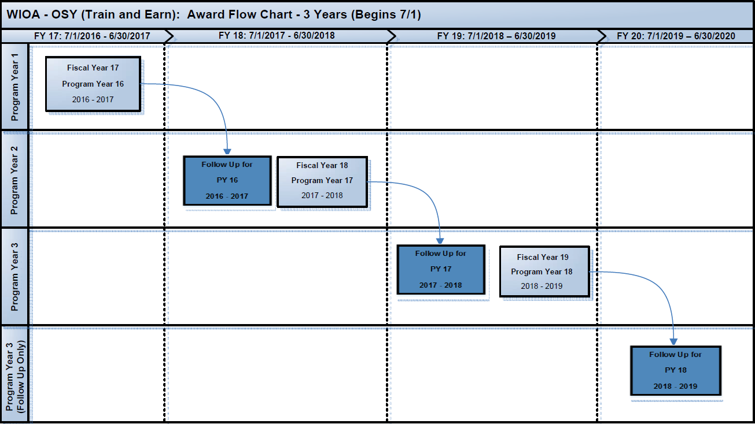

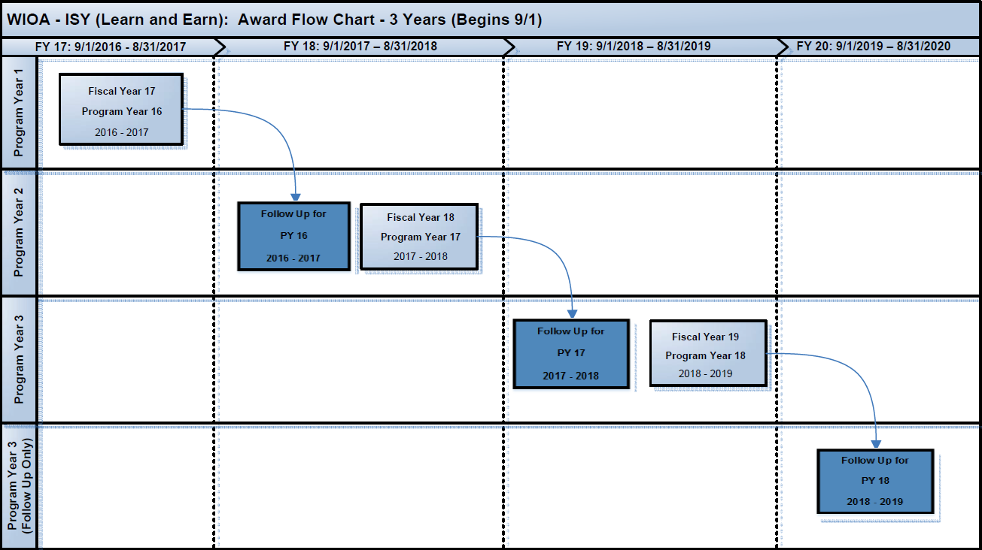

Note: The review and approval for the program year of one budget and the follow up year of the prior year’s budget happen concurrently.

Completed budgets are to be certified by an authorized representative of the Provider’s agency and submitted electronically through PB/MFR. The electronic budget will be reviewed by DYCD Accountability and Compliance Unit (ACU) who will either transmit the budget to the WIOA Budget Review staff to approve the Budget or contact the provider for necessary revisions.

INSURANCE REQUIREMENTS:

Providers must provide DYCD with a Certificate of General Liability Insurance, as well as any renewal certificates required during the contract term. Providers are required to have General Liability Insurance in the sum of not less than one million dollars ($1,000,000) per occurrence to protect themselves and the City of New York and its officials and employees against claims, losses, damages, etc. Required certificates not presented in a timely manner may result in a delay in contract registration or may result in suspension of a contract. The policy must include theft insurance to guard against loss of equipment as a result of a break-in or robbery. Each Provider must be covered for loss due to burglaries, vandalism, fire or floods that affect equipment or furniture that is leased or purchased with DYCD funds. If such equipment is lost or stolen, the Provider must obtain a police report detailing the nature of the incident as well as submit a claim to the insurance carrier. In addition, the Provider must submit an official report to DYCD. The Provider must replace lost or stolen DYCD equipment with funds obtained from settlement of the claim. The Risk Management Unit must receive written notification within fifteen (15) days if the policy is cancelled during the contract term.

Insurance Requirements
The New York City Comptroller’s Office requires that the Certificates of General Liability Insurance have the National Association of Insurance Commissioner (NAIC #) included on the right of the page next to the insurer A box.

The City Law Department requires DYCD to ensure that all Certificates of General Liability for our contracted Providers contain the following statement in the box labeled “Description of Operations/Locations/Vehicles”:

“The City of New York, including its officials and employees, is included as Additional Insured.”

Furthermore, Programs located in Department of Education (DOE) or New York City Housing Authority (NYCHA) facilities must carry insurance that covers and names the City of New York and DOE or NYCHA, as the case may be, as Additional Insured. The Certificate for such a program must contain the following statement in the box labeled “Description of Operations/Locations/Vehicles”:

“The City of New York, and the Department of Education of the City School District of the City of New York [or New York City Housing Authority], including their officials and employees, are included as an Additional Insured.”

Additionally, each certificate of insurance must be accompanied by a copy of the endorsement that is used for the Provider’s policy. If the endorsement contains a box titled “Location of Covered Operations,” it must list the location where services are being provided.

If services are provided in in multiple locations, under “Location of Covered Operations,” the Provider must include the following language: “All locations of operations that are listed in the contract(s)” in lieu of having to list each location where services are provided.

Samples of the Certificates of Insurance and endorsements are available on DYCD’s website here and here.

Providers must make available a Certificate of Insurance, together with a Broker’s Certificate, and the Additional Insured Endorsement, to DYCD; providers must also submit any renewal certificates required during the contract term. Required certificates not presented in a timely manner may result in suspension of the contract. DYCD retains the right to enroll a non-compliant Provider in CIP and to withhold 4.5% of the contract to cover the cost of CIP participation.

Providers must email proof of General Liability coverage for review and approval to DYCDINSURANCE@DYCD.NYC.GOV

All other mandatory insurance policies must be made available for inspection by DYCD staff, CPA Auditors, and/or other authorized agents.

WORK EXPERIENCE

Under WIOA, paid and unpaid work experience is an allowable activity and one of the required fourteen (14) youth program elements.

WIOA section 129(c)(4) prioritizes work experiences with the requirement that local areas must spend a minimum of twenty (20) percent of non-administrative local area funds on work experience. Under WIOA, paid and unpaid work experiences that have as a component academic and occupational education may include the following four categories:

  - Summer employment opportunities and other employment opportunities available throughout the school year
  - Pre-apprenticeship programs
  - Internships and job shadowing
  - On-the-job training opportunities.

As indicated in U.S. Department of Labor Training and Employment Guidance Letter (TEGL) No. 23-14, program expenditures on the work experience program element include wages as well as staffing costs for the development and management of work experiences.

In this regard, program expenditures on the work experience program element can be more than just wages paid to youth in work experience. Allowable expenditures beyond wages can include staff time spent identifying potential work experience opportunities, staff time working with employers to develop the work experience, staff time spent working with employers to ensure a successful work experience, staff time spent evaluating the work experience, participant work experience orientation sessions, classroom training or the required academic education component directly related to the work experience, and orientations for employers as set forth in TEGL 08-15, Item #7: https://wdr.doleta.gov/directives/attach/TEGL/TEGL_08-15_Acc.pdf

Allowable Expenditures
All DYCD Providers are required to spend at least 15% of their allocated funding on Work Experience.

Examples of what would count towards the spending priority on Work Experience services.

- Youth wages including Federal Insurance Contributions Act (FICA) tax;
- Staffing and travel costs for developing and providing Work Readiness training for youth participants;
- Staffing and travel costs to meet and work with employers to develop work experiences for youth participants;
- Staffing and travel costs for on-site monitoring and job coaching at the youth participants’ work site;
- Staffing and travel cost for case management activities directly related to work experience services;
- Stipends and Incentives directly related to work experience services.
- Pre-apprenticeship program cost;
- Classroom training or the required academic education component directly related to the work experience

SECTION ONE

THE BUDGET

BUDGET OVERVIEW

Providers cannot be reimbursed for any costs incurred until their budget is approved by DYCD and the contract is registered in the City’s fiscal system by the New York City Comptroller’s Office.

The budget is an indication of how the Provider anticipates funds will be spent during the budget period and should be as accurate as possible prior to submission.

Budgets must first be entered and submitted via PB/MFR. A system utilized by WIOA’s Train and Earn (OSY) and Learn and Earn (ISY) programs.

The following flowchart represents steps in relation to the contract budget process:

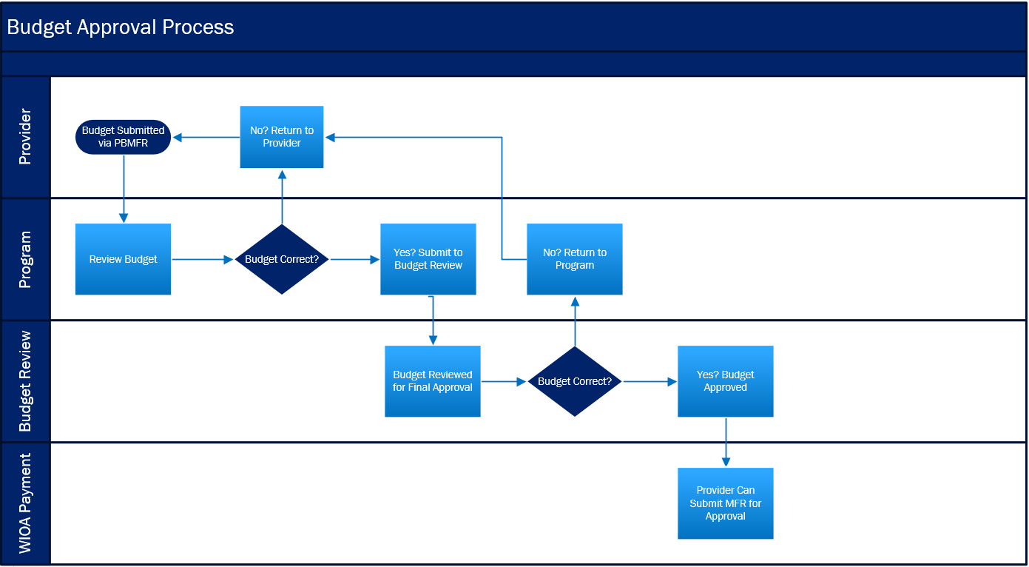

The budget is divided into two categories: Personnel Services (PS) and Other Than Personnel Services (OTPS), as follows:

Personnel Services:
- Salaries & Wages
- Fringe Benefits

Other Than Personnel Services
- Indirect Cost
- Fee for Profit
- Non-Staff Services
- Facility Rental
- Bonding & Liability
- Audit Cost
- Other OTPS
- Stipends

PREPARING THE DYCD BUDGET

Personnel Services: Programmatic expenses for Salaries and Fringe Benefits. Please keep in mind the following information as you complete the DYCD budget:

Cost Allocation - an employee paid with DYCD funds must perform work related to the DYCD contract. Administrative staff performing work under DYCD contracts must be cost-allocated under Personnel Services or budgeted under the Indirect Costs rate category, but not both. Providers may have employees work under multiple program budgets. Estimate the percent of time devoted to each and allocate only the appropriate amount to each program budget. The total of all amount budgeted to one staff person (including programs not funded by DYCD) cannot exceed 100%.

Note: Effective December 31, 2018 New York State’s minimum wage for New York City has increased to $15.00 per hour.

Full-time Employee
For DYCD contracts, a Full-time Employee is defined as an employee who works 35 hours or more per week, is paid on a salary or hourly basis and retains a full-time position with the Provider. A full-time employee shall not be claimed as a part-time employee because their hours are cost-allocated between contracts. For example, if the employee is full-time and is scheduled to work 20% of their time on a DYCD contract, they are still considered a full-time employee per DYCD claiming purposes.

Part-time Employee
For DYCD contracts, a part-time employee is defined as someone who is scheduled to work less than 35 hours per week and/or is paid on an hourly basis and retains a part-time employment status with the Provider.

Providers must enter each individual position on a separate line. For example, if a provider has 5 Instructors, each Instructor must be listed by name on a separate line. The Provider must submit a resume and job description for each employee listed on the budget.

Practices Related to Personnel Services
If a Provider wants to adjust the salary for an employee included on a DYCD budget, a budget modification would need to be submitted to DYCD for review and approval.

Note: The program year of one budget is usually running simultaneously with the follow up year for the previous fiscal year. If a Provider is adjusting the current annual salary for an employee who has been budgeted for the follow up of the previous year, a modification will be needed for both budgets.

Fringe Benefits
The maximum reimbursable rate allowed for fringe benefits is 35%. The rate includes all benefits under the Fringe Benefits category. Fringe Benefits may include but are not limited FICA, MTA Tax, Unemployment Insurance, Workers Compensation, Disability, Life Insurance, Pension, and Medical Benefits.
Effective fiscal year 2020, the minimum Fringe Benefit rate of 7.99% for FICA and MTA tax is required for all contracts.

MTA Tax
The Metropolitan Commuter Transportation Mobility Tax is imposed on certain employers and self-employed individuals engaging in business within the Metropolitan Commuter Transportation District (MCTD). The MCTD consists of the five boroughs of New York City.

Employers:
- This tax applies to you if you are required to withhold New York State income tax from wages and your payroll expense exceeds $312,500 in any calendar quarter.
- Tax rate: 0.34% (.0034) of your payroll expense for employees employed within the MCTD and allocated to your DYCD contract.

Please check the following link for a rate that applies to your organization:

https://www.tax.ny.gov/bus/mctmt/emp.htm

Medical Benefits, Life Insurance, Pension, Workers Compensation, and Disability costs are to be calculated based upon the Provider’s policies.

Note: Backup documentation for fringe benefits charged to the WIOA budget must be kept on file, and is subject to audit review.

Indirect Rate (Indirect Costs)
The Indirect Rate category is used to capture overhead costs incurred by a Provider that operates several programs and has administrative costs that cannot be identified as a direct cost to a specific program. Providers with multiple programs where some administrative costs are shared may incur indirect costs. The maximum Indirect Cost rate allowed by DYCD for contracts utilizing federal funds are subject to the federal Uniform Guidance at 2 CFR Part 200 (see below).

Providers who have a federal approved rate must provide a copy of their current federal approved rate letter or nonprofit rate agreement with the budget. It is the responsibility of the Provider to maintain documentation to justify the percentage and allocation plan used to arrive at the indirect cost rate. This documentation must be made available upon request.

Uniform Grant Guidance re: Indirect Cost
Section on Uniform Grant Guidance
ONLY applies to federally funded Contracts
Including: CSBG, CDBG & WIOA

Under the Uniform Grant Guidance, DYCD must honor a Provider’s (sub recipient’s) federally negotiated rate agreement, or use a 10% Modified Total Direct Cost (MTDC) de minimis rate if a Provider does not have one.

If the Provider never received a federally negotiated indirect cost rate, the Provider can elect to charge a de minimis rate of 10% of MTDC. A de minimis rate of 10% of MTDC is an automatic rate without any review of actual costs. This means that DYCD will honor your request for a 10% de minimis rate without requiring documentation of actual costs.

PBMFR will automatically consider the following subject to indirect costs:
- Wages
- Fringes
- Up to the first $25,000 for each sub-contractor
- Audit costs

Providers can select any of the following OTPS items by flagging them on the OTPS Schedule of the budget:
- Office Supplies
- Participant Supplies
- Maintenance Services
- Staff Travel
- Participant Travel
- Equipment with a unit cost less than $5,000

MTDC excludes:
- Equipment that costs at least $5,000
- Capital expenditures
- Charges for patient care
- Rental costs for off-site facilities
- Tuition remission, scholarships and fellowships
- Participant Support Costs, such as stipends and travel allowances

If the Provider elects a rate lower than 10%, DYCD requires written acknowledgment that the Provider is declining the 10% de minimis rate and confirmation of the rate it will be claiming on the budget.

Note: The 10% De Minimis Decline Acknowledgement Form is available for download on the DYCD website under Budget Review & Risk Management

If the Provider elects a rate lower than their federal approved rate, DYCD requires written acknowledgment that the Provider is declining to use the full federal rate and confirmation of the rate it will be claiming on the budget.

Note: The Lower Federal Indirect Cost Rate Acknowledgement Form is available for download on the DYCD website under Budget Review & Risk Management

Non-Staff Services
Non-Staff Services refers to the following categories: Vendors, Subcontractors and Consultants

Vendors
Vendors are entities or individuals retained to provide services to the contractor and who do not provide direct program services; examples of services provided by vendors are cleaning, security, etc. Vendor Agreements must be maintained on file at the Provider for a minimum of six (6) years and subject to audit. Providers must follow the purchasing procedures outlined in the Fiscal Manual for the procurement of services from vendors (Section 4). For each vendor, a copy of the fully executed vendor agreement must be submitted with the budget.

Subcontractors
Subcontractors are independent entities retained to perform specific programmatic services. A Subcontract Agreement will be governed by the terms of the DYCD contract. The maximum percentage of subcontracting allowed is determined by the respective contract or program area contract based on the RFP.

Subcontractor with an annual budget of over $100,000 will be required to complete the Passport (Vendor and Principal Questionnaires) and provide other information about the entity.

Subcontractors are to be listed in the Subcontractor section of the Non-Staff Services section of the Budget. For each Subcontractor listed, submit a signed, notarized Subcontract Agreement with the subcontractor’s EIN # and a listing of their Board of Directors with the budget. A prime Contractor shall not enter into any subcontract for the performance of its obligations without prior written approval from DYCD Program Management.
After the agreement is made between Prime Contractor and Subcontractor to render services, the subcontractor must be approved by DYCD’s Agency Chief Contracting Officer (ACCO) or designee in the Procurement Unit. Otherwise, the Provider runs the risk of not being reimbursed for services rendered.

All subcontract agreements submitted for approval must be accompanied with the City of New York Subcontractor Approval Form. Upon approval, DYCD will forward a copy of the approval form to the prime contractor for their records and will also approve the subcontractor in the Payee Information Portal (PIP) system. For more information please visit the PIP system at www.nyc.gov/pip.

The prime Contractor will be required to utilize the City’s web-based system, PIP, to identify all subcontractors to obtain subcontractor approval pursuant to PPB Rule section 4-13 and will also be required to enter all subcontractor payment information and other related information in such system during the contract term. Failure of the prime Contractor to list a subcontractor and/or to report subcontractor payments in a timely fashion may result in the Agency declaring the prime contractor in default of the contract and may subject the prime contractor to liquidated damages in the amount of $100 per day for each day that the prime contractor fails to identify a subcontractor along with the required information about the subcontractor and/or fails to report payments to a subcontractor.

Consultants
Consultants are individuals with specific skills retained to perform limited programmatic tasks or to complete program related projects on a temporary and/or limited basis, where the tasks or projects cannot be accomplished by the contractor’s staff. The services provided by the Consultant must be related to the program work scope described in the contract. All consultants paid by the DYCD contract are required to be listed in this section. All consultant agreements must be approved by DYCD Program Management prior to budget or modification submission.

Consultants cannot be Full-time Employees of the contractor. Consultants are self-employed individuals who maintain their own service and financial records.

For each consultant listed, a signed and notarized Consultant Agreement along with a recent resume must be submitted with the budget. Consultants retained by a Provider must enter into a written agreement detailing the specific tasks to be performed. Consultants will be allowed by DYCD only for those services that cannot be performed by Provider staff. If a consultant’s services are required for an extended period, such an individual must be hired as an employee. Consultant Agreements and invoices must be maintained by the Provider for at least six (6) years and are subject to audit. Consultant invoices must include the following details: rate, hours, type of services, date of service, consultant signature, and approval by the Provider’s Executive Director or his/her designee.

Facility Rental
Space costs include expenses associated with paying for space necessary for the operation of a program.

Space Cost/Other
All rent, mortgage and other expenses associated with the use of a facility. Along with the budget, the Provider will be required to submit a copy of the current lease signed by both the Provider and the owner and floor plan. The lease cannot be expired and must indicate the annual rental charges. No renovation or construction projects may be paid with funds from DYCD contracts unless otherwise specified in the contract. Some repairs may be allowed, subject to prior written approval by DYCD Program Management.

NOTE: Space allocation will be subject to audit and may lead to disallowable costs if the allocation does not reflect the actual square footage used for your program.

If renting space from a public school, the Provider must submit a DOE permit with the budget.

Contract Audit Requirements
DYCD monitors fiscal compliance of its Providers through audits and annual fiscal field reviews conducted by certified public accounting firms designated by DYCD. Some Providers are also required to have audits performed in accordance with the Uniform Administrative Requirements, Cost Principles, and Audit Requirements for Federal Awards under 2 CFR Part 200, et.al., or obtain certified audited financial statements on an entity-wide basis or program specific basis, as described below:

• Non-profit providers that expend federal funds of $750,000 or more annually must have an audit performed in accordance with the Uniform Guidance completed within nine months after the end of the contractor's fiscal year and (ii) promptly provide DYCD with a copy of the Uniform Guidance Report after issuance. These Providers should be familiar with and are responsible for compliance with these requirements.

• Non-profit providers that expend funds of less than $750.000 but over $25,000 annually through DYCD must have an independent financial audit conducted by a Certified Public Accounting firm for each specific program.

• For-profit providers that expend funds of $25,000 or more annually must have either a program-specific or an entity-wide independent financial audit conducted by a Certified Public Accounting firm.

Note: A Provider must have $750,000 or more in federal expenditure in order to charge audit costs to their budget.

OTPS
This main category is for programmatic expenses other than Salaries, Fringe Benefits or Non-Staff Services. OTPS lines within the DYCD budget must be filled out by Providers according to the guidelines set forth by their respective program areas. All allocations must be program related and costs must be pro-rated over the operating period. The following are examples of commonly utilized OTPS categories:

Office Supplies
Consumable supplies that do not last or are not permanent in nature. This category includes office and maintenance supplies such as pens, stationery, chalk, erasers, towels, cleaning supplies and books.

Maintenance and Repair
Cost of necessary maintenance or upkeep of building. As per federal regulations 2 CFR Part 200, these costs are only allowable if they are not paid through rental or any other agreement. No renovation or construction projects may be paid with funds from DYCD contracts unless otherwise specified in the contract. However, some repairs may be allowed subject to prior approval by DYCD Program Management.

Staff Travel
Transportation costs refer to costs incurred for local travel by the employees to conduct official business related to the DYCD contract. Travel may be by public transportation, by a Provider’s vehicle, or personal automobiles used for Provider business. Costs for the use of a personal automobile will be reimbursed at the maximum rate provided on the IRS website IRS Standard Mileage Rate. A mileage log must be maintained for both personal and business-owned vehicles used to conduct business related to the funded program. Tickets for traffic violations may not be paid for with funds from DYCD contracts. Additionally, costs for employees to commute to and from work may not be paid with funds from DYCD contracts.

Participant Travel
Participant-related travel expenses for local travel. The unit cost should be equal to the value of the Metrocard (i.e. cost for single ride, round trip, etc.)

Note: If issuing Metrocards to staff or participants for travel, a log must be maintained. Metrocards must be purchased and dispensed in the same program year.

Tours/ Bus Trips
All trips need to have prior approval from DYCD Program Management. Bus companies used for transporting participants must be insured.

Staff Training
Includes expenses for professional development workshops, conferences and licenses required to maintain professional credentials relevant to the DYCD contract.

Postage
All postage related expenses relevant to the DYCD contract.

Advertising
Cost of materials associated with recruitment such as flyers, newspaper and online advertisements that pertain exclusively to the WIOA program. Subject to the federal regulations under 2 CFR Part 200. The WIOA Equal Opportunity tagline must be included in all Program related items. The tagline is as follows:

“<Agency Name> is an equal opportunity employer/program. Auxiliary aides and services are available upon request to individuals with disabilities”.

*Note- where a telephone number is present a TDD/TTY number must be included as well.

Printing
Printing costs (e.g., workshop materials, annual report, etc.) with the exception of related costs for recruitment purposes (for the exclusive use of program activities)

Participant Supplies
Allocations for workshop material and other materials related to participant services.

Utilities
Costs for things such as electricity, gas, telephone, water, oil, security system, internet connectivity, mobile phones, and bundled communication. As per federal regulations 2 CFR Part 200 these costs are only allowable if they are not paid through rental or any other agreement.

Participant Verification
Cost for verifying participant enrollment and achievement of outcomes (i.e. National Clearing House, Wage Works)

Testing
Cost for testing materials used by the participants.

Background Checks
Cost for background checks of the Provider’s employees.

Participant Refreshments
Subject to the limitations of federal regulation 2 CFR 200. Any food-related expense (including meals, snacks, light refreshments, etc.) charged to a WIOA program budget must satisfy and fit in into one of the two categories listed below
- Participant Support
- Entertainment

Food-related expenses associated with Participant Support costs are allowable only if the program includes an education or training component, and the food-related expenses are explicitly listed in the program budget and justified as part of the education or training components.

Participant support costs are defined as direct costs for items such as stipends or subsistence allowances.

Food-related expenses associated with the cost of entertainment are always unallowable except in the very rare instance of when food-related costs that might otherwise be considered entertainment have a programmatic purpose AND are authorized in the budget and approved by program management.

Entertainment expenses are costs related to amusement, diversion, and social activities and any costs directly associated with such costs, including tickets to shows or sports events, meals, lodging, rentals, transportation, and gratuities.

Participant Incentives
Incentives 20 CFR 681.640 states that “incentive payments to youth participants are permitted for recognition and achievement directly tied to training activities and work experiences. The DYCD Providers must have written policies and procedures in place governing the award of incentives and must ensure that such incentive payments are tied to the goals of the specific program; outlined in writing before the commencement of the program that may provide incentive payments; align with the local program’s organizational policies; and are in accordance with the requirements contained in 2 CFR 200.” DOL included the reference to the Uniform Guidance at 2 CFR 200 to emphasize that while incentive payments are allowable under WIOA, the incentives must be in compliance with the Cost Principles in 2 CFR 200. For example, Federal funds must not be spent on entertainment costs. Therefore, incentives must not include entertainment, such as movie or sporting event tickets or gift cards to movie theaters or other venues whose sole purpose is entertainment. Additionally, there are requirements related to internal controls to safeguard cash, which also apply to safeguarding of gift cards, which are essentially cash.

The providers must have approved written policies and procedures in place governing the awarding of incentives and must ensure that such incentive payments are:

- Tied to the goals of the specific program
- Aligned with DYCD’s program organizational policies
- Accord with the requirements contained in 2 CFR 200.

Incentives must be for recognition of achievement of milestones in the program tied to work experience, education, or training. This could include improvements marked by attainment of a credential or their successful outcome. Use of incentives for recruitment, submitting eligibility documentation or general participation in the program is not allowed with WIOA funds. Local areas may use leveraged, non‐WIOA funds for such incentives.

Note: DYCD has mandatory distribution logs that Providers must maintain and submit DYCD upon request.

Equipment Purchase
Equipment purchases are supplies that are durable or permanent in nature, such as furniture, printers, fax machines, televisions and cameras. All equipment purchased with DYCD funds must be listed on the budget. SEE Section 5- Purchasing Procedures of this Manual and the specific references included for compliance with federal regulations regarding definitions of Equipment and Supplies and requirements for Inventory and Control.

All equipment and/or furniture purchased with DYCD funds is the property of the New York City Department of Youth and Community Development and must be tagged “Property of DYCD.” At the end of the contract, all non-depreciated equipment that still has a useful life and was purchased with DYCD funds must be returned if requested by DYCD. DYCD will consider requests for continued use or other recommended disposition of such equipment, upon termination or non-renewal of a contract. Contact the assigned Contract Manager regarding continued use or other disposition of equipment.

An Equipment Purchase Inventory report that lists a serial #, model #, manufacturer, date of purchase and delivery will be required on the MFR when submitting the first claim.

Note: Phone bids are required for any equipment with a unit cost of $250 - $4,999.99. Providers must submit a written request to DYCD to obtain approval from the New York State Department of Labor for prior approval to purchase equipment with a unit cost of $5,000 or more.

Stipends
Stipends are only allowed for the benefit of participants of the program. Stipends may be included as a part of a training program, to assist a participant in acquiring the skills necessary to obtain employment and to subsequently retain employment. A stipend means a payment in exchange for program participation and may be paid according to hourly, daily or weekly rates. A stipend must not be used to displace an employee or position, including partial displacement such as a reduction in hours and wages, to avoid hiring salaried workers, or to perform services that would otherwise be performed by an employee, including an employee who recently resigned or was discharged, an employee who is subject to reduction in workforce, or an employee who is on leave. Stipends may not be used to pay for services being received by the Provider or to avoid payment of FICA, Unemployment Insurance, or Worker’s Compensation Insurance. Stipend allocations are to be entered into the Stipends detail of the Budget. Additionally, any specific guidelines set forth by the respective DYCD Program area, must be followed. All stipends must be pre-approved by DYCD. Providers must submit a Stipend Plan in the form of an agreement between their organization and the participant and a mini budget for DYCD approval.

Note: DYCD has mandatory distribution logs that Providers must maintain and submit to DYCD upon request.

.

THE BUDGET: PROCESS FOR SUBMITTING BUDGET THROUGH PB/MFR

NOTE: The access information provided to you cannot be shared with anyone. Everyone must have a unique log-in access code/password.

After Login you will see a screen with two tabs: PB and MFR

Click on PB menu icon on the top of the page

You will see a budget list screen indicating a PB number for your agency’s DYCD funded programs

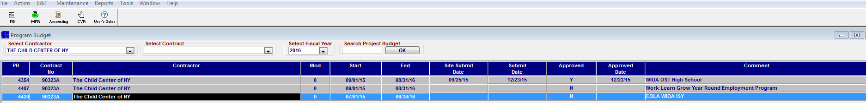

Click on Select Contract and choose the contract that corresponds to the PB that you are submitting.

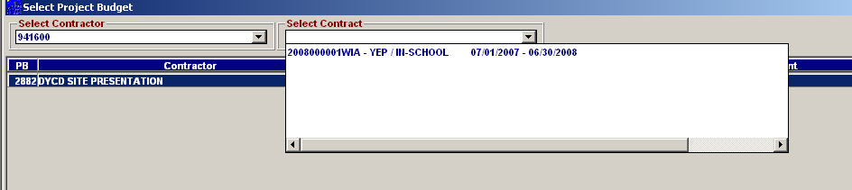

If entering information for a new budget, the column labeled “Mod” is indicated by a zero(0)

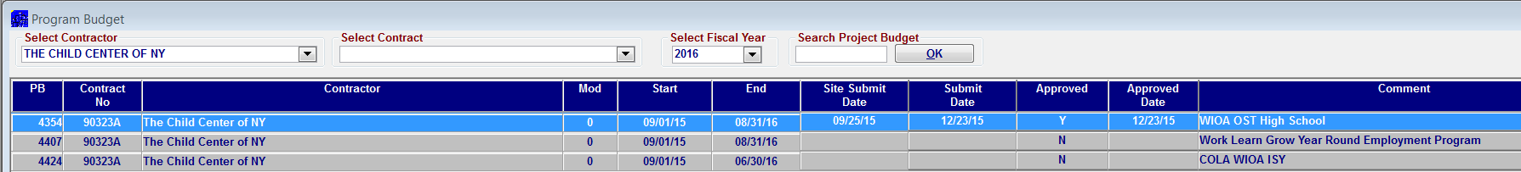

Once you selected a PB, right button click and select the program & year for the PB or PB mod

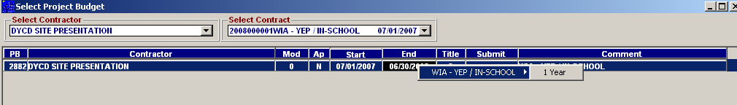

The system will open a Program Budget sheet listing the agency’s program information as well as the cost categories for PS and OTPS

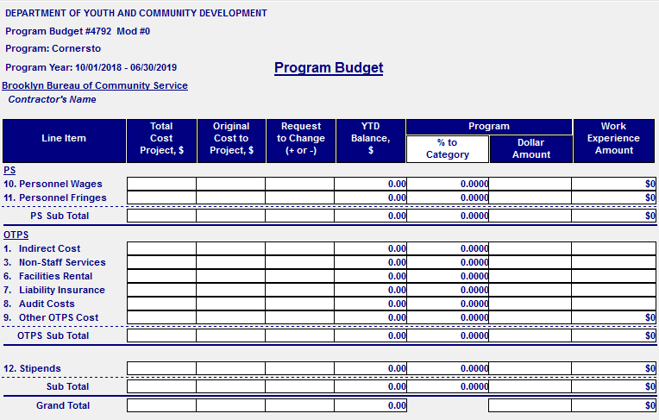

NOTE: Each Line Item has a detailed worksheet that needs to be completed if you are going to claim expenses for that specific category.

PERSONNEL SERVICES

Select Personnel Wages, then double click to open.

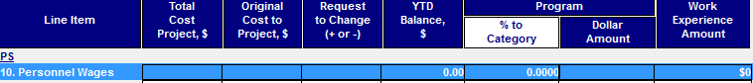

When you open the Personnel Wages screen you will see two tabs: 1. Summary and 2. Detail. Clicking on the Detail Tab will bring you to the Personnel Services Detail data entry screen where you will enter the following information for the staff you will be hiring for the program:

  - Staff title (choose from drop down list)
  - Staff last and first name
  - Title (choose from list by clicking on arrow)
  - Hired date (the hired date is the start date for the agency, not the program)
  - Number of weeks in year (Please use a calendar to count the number of weeks for the program considering the delivery period)
  - Annual salary (this should reflect the actual annual salary with the agency, not a prorated amount)
  - Number of weeks staff will work for the program
  - Percentage of staff salary will be charged to the program
  - Work Experience percentage

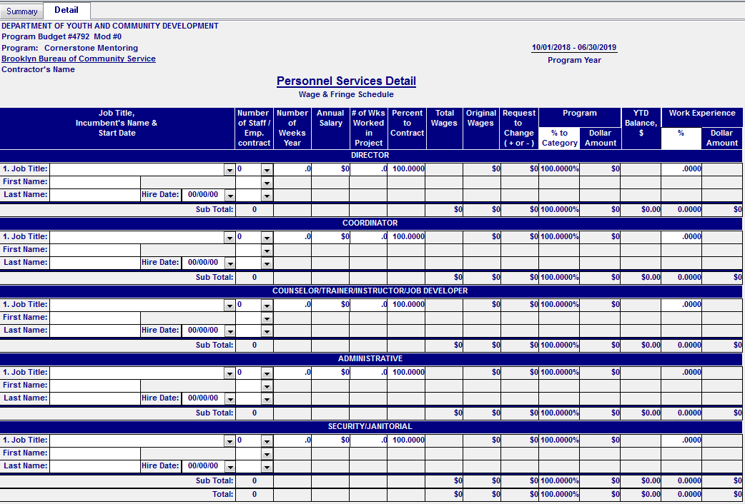

Note: The sheet is categorized by title: DIRECTOR, COORDINATOR, COUNSELOR/TRAINER/INSTRUCTOR/JOB DEVELOPER, ADMINISTRATIVE and SECURITY/JANITORIAL. Under each of these titles, there are sub-titles. Depending on the staff responsibilities, you need to determine the title for the staff will be listed. If the office title given to staff is not listed, send email to Program Management indicating the title you want to add to the system.

Enter 1 from the first drop down box under “Number of Staff/Emp. Contract”.
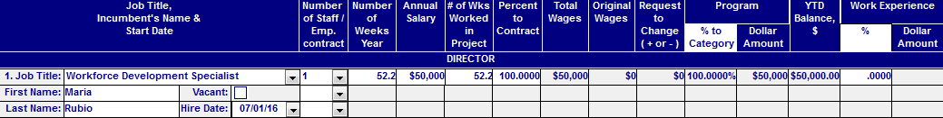

Indicate if the staff line is for the program year (PY) or follow up year (FY) by clicking on the second drop down under “Number of Staff/Emp. Contract”.

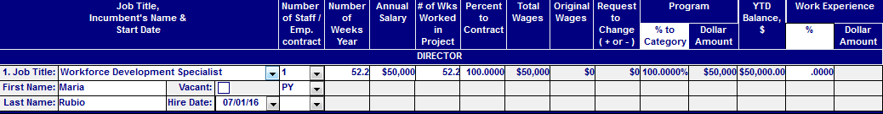

Indicate if the staff is FT or PT by clicking on the third drop down under “Number of Staff/Emp. Contract”.

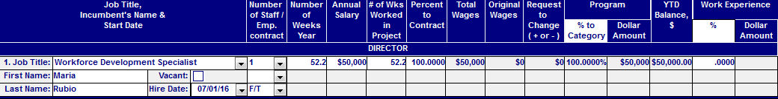

If the staff will be involved with the follow-up services for the program, add a second line with the same information as the first line (if the staff salaries is subject to an increase on the second year of the program (follow- up), enter the new annual salary on the second box).

NOTE: A staff member whose name appears twice on the budget (program year and follow- up year) should only be counted one time. This means the “number of staff” for the second line should be zero (0).

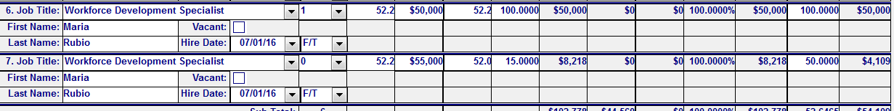

To add another person for chosen title, click on the Add button on the bottom of the page.

When you have entered all the staff listed on the budget, click on the Save button on the bottom of the page

Close the Personnel Wages screen. You will see the summary of total wages entered

The system will take you back to the Program Budget sheet where you are able to see the amount of total wages entered for the program

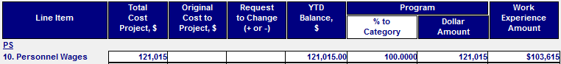

Note: Resumes and job descriptions must be submitted for each staff listed

LIMITATION ON SALARY AND BONUSES
- The limitation on salary compensation which can be charged to WIOA is based on Federal Executive Pay Level II under US Public Law 109-234 enacted in 2006. The annual rate for Federal Executive pay Level II is $189,600. The pay level may change annually, and salary table can be obtained at www.opm.gov.
- Individuals who have a percentage of their total salary cost allocated to WIOA are limited to their cost allocated percentage applied to the Executive Pay Level II rate. For example, someone who earns $200,000 that spends 50% of their time on WIOA-related work is eligible to have up to $90,750 by WIOA, not $100,000

TECHNICAL ADVISORY #11-8 POLICY (for full details go to www.labor.ny.gov. Search Technical Advisory 11-8)

Employee bonuses are an allowable cost if they meet the following criteria:
- A detail description of the agency’s employee bonus system
- An explanation of what behaviors and/or outcomes will be rewarded by an employee bonus
- An explanation of how the proposed bonus system will impact the agency’s performance during the affected period
- An identification of which types of personnel will be eligible for bonuses and the maximum amount of the bonus per type
- If your agency is a non-profit or for-profit organization
- Documentation that demonstrate the agency’s employee compensation including the proposed bonuses, are reasonable for the labor market
- Copy of the written policy on the provision of bonuses in effect at the time of payment of the bonuses

The letter along with all pertaining information can be addressed to the DYCD WIOA designated Director. A budget modification is required.
FRINGE SCHEDULE

Select the Personnel Fringes line then double click to open the Fringe Schedule.

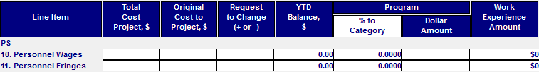

WORK EXPERIENCE - Enter the percentage to be applied to the program for Work Experience

Note: Fringe rate cannot exceed 35%

When you finish click Save, then click Close.

When closing the Fringe sheet, the system will take you back to the Program Budget indicating the total amount for wages and fringes

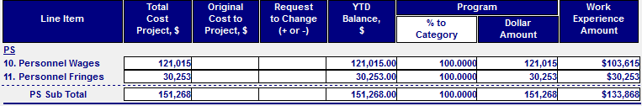

Indirect Cost Worksheet

Select the Indirect Cost line then double click to open the Indirect Cost Schedule Worksheet. This is where you enter the indirect cost rate for your budget.

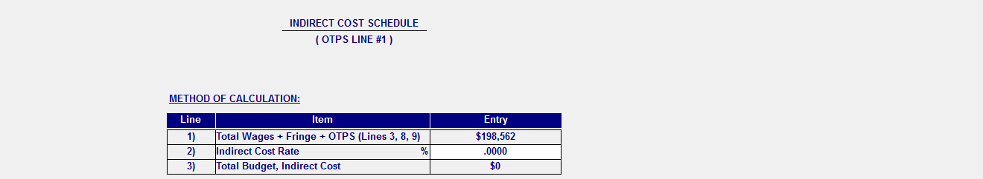

Note: The information captured by the system at this point only includes wages and fringes. Wait until you have finished entering all line item information before entering a rate in this field. The total budget for indirect cost will change as you consider other costs that are allowed as indirect.

If the agency has an approved federal rate, submit copy of the letter from the federal agency. If not, you may budget 10% of your Modified Total Direct Costs (MTDC) contract amount in the Indirect Cost Category without having to provide DYCD with any documentation. This means that DYCD will honor your request for a 10% de minimis rate without documentation of actual costs.

Note: If using a rate less than 10% or less than your federally approved rate an Acknowledgement form will be needed.

NON-STAFF SERVICES

Select the Non-Staff Services line then double click to open the Non-Staff Services worksheet.

The worksheet lists three cost categories:

- VENDOR
- CONSULTANT
- SUBCONTRACTOR

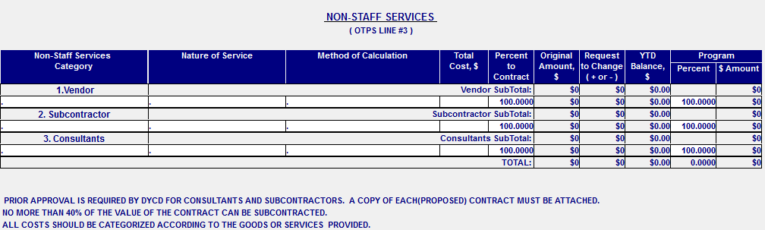

If you are allocating funds in any of the three categories above, include the following information:

- Vendor’s Name
- Subcontractor’s name
- Consultant’s name

- Nature of Service: Indicate the nature of the service that the Subcontractor will provide for the program.
- Method of Calculation: Indicate the Method of Calculation of the Subcontract agreement (e.g. Number of Hours of the services to provide for the program, and the Total amount to be paid to the subcontractor).
- Total Cost: Indicate the total amount of the Subcontract agreement.

Note: The amount for Non-Staff Services cannot exceed more than 45% of the entire budget.

To add a new line click Add menu button on the bottom of the page.

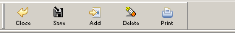

When you finish click Save, then click Close.

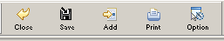

Return to Summary of PB Line Item screen. All dollar amounts will be populated automatically.

Submit the following:

Vendor - Submit Fully executed vendor’s agreement.
Subcontractor - Submit Subcontractor agreement.
Consultant - Submit consultant agreement.

*** Subcontractor services cannot be rendered until DYCD approval is received.

FACILITY RENTAL WORKSHEET

There are two options for charging the cost of facility rental:
1. To lease part or all of the facility.
2. To operate the contract in a facility owned by the contractor.

If the contractor owns the facility a Usage Allowance based on a depreciation methodology can be charged in lieu of space rental. The Department will provide technical assistance to any contractor charging for Usage Allowance.

Select the Facilities Rental line then double click to open the Facility Rental Worksheet.

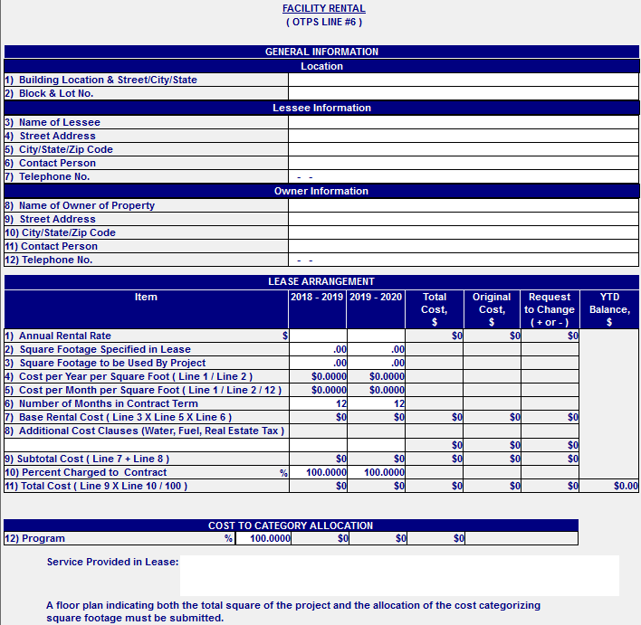

The following information must be entered for each facility listed on your budget:

General Information
  - Building location
  - Complete Address
  - The Block & Lot Number
  - Name of the lessee
  - Lessee’s address
  - Contact person and his/her telephone number
  - Property Owner’s Name
  - Property Owner’s Address
  - Contact Person and his/her telephone number

Lease Arrangement
  - Annual Rent Rate
  - Square Footage Specified in the Lease
  - Square Footage to be used for the contract
  - Annual cost per square foot
  - Number of months the Facility will be used for the Contract
  - Additional Cost Clauses (Water, Fuel, and Estate Tax)

Percentage to be charged to DYCD: Indicate the percentage of facility cost that will be charged to DYCD. Proper measurements for the space used by WIOA should reflect actual space used by staff and participants

Note: A copy of the current fully executed lease must be submitted with the Program Budget.

The system allows for multiple entries when considering rental cost for different locations. To add another Facility Rental worksheet, click the “Add” menu button at the bottom of the page. This will open a new worksheet for you to enter the required information for the additional facility.

When you finish click Save, then click Close.

Return to Summary of PB Line Item screen. All dollar amounts will be populated automatically.

If the agency owns the building (not renting) use “Use Fee / or Depreciation Allowance” worksheet

- After opening Facility Rental worksheet click on the Options button and choose “Use Fee / or Depreciation Allowance” to open the Use Fee / or Depreciation Allowance worksheet.

The following information must be entered:
General Information:
- Building location, (Complete Address)
- The Block & Lot Number
- Square Footage of Building

Cost Item:
- Purchase Price (Date, Cost)
- Land Value (Cost). Optional
- Square Footage to be used for the Contract
- Number of months the Facility will be used for the Contract

Percentage to be charged to DYCD: Indicate the percentage of facility cost that will be charged to DYCD
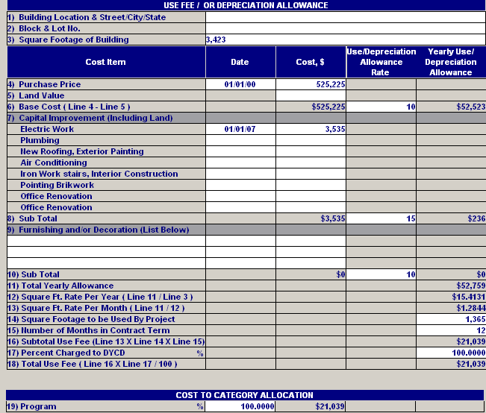

When you finish click Save, then click Close.

Return to Summary of PB Line Item screen. All dollar amounts will be populated automatically.

REMINDER: agency can only charge maintenance costs. WIOA does not allow renovations costs.

LIABILITY WORKSHEET

Select the Liability Insurance line then double click to open the Liability worksheet.

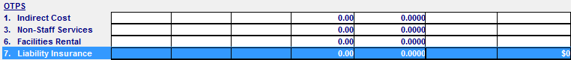

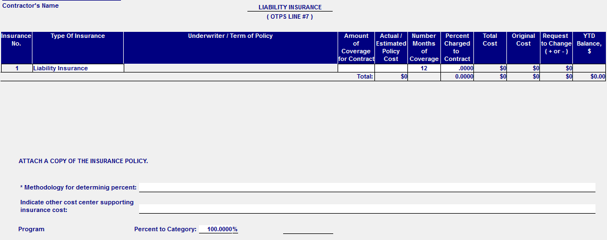

If you are allocating funds for Liability Insurance, include the following information:

- Underwriter/Term of Policy: Indicate the Liability Insurance’ name, and the Term of the policy

- Amount of Coverage for Contract: Indicate the Amount of Bonding & Liability coverage for the Contract

- Actual/Estimate Policy Cost: Indicate the actual or estimate cost of the Bonding & Liability policy

- # of Months of Coverage for DYCD Contract: Indicate the # of months that the DYCD contract with the provider is covered by the Bonding & Liability insurance.
- Percent Charged to the Contract: Indicate the percentage of the Liability insurance cost that is being charged to the DYCD contract

- Contract Cost: Will indicate insurance cost of the Liability
Insurance that is being charged to the DYCD contract

- Methodology for determining percent: CBO must indicate the method used for determining the percentage to be apply to the program

- Indicate other cost center supporting insurance cost: CBO must indicate other cost for supporting insurance cost

When you finish click Save, then click Close.

Return to Summary of PB Line Item screen. All dollar amounts will be populated automatically.

AUDIT COSTS WORKSHEET

Select the Audit Costs line then double click to open the Audit Costs worksheet.

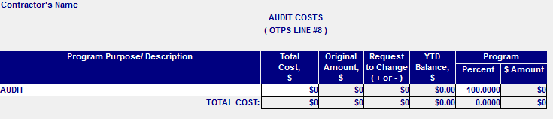

If you are allocating funds for Audit Costs, include the following information:

- Program Purpose/Description: Indicate the Type of Audit (A-133 or Program Audit)

- Unit Cost: Indicate the unit cost of the Audit to be done

When you finish click Save, then click Close.

Return to Summary of PB Line Item screen. All dollar amounts will be populated automatically.

OTHER OTPS COSTS SCHEDULE

Select the Other OTPS Costs line then double click to open the Other OTPS Schedule. This is where you will create lines for all OTPS items.

The OTPS worksheet will display two tabs: 1. OTPS Summary and 2. Equipment Purchase. Select the OTPS Summary tab to enter information for OTPS items needed for your program, and the Equipment Purchase tab to list the equipment purchased for the program.

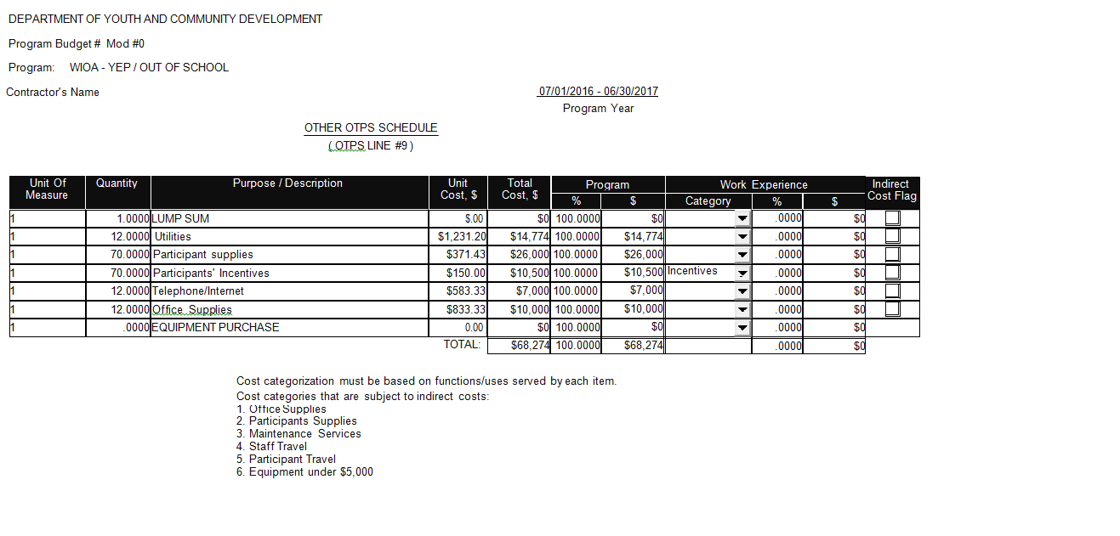
If you are allocating funds for OTPS, include the following information:

- Unit of Measure: Indicate the unit of measure of the OTPS item being charged to the contract
- Quantity: Indicate quantity of the OTPS item being charged to the contract
- Program Purpose/Description: Indicate the Type of OTPS item (i.e. supplies, telephone, etc.) being charged to the contract. Be descriptive when entering this information
- Unit Cost: Indicate the unit cost of the OTPS to be charged to the contract
- Total Cost: Will indicate the total OTPS to be charged to the contract per item escribed

Note: Cost for Incentives must be justified. An Incentive plan and mini budget must be submitted with your budget. Both the plan and mini budget are subject to approval by DYCD Program Management.

WORK EXPERIENCE CLAIMS UNDER OTPS

Work Experience can be captured with the costs associated with Incentives and Staff Travel. If listing these costs as Work Experience claims, click on the dropdown arrow in the Work Experience column and choose the corresponding category.

INDIRECT COSTS CLAIMS UNDER OTPS

Providers can choose to claim Indirect cost for Office Supplies, Participants Supplies, Maintenance Supplies, Staff Travel, Participants Travel and Equipment under $5,000. If claiming these costs as indirect, check mark the box under the column labeled” Indirect Cost Flag.

If requesting approval for equipment, the Equipment Purchase Worksheet must be completed.

Click on the EQUIPMENT PURCHASE tab to open the Equipment Purchase worksheet.

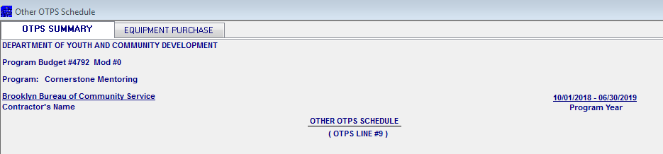

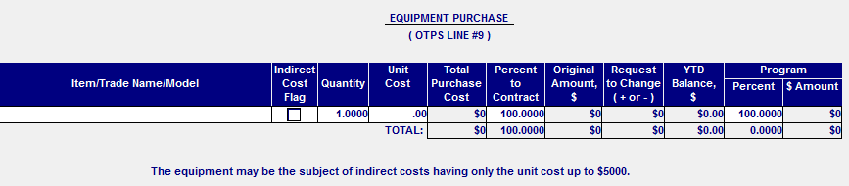

The following information needs to be entered for each equipment listed:

- Quantity: enter the number of items you are planning to purchase
- Item trade/Name/Model: provide the item trade/name and model (E.g. if purchasing a Dell Optiplex-GX620 computer, then the Item Trade/Name/Model should be entered as Dell OPTIPLEX-GX620)
- Unit Cost: Enter the item’s unit cost
- Percent to Project: Enter the percent of the total charge to be applied to the program

To add a new line click Add from the menu on the bottom of the page.

When you finish click Save, then click Close.

Return to Summary of PB Line Item screen. All dollar amounts will be populated automatically.

For purchases in the amount of $250 - $4,999.99, submit three telephone bids. On a spreadsheet include the following information:

1. Vendor’s name
2. Address
3. Telephone Contact
4. Cash discount (if applicable)
5. Freight charge
6. Quoted Delivery Date
7. Date/Time
8. Unit Quantity Specification
9. Price quoted

NOTE: THE LOWER BIDDER SHOULD BE THE ONE CHOSEN TO PURCHASE THE EQUIPMENT

INDIRECT COST CLAIMS FOR EQUIPMENT

When claiming Indirect Cost for equipment below $5,000, check the box labeled “Indirect Cost Flag”.

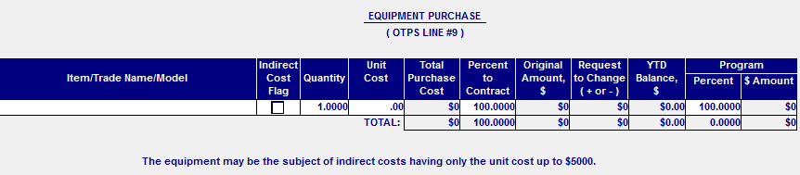

STIPENDS WORKSHEET

Select the Stipends line then double click to open the Stipends worksheet. This is where you will enter stipend information for Classroom Training and Internship.

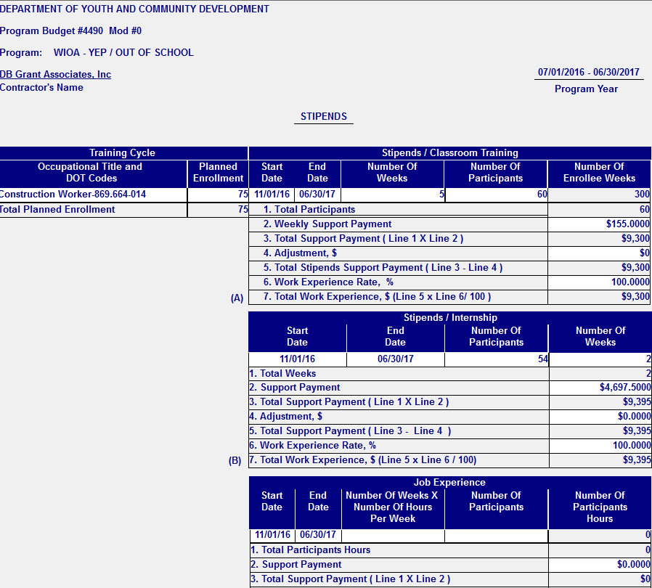
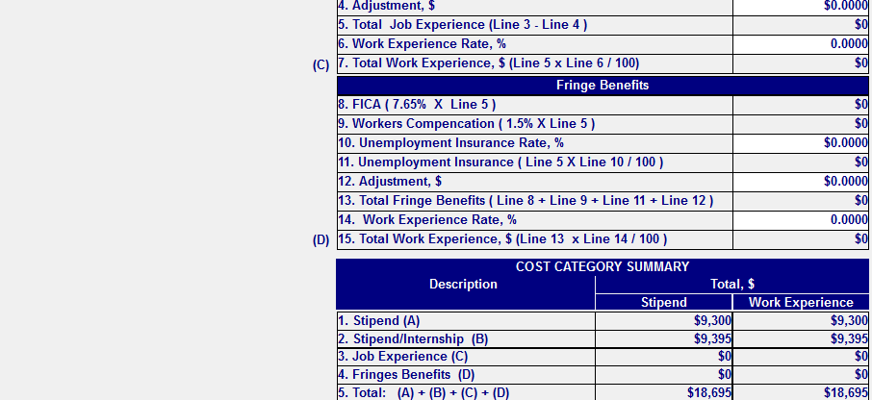

If you are allocating funds for either Stipends/Classroom Training or Stipends/Internship, include the following information:

  - Occupational Title of participants
  - Start Date & End Date of the period or cycle that apply
  - # of weeks of the cycle or period
  - # of Participants for the cycle or period being applied
  - Enter Work experience percentage for each stipend category

When you finish click Save, then click Close.

Return to Summary of PB Line Item screen. All dollar amounts will be populated automatically.

NOTE: Providers are required to submit a detailed Stipend plan and mini budget detailing the stipends will be spent. Both the plan and mini budget are subject to approval by DYCD program staff.

Once all cost categories have been entered and saved, the Program Budget summary sheet will list each cost category dollar amount entered.

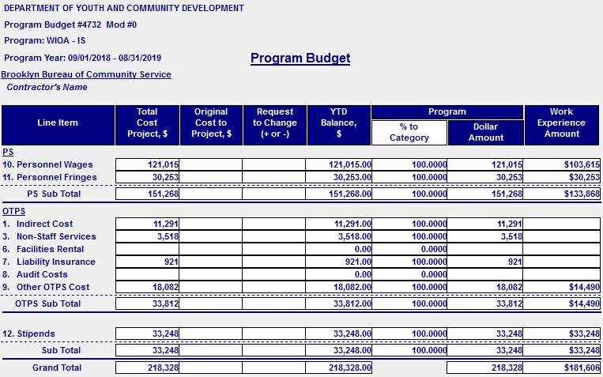

If no more changes are to be made, you can enter the numbers on the Quarterly Expenditures Projections.

QUARTERLY PROJECTION

To Open Quarterly Expenditure Projection, click on the Projection menu button on the bottom of the Summary of PB Line Item screen.

It will open the Expenditure Projection Quarter screen for the contract

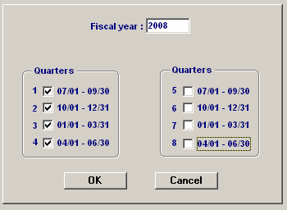

If submitting a budget for WIOA Train and Earn program (OSY), check all 8 quarters for the period. If submitting a budget for WIOA Learn and Earn program (ISY), you will need to select 9 quarters. Click OK.

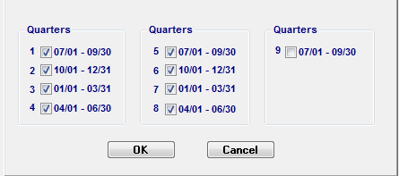

Once the quarters have been selected, the Quarterly Projection will open.

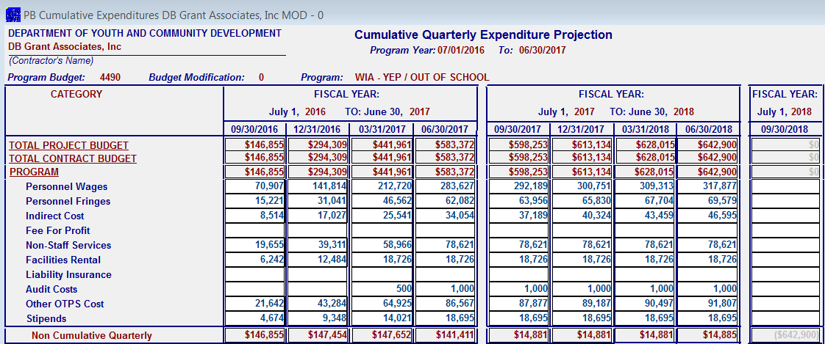

The Quarterly Projection of the Program Budget is a projection based on your anticipated expenditures. The expenditures must be projected to cover the entire duration of services required by the contract (program and follow-up year). The second year will show the amount allocated for follow-up. Contractor must adhere to percentages indicated on the program work scope.

When the projections will initially display cumulative amounts generated by PB/MFR. The provider must enter the cumulative amounts that best indicate how expenses will be charged to their budget.

When you finish entering the cumulative projection for each quarter, click the Save button on the bottom of the page than click Close.

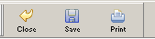

Note: This should be the last worksheet you complete. If changes are made to your budget, the projections may reset to the system generated amounts and will have to be re-entered.

Program Budget Cover Sheet

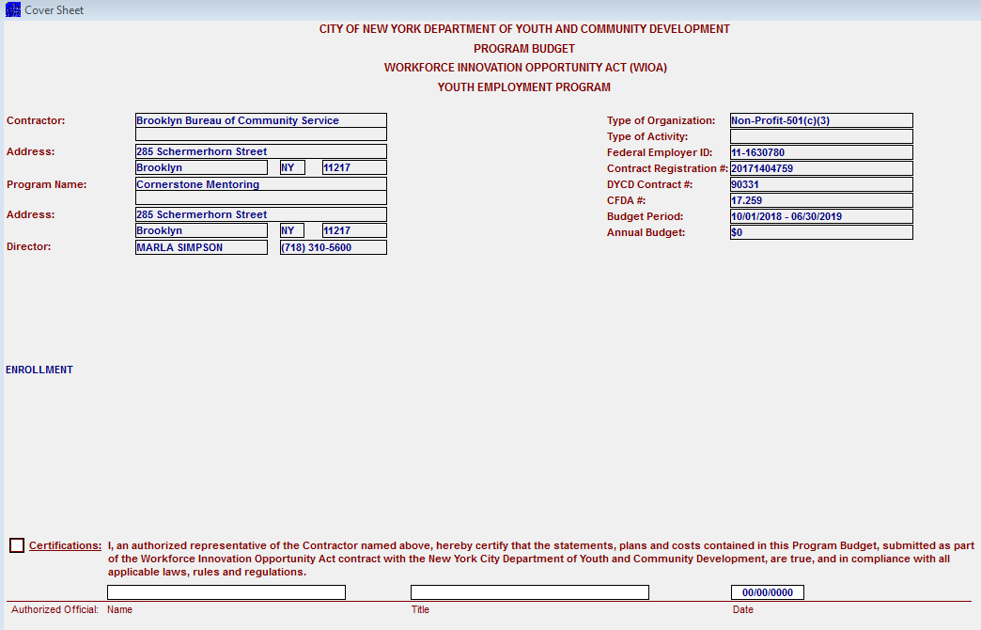

The following information will be populated automatically.

- Contractor’s Name
- Project’s Name
- Director
- Type of Organization:
- Federal Employer Identification Number (EIN)
- Term of the Project
- Program Budget
- CFDA number
- Participants enrollment goal

Before you are able to electronically submit the budget, the authorized agency’s representative must check the box indicating they have read the certification statement on the bottom of the sheet and must enter title, name and date

SUBMITTING PROGRAM BUDGET TO DYCD

To Submit Program Budget DYCD for review and approval return to the main selection screen, select Program Budget and click the Submit button on the bottom of the page.

SECTION TWO

BUDGET MODIFICATIONS

A Budget Modification does not increase or decrease a contract award amount; it serves to reallocate money between line items of an already approved budget. Changes to the approved and registered budget may be submitted only as they relate directly to the accomplishment of services required in the contract. The following flow chart depicts the WIOA budget modification process.

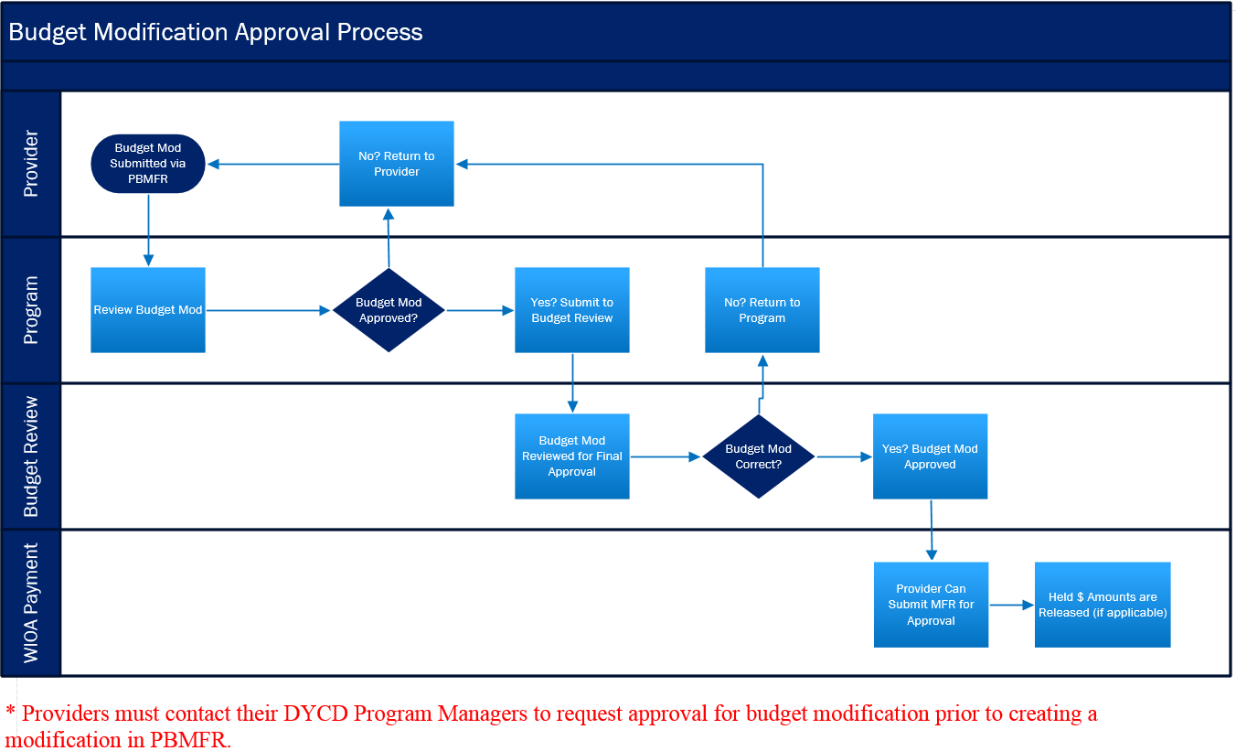

PERSONAL SERVICE SCHEDULE MODIFICATION GUIDELINES

All changes affecting the actual salary on a line in the personal services schedule require modification. This includes but is not limited to:

- Filling vacancies
- Promotions, merit increases, collective bargaining increases, CAE increases
- Position elimination’s downgrading or reclassification
- Reallocation of personal service costs
- New positions

OTPS SCHEDULE MODIFICATION GUIDELINES

OTPS Schedule Lines for may be increased or decreased by the contractor. The lines may include the following as well as other lines listed on the original budget or most recent approved modification:

- Utilities
- Maintenance and Repair
- Security and Protection
- Participant and Staff Supplies
- Telephone
- Postage
- Staff Travel

Note: Modifications are not effective until approval is provided by the Department in writing. Reimbursement of costs will only be permitted against approved modifications.

INSTRUCTIONS FOR COMPLETING A BUDGET MODIFICATION VIA PB/MFR

Once you log in to the system, click on the arrow for box labeled “Select Fiscal Year”.
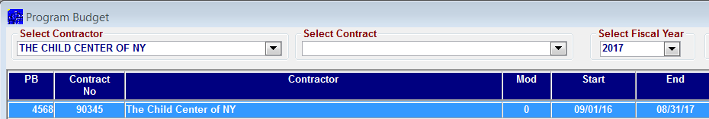

The system will display all the program budgets your agency has for the fiscal year selected.
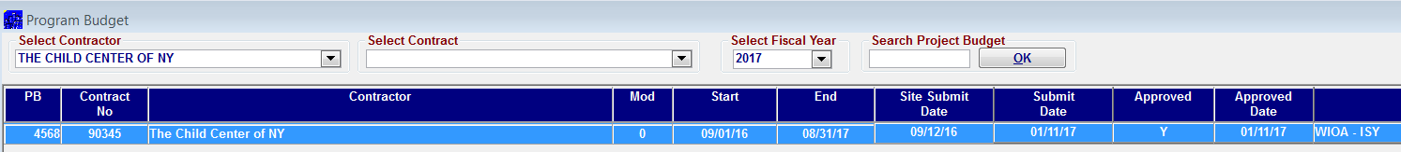

Highlight the program budget you want to modify then click on the “Add Mod” button at the bottom of the screen. Follow the system prompts and a budget modification will appear in the list of program budgets. Double click on the new modification to open.

The system will display the Program Budget summary of line items indicating the latest approved budget.

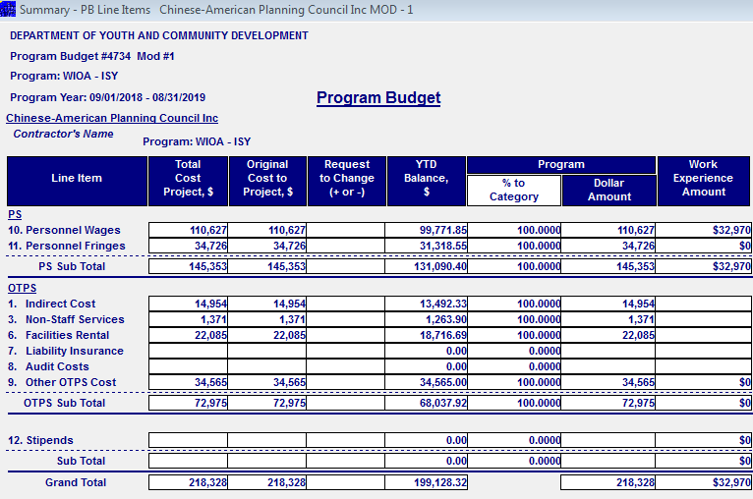

To access any of the cost categories, click on “View Year” then double click on the cost category you want to modify. For example, if you want to modify personnel wages, double click on the row labeled ‘PERSONNEL WAGES”.

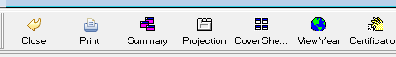

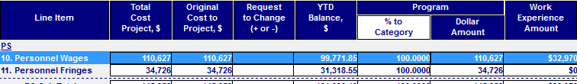

The system will display the Personnel Service Detail spreadsheet. If changing the salary allocation for any staff and Work Experience, enter the new percentage for the staff. The system will calculate the allocation to the contract.

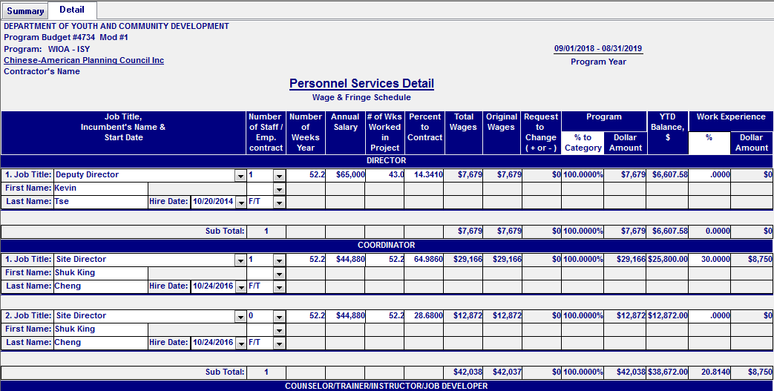

If adding a new staff under any title, place the curser on the last row and click on “ADD”.

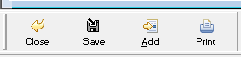

You will see another row added to the spreadsheet. Enter the information required for the new employee.

Once you complete all the changes, save the data by clicking on the save icon.

Click on ‘Close”.

NOTE: You can enter changes to any of the cost categories. Where applicable, back up documentation must be submitted with the modification.

Once all changes have been made, open the projections sheet and enter the cumulative quarterly projections for each cost category.

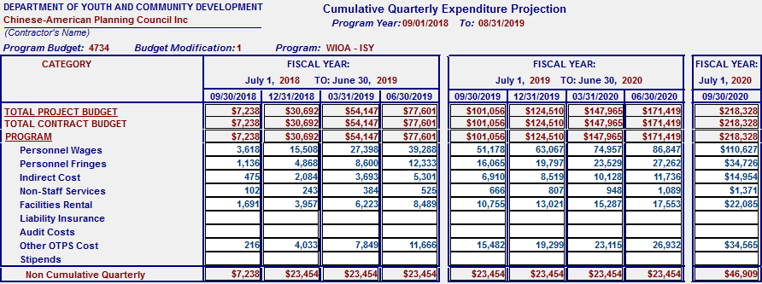

Save and close the page.

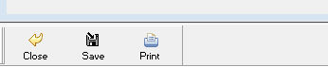

Open the Explanation of Change at the bottom of the Program Budget summary and write a detailed justification for submitting the budget modification. This page should list all the changes made to the modification.

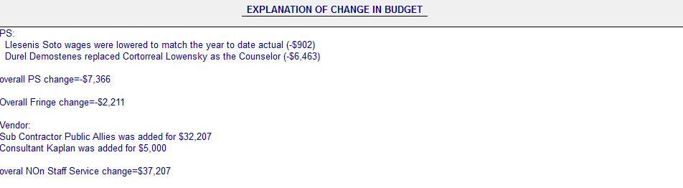

Save and close the page.

The system will take you back to the Program Budget summary. Click on Close.

You will return to the listing of your agency’s WIOA program budgets. Highlight the budget modification.

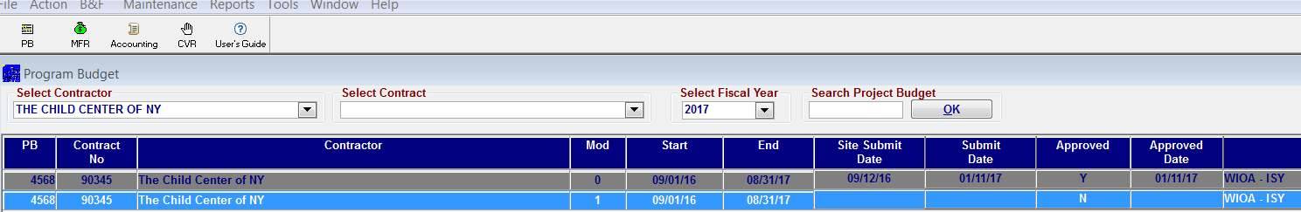

Click on submit.

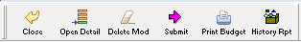

The system will prompt a message confirming you want to submit. Click yes to proceed.

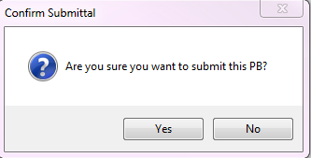

DYCD will receive an email indicating the budget modification has been submitted by your agency. DYCD Accountability and Compliance Unit will perform a preliminary review. Once they have completed their review, the budget modification will be sent to DYCD WIOA Budget Review team for final review and approval.

If clarification is needed, a detailed email will be sent asking for further details and justification of the changes. You are responsible for providing answers by the due date specified on the email. Based on the answers/back up documentation, another analysis will be performed. If all the items are addressed accordingly, the budget modification will be approved.

An email will be sent to the person whose email is listed in PBMFR indicating the approval. Copy of the budget modification will be sent to the designated person that appears on the Contractor Detail page.

SECTION THREE

SUBMITTING MONTHLY FINANCAL REPORTS IN PB/MFR

MONTHLY FINANCIAL REPORT (MFR) OVERVIEW

The Monthly Financial Report (MFR) is the mechanism by which contract agencies identify and report their monthly expenditures to The City of New York Department of Youth and Community Development (DYCD).

Expenditures reported on the MFR must be consistent with both the information in the contractors’ General Ledger and the Approved Program Budget.

MFR SUBMISSION

Monthly Financial Report must be submitted to The CAFD Payment Unit within the first five working business days of each month, reflecting the prior month’s expenditures. If a CBO cannot submit the MFR by the fifth working day, the CBO must request a written exemption with the proposed submission date from Contract Management and Financial Management. Once the request is approved, the CBO may submit the MFR by the due date specified on the approved request. MFRs not submitted by the due date, are considered late.

The Monthly Financial Reports must be submitted to DYCD by program type only. Each MFR must represent only one particular/funding source (WIOA, etc.) even when the same contractor has multiple program/contracts. The PBMFR application is the only source used to submit the Monthly Financial Reports. No hard copy will be accepted. Contractor must maintain a monthly folder that includes copies of the MFR along with any supporting documentation that relate to the postings on each MFR.

_______

INSTRUCTIONS FOR THE COMPLETION OF THE MONTHLY FINANCIAL REPORT WHEN SUBMITTING ON LINE via PBMFR

After logging to the remote terminal:

Click on MFR menu icon on the top of the page

You will see a screen labeled SELECT CONTRACT

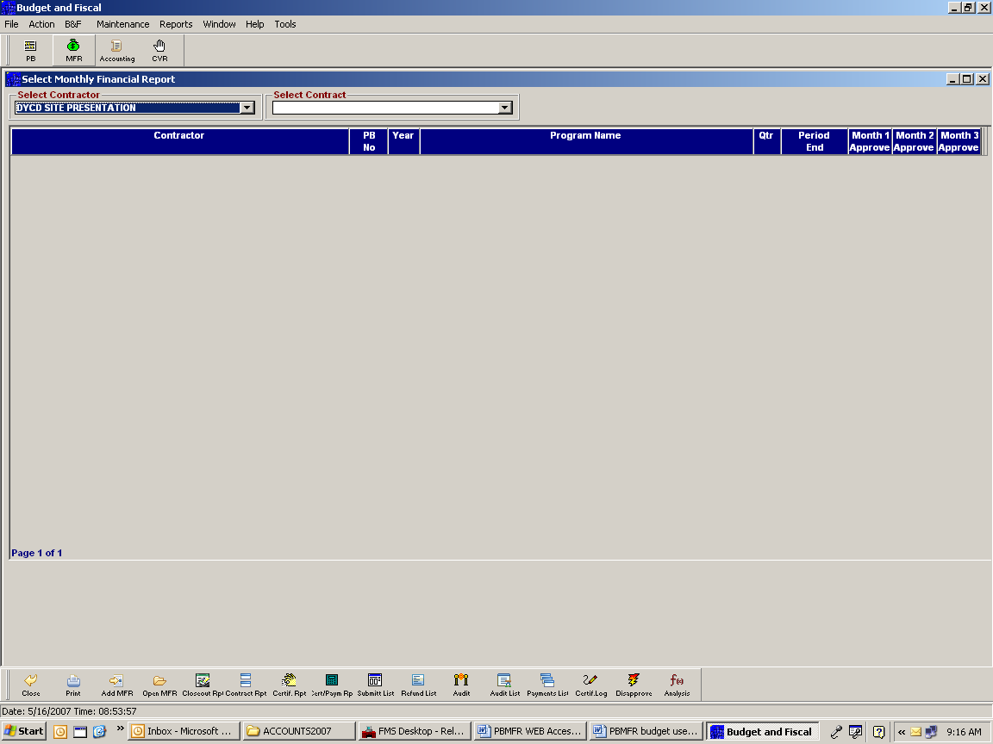

Click on the arrow. You will see a listing of the contracts for your agency’s awards whose budgets have been approved

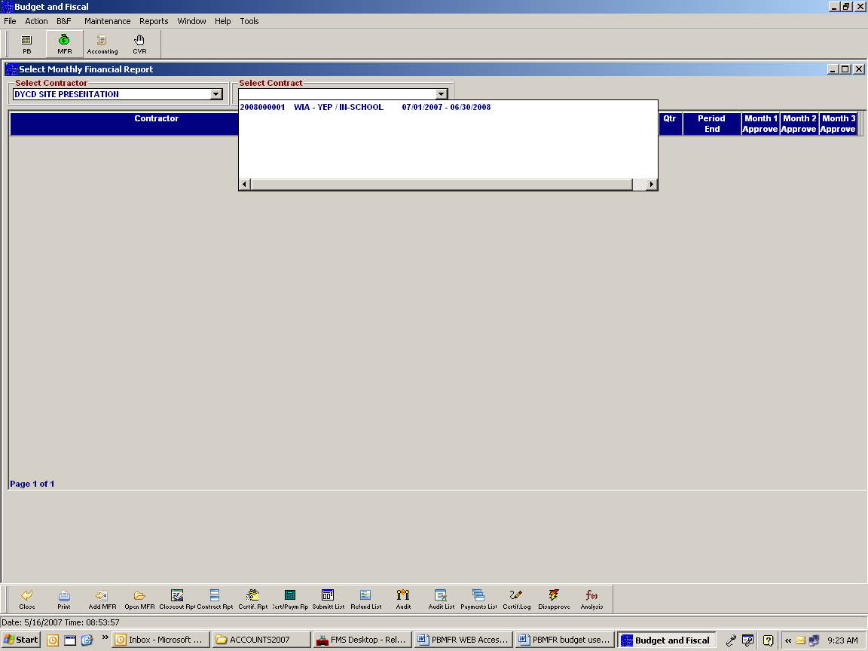

Highlight the contract you want to submit the MFR

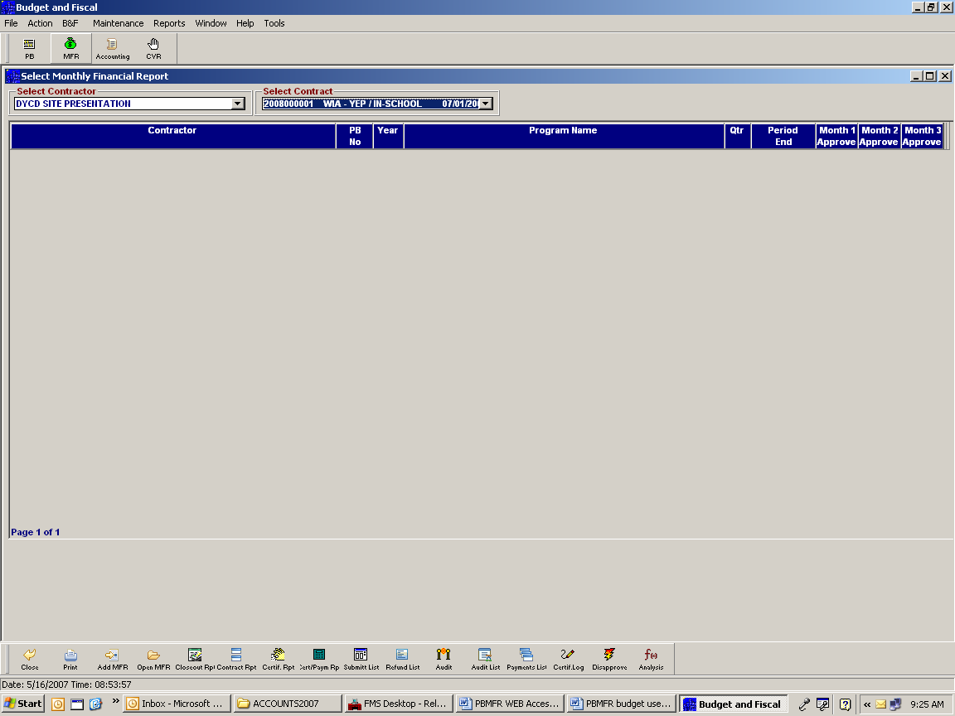

On the bottom of the screen you will see a template with a list of icons.

Click on ADD MFR

You see a prompt message that says “NEW MFR HAS BEEN
SUCDESSFULLY ADDED.” Click OK.

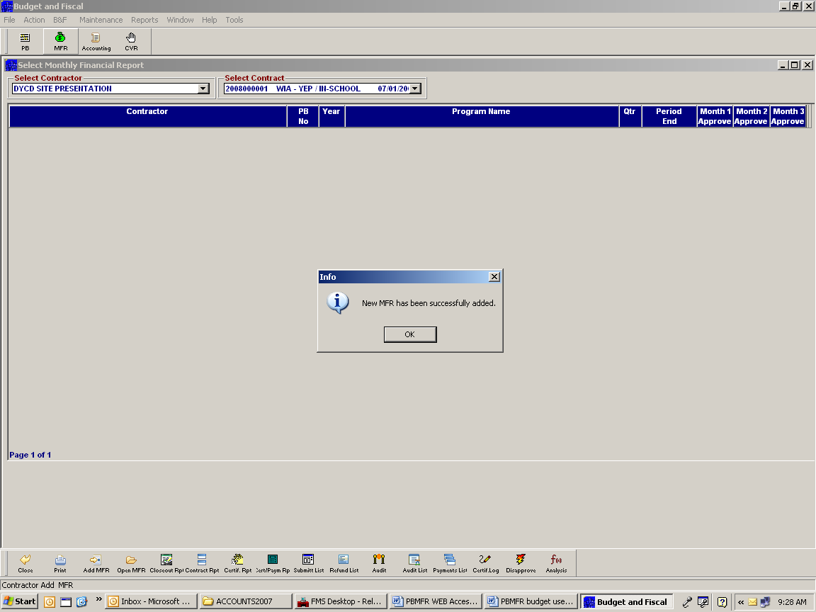

The system will create the first quarter of the program’s budget

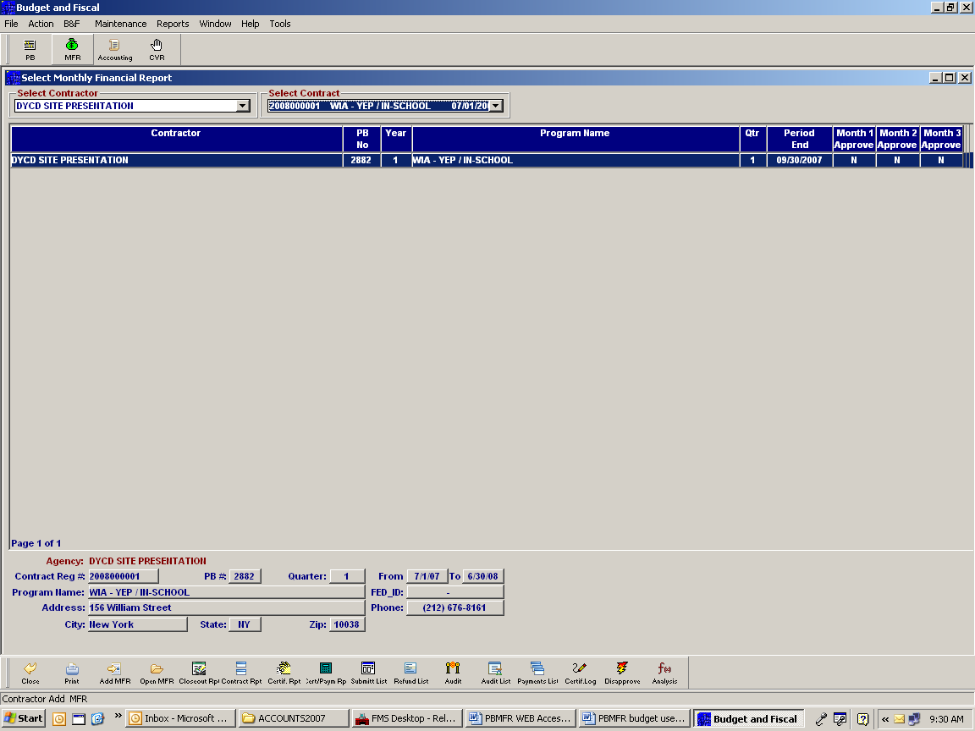

Double click OPEN MFR on the bottom of the screen or double click on quarter

You will then see the Monthly Financial Report (MFR). The MFR contains information such as the name of the agency, telephone number, contract registration number, term of contract, name of project, fax number, report date, type of contract, address, federal ID # period ending and month. You will also see the approved budget and the quarterly expenditures projections numbers as they were approved

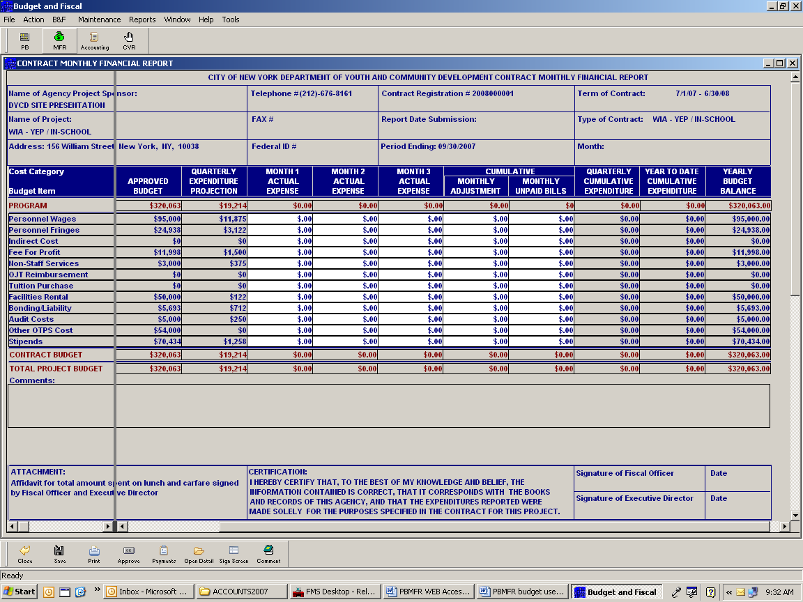

You will also see a MONTH 1 ACTUAL EXPENSE column, MONTH 2 ACTUAL EXPENSE column and MONTH 3 ACTUAL EXPENSE column

Depending for which month you are submitting expenses, double click on the Personnel Wages’ row. You will now see the PERSONNEL SERVICE/WAGES ANALYSIS/WORK EXPERIENCE ROSTER for the month you are claiming expenses

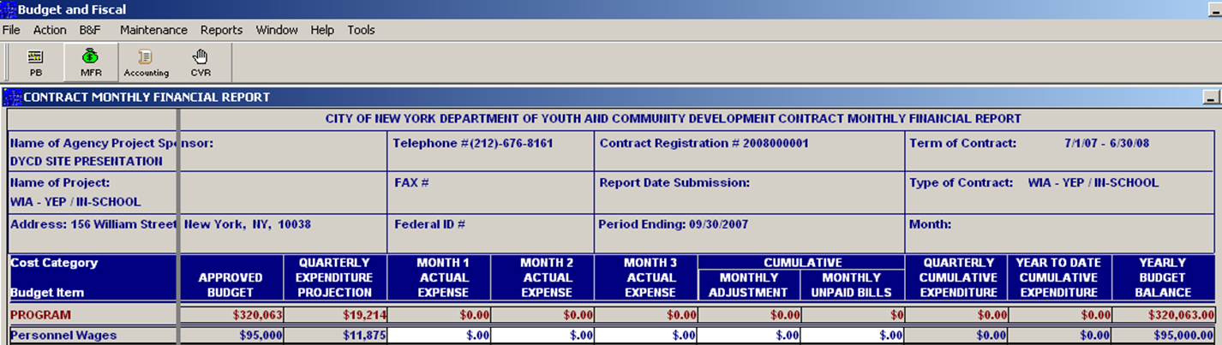
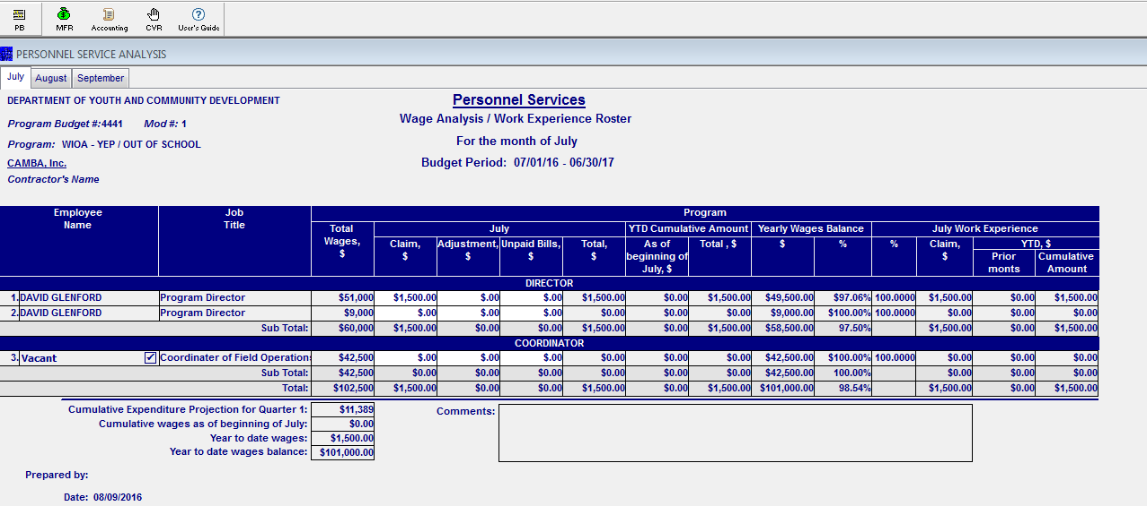

Place the cursor on the column labeled CLAIM

Enter the expenses incurred for each staff. It is necessary that you enter actual expenses as reflected on the ledger. If you have any adjustments, enter them on the ADJUSTMENT column. Enter any unpaid expenses in the UNPAID BILLS column. The Work Experience claim will be automatically calculated based on the percentages entered on the program budget

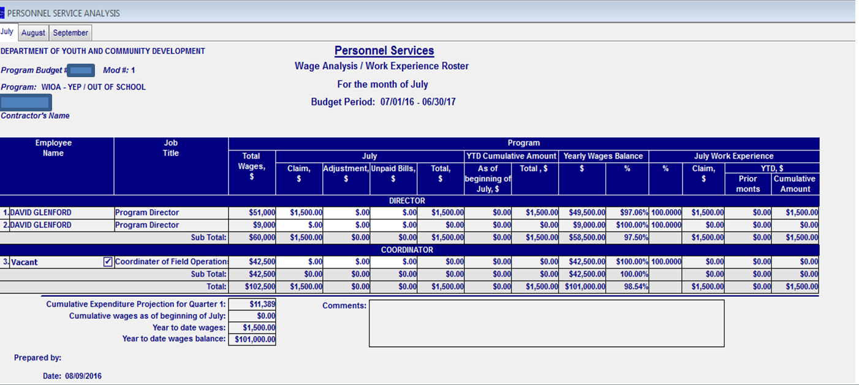

After you finish entering all financial data, on the bottom of the page you will see a template with the following icons: CLOSE, SAVE, PRINT and COMMENTS. Click on SAVE and then click close

The system will take you back to the MFR. Double click on the PERSONNEL FRINGES row
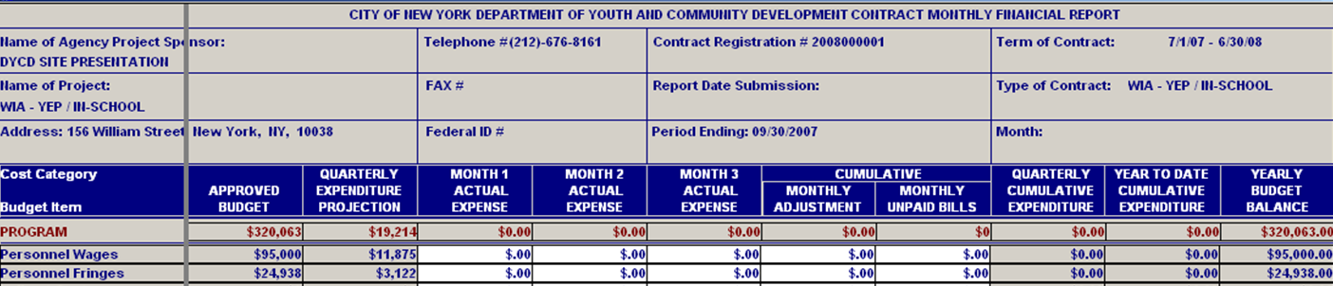

You will see the PERSONNEL SERVICES/FRINGE BENEFITS ANALYSIS WORKSHEET for the month you submit the claim. This worksheet details all itemized cost categories under fringes. It will also automatically generate the total fringe cost for the month as per the total wages incurred for the month and the fringe rate approved ($1,500 x 22.5210%=$337.82). It will also automatically generate the FICA cost for the month. While you can bill for more than the total cost generated for fringe, you cannot bill for a higher FICA COST. The FICA COST has a built-in formula that considers the rate currently approved times the total wages spent for the month. The system will not allow you to change the cost for FICA. The Work Experience claim will be automatically calculated based on the percentages entered on the program budget.

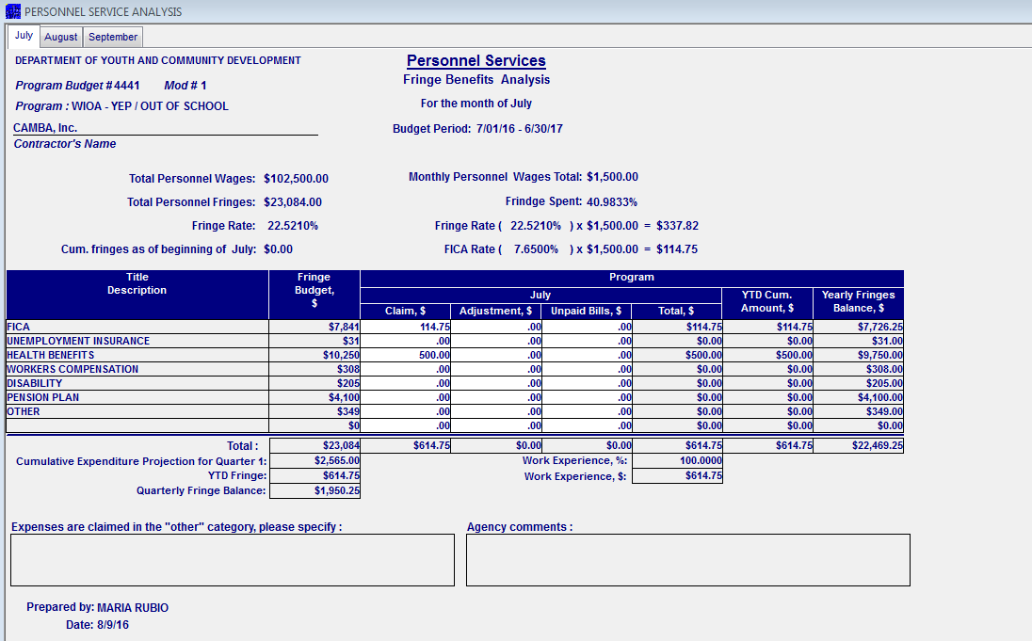

After you finish entering all the actual expenses for the month, click the save box and then click Close. You will get a message that says, “ALL CHANGES WILL BE PERMANENTLY SAVED.” Click the yes box. Click the close box. The system will take you back to the MFR.

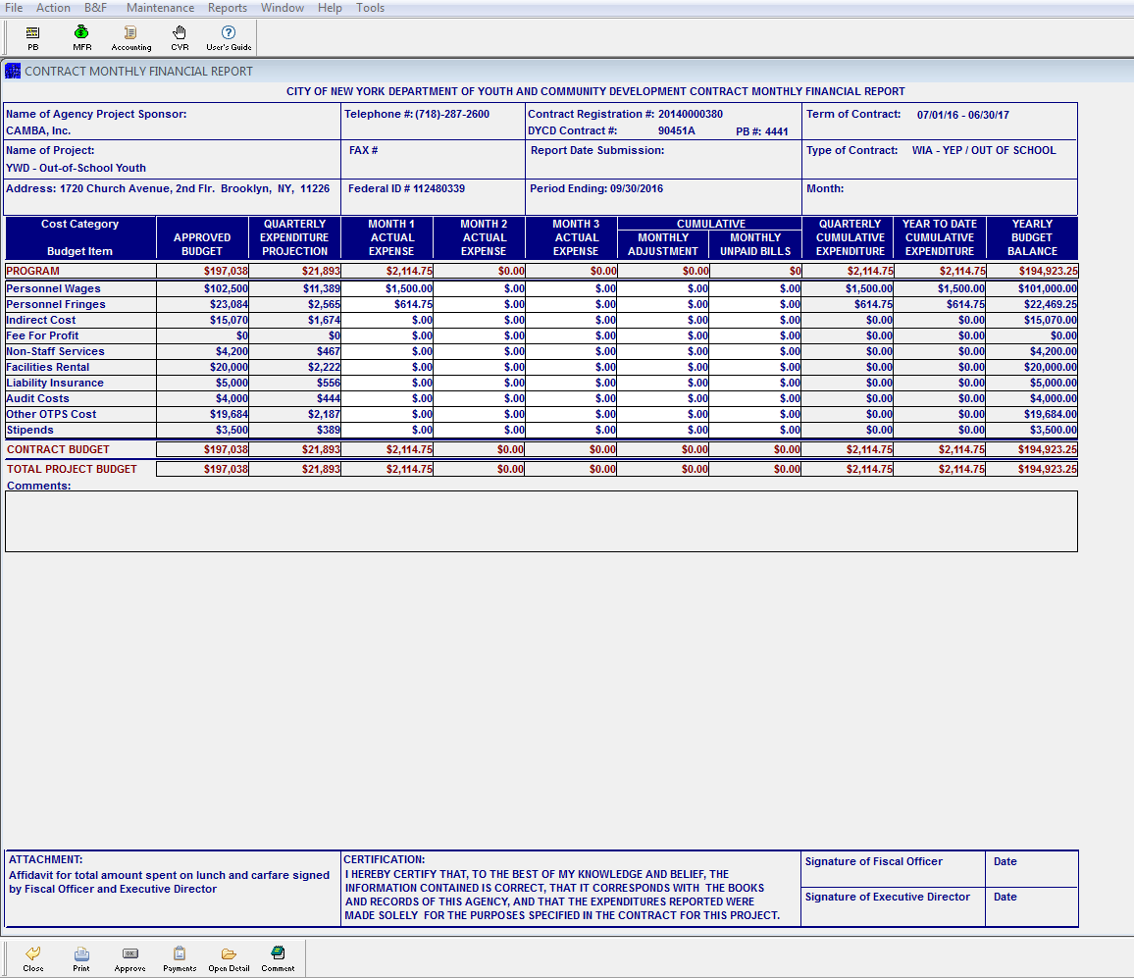

For Non Staff Services claims, double click on the cost category. The system will open another screen where you will enter the expenses incurred for the month for each approved cost category

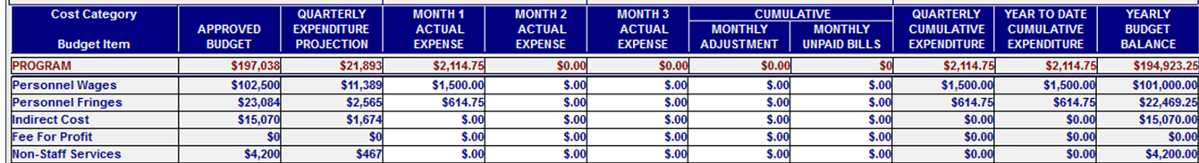

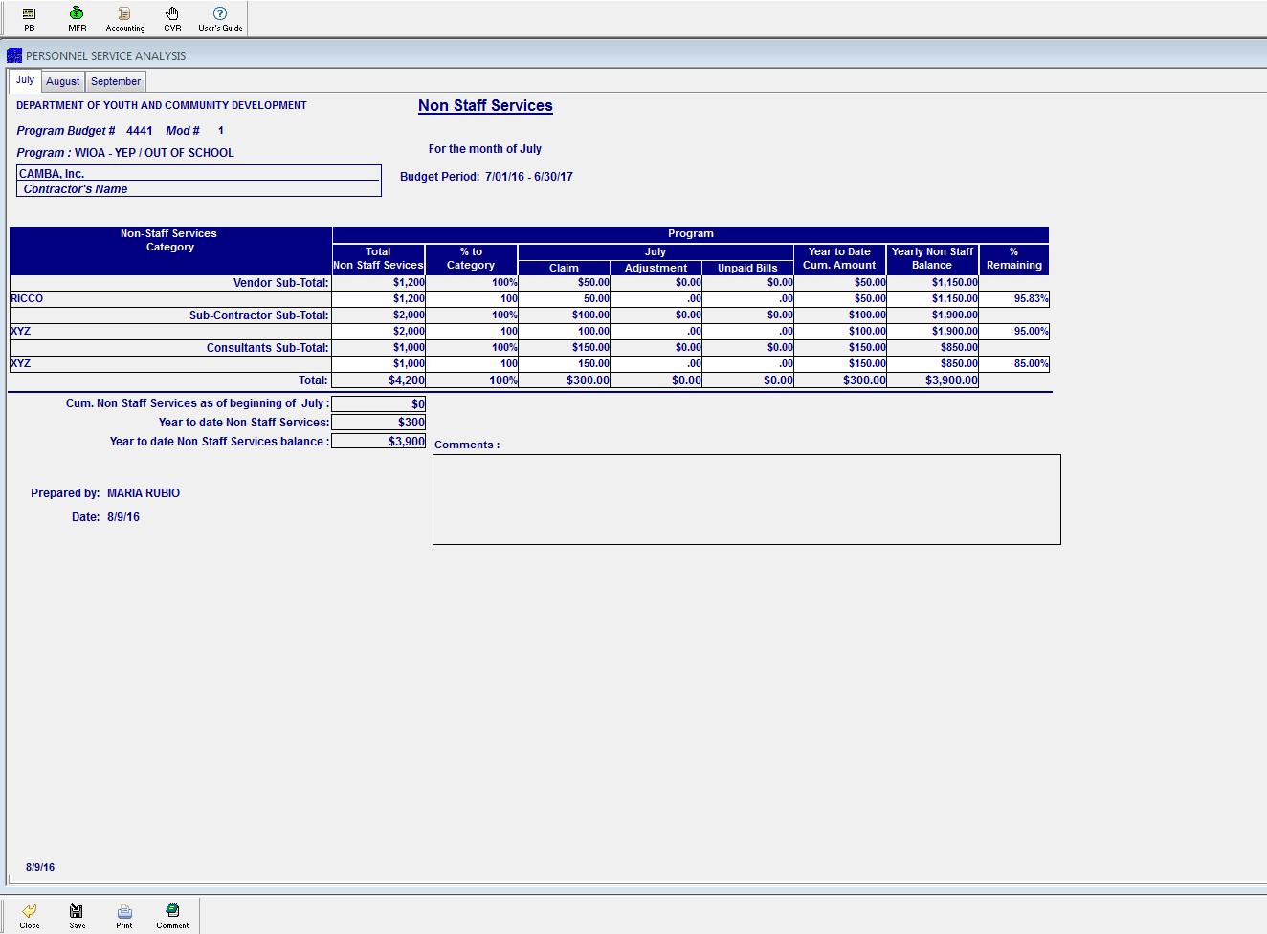

After completion of all entries for the month, click on save and then click on close.

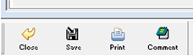

Enter the expenses incurred for facility rental and liability insurance. These cost categories are not subject to itemized worksheets

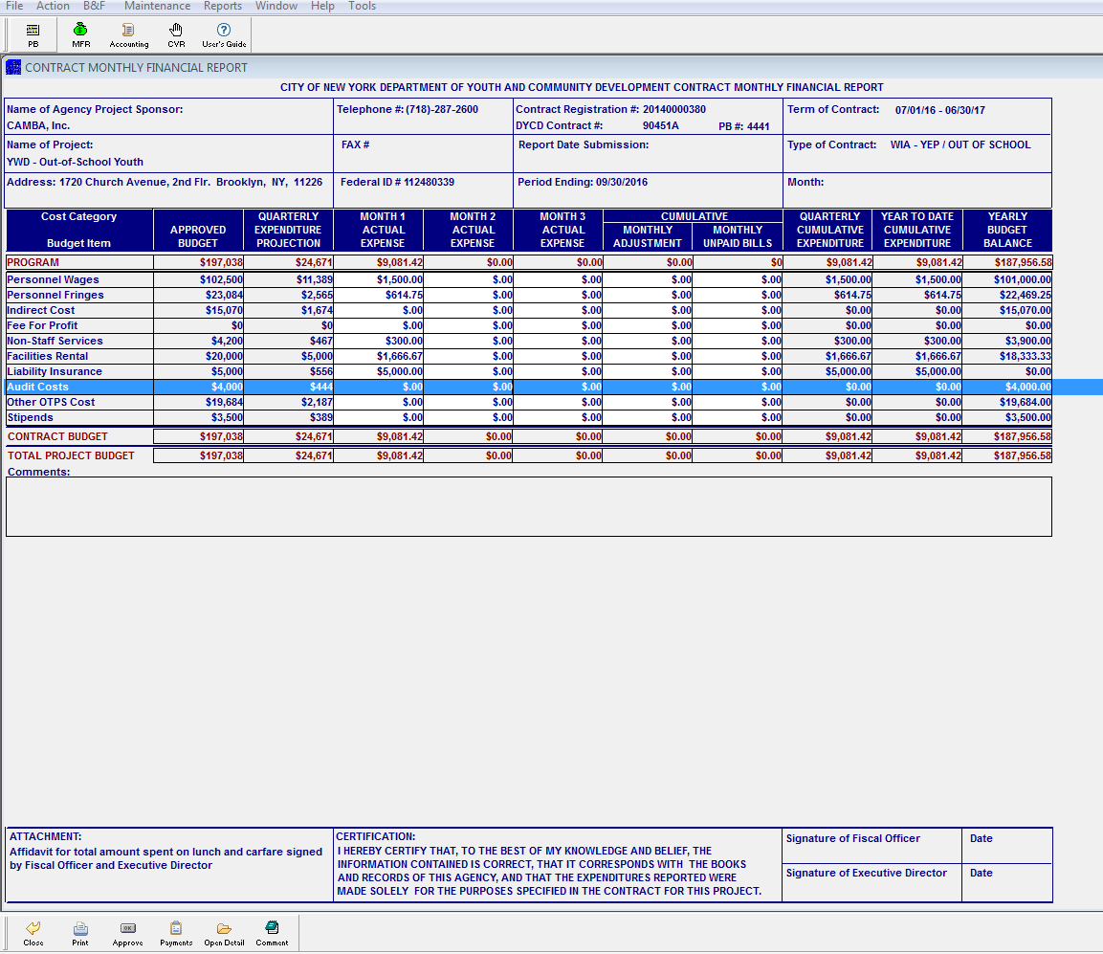

** Expenses for Audit Cost should not be incurred during the first month of the contract. The cost should post when the auditor is engaged to perform the audit for the program and payment is issued

OTHER OTPS COST, double click on the row. The system will take you to the OTPS ANALYSIS WORKSHEET. Enter costs incurred for the month for each cost category

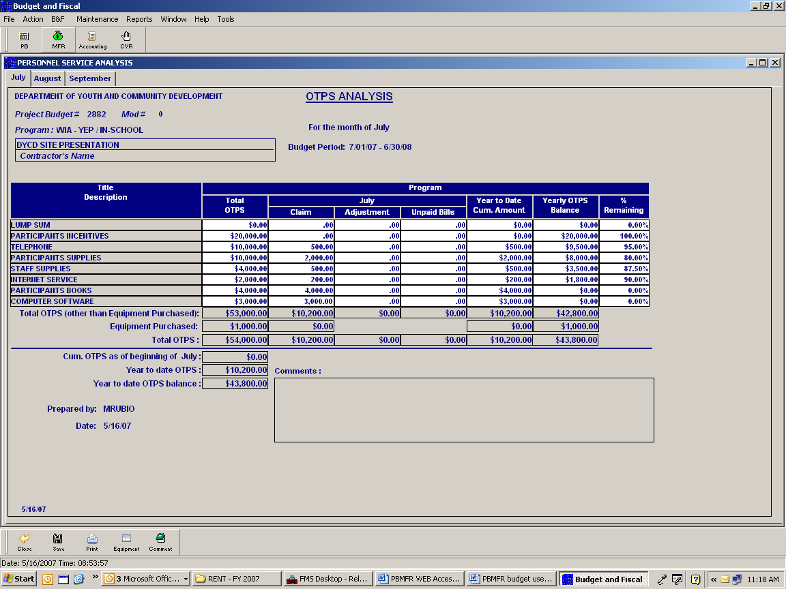

If you are going to enter cost for equipment, click on the EQUIPMENT BOX

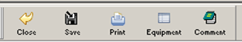

The equipment worksheet details the approved equipment. Enter all information pertaining to the purchase of the equipment such as actual description, serial number, model, manufacturer, date of purchase, location and claim $amount.

On the bottom of the page, you will see DYCD the contact information for two staff. Call either one and obtain tag(s) numbers. You will not be able to save the data if the tag numbers are not entered.

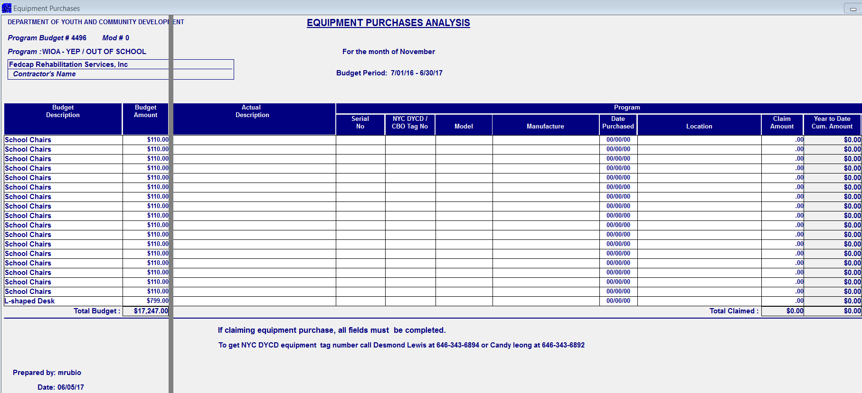

Click the save box and then the close box

After closing, the system will take you back to the MFR

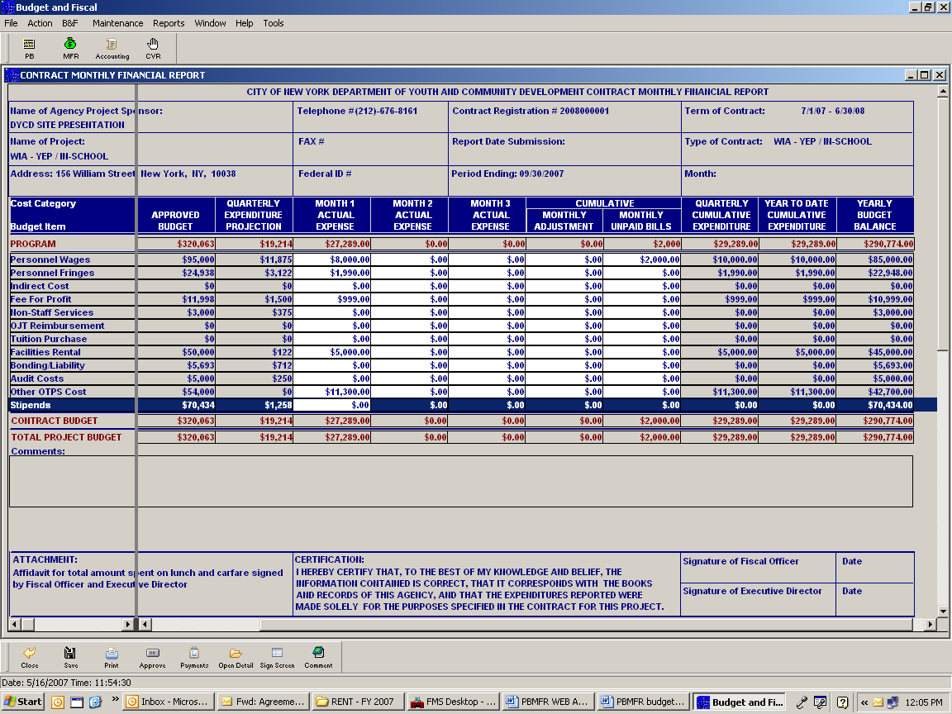
Click on Stipend

The system will open the stipend itemized sheet. Enter the expenses incurred for the month. Based on the amount entered, the system will automatically calculate the Work Experience based on the percentage entered on the budget

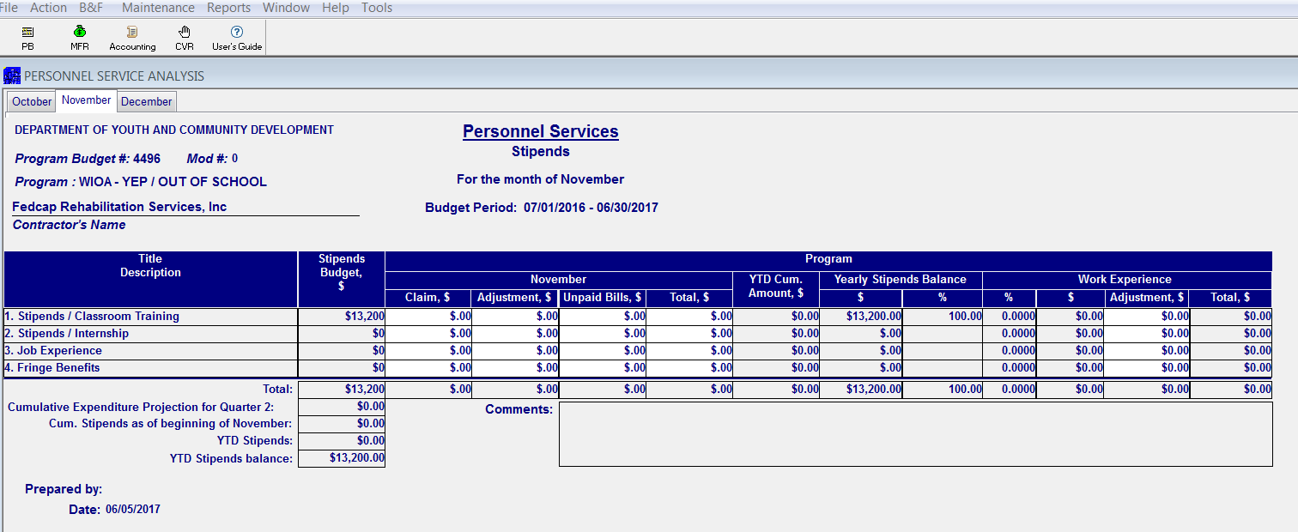

Click on the save box and then click on the close box

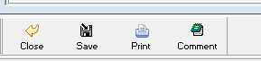

Once all costs have been entered for each cost category and you have checked the entries based on the general ledger, enter the cost for indirect based on the percentage approved. Higher cost entered for indirect will cause the MFR to be rejected

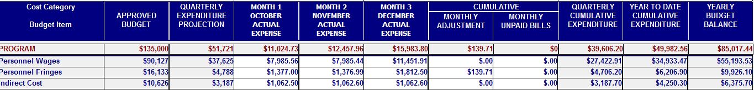

Contractors are required to submit proof for Work Experience. Each contractor has been given a designed sheet that includes the information for each award. The monthly WE tracker must be uploaded to PBMFR, reflect activities conducted by each staff and it must conclude with the percentage entered on the budget. Each sheet must be properly signed and dated.

Once you determine all cost conclude with the general ledger, you can submit the MFR

To submit the MFR:

Click the sign screen box on the bottom of the screen

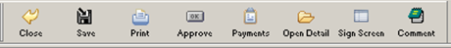

A box will appear for the SIGNATURE OF THE FISCAL OFFICER AND THE SIGNATURE OF THE EXECUTIVE DIRECTOR.
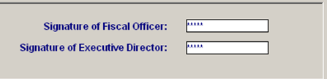

For the Fiscal Officer’s signature, enter the first 5 digits of the contract registration number.

For the signature of the executive Director, click on the box labeled Signature of the Executive Director, enter the last six digits of the contract registration number.

NOTE: The contract registration number can be found on top of the MFR

Once all signatures have been entered, a message will appear that says, MFR HAS BEEN SUBMITTED SUCCESSFULLY! Click OK.

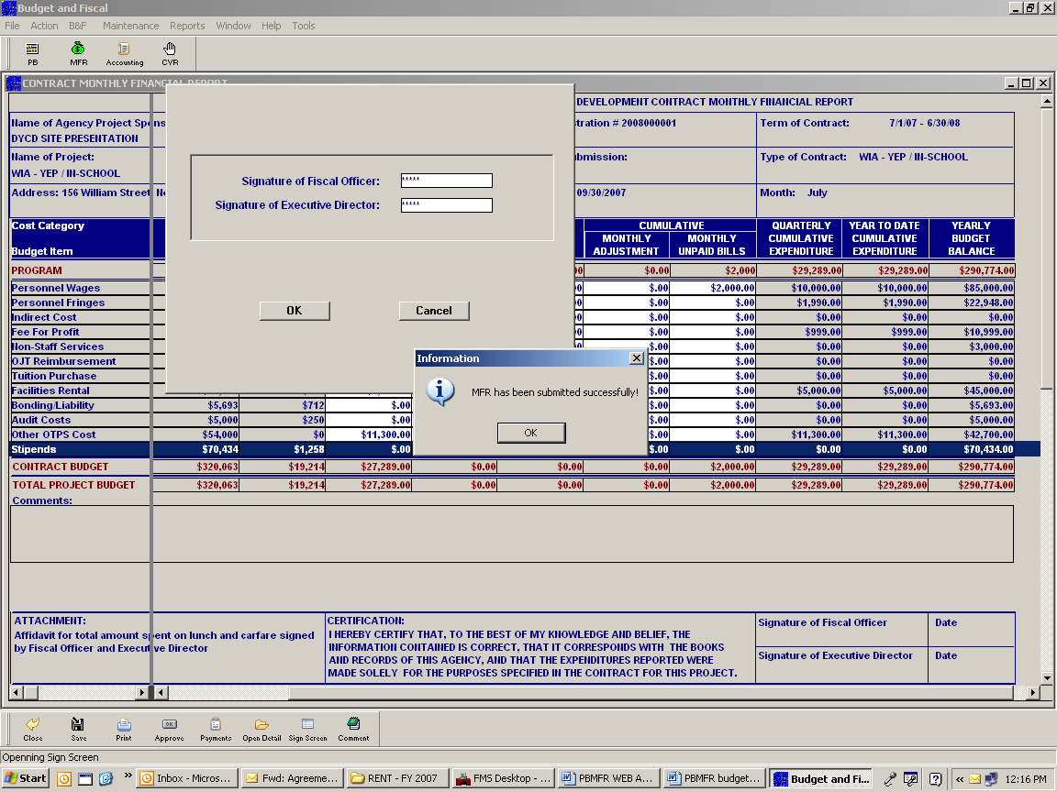

NOTE:

- Fiscal staff should by no means enter the code for the Executive Director unless a hard copy has been officially signed by the Executive Director

The system will take you back to the MFR. You will the date on the bottom right hand side of the MFR. Each date reflects when the MFR was officially signed. No MFR is complete until both dates appear

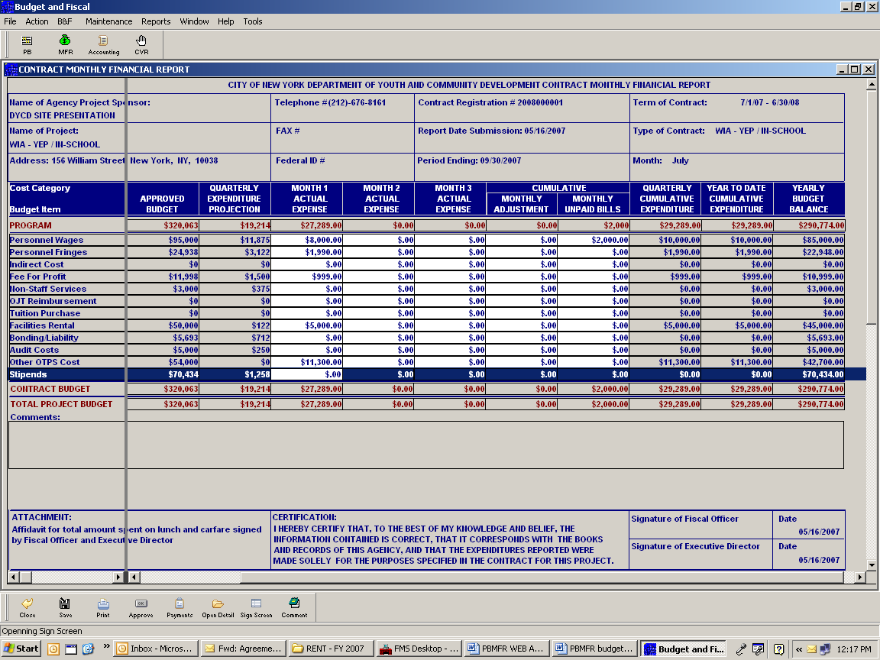

DYCD WILL RECEIVE AN E-MAIL INDICATING THAT YOUR MFR WAS SUBMITTED. DYCD WILL CONDUCT AN ANALYSIS AND PROCESS THE PROPER PAYMENT. IN THE EVENT THERE ARE DISCREPANCIES, THE FISCAL ANALYST WILL SEND AN EMAIL. A PROMPT REPLY TO THE E-MAIL WILL ALLOW PAYMENTS TO BE PROCESSED ON TIME

Note: Staff whose emails are registered in PB/MFR will receive a detailed sheet for the payment issued

SECTION FOUR

INTERNAL CONTROLS
AND
GENERAL ACCOUNTING PROCEDURES

INTERNAL CONTROLS

2 CFR 200.61: Internal controls means a process implemented by a Non-Federal entity, designed
to provide reasonable assurance regarding the achievement of objectives in the following categories:
- Effectiveness and efficiency of operations.
- Reliability of reporting for internal and external use; and
- Compliance with applicable laws and regulations

2 CFR 200.62: For Non-Federal entities administering Federal awards a process must be implemented to provide reasonable assurance regarding the achievement of the following objectives for Federal awards:
- Transactions are properly recorded and accounted for, in order to:
- Permit the preparation of reliable financial statements and Federal reports;
- Maintain accountability over assets; and
- Demonstrate compliance with Federal statutes, regulations, and the terms and conditions of the Federal award.

These internal controls should be in compliance with guidance in “Standards for Internal control in the Federal Government” issued by the Comptroller General of the United States or the “Internal Control Integrated Framework”, issued by the Committee of Sponsoring Organizations of the Treadway Commission (COSO).
Management should keep in mind that internal control is the foundation of every successful financial and operational system. Adequate internal control is very important in safeguarding an entity against mismanagement, waste, fraud, and program abuse. It may be viewed as a set of processes put in place by an entity to minimize risk and ensure the integrity of its financial and operational structures.

The Providers’ executive and management staff are responsible for establishing and maintaining an internal control structure. Internal controls will vary from one Provider to the next, depending on such factors as their size, nature of operations and objectives. However, the need for internal controls remains the same; a Provider should find the most efficient and effective way of implementing its needed internal control procedures.

The following are examples of internal control activities:
- Segregation of Duties: Duties and responsibilities must be divided among different staff members to reduce the risk of error or fraud. In large Provider organizations, there are often different staff members responsible for procurement and for payment.
- Proper Execution of Transactions and Events: Transactions and significant events must be authorized only by persons acting within the scope of their authority.
- Documentation of Transactions: All transactions need to be clearly documented, and all documents must be readily available for inspection.
- Secure Physical and Financial Assets: A Provider must safeguard its assets, including cash and equipment. Maintenance of accurate inventory records and periodic inventory checks will help prevent loss or unauthorized use of the Provider’s assets.

Retention of Accounting Records

Financial records, supporting documents, statistical records, and all other Non-Federal entity records pertinent to a Federal award must be retained for a period of three (3) years from the date of submission of the final expenditure report.
Therefore, in accordance with the requirements of OMB Uniform guidance 2 CFR 200.333, Providers must retain all contract related financial records, including auditors’ reports, for three (3) years after the final invoice of the contract is paid. The three (3) year retention period assumes no audit/litigation problems would require an extended retention period. If any litigation, claim or audit is started before the expiration of the original retention period, the records must be retained until all findings have been resolved and final action has been taken, or until the end of the regular three (3) year record retention period, whichever is later. Providers are subject to audit/or investigation for such an additional period.

Bookkeeping Practices and Procedures
Providers are required to have a financial management system which will provide at least the minimum standards set forth in 2 CFR 200.302, Financial Management. The financial management system of each provider shall provide federally required records and reports that are uniform in definition, accessible to authorized DYCD, Federal and State staff, and verifiable for monitoring, reporting, audit, program management, and evaluation purposes.
Additionally, providers shall ensure that their own financial systems as well as those of their sub-contractors (if applicable) provide fiscal control and accounting procedures that are in accordance with applicable generally accepted accounting principles (GAAP).

Providers must maintain separate accounting records for funds received through each contract with DYCD. Accounting records must be established and maintained in accordance with Generally Accepted Accounting Principles. It is essential that the Provider maintain accurate, complete and permanent books and records, available for inspection by a DYCD staff member or its designee.

DYCD staff and its representatives will conduct both announced and unannounced site visits to Providers during the contract term to ensure that the books and records are being appropriately maintained.

Timesheets
Timesheets must be completed for all full and part-time employees. Each timesheet must be signed and dated by the employee and the employee’s supervisor. The Executive Director’s timesheet must be reviewed and approved by a member of the Board of Directors.

Electronic timesheets may be maintained if they are certified as accurate by the signature of the Executive Director or a senior level management designee.

Cost Allocation
Cost allocation is the distribution of one cost across multiple funded contracts. A cost allocation methodology identifies the type of expenses that are being claimed and establishes a basis for allocating costs to business units or cost centers based on an appropriate allotment of such cost.

- Requirement:
Each Provider must develop a written cost allocation plan. The plan must include an explanation of its methodology detailing the basis used in allocating cost to its various DYCD programs. Time distribution records must reflect an after-the-fact determination of the actual activity of each employee. Cost allocation is established on the premise that Providers maintain an adequate accounting system and accounting records to document costs and support claims. Allocation methods and distribution of cost must be based on a generally accepted accounting practice prescribed by OMB Super Circular regulatory guidance and in accordance with Generally Accepted Accounting Practice. Refer to Office of Management and Budget for guidance: 2 CFR Chapters I, and Chapter II, Parts 200, 215, 220, 225, and 230 Uniform Administrative Requirements, Cost Principles, and Audit Requirements for Federal Awards and promptly made available to DYCD or its contracted CPA firms.

- Approach:
When allocating cost to a contract the following must be considered:
- Allowable direct costs that apply to only one program must be charged directly to that program or contract and cannot be cost allocated.
- Allowable direct costs that can be identified across multiple programs must be pro-rated using a base most appropriate to the cost being pro-rated.
- Allowable indirect costs (cost that benefit all programs and cannot be identified to a specific program) are allocated to programs, grants, etc., using a base that results in an equitable distribution.
- A Provider is not allowed to charge more than 100% of a cost across programs.

- Documentation:
Regardless of the cost allocation method used, expenses claimed must be supported by documentation of cost distribution showing the benefit each program received. Please note that approval of a DYCD budget does NOT constitute approval of a Provider’s cost allocation plan and method used.

A reasonable cost allocation plan must be presented to show the basis used to allocate the amounts incurred in each of the funded programs. The basis applied cannot be based on the budgeted amount; rather it must be based on the benefit derived by each program from that particular expense, (e.g. time, space, usage, etc.).

- Audit:
All expenses submitted for reimbursement are subject to an audit to assess whether the expenses are allowable and reasonable based on the cost allocation method used. Unreasonable cost allocations will result in disallowed costs. See Section Eleven for additional details on audit requirements.

Compliance with the Requirements of the Non-profit Revitalization Act of 2013

DYCD expects all funded Providers to be in compliance with the new requirements of the New York Not-for-Profit Corporation Law, as mandated by the Non-Profit Revitalization Act (the Act) signed into law in New York in 2013 and subsequent amendments passed on November 28, 2016. Compliance with the requirements of the Nonprofit Revitalization Act is subject to verification by DYCD or its contracted audit firms.

There are many publicly available resources to help Providers understand the new governance requirements of New York law (which go beyond the points highlighted here); DYCD can suggest possible resources, if necessary. For further information please visit the New York Attorney General's Charities of Bureau website: http://www.charitiesnys.com.

- Conflict of Interest
Section 107 (h) (1-2) of WIOA discusses conflict of interest for Local Workforce Development Boards (“LWDB”). Each LWDB must establish a conflict of interest and code of conduct policy. These policies will ensure that employees, individuals or representatives of organizations entrusted with public funds will not personally or professionally benefit from the award or expenditure of such funds. For purposes of this Manual, this requirement is not limited to only LWDB, but all recipients of DYCD funds that fall under the broad category of “Sub-recipient.”
In particular (and without limitation), DYCD expects all funded not for profit Providers to maintain and follow a conflict of interest policy as required by the act S 715-A Conflict of Interest Policy,

- Whistleblower Compliance Requirements
Providers with 20 or more employees and in the prior year annual revenue in excess of $1,000,000 are required to have a whistleblower policy in accordance with the Non-Profit Revitalization Act S-715-B Whistleblower Policy.
Generally, a whistleblower policy is a procedure by which individuals may report suspected improper conduct within an organization without fear of retaliation or adverse employment consequences for doing so; and a procedure within the organization for collecting, recording, reporting, and addressing allegations of suspected improper conduct.

- Audit Requirement
Providers are required to be in compliance with the requirement to file an independent certified public accountant's audit or review report to the Charities of Bureau and submission to DYCD.
A. If the organization's revenue was between $250,000 and $500,000, attach an independent
Certified Public Accountants' review report and financial statements to Form CHAR500. B. If the organization's revenue was over $500,000, attach an independent Certified Public Accountants' audit report and financial statements to Form CHAR500.
See section eleven for further details on audit requirements.

Employees Personnel Files
Employees’ personnel files must include all pertinent documents used in the hiring process. The hiring documents must include at the minimum, the following documents:

- Employment Application
- I-9 Employment Eligibility Verification
- Authorized working papers for individual under 18
- Job Description
- W-4 form
- Resume
- Copy of Educational Degree, Diplomas or Certificate
- Background Check
- Personnel Action Form
- Direct Deposit Authorization
- Appointment Letter/Salary

Resigned Employees
Employee vacation and sick time accumulated during the course of employment are allowed to be paid to that employee under the DYCD contract upon separation from employment, when such separation occurs during the contract operating period and the Provider has a policy allowing for payment for such time. If the employee’s time is cost allocated, it must be charged accordingly.

Vendor Invoices
All invoices maintained as documentation to support a claim must be in its original form and must display the Provider’s name and address as the recipient of the goods/services. All invoices must be maintained and made available for review, in accordance with Generally Accepted Accounting Principles and the record keeping requirements of the contract.

Bank Accounts
Providers are not required to maintain separate bank accounts for each contract award. Electronic Funds Transfers (EFT) of the contract award can now be made to a single Provider bank account. The EFT Enrollment form can be found on DYCD’s Help Desk webpage and via:

EFT Enrollment Form (Direct Deposit)

Providers are required to transfer all DYCD funds from the EFT account to the appropriate payroll and general accounts. Bank reconciliation of all accounts must be prepared, signed and dated on a monthly basis, and subsequently reviewed signed and dated by upper management. All bank reconciliations should be kept on file for examination by DYCD or its designees.

Signatories
DYCD requires that a Provider have at least two signatures on each check. Every Provider is expected to comply with this policy unless it has received prior written authorization from DYCD stating otherwise.

Cash Flow
The cash flow process is initiated following registration of the contract with the New York City Comptroller’s Office. DYCD is unable to release funds until the contract is registered.
Unlike discretionary contracts an initial advance is not available for WIOA contracts.

Disbursements
Disbursements, except those from petty cash funds and payment with the Provider’s corporate credit or debit card, must be made by check. Providers should adhere to the following control functions when handling DYCD disbursements:

- The function of approving vouchers, preparing checks and recording disbursements must be handled by different employees.
- Employees handling disbursements must not have duties related to cash receipts or the reconciliation of bank accounts.
- Vouchers payable must be established for each payment and recorded promptly.
- Payment must be made only after the original voucher and all copies of pertinent papers have been approved.
- Invoices should be cancelled or stamped “Paid” to prevent duplication of payment.
- Confirmation receipts for online purchases must be printed out and retained by Providers.
- A periodic review of vouchers must be made by an authorized person to determine that all processing steps are being followed properly.
- Payroll checks must be checked for accuracy by someone of higher authority than the payroll preparer.
- Voided checks should be carefully preserved and filed after appropriate processing.
- Provider should have a written prohibition against drawing checks payable to cash.
- Provider should have a written prohibition against signing checks in advance.

If a Provider is unable to comply with the control functions described above, comparable reasonable procedures (compensating controls) must be developed to allow for proper accountability and segregation of duties in handling disbursements. A written description of these comparable procedures must be sent to your DYCD Program Manager.

Unclaimed Funds

Unclaimed funds are funds that become available in the Provider’s bank account due to returned checks or checks that were never cashed by the intended recipient. Undistributed funds remain the property of DYCD and must be reimbursed to DYCD at the end of the fiscal year. The following steps must be taken to account for DYCD unclaimed funds:

- Providers are required to exhaust all efforts to contact the intended recipient, in a timely manner, within 90 days from the check date.
- After the 90-day period, the Provider is required to place a stop payment on those checks and return the funds to DYCD within 10 days.
- Providers are required to retain all evidence of the steps used to contact the intended recipients.
- Providers are not allowed, at any time, to submit DYCD unclaimed funds to New York State Office of Unclaimed Funds.

SECTION FIVE

PURCHASING PROCEDURES

GENERAL PROCUREMENT POLICIES

Any procurement of goods and/or services is to be conducted in the Provider’s name. The Provider is responsible for ordering, receiving, inspecting and accepting merchandise. The name of the Department of Youth and Community Development, its officials, employees, or the City of New York must not be used, under any circumstances, for the purpose of ordering and/or securing goods and services from a vendor. Invoices, bills, receipts, etc., must be issued in the name and address of the Provider. All expenditures must comply with applicable laws and contract regulations, and are subject to audit.

The following general guidelines must be adhered to for purchasing goods and/or services:

1.Contractors must have a budget approved by DYCD.

2.The approved budget must contain the appropriate category that corresponds to the item(s) to be purchased.

3.There must be sufficient funds available in the budget category to accommodate the purchase.

4.The expenditure must occur within the same budget period that the goods or services are received or delivered.

5.The expenditure must be necessary to support the contractor’s objectives as detailed in the contract.

PLEASE NOTE:
No Equipment valued at $5,000 or more may be purchased without prior approval from DYCD, which is also subject to obtaining approval from the New York State Department of Labor (NYS DOL). Accordingly, Providers will not be reimbursed the cost of any Equipment purchased without such prior approval.

Purchasing Requirements/Competitive Bidding (
The procurement of goods shall be governed by the competitive bidding requirements described below. The purpose of competitive bidding requirements is to establish a procedure that will secure the best possible price for goods and services while allowing for appropriate competition. The procurement process must be open and competitive (that is, no vendor qualified to provide the goods or services may be restricted from bidding and there must be fair competition among those bidders). These procedures also apply to the rental or leasing of equipment. A procurement shall not be artificially divided in order to meet the requirements of this section. The monetary thresholds identified below refer to payments made or obligations undertaken in the course of a one (1) year period with respect to any one (1) person or entity.

Federal Guidelines: §200.320 Methods of procurement to be followed.
The non-Federal entity must use one of the following methods of procurement.
(a) Procurement by micro-purchases. Procurement by micro-purchase is the acquisition of supplies or services, NOT Equipment as defined below and in §200.33, the aggregate dollar amount of which does not exceed the micro-purchase threshold (§200.67 Micro-purchase) currently $10,000. To the extent practicable, the non-Federal entity must distribute micro-purchases equitably among qualified suppliers. Micro-purchases may be awarded without soliciting competitive quotations if the non-Federal entity considers the price to be reasonable.
§200.94 Supplies means all tangible personal property other than those described in §200.33- Equipment A computing devise is a supply if the acquisition cost is less than the lesser of the capitalization level established by the non-Federal entity for financial statement purposes or $5,000, regardless of the length of its useful life.
§200.33 Equipment means tangible personal property (including information technology systems) having a useful life of more than one year and a per-unit acquisition cost which equals or exceeds the lesser of the capitalization level established by the non-Federal entity for financial statement purposes, or $5,000. See also §§200.12 Capital assets, 200.20 Computing devices, 200.48 General purpose equipment, 200.58 Information technology systems, 200.89 Special purpose equipment, and 200.94 Supplies.

(b) Procurement by small purchase procedures. Small purchase procedures are those relatively simple and informal procurement methods for securing services, supplies, or other property that do not cost more than the Simplified Acquisition Threshold. If small purchase procedures are used, price or rate quotations must be obtained from an adequate number of qualified sources.

- For purchases of supplies or services with a value of $10,000 (federal micro-purchase threshold) or less, no competitive bids are required the price is determined to be reasonable and prudent and set forth above.
Documentation of the purchase must be maintained by the Provider. This documentation must include the name of the vendor, the item purchased, the date and amount paid.

- Purchases from $5,001 - 25,000
Provider shall conduct sufficient market research and/or competition to support its determination that the price of such purchased goods, supplies, services or equipment is reasonable. Documentation of the market research and the purchase must be maintained by the Provider. This documentation must include the name of the entities contacted, the vendor, and the item purchased, the date and amount paid.
- Purchases $25,001 or greater
A minimum of three (3) written bids must be obtained for the purchase of goods, supplies or services of similar items where the cost can reasonably be expected to be $25,001 or greater. The bids must contain a description of the item requested, the time, date, place and form of requested responses, and the name of the employee responsible for securing bids. The bids must be maintained by the Provider.

Sole Source Procurement
Purchases exceeding $5,000 of non-federal funds where a Provider is purchasing items that are considered to be sole source in nature, do not require bids. Sole source procurements are exceptions to normal purchasing procedures and are permitted only when there is one, and only one, potential bidder or offer for an item or service.

Examples of circumstances that could justify sole source procurements are:
  - Health and Liability Insurances, Workers Compensation
  - One-time performances by artists for participants
  - Utilities (gas, electricity, telephone)

Note: The selection of Consultants and Subcontractors are not subject to a formal bidding process, but must demonstrate a prudent and reasonable degree of care.

Proof of Delivery Date:
DYCD may require proof of delivery date for goods purchased between June 20th and June 30th.

Inventory
Providers must maintain an inventory of all furniture and equipment purchased with DYCD funds. An inventory control decal must be placed on the equipment indicating that it is the property of New York City.

Inventory and Control

Providers are expected to establish and maintain a control system to ensure adequate safeguards to prevent loss, damage, or theft of Equipment, as defined above, or such other property whose purchase is funded by DYCD with a single item value below five thousand ($5,000) dollars (e.g. computers, printers, scanners, furniture) (Equipment and such property together to be referred to herein as Property).

The control system should include maintenance of an ongoing inventory of all Property purchased during the term of the contract. The inventory list must be itemized, updated, and submitted to DYCD as part of the Monthly Financial Report and should include the following:

- description of the Property;
- manufacturer’s serial number, model number, Federal Stock number, national stock number, or other identification number;
- source of the Property, including the WIOA CFDA award number (17.259) and DYCD contract number;
- acquisition date (or date received, if the Property was furnished by the federal government) and cost;
- percentage of federal participation in the cost of the Property;
- location, use and condition of the Property and the date the information was reported;
- unit acquisition cost;
- ultimate disposition data, including the date of disposal and sales price.

Contractors should conduct on-site physical inventories of Property at least twice a year and record the facility and room location for each item of Property.

At least once every two years, DYCD will conduct physical inventories at Contractors’ sites, to verify the existence, current utilization, and continued need for the Property. DYCD will reconcile its records with contractors’ inventories of Property.

All Property purchased with contract funds shall be marked “Property of the Department of Youth and Community Development”. These labels may be obtained from DYCD. Receipts for all items purchased with contract funds should be kept in a separate file, labeled “Property Purchased with DYCD Funds”.

A physical inventory is required every year, and inventory records must include the date of the last physical inventory review.

Relinquishment or Disposal of Furniture and Equipment
All furniture and equipment purchased with DYCD funds remain the property of the City of New York and must be returned at the end of the contract. Providers must contact their DYCD Program Manager to arrange for disposition of equipment.

If it is determined that the equipment bought with DYCD funds is fully depreciated and has no further useful value, please notify Contract Agency Finance, in writing, with a list of the equipment, serial number(s), model number(s) and purchase date. Providers will receive written notification with specific instructions regarding the disposal of equipment.

Inventory lists must include the method and reasons for disposition and the value of disposed equipment. In cases of loss or theft, property lists must include all pertinent information to support the claim. If appropriate, copies of police reports must be attached.

WIOA PURCHASING PROCEDURES

The Uniform Guidance, 2 CFR 200.317 – 200.326, provides procurement standards for all recipients of Federal grants. All providers must establish procurement policies and procedures that are within the guidelines of 2 CFR 200.317 – 200.326.Additionally, all providers must be guides by applicable WIOA and USDOL regulations.

The OMB Uniform Guidance on Administrative Requirements took effect for all non-federal entities’ for fiscal years beginning after December 26, 2014.
PROCUREMENT:
In the new uniform guidance, there are five general standards:
- The organization must maintain written policies and procedures over procurement that meets the following standards and any other applicable laws and regulations.
- Costs incurred must be necessary and cost-effective.
- All procurement transactions must provide full and open competition.
- The organization must maintain written standards of conduct covering conflicts of interest.
- The organization must maintain documentation addressing cost and price analysis, and vendor selection, as applicable for selected method of procurement (discussed next).
Then, there are five available methods of procurement for each purchase:
- Micro-purchases of Supplies (as defined above and in §200.93 or Services but NOT Equipment: Less than $10,000
  - No competitive quotes required provided price is reasonable
  - Spread purchases out among qualified suppliers
- Small purchases: Between $10,000 and $150,000
  - Rate quotes must be obtained from an “adequate” number of qualified sources – it is left up to the organization to determine what “adequate” is for each procurement
  - Quotes can be obtained from suppliers or from public websites
- Sealed bids: More than $150,000
  - Two or more qualified bidders
  - Publicly advertised and solicited from adequate suppliers
  - Lowest bidder for the fixed price contract wins
- Competitive proposals: More than $150,000
  - Written policy for conducting technical evaluations of reviewing proposals and selecting the recipient
  - Most advantageous bid wins, price and other factors considered
- Sole source: Any amount, must meet one of the following four requirements
  - Good/service is only available from a single source
  - Only one source can provide the good/service in the time frame required
  - Written pre-approval from the Federal awarding agency
  - Competition is deemed inadequate, after solicitation attempts through one of the other methods.

Providers must document the process followed in its selection of the most responsible lowest bidder and upon request, submit the same to DYCD. The criteria for selection of the most responsible lowest bidder should include at least the following:

A. Meeting or exceeding the bid specifications;

B. Price;

C. Reliability of bidder;

D. Net 30 days, unless discount is given; and,

E. Availability of Goods and Time Frame for Delivery

Providers shall make every reasonable effort to obtain competition before the purchase of commodities or services. Contractors must document any situation where reasonable competition is not available.
DYCD’s Contract Agency Audit Unit will review documentation that Providers maintain and track the status of less valuable items (below $5,000) in their inventory for the purposes of orderly management and recordkeeping for their programs. This is particularly important when items with a value of less than $5,000, in any program, have a significant cumulative value (e.g., $10,000 or more)
Additional provisions regarding Equipment.
(1) Use the equipment for the authorized purposes of the project during the period of performance, or until the property is no longer needed for the purposes of the project.
(2) Not encumber the property without approval of the Federal awarding agency or pass-through entity.
(3) Use and dispose of the property in accordance with paragraphs (b), (c) and (e) of this section.
(b) A state must use, manage and dispose of equipment acquired under a Federal award by the state in accordance with state laws and procedures. Other non-Federal entities must follow paragraphs (c) through (e) of this section.
(c) Use. (1) Equipment must be used by the non-Federal entity in the program or project for which it was acquired as long as needed, whether or not the project or program continues to be supported by the Federal award, and the non-Federal entity must not encumber the property without prior approval of the Federal awarding agency. When no longer needed for the original program or project, the equipment may be used in other activities supported by the Federal awarding agency, in the following order of priority:
(i) Activities under a Federal award from the Federal awarding agency which funded the original program or project, then
(ii) Activities under Federal awards from other Federal awarding agencies. This includes consolidated equipment for information technology systems.
(2) During the time that equipment is used on the project or program for which it was acquired, the non-Federal entity must also make equipment available for use on other projects or programs currently or previously supported by the Federal Government, provided that such use will not interfere with the work on the projects or program for which it was originally acquired. First preference for other use must be given to other programs or projects supported by Federal awarding agency that financed the equipment and second preference must be given to programs or projects under Federal awards from other Federal awarding agencies. Use for non-federally-funded programs or projects is also permissible. User fees should be considered if appropriate.
(3) When acquiring replacement equipment, the non-Federal entity may use the equipment to be replaced as a trade-in or sell the property and use the proceeds to offset the cost of the replacement property.
(d) Management requirements. Procedures for managing equipment (including replacement equipment), whether acquired in whole or in part under a Federal award, until disposition takes place will, as a minimum, meet the following requirements:
(1) Property records must be maintained that include a description of the property, a serial number or other identification number, the source of funding for the property (including the FAIN), who holds title, the acquisition date, and cost of the property, percentage of Federal participation in the project costs for the Federal award under which the property was acquired, the location, use and condition of the property, and any ultimate disposition data including the date of disposal and sale price of the property.
(2) A physical inventory of the property must be taken and the results reconciled with the property records at least once every two years.
(3) A control system must be developed to ensure adequate safeguards to prevent loss, damage, or theft of the property. Any loss, damage, or theft must be investigated.
(4) Adequate maintenance procedures must be developed to keep the property in good condition.
(5) If the non-Federal entity is authorized or required to sell the property, proper sales procedures must be established to ensure the highest possible return.
(e) Disposition. When original or replacement equipment acquired under a Federal award is no longer needed for the original project or program or for other activities currently or previously supported by a Federal awarding agency, except as otherwise provided in Federal statutes, regulations, or Federal awarding agency disposition instructions, the non-Federal entity must request disposition instructions from the Federal awarding agency if required by the terms and conditions of the Federal award. Disposition of the equipment will be made as follows, in accordance with Federal awarding agency disposition instructions:
(1) Items of equipment with a current per unit fair market value of $5,000 or less may be retained, sold or otherwise disposed of with no further obligation to the Federal awarding agency provided written approval has been obtained by DYCD.
(2) Except as provided in §200.312 Federally-owned and exempt property, paragraph (b), or if the Federal awarding agency fails to provide requested disposition instructions within 120 days, items of equipment with a current per-unit fair-market value in excess of $5,000 may be retained by the non-Federal entity or sold. The Federal awarding agency is entitled to an amount calculated by multiplying the current market value or proceeds from sale by the Federal awarding agency's percentage of participation in the cost of the original purchase. If the equipment is sold, the Federal awarding agency may permit the non-Federal entity to deduct and retain from the Federal share $500 or ten percent of the proceeds, whichever is less, for its selling and handling expenses.

Department of Youth and Community Development
Contract Agency Audit Unit
123 William Street, 17th Floor
New York, NY 10038

WIOA CLOSEOUT INVENTORY FORM

Sub recipient Name:___________________________ Person: __________________ __

Date: ______________ Phone Number: ____________________

We certify that the information provided is correct and accurate.______________________

Property Information |  | Acquisition Information |  | Final Disposition Information
Description | ID Number | Date Acquired | Cost Basis | Condition | Fair Market  Value | Federal program transferred to  (if applicable)

Print Name
Signature

1. Description | Provide a brief description of the equipment, e.g. Dell Computer OptiPlex GX1. Dell Trinitron monitor.
2. ID Number | Enter the identification number used to track the equipment for inventory control; e.g., manufacturer's serial number, model number, Federal stock number, national stock number, WIOA Tag number, or other identification number.
3. Date Acquired | Enter the date the equipment was acquired (or date received), if the equipment was furnished with federal funds.
4. Cost Basis | Enter the per-unit cost of equipment or the aggregate cost of supplies at the time of procurement.
5. Condition | Enter the condition of the equipment or supplies (good, fair, poor, not working, etc.) at the time of disposal.
6. Fair Market Value | Enter the fair market value of each inventory listing. The fair market value of equipment inventory is the going rate that a buyer would reasonably pay for it. It can be accomplished by an appraised value or comparison to the value of similar items.
7. Federal program transferred to approve WIOA program. | Provide the name of another federal program the inventory will be transferred to (if applicable).
Instructions for Completing WIOA Closeout Inventory Form

SECTION SIX

CREDIT/DEBIT CARDS POLICIES AND PROCEDURES

Policies and Procedures for Use for Credit/Debit Cards
Credit cards must be established in the name of the Provider and used solely for carrying on the operations of the Provider. Written policies and procedures are necessary to establish an internal control structure for credit/debit card use. A Provider’s Board of Directors must first determine whether to approve use of credit or debit cards; once the Provider’s Board has approved the use of credit/debit cards, the Board must adopt a comprehensive credit/debit card policy that, at a minimum:

- Identifies all authorized users
- Sets appropriate credit limits
- Establishes custody of the cards when not in use
- Requires proper documentation for all transactions
- Establishes a means to recoup any unauthorized expenditures
- Specifies that the safeguard of, and charges appearing on, each card, are the responsibility of the cardholder
- Prohibits purchases that are personal in nature
- Prohibits use of cards to split orders or otherwise circumvent bidding thresholds
- Limits the use of staff and/or volunteer personal credit cards for Provider-related purchases to emergency situations (with emergencies to be defined) where standard procurement methods are unfeasible. Such expenditures, moreover, must be consistent with the Provider’s purchasing policies and procedures
- Sets limits on the amount that can be purchased in any individual transaction; and requires preapproval for purchases over that limit
- Limits cash withdrawals/advances to emergency situations (with emergencies to be defined), and requires such withdrawals to be governed by the following rules:
  - Amount may not exceed $200 per ATM withdrawal.
  - The Provider’s Executive Director or a designee must authorize cash withdrawals. If the Provider’s Executive Director is the individual making such cash withdrawals, the Provider’s Executive Director must receive authorization from the Provider Board Chairperson.
  - When a payment is made with cash from an ATM withdrawal a receipt from the transaction is filed and maintained in an ATM transaction and cash box (this must be a box kept separate and apart from the petty cash box).
  - Any cash withdrawn from a credit/debit account that is not utilized in a purchase must be deposited in the ATM transaction and cash box or re-deposited in the agency credit/debit account.
  - Each expense emanating from an ATM withdrawal must be recorded in the Provider’s general ledger to its corresponding expense account, with an offsetting entry to the credit account associated with the credit/debit card. A monthly reconciliation of the ATM transaction box and the credit/debit general ledger account must be performed.
  - The Provider is not allowed to comingle DYCD funds from cash balances related to ATM withdrawals with Non-DYCD funding streams. Separate general ledger accounts must be established to account for DYCD cash balances related to ATM withdrawals.
The CFO or Comptroller must ensure that a proper review of claims is performed prior to the payment of each credit card statement. This includes requiring that itemized receipts or other similar documents signed by the individual making the purchase adequately support all charges on the statements. In the case of debit card usage, bank statements must be regularly and timely reviewed and checked against supporting documentation.
TITLE 1 POLICY FOR CREDIT CARD USAGE:
Providers should have written policies and operating procedures for credit card use that meet Title 1 fiscal and accounting requirements. Agency policies and procedures should include:
- Instructions on employee responsibility and written acknowledgements signed by the employee.
- Spending and transaction limits for each cardholder both per transaction and on a monthly basis.
- Written requests for higher spending limits.
- Record-keeping requirements, including review and approval processes.
- Clear guidelines on the appropriate uses of credit cards, including approved and unapproved vendor categories.
- Guidelines for making purchases by telephone, fax or internet.
- Periodic audits for card activity and retention of sales receipts and documentation of purchases.
- Procedures for handling disputes and unauthorized purchases.
- Procedures for card issuance and cancellation, lost or stolen cards, and employee termination.
- Segregation of duties for payment, accounting and reconciliation.
- Procedures for transferring paper records to electronic record storage, if applicable.

Providers should establish or review existing policies/procedures on credit card use to ensure they are up to date and responsive to the above policy.

SECTION SEVEN
PETTY CASH POLICY
- Petty Cash Fund Use Establishment
To facilitate the payment of certain minimal charges that cannot be handled by check, Providers may establish a Petty Cash Fund for up to $1,000. It is important to remember that items purchased with Petty Cash Funds are subject to the same regulations and accounting practices as expenses paid by check.

The Petty Cash Fund must be maintained in a secure place to safeguard against loss from unauthorized use or disposition. In the event of loss due to theft or fire, the Provider will NOT be reimbursed for loss of the Petty Cash Fund.

B. Petty Cash Fund Use

A Petty Cash Fund shall be governed by the following rules:

- A Petty Cash Expense may not exceed $200 dollars per total purchase.

- The Provider’s Executive Director or a designee must authorize petty cash expenses.

- When a cash payment is made from the Petty Cash Fund, a Petty Cash Voucher (on DYCD’s website) together with receipt is placed in the petty cash box.

- Therefore, the total of cash remaining in the box plus the total amount of vouchers therein must equal the petty cash fund amount.

- Each voucher must be supported with a receipt or invoice which shows:

- The vendor name
- Date of purchase
- Items purchased
- Price per item
- Total price for the quantity received
- Who made the purchase

Appropriate accounting distribution must be completed as described in step # 6.
Custodian may require purchaser to sign or initial original receipts.
Upon receipt of completed information, the petty cash expenditures will be
reimbursed by the fund custodian.

- Each expense from the petty cash voucher must be journaled in the Provider’s general ledger to the appropriate expense account with an offsetting entry to the petty cash account.

- Periodically, when the amount of cash remaining in the box requires replenishment, a check is drawn for the amount of all vouchers in the box. Cash from the check is placed in the petty cash box to replenish the Petty Cash Fund to its full amount. The reimbursement check amount is to be credited to the applicable operating cash account with an offsetting debit to the petty cash general ledger account. A separate Petty Cash Voucher Form must be used for the replenishment of the Petty Cash Fund.

- A monthly reconciliation of Petty Cash funds with the petty cash general ledger account must be performed. The reconciliation must be performed by someone other than the custodian of the fund. Completed reconciliations and related supporting documentation should be forwarded to the Controller where they will be reviewed for accuracy.

- The Provider is not allowed to commingle DYCD funds used for petty cash. A separate general ledger account must be established to account for DYCD petty cash.

SUGGESTED PETTY CASH CONTROL PROCEDURES:

- In the event the fund custodian has a scheduled absence, a temporary custodian can be assigned by the department head. The funds must be counted in the presence of the authorized custodian before the leave period begins and again once the custodian returns.

- Unannounced cash counts should be performed quarterly by someone other than the custodian. The individual should be selected by the department head, preferably not the same person each quarter. The cash counts should be recorded on an official Cash Count Form. This cash count should always be done in the presence of the custodian and when completed should be signed by the performer as well as the custodian. Any over/shorts should be reported to the Controller for proper recording and to correct the cash position.

- Where possible, keep locked box in limited access locked drawer, safe or file cabinet. Funds must be secured each time the custodian leaves the office. The keys to the box and file cabinet, safe, or drawer should be kept in the possession of the custodian, not left in the desks or in the office overnight.

Examples of reimbursable expenses for which use of pretty cash may be appropriate:
- Local travel by public transportation
- Programmatic supplies
- Postage (The purchase of one hundred stamps will be allowed through petty cash.)

Examples of non-reimbursable expenses are:
- Personal expenses
- Alcoholic beverages for a staff party

SECTION EIGHT

GENERATED INCOME

OVERVIEW OF GENERATED INCOME

Income derived by a Provider as a result of resources paid for by the Department of Youth and Community Development is considered Generated Income. Providers engaged in such income generating activities must maintain a monthly report of those activities. These reports must be made available to DYCD for review upon request.

Providers with income generating activities must adhere to the following bookkeeping standards:

    - A separate bank account must be established;
    - All bank documents, such as deposit slips, reconciliations, statements, canceled checks must be properly maintained on file;
    - Signature cards must be properly maintained on file;
    - A separate cash receipts journal must be established to record cash receipts generated;
    - A separate cash disbursement journal must be maintained to record cash expenditures (the cash disbursement journal must be established in a form that reflects the nature of the expense);
    - Supporting documentation for each disbursement recorded in the cash disbursement journal must be properly maintained on file;
    - If appropriate, a general ledger must be maintained in order to summarize monthly transactions;
    - A monthly trial balance must be taken; and
    - All financial and accounting records relating to income-generating activities must be available for examination and audit by DYCD or its designees upon request.

Grants that a Provider receives from other government sources or foundations are not considered generated income.

SECTION NINE

NON-REIMBURSABLE EXPENSES

Non-Reimbursable Expenses

Expenditures for items neither budgeted nor allowable under DYCD Federal, State and City guidelines will not be reimbursed.

The following expenses are not allowed by DYCD:

- Expenditures for items neither budgeted nor allowable under DYCD Federal, State and City guidelines for Providers
- Purchase of land and buildings
- Taxes from which municipalities are exempt (Sales Tax, NYS Franchise Tax, Federal Unemployment Tax (FUTA)
- Capital improvements, which are defined to mean the erection of substantial structures which are capital in nature, or the valuable additions to or valuable modifications of real estate; this includes expenditures for hard surfacing, cement installations, substantial repairs to a building, basic heating, lighting or sanitary equipment and installation, permanent outdoor lighting systems, fencing (except for partial fencing justified as a safety device), swimming and wading pools and tennis courts;
- Personal membership fees in clubs or professional Providers and associations
- League franchise fees in the name of an individual
- Interest and penalty costs
- Activities for which a provider has already charged a fee to participants
- Activities that are normally considered a part of the regular school day
- Activities of a commercial nature
- Expenditures for pre-paid payroll or consulting services. The date on the check (pay date) must be on or after the period of service
- Expenditure for fund raising activities
- Expenditures for stipends when used to replace existing staff and/or for the primary purpose of saving money by using low cost labor, and to avoid paying fringe benefits, or to replace other funding. Special exceptions may be made in advance with approval from DYCD and Office of Children and Family Services, when no other sources are available, and stipends are critical for the implementation of the program model
- Prizes other than inexpensive awards such as trophies, medals or ribbons
- Medical liability insurance and fire insurance on capital structures
- Security Deposits
- Some bonuses (see page 44 for criteria)
- Severance payment
- Tips and Gratuity
- Alcoholic Beverages
- Entertainment costs if federal funds are used.
- Expenses outside the budget operating period are not allowed.
- Funds cannot be used for litigation expenses, cost of paying legal settlements, or costs for paying legal judgments.
- Any other disallowed costs under the Uniform Administrative Requirements, Cost Principles, and Audit Requirements for Federal Awards , 2 CFR Part 200 et.al. or as directed by DYCD or any of its oversight agencies.

SECTION TEN

YEAR END CLOSE OUT

YEAR END CLOSE OUT

Contract Term
The Provider must perform all contract services and receive all goods and vendor services by the last day of the budgeted operating period. Employer’s FICA and New York State Unemployment Insurance (SUI) expenses applicable to salary expenditures incurred and paid through the last day of the contract period must be included. Any expenditure made for goods and services which are received after the last day of the contract/budget period will NOT be accepted as an authorized expenditure. There are no exceptions to this rule.

WIOA CLOSEOUT PROCESS

Closeout is the process by which a funding agency or a grantor determines that all applicable administrative actions and all required work of an award have been completed by a grantee.
The Uniform Guidance states “The federal awarding agency or pass-through entity will close-out the Federal award when it determines that all applicable administrative actions and all required work of the Federal award have been completed by the non-Federal entity”

The goal of DYCD is to ensure the successful execution and the timely closeout of all DYCD Federally funded contracts after the funding period covered by the awards has expired. To accomplish this goal, DYCD requires that providers submit closeout packages and related documents 90 calendar days after the expiration of a funding period or the termination of an award.
Title 20 Code of Federal Regulations (CFR) WIOA Final Rule Section 667.300 (d) states that a financial report is required after the expiration of a funding period or the termination of grant support. To ensure that all providers awarded WIOA Federal funds comply with the requirements of Title 20 CFR Section 667.300 (d) when the contract has reached the end date of the agreement applicable closeout procedures are followed. Generally, a Closeout Letter is sent to the organization’s management informing them of the need for completion and submission of their Closeout Package which is e-mailed to the organization three (3) weeks from the date of the letter.
The Closeout Package should be submitted with a copy of the organization’s applicable Audit report and the contract’s final Monthly Financial Report (MFR).

The Closeout Package includes the following information:

Closeout Checklist, Report of Contractor Summary of Activity (Form B), Final Report of Accrued Expenditures (Form C), Audit Information (Form D), Records Retention Form (Form D-1), Contractor’s Release (Form E-1), Contractor’s Release and Assignment (Form E-2), Contract Closeout Tax Certification (Form F), Final Property Inventory Certification (Form G-1), Inventory Log (Form G).

SECTION ELEVEN

CENTRAL INSURANCE PROGRAM
(CIP)
FOR PARTICIPATING PROVIDERS

CENTRAL INSURANCE PROGRAM (CIP)

The Central Insurance Program (CIP) serves the insurance needs of not-for-profit contractors who do business with human services agencies in the City.
CIP provides comprehensive general liability, workers' compensation, and disability benefit programs to these vendor agencies. The Central Insurance Program is operated by the Mayor’s Office.
DYCD will deduct 4.5% of a contract’s total budget to cover the cost of the insurance. The 4.5% is non-reimbursable..
General Liability Insurance
General Liability Insurance is automatically assigned to Providers that opt to participate in the CIP.

The General Liability policy provides coverage limited to one million dollars ($1,000,000) per occurrence for incidents that occur in connection with program activities described in the Provider’s contract with DYCD. The General Liability policy also provides coverage for the costs of defending claims or suits resulting from bodily injury or property damage.

The policy also provides coverage for verifiable medical expenditures for authorized participants injured in the program. All injuries, however slight, to any program participant, volunteer, visitor, or others must be reported on a DYCD Incident Report Form. The Incident Report Form must be on file with DYCD before submission of related medical bills.

Original medical and dental bills must be submitted with a second copy of the Incident Report Form.

Workers’ Compensation and Disability Insurance
Workers’ Compensation covers injuries suffered by employees while on the job. This coverage only pertains to employees listed on the DYCD budget.

Disability benefits to employees listed on the DYCD budget are provided in case of a non work-related illness or injury causing disability.

The Provider must submit the Employer’s Report of Injury (C-2 Form) and/or the Form for Disability to the CIP Program.

Staff Changes made in contracts with CIP
When new staff is hired, the Provider must submit an Individual Enrollment Form to DYCD. When an employee is terminated or resigns, the Provider must submit a Termination Roster. The completion of this roster will ensure that the name(s) of former employees are removed from the Central Insurance Program. In both instances, the forms are to be returned to DYCD.

Exclusions
CIP insurance does not include coverage for allegations of child or sexual abuse. The Provider must immediately notify DYCD of any incident or allegation of abuse of a program participant by any of the Contract’s administrators or staff, including both paid staff and volunteers. Written notification is to be submitted on DYCD’s Incident Report Form.

The term “abuse” refers to any physical, sexual, emotional or verbal abuse, or any other maltreatment of a program participant. Compliance with this reporting requirement does not satisfy any other legally mandated reporting of abuse, such as notifying the law enforcement officials or notifying the NYS Central Register of Child Abuse and Maltreatment.

The CIP coverage terminates at the end of each fiscal year.

Forms and additional information related to CIP may be obtained from the Central Insurance Program.

Mayor’s Office of Operations
Central Insurance Program
253 Broadway – 5th Floor
New York, New York 10007
Tel: (212) 788-7600

SECTION TWELVE

AUDIT

Reporting and Audit Requirements

Not-for-Profit Providers that contract with DYCD are required to comply with all applicable state and federal laws with respect to required filings. For federal reporting purposes, most Not-for Profit Providers may be required to file an information return (e.g. the I.R.S. Form 990). In accordance with New York State law, Providers may be required to register with the Charities Bureau of the New York State Attorney General’s Office; in addition, Providers that solicit funding from the public are required to file NYS Attorney General’s Office financial forms that vary depending on the Provider’s gross revenues.

The following chart summarizes the requirements of the Nonprofit Revitalization Act of 2013:

Effective Dates | Level of Gross Revenues | CPA Audit or CPA Review
July 1, 2014 through  June 30, 2017 | Less than $250,000 | No CPA Audit or CPA Review required, but must file an unaudited financial report on form provided by the  Attorney General
 | At least $250,000 but not more than $500,000 | CPA Review
 | More than $500,000 | CPA Audit
July 1, 2017  through  June 30, 2021 | Less than $250,000 | No CPA Audit or CPA Review required, but must file an unaudited financial report on form provided by the  Attorney General
 | At least $250,000 but not more than $750,000 | CPA Review
 | The $500,000 threshold increases to $750,000 | CPA Audit
July 1, 2021 and forward | The $250,000 threshold remains constant | No CPA Audit or CPA Review required, but must file an unaudited financial report on form provided by the  Attorney General
 | At least $250,000 but not more than $750,000 | CPA Review
 | The $750,000 threshold increases to $1,000,000 | CPA Audit

Regardless of the size or type of a not-for-profit Provider, an annual audit can help to improve operations and provide proper accountability for public and private resources.

In addition, DYCD funded Providers are subject to the following requirements:

Contracts with DYCD Funding Greater Than $75,000

Providers with aggregate DYCD funding greater than $75,000 will be audited by a CPA firm under contract to DYCD. The Auditor will perform random verification checks of the expenditures claimed on the HHS Accelerator Financials. The audit is performed after the fiscal year is completed and relates only to DYCD contracts. The Provider will be notified of the findings and questioned costs. Unresolved questioned cost(s) may have to be reimbursed to DYCD.

Contracts with DYCD Funding Between $25,000 and $75,000

Providers with aggregate DYCD funding between $25,000 and $75,000 are subject to fiscal field reviews (“FFR”). A FFR evaluates a Provider’s system of internal accounting and administrative controls. The objective of the FFR is to ensure that Providers adhere to the procedures and requirements cited in the Fiscal Manual and the contract. The FFR notes both administrative and fiscal findings. FFRs are performed either by DYCD Audit staff or CPA firms under contract to DYCD.

Audit: Federal Requirements

Providers that expend $750,000 or more in federal awards per fiscal year must have a single or program-specific audit conducted for that year in accordance with the provisions of Title 2 CFR 200.500, Subpart F of the OMB Uniform Administrative Requirements (Super Circular). Super Circular Subpart F replaces the previous OMB Circular A-133 to implement new requirements of the Single Audit Act which raised the single audit threshold from $500,000 to $750,000 effective for fiscal years beginning on or after December 26, 2014.
The providers are required to submit their A-133/Agency wide financial report to DYCD. The deadline for the financial report submission is the earlier of thirty (30) days from the completion of the financial audit/review or nine (9) months from the organization’s Fiscal/Calendar year end. A Fiscal Year ended June 30 and a Calendar Year ended December 31 has a March 31 and September 30 deadline respectively.

OMB SUPER CIRCULAR - A-133 SEFA REPORT

The Schedule of Expenditures of Federal Awards (SEFA) content is critical and essential in reconciling the Monthly Financial Report (MFR) expenses with the audited figures reflected in the SEFA report. If the provider lumps federal expenditures into one total figure, it becomes impossible for DYCD staff to identify the proportionate dollar amount that is related to each contract period.

DYCD is requesting the providers’ cooperation in disclosing this information appropriately in the SEFA section of the audit report. This entails advising your CPA firm of the requested disclosure presentation as suggested by OMB Circular A-133 Section 310(b), which states:

“The auditee shall also prepare a schedule of expenditures of Federal awards for the period covered by the auditee’s financial statements. While not required, the auditee may choose to provide information requested by Federal awarding agencies and pass-through entities to make the schedule easier to use”. For example, when a federal program has multiple award years, the auditee may list the amount of Federal awards expended for each award year separately.

2 CFR 200.508 – Auditee (Provider) Responsibilities:
The auditee (provider) must:
(a) Procure or otherwise arrange for the audit required by this part in accordance with §200.509 Auditor selection, and ensure it is properly performed and submitted when due in accordance with §200.512 Report submission.
(b) Prepare appropriate financial statements, including the schedule of expenditures of Federal awards in accordance with §200.510 Financial statements.
(c) Promptly follow up and take corrective action on audit findings, including preparation of a summary schedule of prior audit findings and a corrective action plan in accordance with §200.511 Audit findings follow-up, paragraph (b) and §200.511 Audit findings follow-up, paragraph (c), respectively.
(d) Provide the auditor with access to personnel, accounts, books, records, supporting documentation, and other information as needed for the auditor to perform the audit required by this part.
The USDOL regulation, 20 CFR 683.410(a) as proposed, require:
Each sub-recipient (provider) of funds under title I of WIOA have regular oversight and monitoring of its WIOA program(s) as required under title I of WIOA as well as under 2 CFR part 200 in order to:
- Determine that expenditures have been made against the proper cost categories and within the cost limitations specified in the Act and the regulations in this part and in accordance with DYCD contract requirements;
- Determine whether there is compliance with other provisions of the Act and the WIOA regulations and other applicable laws and regulations;
- Assure compliance with 2 CFR Part 200.
WIOA Section 107(d) (8) also mandates program oversight responsibilities for the pass-through entity (DYCD) which must be sufficient to accomplish the following:
- Financial monitoring must cover all DYCD programs, functions, or activities supported by Federal and/or State funds administered by the provider.
- Financial monitoring must determine that expenditures have been charged to the cost categories and within the cost limitations specified in applicable laws and regulations and DYCD contract.
- Financial monitoring must include the development and implementation of a risk assessment tool. The risk assessment tool must have the capability of identifying both high-risk providers and associated areas of high risk within the provider’s operations.
- Comprehensive records of all monitoring activities must be retained in accordance with the record retention requirements in this manual.
- All reviews/monitoring must result in a written monitoring report, and there must be a review and approval process for all final issued reports.
- Monitoring reports must identify instances of noncompliance with Federal, State and/or DYCD requirements, and provide recommendations for corrective action and program quality enhancements.
- Any findings that require a corrective action plan must have an associated time frame for completion.
- Subsequent monitoring must be performed to review implementation of any corrective action plans recommended during previous monitoring.
- A final letter must be issued to provider(s) upon resolution/acceptance of any corrective action plans.
AUDIT - WORK EXPERIENCE TRACKING:
Service providers must ensure regular and on-going monitoring and oversight of the work Experience (WE) process. Monitoring may include on-site visits and telephone/email communication with the employer/trainer and participant to review the participant’s progress in meeting training plan objectives. Any deviation from the Work Experience 0agreement should be dealt with promptly.
The WIOA service provider’s oversight of the Work Experience participant’s training and payroll records may be reviewed by DYCD staff, Federal, State and local fiscal and program monitors. These entities will have the right to access, examine and inspect any site where any phase of the WIOA Work Experience program is being conducted. The provider must maintain its records and accounts in such a way as to facilitate the audit.
All WIOA Providers are required to adhere to the following:
- Federal Regulations require that WIOA “Time and Effort” Reports be completed in a timely manner and be made available to Federal, State and DYCD fiscal and program monitors.
- Proper Work Experience documentation/records must be maintained in such a way to facilitate an audit.
- The Work Experience Tracking Reports are subject to Fiscal Field Review and Audit; therefore, it is important that all reports are filled out accurately.
Technical Assistance

DYCD may be able to provide technical assistance to a Provider in matters that may affect contract performance, such as compliance with applicable laws and regulations, preparation of required reports, and dissemination of information necessary to keep the Provider abreast of changes that may affect program operation and reporting. The Provider should contact DYCD with questions about any applicable fiscal procedures.

