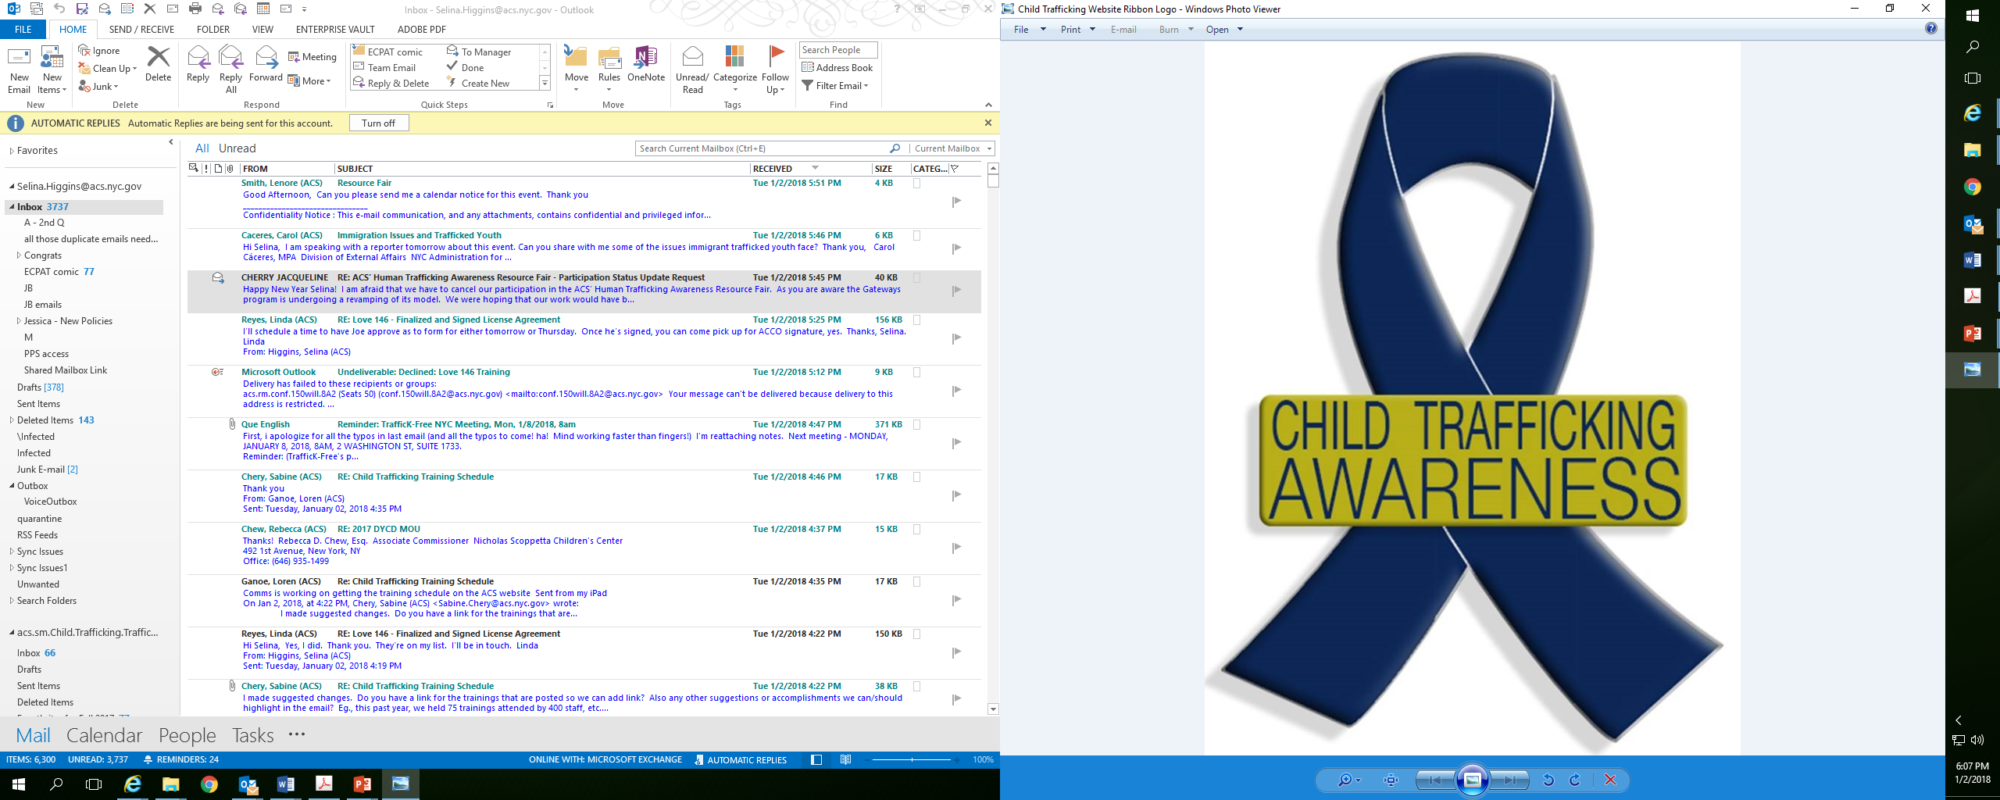
NYC Administration for Children’s Services’ Office of Child Trafficking Prevention and Policy

A Selection of NYC Services for Sex and/or Labor Trafficked Youth:

- NYC Administration for Children’s Services’ Office of Child Trafficking Prevention and Policy: Child.trafficking@acs.nyc.gov
OCTPP leads all aspects of ACS’ policy and practice concerning trafficked and commercially sexually exploited children.
- NYC Administration for Children’s Services’ Immigrant Services: Training and TA, information about legal services and resources. Contact Bojana Zezelj at 917-551-7968.
- Ali Forney Center: Housing and supportive services for male and female LGBTQ youth: 212-222-3427 or www.aliforneycenter.org
- Day One: Individual services for exploited and trafficked males & females, and intimate dating violence, training: 212-566-8120,
Ext. 5692 or socialworker@dayoneny.org
- The Door: Multi-service center for all teens (male, female, LGBTQ) ages 12 – 21: 212-941-9090 or www.door.org
- GEMS: Individual and group work services for exploited and trafficked females, housing, mentoring training: www.gems-girls.org
- Hetrick Martin Institute: Services and referrals for male and female LGBTQ youth ages 13 – 24: 212-674-2400 or www.hmi.org
- JCCA’s Gateways Program (JCCA): Residential Foster Care for females (active ACS cases must be referred through the Office of Placement): gateways@jccany.org
- JCCA’s Center for Healing: Evidence based, clinical services for JCCA referred children and families who have experienced child sexual abuse and/or exploitation. 914-769-0164
- Mt. Sinai Adolescent Health Center: FREE Medical, Dental, Optometry, Mental Health, Counseling, Mentoring and Transitioning Services for males and females up to age 24 (must register by age 22): 212-423-3000 for appointment
- New Beginnings at Mt. Sinai-St. Luke’s: Preventive services with family participation, specifically for sexually abused and/or trafficked males and females: 212-523-2685
- PurPLe Clinic: FREE safe primary health care clinic for male and female survivors of sex abuse and/or trafficking: purpleclinic@institute.org
- Safe Horizon’s Anti-Trafficking Program: Counseling, basic needs, legal services, linkage to services, training. 718-943-8631
- Safe Horizon’s Streetwork Project: Drop In Centers in all 5 boroughs: www.safehorizon.org
- Sanctuary for Families’ Immigration Intervention Project: Services in over 30 languages, locations in 4 boroughs, but serves Citywide. 718-250-4240 or www.sanctuaryforfamilies.org
- Sanctuary for Families’ Justice and Empowerment for Teens (JET) Initiative: Training, advocacy and clinical services for all exploited or risk of exploitation youth. Email jlee@sffny for the referral form.
- U.S. Department of Labor, Wage and Hour Division: Community education/training, referrals, investigates employers, computes and recovers back wages for immigrants or labor trafficked, minors, wage loss and wage theft victims.
212-264-8185 or www.wagehour.dol.gov

ACS OCTPP 1-4-18

Updated 1-22-16

