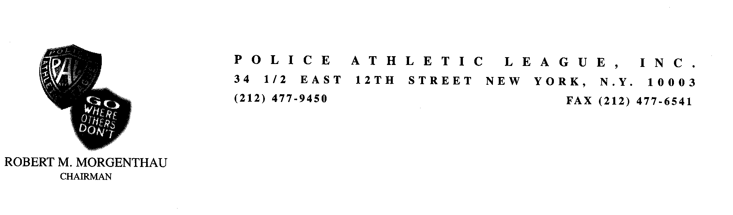
HARLEM GLOBETROTTERS RETURN TO HARLEM FOR 2ND ANNUAL POLICE ATHLETIC LEAGUE EVENT

News Release: Contact: Alicia Maxey Greene
October 8, 2008 212-335-9400

Manhattan District Attorney Robert M. Morgenthau, Chairman of the Police Athletic League (PAL) of New York City, will join New York Police Commissioner Raymond W. Kelly in hosting The Original Harlem Globetrotters vs. the Washington Generals in a game at PAL’s 369th Harlem Armory Center.

PAL distributed 2,500 tickets to public school children throughout New York City for today’s game during which Assemblyman Keith Wright, of Harlem, and New York 1 Anchor Dominic Carter will serve as guest Generals. Tip-off is at 10:30 a.m. The event runs until noon followed by an autograph signing with the Harlem Globetrotters. The center is located at One West 142nd Street at Fifth Avenue.

Mr. Morgenthau said, “I am thrilled that the Harlem Globetrotters will again showcase their superior and entertaining basketball skills. I am also pleased that PAL has played a significant role in the transformation of an armory that was formerly used by the first African-American regiments in World War I, and is now an exceptional haven for the Harlem community, particularly for children.”

Commissioner Kelly said, “Together the Police Athletic League and the Harlem Globetrotters are a formidable team that helps New York City school children to aim high. The winning continues with PAL programs citywide, even when the exposition game ends.”

Felix Urrutia, Executive Director of PAL, said, “By hosting the world famous Harlem Globetrotters in the Police Athletic League’s 369th Harlem Armory, thousands of neighborhood kids are afforded a life-long memory right in their community. PAL is grateful for the opportunity to combine entertainment, history and youth development all in one morning.”

Kurt Schneider, Chief Executive Officer of the Harlem Globetrotters, said, “We are thrilled once again to partner with PAL to bring the world famous Harlem Globetrotters to the school kids of Harlem. PAL represents the best and purest form of outreach to children, and we are excited to partner with them to share smiles, laughter and goodwill.”

The event provides children in the community an opportunity to see the wide-range of activities offered at the PAL 369th Harlem Armory Center, including basketball, volleyball, rock climbing, high ropes, tennis and golf. Additionally, the center provides enrichment programs, such as tutoring, mentoring and computer training. Adults in the surrounding community also have access to the state-of-the-art center for large public events, such as graduation ceremonies, festivals and job and career fairs. The Harlem Armory is the only active National Guard Armory that offers this type of use to the community.

The PAL 369th Harlem Armory Center features a 50,000 square foot drill floor and three tiers of updated stadium seating for nearly 3,000, six modern tennis courts and a multi-purpose court equipped for basketball and volleyball. Additional space is available for gymnastics, fencing and golf. A rock climbing wall and high ropes course is also available, along with three classrooms, a tennis lounge, computer room and office space.

Today’s event was made possible through fundraising efforts by Center Director Andrew Walker and Facilities Manager Keith Martin.

The Police Athletic League, founded in 1914, has been serving New York City’s young people for over 90 years. PAL currently provides recreational, educational, cultural and social activities to 70,000 boys and girls each year. It is the city’s largest, independent, nonprofit youth organization.

###

