11/10/25 - 11/14/25
STANDARD PEDESTRIAN RAMP UPGRADES - MANHATTAN AND QUEENS PROJECT: HWPR24MQ BOROUGH: QUEENS DATE ISSUED: 11/07/25
The following is an anticipated work schedule for the upcoming week. However, due to unforeseen field
and weather conditions, it may become necessary to change some scheduled work locations, operations and dates.
DATE |  | WORK HOURS | LOCATION |  | OPERATION
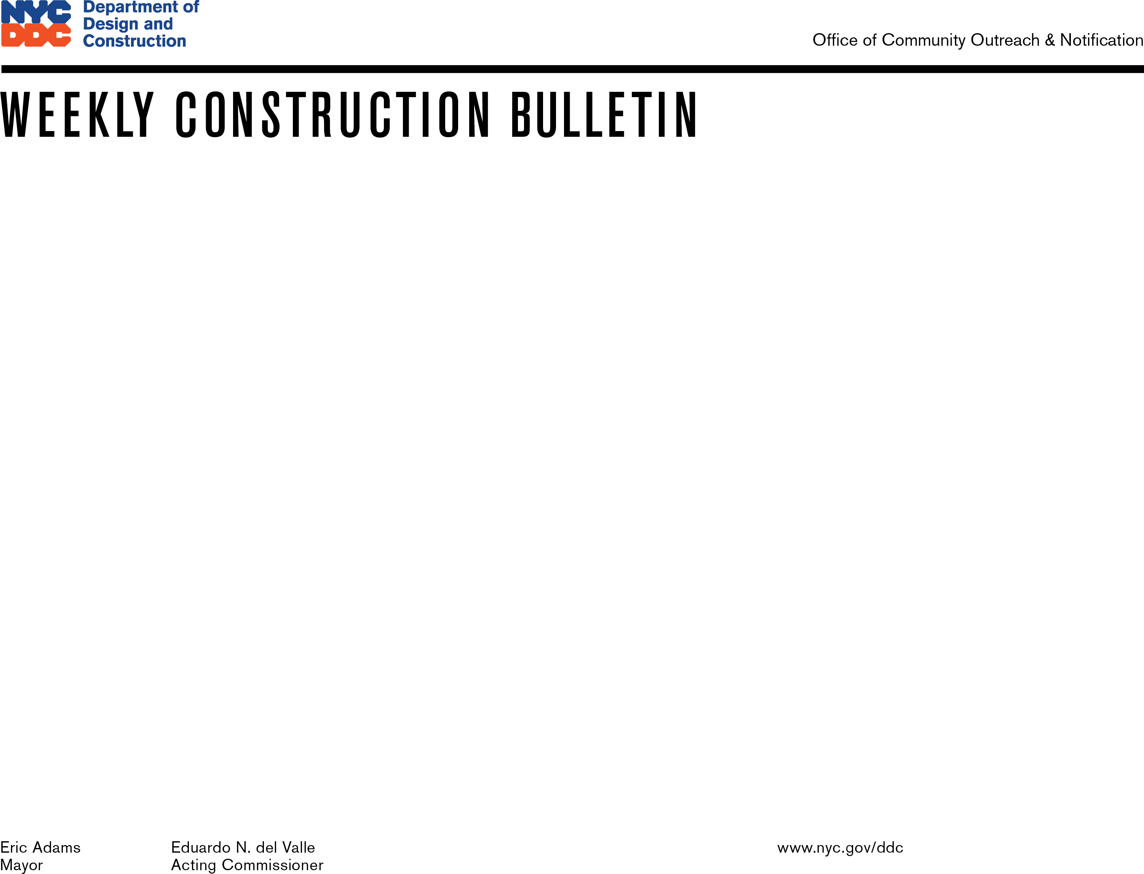  11/10/25–11/14/25 7:00 am–6:00 pm |  |  | - 30 Avenue & Steinway Street  - Ditmars Blvd. & Steinway Street  - Ditmars Blvd. & 43rd Street  - Ditmars Blvd. & 45th Street  - 51st Avenue & 72nd Street  - 36th Avenue & 73rd Street  - 34th Avenue & 64th Street  - Northern Blvd. & 62nd Street  - 50th Avenue & 69th Street  - 49th Avenue & 70th Street  - 47th Avenue & 70th Street  - 51st Avenue & 72nd Street |  | Excavation and Installation Pedestrian Ramps
WATER SHUT-OFF NOTIFICATIONS: In addition to a 72-hour Advisory, a prior 24-hour notification will be distributed / posted to any / all affected locations(s).
NO PARKING SIGNS: Will be distributed / posted 72 hours prior to the temporary elimination of street parking. Please observe posted parking regulations in construction areas.
FOR FURTHER INFORMATION: Contact Wildor Saint Fort, the Community Construction Liaison at (845) 405-3761 or hwpr24mqccl@gmail.com

