PROMOTION EMAIL TEMPLATES
Thank you for spreading the word about WorkWell NYC clinics! Whether you are hosting one yourself or there is one happening in your worksite or around your area, you can use these email templates to help get the word out to your colleagues. Each email has a suggest subject line. The first template is for an initial announcement and the second is for a reminder. Just fill in the highlighted sections as well as the purple box regarding the clinic you are promoting. Copy it into an email and send!

Email #1: Initial announcement of the flu clinic
Subject line: Get the Shot, Not the Flu! Get your free flu shot at work
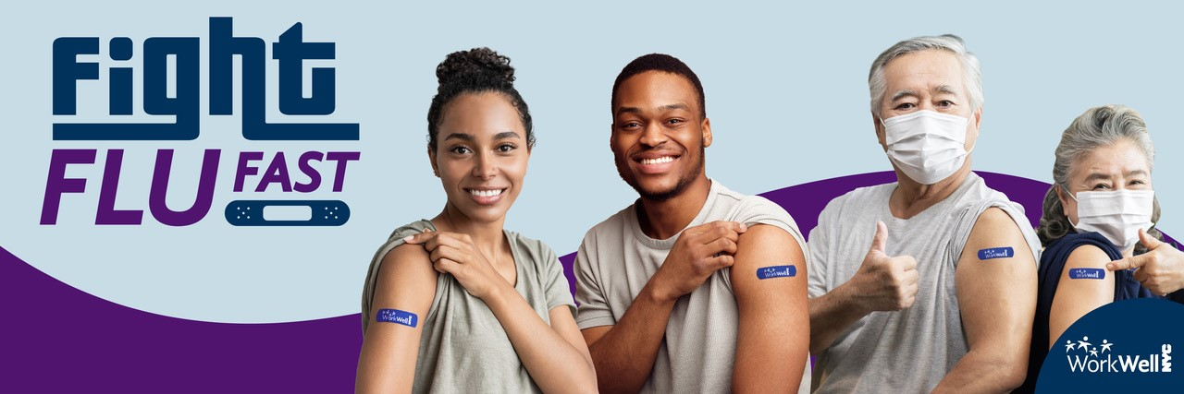
Dear [AGENCY/WORKSITE NAME] employees:
Flu season is almost here! Take steps in protecting yourself and your family from the influenza virus by getting your flu shot. The flu is a respiratory disease that can cause mild to serious illnesses and even healthy people can become very ill from the flu. Getting your flu shot is the best way to prevent you and your loved ones from getting sick.
WorkWell NYC offers free flu shots to City employees and their families. Worksite flu clinics offer a quick, convenient and effective way to help you stay flu-free.
Get your flu shot at:
[Agency/location name]
[Date(s) and Time(s)]
[Location – address and room]
[Indicate if wheelchair accessible]
 | Make an appointment here: on.nyc.gov/fluclinic.  To schedule your worksite appointment over the phone,  call 866-481-4391 between 8 AM and 6 PM ET.
 | Print your consent form and get your flu shot!  Please complete your consent form before your appointment and arrive at your appointment time to minimize wait time.
Can’t make it to the clinic? Free flu shots are also available at participating pharmacies and in-network medical offices. Contact your health insurance provider for more information or visit the NYC Health Map webpage for more info.
For questions, visit on.nyc.gov/wwnycflu or contact [AMBASSADOR NAME] at [AMBASSADOR EMAIL/PHONE]

Email #2: Reminder about the flu clinic
Subject line: Reminder: Get your free flu shot
Dear [AGENCY/WORKSITE NAME] employees:
A flu shot is the best way to protect you, your family and your colleagues against the flu and its complications. A flu shot takes seconds – but can prevent days or weeks of illness.
WorkWell NYC is bringing free flu shots right to our area:
[Agency/location name]
[Date(s) and Time(s)]
[Location – address and room]
[Indicate if wheelchair accessible]
 | Ready for your flu shot?  - Make an appointment for your worksite flu shot here.  - Print out your consent form and fill it out before arriving.  - Wear clothing that allows access to your upper arm.  - Bring your employee ID to your appointment.
 | Can’t make it to the clinic?  - Check out other WorkWell NYC clinics or get your free flu shot  from participating pharmacies and in-network medical offices.  - Visit the NYC Health Map webpage for more information.

Everyone can do their part to prevent the spread of respiratory illnesses like flu. Make your appointment today – get the shot, not the flu!
For questions, visit on.nyc.gov/wwnycflu or contact [AMBASSADOR NAME] at [AMBASSADOR EMAIL/PHONE]

