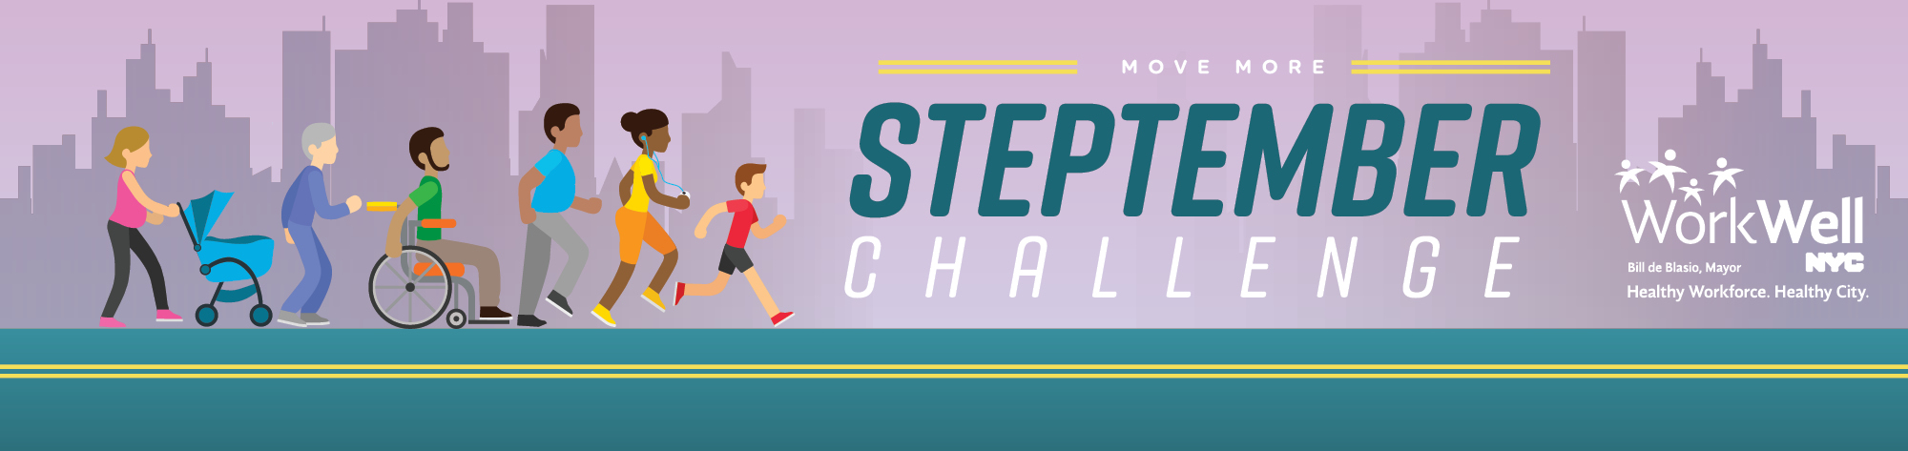
Hey (insert agency) Employees!

Let’s get moving! Join the MoveMore: STEPtember Challenge and get fit with your colleagues in a friendly walking competition against other city agencies.

Registration is now open, so make sure you head on over to www.nyc.gov/movemore today to join one of the (insert agency) teams! (Spots are limited). Team and individual prizes will be awarded so everyone has a chance to win!

Any questions about the challenge? Need help signing up? Join WorkWell NYC on one of three webinar calls:

STEPtember Informational Webinars
Tuesday, August 21st at 1:00pm
Thursday, August 23rd at 12:00pm
Wednesday, August 29st at 12:00pm
Click here to register

You can also find registration help by viewing the FAQ’s here. If you are still unable to sign up after doing so, please reach out to workwell@olr.nyc.gov with the subject line “STEPtember Inquiry”.

Please note:

You are not required to have a wearable device to participate in this challenge -- an iPhone or an Android is able to track your steps for you! (Just make sure you are carrying it around with you, of course.)

If you do not have a mobile device that integrates with MoveSpring, don’t fret! Email the WorkWell NYC team at workwell@olr.nyc.gov to discuss ways in which you can still participate.

If you have any physical limitations and would like to participate in the challenge, please email workwell@olr.nyc to learn how to sign up.

www.nyc.gov/movemore || workwell@olr.nyc.gov

