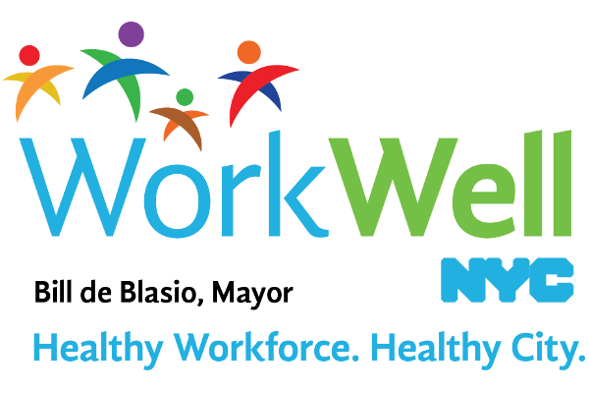

Don’t Miss Out On The Fun!

Registration for the **STEPtember Walking Challenge** will be closing this Friday, **September 7th** at 5pm. Make sure you register before it’s too late!

Join one of the (insert agency) teams today and step your way to victory!

If you have any physical limitations and would like to participate in the challenge, please email [workwell@olr.nyc.gov](mailto:workwell@olr.nyc.gov) to learn how to sign up.

***Let’s Get Moving!***

REGISTRATION CLOSES: **Friday,** **September 7th**

CHALLENGE BEGINS: **Wednesday, September 12th**

CHALLENGE ENDS: **Wednesday, October 10th**

**Visit** [**www.nyc.gov/movemore**](http://www.nyc.gov/movemore) **to register!**