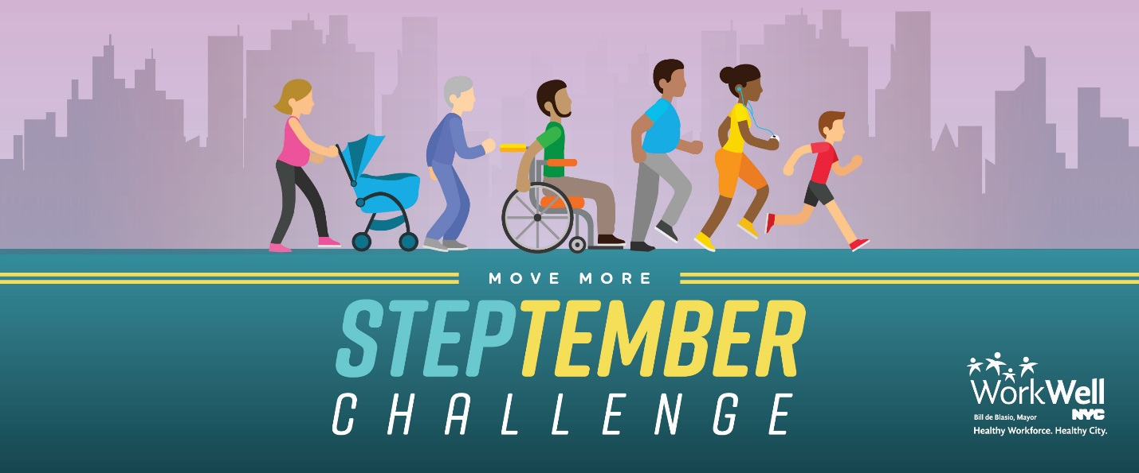
Have you signed up for the STEPtember Walking Challenge yet? If not, it’s not too late! Join one of our teams today to step your way to victory! The challenge is set to begin in (insert days here) days. Don’t miss out!

You can register online and view the FAQs at www.nyc.gov/movemore. If you have issues enrolling, please email workwell@olr.nyc.gov with the subject line “STEPtember Inquiry.”

Please note:

You are not required to have a wearable device to participate in this challenge -- an iPhone or an Android is able to track your steps for you! (Just make sure you are carrying it around with you, of course.)

If you do not have a mobile device that integrates with MoveSpring, don’t fret! Email the WorkWell NYC team at workwell@olr.nyc.gov to discuss ways in which you can still participate.

If you have any physical limitations and would like to participate in the challenge, please email workwell@olr.nyc to learn how to sign up.

www.nyc.gov/movemore || workwell@olr.nyc.gov

