**FY 2025 Continuum of Care Program Grant Inventory Worksheet Instructions**

**for**

**CoCs, Collaborative Applicants, and Project Applicants**

|  |  |
| --- | --- |
| Official seal of the U.S. Department of Housing and Urban Development | U.S. Department of Housing and Urban Development  Community Planning and Development  Office of Special Needs Assistance Programs |



Table of Contents

Introduction 1

Overview of the GIW update and review process: 1

Reviewing the GIW for Accuracy 2

Guidance for Requesting Changes 7

**A.** **Field Office and Collaborative Applicant Information Fields** 7

**B.** **Applicant and Project Information Fields** 7

**C.** **Identifying the Type of Change Requested** 9

**D.** **Current Budget Line Items (BLIs) and Unit Configuration Fields** 10

**E.** **Adding Renewal Projects to the GIW** 10

**F.** **Removing Projects from the GIW** 10

**G.** **Budget Corrections** 11

**H.** **Unit Configuration Corrections** 11

Guidance for Completing the Rental Assistance Worksheet 13

**Instructions for CoCs completing the Rental Assistance Worksheet:** 13

**Using the FY 2025 Fair Market Rents Document System to identify current FMRs:** 16

Conclusion 17

**Introduction**

The Grant Inventory Worksheet (GIW) is a spreadsheet used to record all grants in each Continuum of Care (CoC) that are eligible for renewal in the CoC Program Competition. In previous years, the Office of Special Needs Assistance Programs (SNAPS) provided GIWs to Collaborative Applicants, project applicants, and interested stakeholders by posting GIWs to the HUD.gov website for review. *However, this year, the GIW will be sent directly to Collaborative Applicants by SNAPS Desk Officers.* Collaborative Applicants will send requests for changes to the CoC NOFO inbox. The GIW calculates an Annual Renewal Amount (ARA) for each project, which is the sum of all renewable budget line items (BLIs). The ARA is the total renewal amount a project may request in the CoC Program Competition, e.g., rental assistance, leasing, supportive services. The sum of all ARAs within the CoC is then used to calculate the CoC’s Estimated Annual Renewal Demand (ARD). The Estimated ARD is then used by CoCs to get an idea of the maximum renewal funding available to the CoC prior to any adjustments made by HUD during the CoC Program Competition.

SNAPS conducts a preliminary review of the GIWs prior to dissemination to capture all projects that may be eligible for renewal. However, it is possible a project was inadvertently omitted and BLI amounts may not capture grants amended after the CoC Program Competition; therefore, SNAPS requests that CoCs, Collaborative Applicants, and project applicants review the GIW to ensure accuracy and report missing or incorrect information using a GIW Change Form.

**GIWs are not to be used to request grant agreement amendments that have not already been fully executed by local HUD field offices.**

This document provides detailed instructions to CoCs, designated Collaborative Applicants and project applicants for the review and verification of eligible renewal projects and project budget information on the FY 2025 GIW.

**Overview of the GIW update and review process:**

|  |  |  |
| --- | --- | --- |
|  | **Steps** | **Due Date** |
|  | GIWs emailed to Collaborative Applicant with CoC and Project Applicant review instructions and GIW Change Form | 6/18/2025 |
|  | GIW Change Forms due to CoC NOFO inbox from CoC Collaborative Applicants. | 7/29/2025 |
|  | Desk Officers complete review of GIW Change Forms and send revised GIWs to Collaborative Applicants | 8/15/2025 |

* SNAPS used various sources to populate the GIW with projects that may be eligible for renewal in FY 2025. Eligibility requirements for renewal require that grants have an expiration date in calendar year (CY) 2026 (January 1, 2026 through December 31, 2026).
* In addition to grants awarded funding during the FY 2024 CoC Program Competition, GIWs may also include YHDP projects and new projects awarded in earlier CoC Program Competitions (e.g. FY 2022, FY 2023, etc.) that have expiration dates in CY 2026 and are eligible for renewal for the first time in FY 2025. Additionally, this is the first year that Special NOFO (SNOFO) projects could be eligible for renewal, so long as the SNOFO grant is expiring in CY 2026.
* The GIWs and a GIW Change Form (to be used for requesting changes to the GIW) will be sent directly to Collaborative Applicants. A Rental Assistance Worksheet tab is included on the GIW Change Form if needed due to changes related to rental assistance.
* Collaborative Applicants are responsible for ensuring the GIW accurately lists all projects eligible for renewal funding in the FY 2025 CoC Program Competition. GIWs reviewed by SNAPS may be incomplete or inaccurate; therefore, Collaborative Applicants, in consultation with Project Applicants, must verify the accuracy of the information. If changes or corrections are required, Collaborative Applicants must submit requests to correct the GIW by completing a GIW Change Form and sending it to the [CoCNOFO@hud.gov](mailto:CoCNOFO@hud.gov) inbox for review and approval by the SNAPS Desk Officer. GIW Change forms will not be accepted from Project Applicants.
* Desk Officers will review the change form to confirm accuracy and compliance with the CoC Program, reconcile any discrepancies with the CoC, and approve or reject the GIW Change Form request.
* The approved GIW Change Form will be used by SNAPS to update the original GIW. If additional changes are identified after the GIW process concludes, which is the date GIW Changes Forms are sent to SNAPS, those changes should be sent to your local HUD field office representative who will forward them to your SNAPS desk officer.
* Desk Officers will send revised GIWs to the Collaborative Applicant.

**Reviewing the GIW for Accuracy**

Collaborative Applicants, with assistance from project applicants, MUST:

* review the information populated on the GIW and correct any inaccuracies using the GIW Change Form (Revised GIWs must not be submitted to the local HUD field office);
* ensure the GIW captures the CoC’s entire inventory of grants in your CoC that are eligible for renewal in the FY 2025 CoC Program Competition; and
* consult with project applicants and SNAPs Desk Officers as needed.

If the Collaborative Applicant or a project applicant identifies a missing project(s), a project(s) that should be removed, or a project(s) that needs its information updated (e.g., BLI changes through a grant agreement amendment), the Collaborative Applicant must note the required changes on a GIW Change Form and submit it to [CoCNOFO@hud.gov](mailto:CoCNOFO@hud.gov) for review by SNAPS. The GIW Change Form mirrors a blank GIW for ease of use and recording information that is incorrect or missing from the GIWs. Collaborative Applicant must not list every project within the CoC on the GIW change form. **Please ensure the GIW Change Form only includes the projects that must be corrected or removed.**

**\*\* Please also be aware that GIW Change Forms sent directly to your local HUD Field Office will not be accepted or reviewed. \*\***

1. **Description of GIW Fields:**

* **Field Office** –This cell is populated with the name of the local HUD CPD field office assigned to the CoC.
* **CoC Number** –This cell is populated with the number assigned to the CoC (e.g., AK-500)
* **CoC Name –**This cell is populated with the name assigned to the CoC (e.g., Anchorage CoC).
* **Collaborative Applicant (CA) Name** –This cell is populated with the organization designated by the CoC to coordinate and submit its GIW, FY 2025 Registration, and FY 2025 CoC Consolidated Application to HUD. The Collaborative Applicant’s name in this cell MUST match the name entered on the CoC Applicant Profile in *e-snaps*.
* **DV ARD (Estimated)** – This cell is a calculation of the total ARA amounts for all projects listed on the GIW that were originally funded with DV Bonus funds (including funds reallocated from projects originally funded with DV Bonus funding).
* **YHDP ARD (estimated)** - This cell is a calculation of the total ARA amounts for all projects listed on the GIW that were originally funded with YHDP funds.
* **CoC's Estimated Annual Renewal Demand** –This cell is a calculation of the total ARA amounts for all the projects listed on the GIW.
* **Column A - (Applicant Name)** –This cell is populated with the Project Applicant's name. For returning UFAs, the Collaborative Applicant’s name should be listed in column A for all projects; this does not apply to newly designated UFAs during the FY 2024 CoC Program Registration process.
* **Column B - (Project Name) –**This cell is populated with the project’s name.
* **Column C - (Grant Number) –**This cell is populated with the most recent grant number or project number issued by HUD.
* **Column D - (Expiration Year) –**This cell is populated with the year the project will expire. All projects listed must have a 2026 expiration year. The Expiration Year field has a validation implemented where any year that is not 2026 will be highlighted in RED.
* **Column E - (Project Component)** –This cell is populated with the project component. *Reminder: Collaborative Applicants cannot change the component type during the GIW process.*
* **Column F – (Restriction)** – This cell is populated with the original source of funds (DV or YHDP) to indicate a restriction in the reallocation of that project.
* **Column G - (Leasing)** –This cell is populated with the amount of grant funds designated for leasing.
* **Column H - (Rental Assistance)** –This cell is populated with the amount of project funds designated for rental assistance.
* **Column I - (Supportive Services)** This cell is populated with the amount of project funds designated for supportive services.
* **Column J - (Operating Costs)** This cell is populated with the amount of project funds designated for operating costs.
* **Column K - (HMIS)** This cell is populated with the amount of project funds designated for HMIS.
* **Column L – (VAWA)** – This cell is populated with the amount of project funds designated for VAWA costs.
* **Column M – (Rural)** - This cell is populated with the amount of project funds designated for rural costs.
* **Column N - (Administrative Costs)** –This cell is populated with the amount of project funds designated for administrative costs.
* **Column O** - **(FMR or Actual Rent) –**The Collaborative Applicant needs to populate this cell (if applicable) with whether the rental assistance project is using FMR or Actual Rent Amounts.
* **Columns P – W (Unit Configuration) -** These cells are populated with the number of units and unit types (SRO, 0BR, 1BR, etc.) funded by the rental assistance BLI, as indicated in the previously awarded project application.
* **Column X - (Total Unit)** –This cell is a calculation of all the units funded by the rental assistance BLI. This is the total number of units as indicated in the previously awarded grant application.
* **Column Y - (Total ARA)** –This cell is pre-populated with the sum of Current BLI Amounts (columns G – N).

1. **Key Policies and Considerations**
   1. **Funding for Specific Subpopulations**. The House and Senate Committees on Appropriations expressed that for projects awarded for specific subpopulations (e.g., homeless youth or survivors of domestic violence, dating violence, sexual assault or stalking), the renewal funding, including reallocation and replacement funding, must continue serving the specified subpopulation. Therefore, to assist CoCs in understanding the impact of this restriction, the GIW includes a column identifying the impacted projects and two fields identifying the ARD of those projects – **DV ARD** and **YHDP ARD**. Those fields can be found in the header of the GIW.
   2. **Youth Homelessness Demonstration Program (YHDP) grants.**  YHDP grants are initially awarded under the YHDP Notice of Funding Opportunity (NOFO). YHDP grants expiring in CY 2026 are eligible to receive renewal funds under the CoC Program. The FY 2025 GIWs include former YHDP grants that have already been renewed under the CoC Program in prior CoC Program funding years, as well as expiring YHDP grants expected to renew under the CoC Program for the first time. Expiring YHDP grants renewing for the first time were originally multi-year grants, so the project’s ARA was calculated based on a 12-month term. CoCs must verify the ARA was calculated correctly.
   3. **Special NOFO Grants.** SNOFO grants were initially awarded in FY 2022 and had terms of 3 years. Many SNOFO projects have grant terms expiring in CY 2026 and are eligible to renew in FY 2025. Renewals are for 12-month terms like regular CoC grants. To identify these projects, they are highlighted on the GIW.
   4. **Capital Costs.** Capital costs (new construction, rehabilitation, or acquisition) are not renewable; therefore, projects renewing for the first time that included capital costs in its original award must not include any capital costs, or administrative costs associated with capital costs, in the renewal project’s ARA.
   5. **Project Component Corrections and Transition Grants.** Recipients are not permitted to submit requests to change a project component during the GIW reconciliation process. However, if the GIW does not capture the correct component of transition grants, CoC’s must submit a GIW Change form to request a correction.
   6. **Budget Changes.** 24 CFR 578.105(b)(1) states that recipients or subrecipients may not make significant changes to a project without prior HUD approval, evidenced by a grant amendment signed by HUD and the recipient. Significant changes include a change of recipient, a change of project site, additions, or deletions in the types of eligible activities approved for a project, a shift of 10 percent or more from one approved eligible activity to another, a reduction in the number of units, and a change in the subpopulation served.

When recipients make budget changes, the **total ARA for the project cannot increase**; therefore, to accommodate a shift of funds from one activity to another, one or more of the existing line items must be decreased concurrently. Additionally, recipients cannot reduce the number of units served by the project, so HUD cautions recipients against carving funds out of the Rental Assistance or Leasing BLIs.

Recipients must have an executed grant agreement amendment to shift funds among BLIs if it results in a shift of more than 10 percent from an approved eligible activity to another. If the project applicant has an executed grant agreement amendment and the new BLI amounts are not correctly reflected on the GIW provided by HUD, enter the project information on the GIW Change Form and complete the *Current Budget Line-Item Amounts* section of the form with the correct BLI information. Select “Budget Correction” in column ‘Z’ and provide comments describing your budget correction request in column ‘AA’. When sending the change form to the CoC NOFO inbox, a copy of the executed grant agreement amendment must be included.

* **Only significant budget changes that are evidenced by a grant agreement amendment may be reflected in the GIW. A significant budget change is a shift of more than 10 percent from the originating BLI or an addition or deletion of a BLI (see 24 CFR 578.105).**

**If the recipient would like to make budget changes that do not require a grant agreement amendment (i.e., a shift of 10% or less from the originating BLI) those must not be made through the GIW process, but the recipient may update their project application to reflect the budget change. \***

* 1. **Consolidations.** The CoC Program Competition is the only method recipients can use to consolidate grants. Therefore, FY 2025 GIWs should capture those grants consolidated during the FY 2024 CoC Program Competition.
  2. **CoC Mergers and CoC Splits.** For CoCs that merged or split from another CoC for FY 2025, the CoC’s Collaborative Applicant must verify that the merged GIW or the GIWs for CoCs that split into one or more CoCs includes all projects eligible to renew within the CoC. If a CoC merger or split has not been completed but is expected to be completed by the CoC application submission deadline, the CoC must send an email to [CoCMerger@hud.gov](mailto:CoCMerger@hud.gov), if they have not done so already. SNAPS will review the request and, if approved, issue the CoC Number and Name to the designated Collaborative Applicant of the newly merged CoC or the Collaborative Applicants of the CoCs that were split. The SNAPS desk officer will provide the Collaborative Applicant(s) with a revised GIW worksheet for review.
  3. **CoC Planning and Unified Funding Agency (UFA) Costs.** CoC Planning and UFA costs grants are **NOT** included on GIWs as these types of projects are not renewable and do not contribute to a CoC’s ARD.

**Guidance for Requesting Changes**

If a discrepancy is identified with the CoC Name, Collaborative Applicant Name, or the renewal project information on the GIW, Collaborative Applicants must use the GIW Change Form to correct the information. If the GIW Change Form information is approved by your SNAPS desk officer, the revised GIW will be sent to the Collaborative Applicant.

The FY 2025 GIW Change Form is divided into sections that mirror the GIW. The sections are highlighted below:

1. **Field Office and Collaborative Applicant Information Fields**

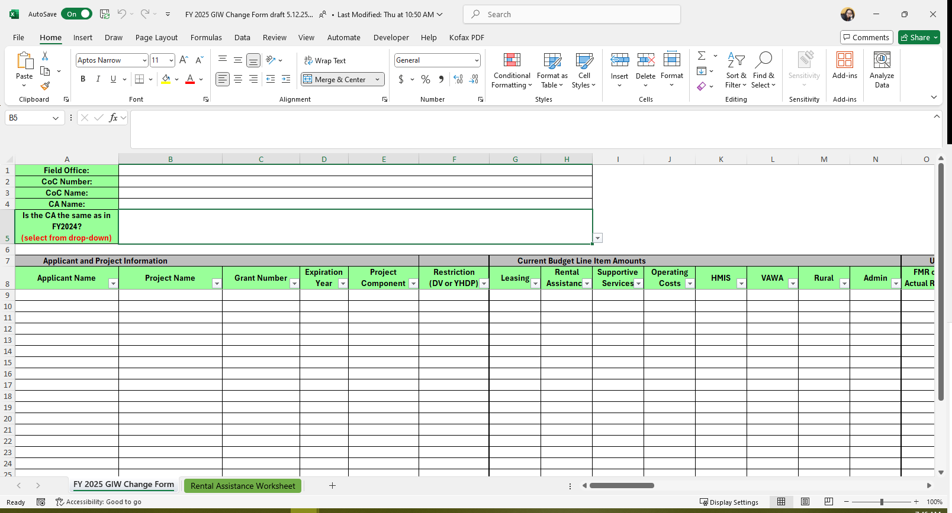

This section of the GIW Change Form contains basic information about the CoC.

When requesting project changes, this section must be completed by the Collaborative Applicant using the information from the GIW. However, if the Collaborative Applicant changed after FY 2024, the correct Collaborative Applicant Name must be entered and “No” should be selected by the Collaborative Applicant for the question, “Is the CA the same as in FY 2024?”

The Collaborative Applicant listed MUST match the Collaborative Applicant identified *in e-snaps* in the CoC Applicant Profile.

1. **Applicant and Project Information Fields**

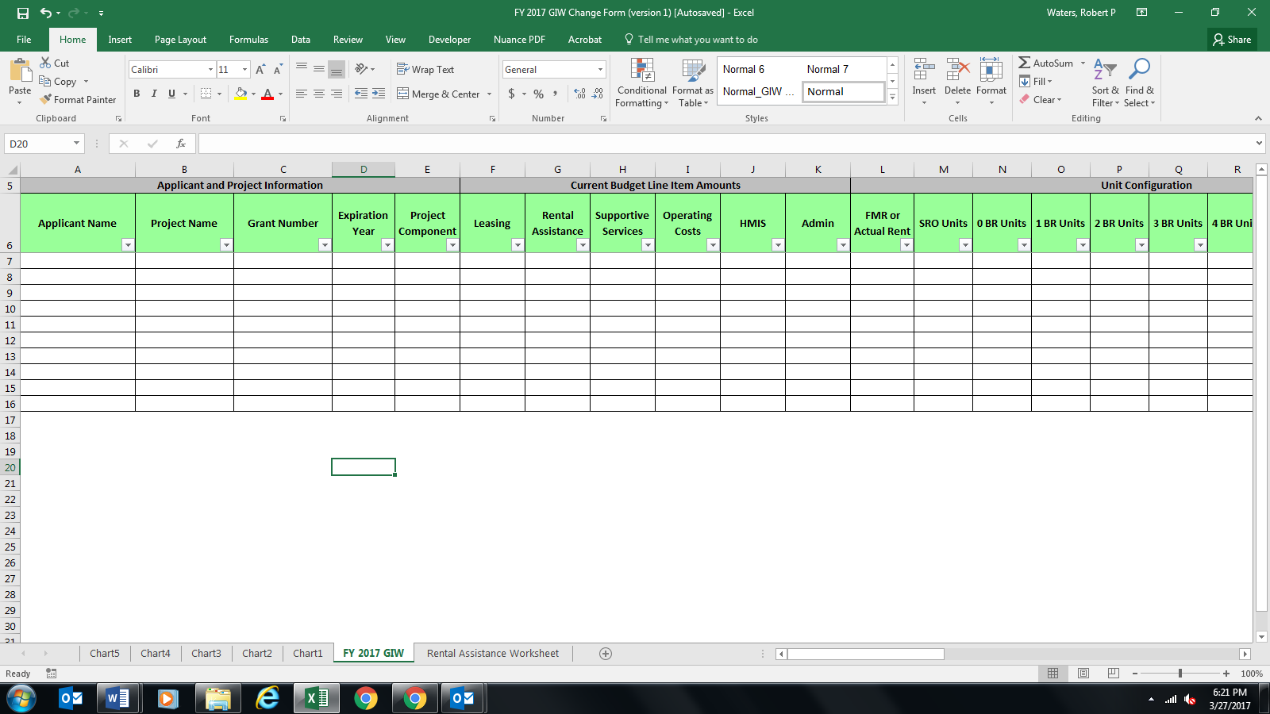

For any change request to a project’s information on the GIW, Collaborative Applicants must enter the accurate Applicant and Project Information on the GIW Change Form to ensure the project is properly identified when it is added, removed, or edited.

Complete the information for this section using the populated GIW information. For incorrect information on the GIW, (e.g., changed due to a grant agreement amendment, etc.), enter the correct information and enter a comment in Column AA, and indicate the “Type of Change” in column Z.

1. **Applicant Name**:
   * Enter the applicant name as it appears on the GIW; **or**
   * if the applicant name is different from the name on the GIW (e.g., rebranded organization name, transferred grant to another organization).
2. **Project Name**:
   * Enter the project’s name as it appears on the GIW; **or**
   * If the project name has changed, enter the new name. Only indicate a project name change if it is significant (e.g., Hope House is renamed New Horizons), do not indicate minor changes (e.g., Hope House 2022 to Hope House 2023).

1. **Grant Number**:
   * Enter the current grant number as it appears on the GIW; **or**
   * If the grant number is incorrect enter the correct grant number for the project.
2. **Expiration Year**:
   * Enter 2026 if the project is expiring in CY 2026 and is eligible for renewal in the FY 2025 CoC Program Competition.
   * If the project is not eligible for renewal and must be removed from the GIW enter the expiration year the grant is expected to expire.
3. **Project Component**:
   * enter the component type (e.g., TH, SSO).
   * This will only change if HUD populated an incorrect component on the GIW, which is rare.
4. **Identifying the Type of Change Requested**

Prior to entering additional project information, Collaborative Applicants must use Column Z and Column AA to identify the type of change requested. For every project added to the GIW Change Form, select the type of change requested from the drop-down menu in the “Type of Change” column (Column Z) and provide additional details of the request in the “Comments” column (Column AA) to aid HUD in understanding the nature of the request.

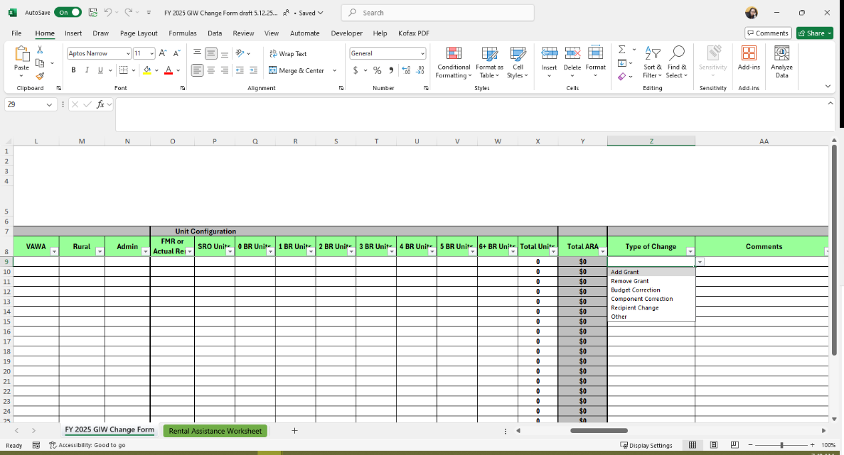

**Types of changes that can be requested include:**

1. Add/Remove a Grant
   * Collaborative Applicants can request to add a grant that was omitted from the GIW but was determined to be eligible for renewal in the FY 2025 CoC Program Competition. The grant must have an expiration date between January 1, 2026 – December 30, 2026.
   * Collaborative Applicants may submit a request to remove an ineligible grant from the GIW. For example, if the grant will not have a CY 2026 expiration date and will be ineligible for renewal in the FY 2025 competition. The project must be removed from the GIW.
2. Budget Corrections – enter budget corrections to capture permanent budget changes recorded in a grant agreement amendment. Collaborative Applicants must not include budget changes requested by recipients that do not trigger an amendment (i.e. less than 10% of the BLI being adjusted).
3. Unit Configuration corrections for projects receiving rental assistance funding. Unit configuration corrections cannot increase the project’s ARA.
4. Other - If the required correction cannot be categorized by the pre-populated selections in the Type of Change drop down menu, Collaborative Applicants can select “Other” and provide further details of the required changes in the Comments column.
5. Recipient change – if the grant has been amended to transfer to a new recipient.
6. **Current Budget Line Items (BLIs) and Unit Configuration Fields**

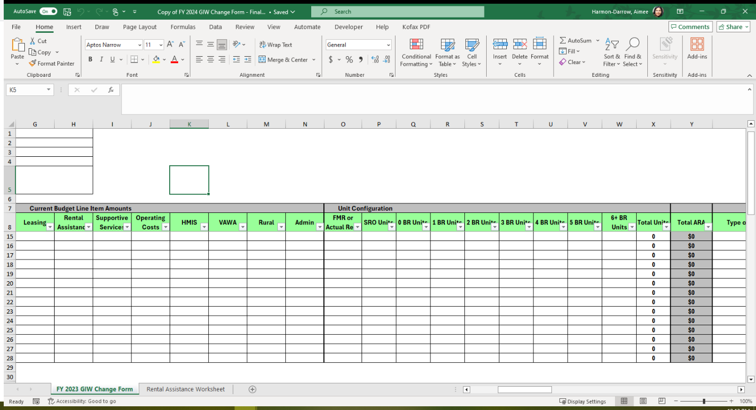

If the Applicant and Project Information for a project is the only change required, Collaborative Applicants must complete this section by copying the information from the project’s Current Budget Line Items and Unit Configuration (if applicable) section of the populated GIW.

Collaborative Applicants must also use this section to request a change to a project’s budget information populated by SNAPS on the GIW; or to add accurate project information for any first-time renewal project(s) that needs to be added to the GIW.

**All the columns for a row of the GIW Change Form must be completed to reflect the project(s) as they should appear on the revised GIW.**

Do not include acquisition, rehabilitation, new construction, and any administrative costs associated with these capital costs, as these costs are not renewable.

1. **Adding Renewal Projects to the GIW**

If an eligible renewal project(s) is missing from the GIW, the Collaborative Applicant must complete the GIW Change Form and submit it to [CoCNOFO@hud.gov](mailto:CoCNOFO@hud.gov) for review. To submit a request to add an eligible project, Collaborative Applicants and project applicants complete the following:

* Project Applicant and Project Information section of the GIW Change Form.
* Current BLI amounts and if applicable, the Unit Configuration Sections. Enter the current budget line items as indicated in the current grant agreement or grant agreement amendment. Column “Y” contains a formula calculation. The total budget amount for the projects will automatically populate in Column “Y”. Check the information entered to ensure the totals are accurate. Projects requesting funds for rental assistance must also complete the Unit Configuration Section.
* Select the appropriate response from the dropdown in the “Type of Change” column.
* Enter a comment in the "Comments" column, indicating the project is eligible for renewal.

1. **Removing Projects from the GIW**

If a project will not renew, or is not eligible to apply for FY 2025 funds in the CoC Program Competition, Collaborative Applicants and project applicants must:

* Enter the Applicant and Project Information.
* Enter ‘0’ for all BLIs.
* Select appropriate response from the dropdown in the “Type of Change” column.
* Enter a comment stating the reason for removing the project in the “Comments” column.

**Do not submit requests to remove projects from the GIW that the CoC expects to reallocate during the FY 2025 Funding Year. The GIW is not the mechanism for capturing reallocations and these projects must remain on the GIW and count towards the CoC’s Estimated ARD.**

1. **Budget Corrections**

Project applicants must verify the BLI amounts on the GIW match the amounts listed in their CoC award, grant agreement, or grant agreement as amended. If there is a discrepancy with a project’s budget, the Collaborative Applicant must enter the correct project and budget information on a GIW Change Form and submit it to CoCNOFO@hud.gov.

SNAPS will confirm that a grant agreement amendment has been, or will be, executed before the CoC Program Competition application submission deadline. In the "Comments" Column (Column AA), clearly indicate the reason for editing a pre-populated project. *Additionally, include a copy of the executed grant agreement amendment when submitting the change form.*

1. **Unit Configuration Corrections**

A project applicant that has a rental assistance BLI cannot change the number of units (e.g., increase or decrease the number of units) or unit configuration (e.g., change from 3 – 1-bedroom units to 2 – SRO units and 1 – 2-bedroom unit) without authorization from the local HUD field office and an executed grant agreement amendment. Additionally, these types of changes cannot increase a project’s ARA.

If the number of units or unit configuration on the GIW is inaccurate due to an executed grant agreement amendment, Collaborative Applicants will enter the project information and the correct number and configuration of units on the GIW Change Form. In the "Comments" Column (Column AA), clearly indicate the reason for editing a pre-populated project. **The GIW Change Form must also include a completed Rental Assistance Worksheet to calculate the rental assistance budget accurately, and to ensure the unit configuration does not result in an increased ARA.**

The ARA for leasing projects is not established by the number and configuration of units. Therefore, Collaborative Applicants should not submit a GIW Change Form to add or change the number or configuration of units or structures.

**Guidance for Completing the Rental Assistance Worksheet**

**(RENTAL ASSISTANCE PROJECTS ONLY)**

The GIW includes rental assistance information (units and budget) for CoC Program rental assistance projects. GIW Change Forms include a Rental Assistance Worksheet tab that Project Applicants and Collaborative Applicants must use to ensure the amount of 1-year funding for rental assistance is correct. The Rental Assistance Worksheet allows Collaborative Applicants to calculate the total rental assistance amount for the units assisted by the project using the number and configuration of units (e.g., 1-bedroom unit, 2-bedroom unit, etc.) and the actual rent amounts for the FY 2025 FMR for the project’s geographical area.

**Collaborative Applicants are only required to complete the Rental Assistance Worksheet for the following project(s):**

* rental assistance projects changing from FMR to actual rent (shifting funds out of the rental assistance line item);
* rental assistance projects that require unit configuration corrections;
* rental assistance projects originally awarded one-year renewal funding in FY 2024 or prior and will submit its first one-year renewal project in FY 2025; or
* multi-year grants originally awarded rental assistance funds for multiple years and will submit its first one-year renewal project in FY 2025.

HUD recognizes that individuals and families that present as homeless require units that match their specific needs; therefore, the units served with CoC rental assistance funds may not match the exact unit configuration as indicated in the CoC project application. Recipients should not change their proposed unit configuration to account for these fluctuations during the renewal process annually. If for some reason a permanent change is necessary, recipients should discuss the circumstances that warrant a permanent change with the local HUD field office. If the unit configuration on the GIW is not accurate as result of an approved grant agreement amendment, CoCs are instructed to enter the project information and the correct unit configuration on the GIW Change form. The GIW Change Form must also include a completed Rental Assistance Worksheet to ensure the unit configuration does not result in an increased ARA.

Completing this worksheet will ensure the total rental assistance amount entered in the rental assistance BLI in Column H of the GIW Change Form is accurate. The worksheet includes multiple tables to allow project applicants that have multiple FMR areas within a single project to calculate the different FMR amounts. The Rental Assistance Worksheet also contains a link to the [FY 2025 Final Fair Market Rents Documentation System](https://www.huduser.gov/portal/datasets/fmr/fmrs/FY2025_code/select_Geography.odn) that is used for determining the FY 2025 FMR amounts that will be used during the FY 2025 application process. Project applicants must use Actual Rent amounts or enter the FY 2025 FMRs to calculate the rental assistance budget. When all data has been entered for all FMR areas, the total rental assistance budget will auto-calculate at the top of the form.

### **Instructions for CoCs completing the Rental Assistance Worksheet:**

To determine the eligible rental assistance amount for a renewal grant, click on the Rental Assistance Worksheet Tab attached to the GIW Change Form and complete the appropriate fields on the worksheet.

If the GIW Change Form includes multiple projects that require rental assistance worksheets, Collaborative Applicants must duplicate the Rental Assistance Worksheet Tab as many times as necessary. To create additional Rental Assistance Worksheet tabs, perform the following steps:

1. Move your mouse cursor over the tab name of the Rental Assistance Worksheet.
2. Right Click on the tab and select the option Move or Copy.
3. Once the Move or Copy window is displayed, select (move to end).
4. Click the checkbox next to Create a copy and then click OK.
5. A message box should appear, select “Yes”.
6. If necessary, delete any data entered in the Project Name, Project Number and County/FMR Area fields that were copied from the previous worksheet.
7. If necessary, delete the amounts entered in the # of Units and FMR columns that were copied from the previous worksheet.

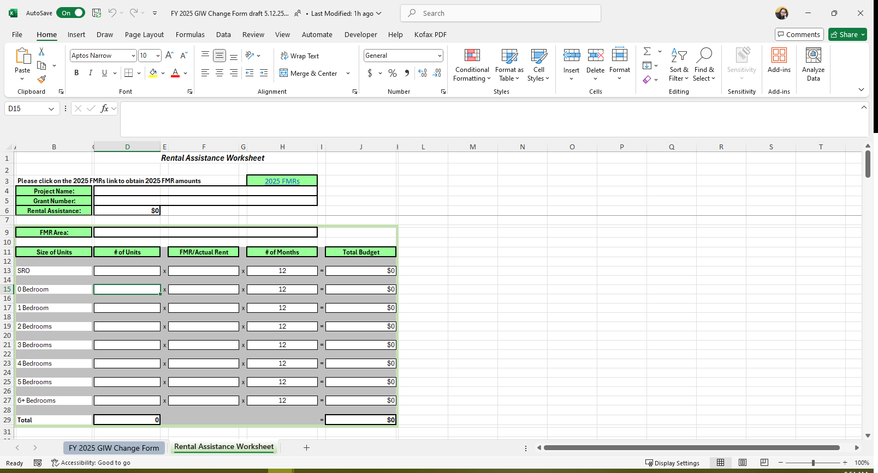

Figure 1: Sample Rental Assistance Worksheet

**For each project that requires a Rental Assistance Worksheet, Collaborative Applicants must complete the following fields:**

* **Project Name –** enter the name of the renewal project.
* **Grant Number –** enter the Project Number, which is the grant number from the current grant agreement or grant agreement amendment.
* **Rental Assistance – Do NOT enter anything in this field.** This field will auto-calculate the Rental Assistance BLI amount based on the information entered on the worksheet.
* **FMR Area –** enter the name of the County or Metropolitan area (MSA) where the units are located.
* **Size of Units –** this column lists the size of units based on the FMR tables. **Do not alter the rows or change the information in these fields.**
* **# of Units –** enter the number of units for each unit size in the renewal project.
* **FMR/Actual Rent –** project applicants and Collaborative Applicants must enter the FMR rate for each unit size based on the FY 2025 FMR table in the Fair Market Rents Document System or enter the Actual Rent cost for the unit size(s) in the project.
* **# of Months –** renewal projects are limited to one-year funding; therefore, 12 months is populated. **Do not change the information in this field.**
* Complete the FMR Table as many times as necessary and copy the total rental assistance amount generated at the top of the worksheet to the GIW Change Form.
* For rental assistance projects serving multiple FMR areas, there are 10 FMR Area tables within a single worksheet. An FMR table must be completed for each FMR area served by the project and the Rental Assistance amount will be calculated automatically at the top of the form.

**Special Note:** For rental assistance projects that have SRO units and/or 5+ units, use the following formulas to manually calculate the total rental assistance to enter in the applicable cell(s) on the GIW:

* SRO = 0Bdrm FMR x 0.75
* 5 Bedroom = 4Bdrm FMR x 1.15
* 6 Bedroom = 4Bdrm FMR x 1.30
* 7 Bedroom = 4Bdrm FMR x 1.45
* 8 Bedroom = 4Bdrm FMR x 1.60
* 9 Bedroom = 4Bdrm FMR x 1.75

### **Using the FY 2025 Fair Market Rents Document System to identify current FMRs:**

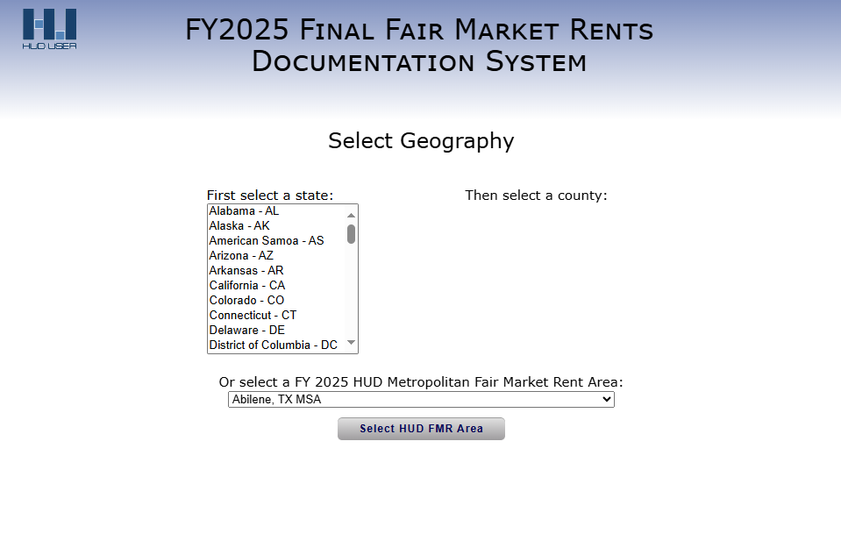

*Figure 2: Screenshot of FMR Documentation System*

1. If the project is using county-level FMR rates for determining the project’s rental assistance budget, Collaborative Applicants must first select the state and the county where the unit(s) are located. Once the location is selected, confirm the submission by clicking “Next Screen…” to display the FMR table that includes FMR rates for the geographic area according to bedroom size.
2. If the project is using FMR rates for an entire metropolitan area, Collaborative Applicants must use the dropdown menu at the bottom of the screen to select the appropriate metropolitan area. Click “Select HUD FMR Area” to confirm your selection and display the FMR rates for metropolitan areas according to bedroom size.

**Conclusion**

This concludes the FY 2025 GIW update and review process for CoCs, Collaborative Applicants, and project applicants. Once the GIW review period ends, HUD will review GIW Change Forms received from all Collaborative Applicants, update GIWs with the revisions approved during the GIW Change Forms review process, and email GIWs that were revised to the respective Collaborative Applicant contacts.