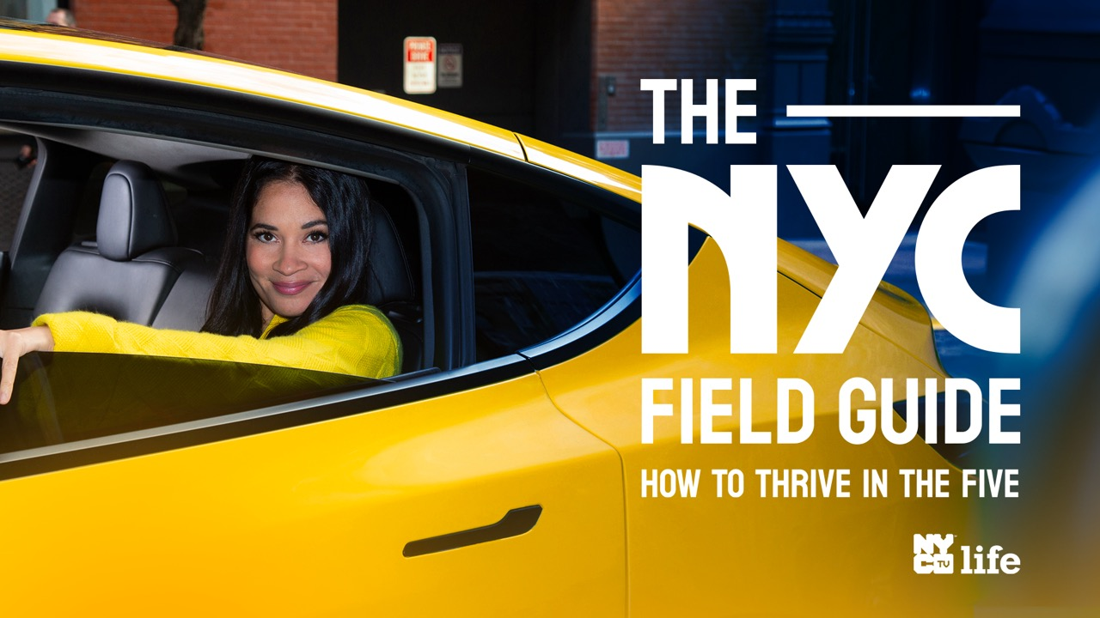

***The NYC Field Guide: How to Thrive in the Five* promo social media kit**

“The NYC Field Guide: How to Thrive in the Five” series, premiering June 26 on NYC Media/NYC Life, offers unique tips, hacks and expert information from celebrities, New Yorkers and NYC officials for how to live, work and play in the five boroughs of New York City.

[**Twitter/X handle @nyc_media**](https://twitter.com/NYC_Media)

* New Yorkers, you're the most street-smart & savvy people in the world!

@nyc_media's premiering #NYCFieldGuide, a new TV series @NMPFilms on June 26, and want YOU to tell us your best tips and hacks around the city. 🏙️  
Share some of those trade secrets with #NYCFieldGuide. 👀

* New Yorkers: got a great tip for thriving in the 5 boroughs? ✍️

Share your tricks of the trade for getting around the best darn city in the world with @nyc_media & the hashtag #NYCFieldGuide! Can't wait to hear your secrets. 👀

* NYC, we're gonna drop the biggest tips and hacks on how you can thrive in the five, from celebs and city experts, on our upcoming series #NYCFieldGuide with host @NYCMicaela!  
  Wanna add your personal idea? Drop us a tip with #NYCFieldGuide. 🏙️

[**Facebook handle @nycmedia**](https://www.facebook.com/NYCMedia)

* New Yorkers, you're the most street-smart & savvy people in the world!

@nycmedia's premiering #NYCFieldGuide, a new TV series @NMPFilms on June 26, and want YOU to tell us your best tips and hacks around the city. 🏙️  
Share some of those trade secrets with #NYCFieldGuide. 👀

* New Yorkers: got a great tip to thrive in the 5 boroughs? ✍️

Share your tricks of the trade for getting around the best darn city in the world with @nycmedia & hashtag #NYCFieldGuide!

* NYC, we're gonna drop the biggest tips and hacks on how you can thrive in the 5, from celebs and city experts, on our upcoming series #NYCFieldGuide with host Micaela Birmingham!  
  Wanna add your personal idea? Drop us a tip with #NYCFieldGuide. 🏙️

[**Instagram**](https://www.instagram.com/madein_ny/)[**/Threads**](https://www.threads.net/@madein_ny) **handle @madein_ny**

* New Yorkers, you're the most street-smart & savvy people in the world!

NYC Media’s premiering #NYCFieldGuide, a new TV series @NMPFilms on June 26 hosted by @micaelabirmingham - and want YOU to tell us your best tips and hacks around the city. 🏙️  
Share some of those trade secrets with #NYCFieldGuide. 👀

* New Yorkers: got a great tip for thriving in the 5 boroughs? ✍️

Share your tricks of the trade for getting around the best darn city in the world with @micaelabirmingham & hashtag #NYCFieldGuide!

* NYC, we're gonna drop the biggest tips and hacks on how you can thrive in the five, from celebs and city experts, on our upcoming series #NYCFieldGuide with host @micaelabirmingham!  
  Wanna add your personal idea? Drop us a line with #NYCFieldGuide. 🏙️

***More Information, Including Show Promo, Available*** [***Here***](https://www.nyc.gov/site/media/shows/the-nyc-field-guide.page)