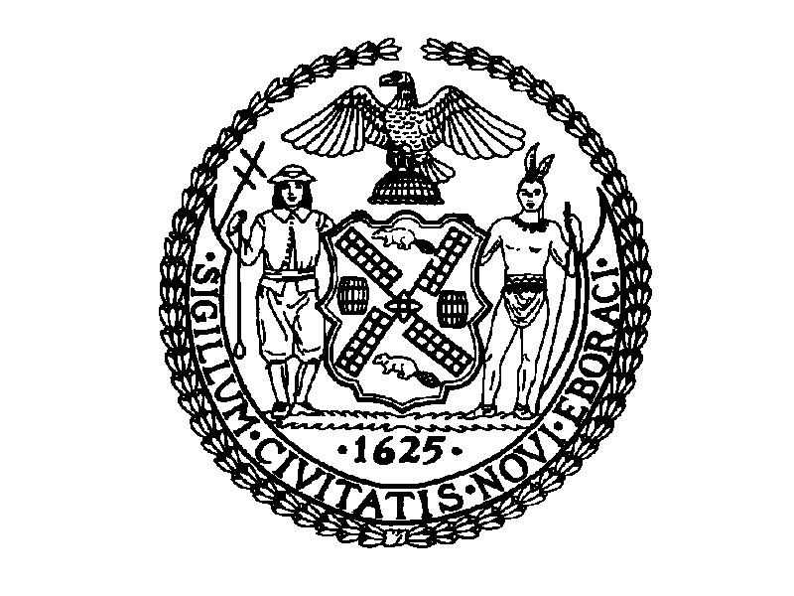
THE CITY OF NEW YORK
MANHATTAN COMMUNITY BOARD NO. 3
59 EAST 4TH STREET - NEW YORK, N.Y. 10003
PHONE: (212) 533-5300 - FAX: (212) 533-3659
HTTP://WWW.CB3MANHATTAN.ORG - INFO@CB3MANHATTAN.ORG

DAVID MCWATER, BOARD CHAIR SUSAN STETZER, DISTRICT MANAGER

MOTION: To approve the following recommendations of the Waterfront Task Force for the improvement of the waterfront from the Brooklyn Bridge to the entrance of East River Park. These recommendations were formulated as a result of many community meetings with residents, particularly, the community design workshops that were facilitated by City College Architectural Center (CCAC) with the assistance of the National Parks Service Rivers and Trails Program. (The complete Charrette Report and Design Principles of the workshops, prepared by CCAC, is available for review in its entirety.) The recommendations listed below elaborate on the Summary of Design Principles that was approved by the Board on June 22, 2004 (see page 8).

These recommendations are in addition to the list of short-term improvements to the esplanade from the Brooklyn Bridge to Pier 35 that were submitted by Community Board #3 to the NYC Department of Transportation at its request in June 2003.
________________________________________________________________________

Greening the Greenway
Principle: “Green this section of the East River Greenway and FDR corridor to reduce pollution and add “more nature.”

This stretch of the Manhattan Greenway from the Brooklyn Bridge to East River Park is currently a harsh urban environment, characterized by asphalt and other impervious surfaces and a continuous concrete bulkhead that separates people from the water’s edge. In fact, there is virtually no “green” on this entire stretch of the “Greenway.” In addition to these concerns, the FDR creates air pollution, noise pollution, and contaminated run-off that could be at least partly remediated through various “greening” strategies.

Recommendations
- Widen greenway for bicycle and pedestrian access, as well as park and pier zones, beyond the current esplanade
- Redesign pedestrian portion of the “greenway,” e.g., with plantings, green spaces, and possibly a meandering path
- Green up the view corridors into neighborhoods to invite people down to the water and extend adjacent neighborhood green spaces to edge of water
- Build green roofs on buildings on piers and nearby public buildings
- Add green planted piers or barges for passive recreation
- Create “softer” or more naturalized shoreline
- Create wetland to remediate water pollution and run-off and to mitigate new piers
- Modify DOS building with green roof and park on top (ex: Riverbank State Park)
________________________________________________________________________

Alternative Transportation
Principle: Reduce noise, air and water pollution and hazards caused by vehicular traffic, while increasing clean, accessible forms of public transit, waterborne transportation and pedestrian and bicycle access to and along the waterfront.

The Lower East Side is currently denied access to the Greenway by barricades and poor design that ignores pedestrian and bicycle connections. At the same time, the area is grossly underserved by public transportation. Better access to the Greenway, improvements to the linear Greenway trail facilities and new forms of non-polluting public transit along South Street are especially needed.

Recommendations:
Pedestrian connections
- Improve attractiveness and safety of Greenway for pedestrians in order to encourage walking for transportation and recreation
- Improved pedestrian accommodations connecting neighborhoods to the waterfront are
essential. (See Community Connections section.)

Bicycling
- Improve existing bike routes on Greenway with dedicated bike lanes, especially near
Pier 42 to East River Park
- Add bike racks at all existing and future destination points
- Create additional and safer bike lanes on streets leading to Greenway
- Prohibit parked vehicles, which now overhang into existing bike lane
- Promote bike rentals and bike shops in Greenway area

Waterborne transportation
- Add water taxi or ferry that uses clean-air technologies at a location that minimizes impact on neighborhoods and parks (possible locations: between Piers 36 and 42 or at Pier 35)
- Make ferry connections to Governor’s Island and Brooklyn in the future to access recreational facilities
- Create facilities for small boats

Rail
- Make East Broadway subway stop accessible for people with disabilities
- Add light rail or other non-polluting transportation along the waterfront connecting to other Lower Manhattan neighborhoods

Buses
- Extend M14A and M15 bus routes along South Street or add new waterfront route
- Establish bus connection between LES waterfront and Brooklyn
- Add rubber-tire trolley along waterfront and to West Side
________________________________________________________________________

Vehicular Routes
Principle: “Humanize” the FDR by making pedestrian safety and amenities a high priority in all design and transportation decisions.

There is a very clear consensus that whether the elevated FDR is dismantled or remains, noise and air pollution and pedestrian safety issues must be addressed.

Recommendations:
- Remove bus parking
- Replace fencing and align openings to connecting street ends
- Address noise and air pollution
- Remediate pollution and run-off from FDR with wetlands and other greening
- Promote clean energy vehicles
- Add traffic calming measures on South Street and other nearby “problem” streets
- Design sound baffling (sound attenuation) for FDR and bridges
- ”Humanize” spaces underneath the transportation structures (FDR and bridges, especially Manhattan Bridge subway noise)
- Design the space underneath the FDR; to provide street-end connections
- Create an “active zone” under the FDR that might include recreational activities; restrict any commercial activity or park concessions to this zone
________________________________________________________________________
Community Connections
Principal: Make clear, unobstructed, pedestrian-friendly connections to the waterfront to heighten awareness of the water, get people to the edges with ease, and capitalize on the exceptional views.

The neighborhoods of the Lower East Side are currently separated from the waterfront by chain link fences and “Jersey barriers” blocking access to the waterfront, even at the few existing crosswalks across South Street. Other conditions, such as poor lighting under the FDR and on the esplanade and the need for better streetscaping and crosswalks on connecting streets, increase the divide between the neighborhoods and the water.

Recommendations:
- Add more lighting under FDR and on waterfront
- Install traffic lights (particularly at Rutgers Street and Wagner Place) and better marked pedestrian crossings across South Street
- Extend street network and neighborhood green spaces to water’s edge with street-end parks, and ideally, beyond the edge onto new street-end piers
- Choreograph/capitalize on exceptional views, especially of the two bridges
- Create waterfront destinations such as gathering spots to bring neighborhoods together (Chinatown, Two Bridges, Lower East Side)
- Strengthen pedestrian connections between Chinatown and waterfront
- Strengthen Allen-Pike Street connection to waterfront
- Improve pedestrian connections and streetscaping on Catherine Street and alongside Brooklyn Bridge on Robert F. Wagner Sr. Place
- Create an entrance to the esplanade from the middle section of Smith Houses, between Wagner Place and Catherine Slip
- Rutgers Street could be a “two-way gateway” from subway and a grand entrance to park
- Activate spaces under bridges with good lighting schemes, greenery, temporary market stalls, etc.
________________________________________________________________________

Waterfront Destinations
Principle: The waterfront should be a primary cultural and recreational destination that will unite diverse neighborhood cultures.

At present, this stretch of the waterfront lacks the kinds of destinations and amenities found along many other parts of the Manhattan Greenway. On the Lower East Side, the quality of the Greenway trails for active recreation lags far behind other areas, especially on the West Side. There are few spots for passive recreation and none that are suitable for gatherings or cultural activities.

Recommendations

- The Greenway is the primary destination for walking, biking, skating and experiencing the waterfront; improved access, safety, and amenities for these activities is the highest priority
- Add cultural programming to bring diverse cultures together on the waterfront, working with local neighborhood groups
- Create spaces for family gatherings, special events, and active and passive recreational activities
- Create pleasant and safe walking, biking, and skating experience to connect to other destinations such as East River Park or Hudson River Park, Staten Island Ferry, Statue of Liberty/Ellis Island, etc.
- Water-related sports/recreation: e.g., small boats, swimming (floating barge or pool in river)
________________________________________________________________________
Between the Bridges (the esplanade)
Principle: Maximize space for public access along the water’s edge for neighborhood residents. Increase opportunities for visual and physical contact with the water.

In spite of exceptional views of the two bridges, the esplanade between the Brooklyn and Manhattan Bridges is a monotonous stretch along the straight edge of the bulkhead, mostly under the FDR Drive. Design strategies are needed to soften the edges, provide public spaces out from under the dark, noisy FDR, and create connections with the adjoining residential neighborhoods.

Recommendations:
- Create new public space out beyond the FDR by adding new street-end piers, boardwalks, barges, and/or new “softer” edges
- Extend neighborhood green spaces to edge of water, especially at Pike Street and Catherine Street; include bike trails, safe crossings, and signage
- Regrade and repave the area of the Greenway adjacent to South Street between Catherine and Rutgers Streets to correct the current flooding/pooling problem
- Provide adequate space for fishing and safe separations between pedestrians and fishing lines
- Improve waterfront edge to serve recreational neighborhood uses
- Eliminate parking under FDR and add this space to park area
- Provide pedestrian access and improvements to existing natural beach area near Brooklyn Bridge
- Clean up and improve pedestrian connections along Brooklyn Bridge anchorage (Robert F. Wagner Sr. Place)
- Use “greening” strategies such as naturalized edges and coves or canals
- Add green-planted piers or barges for passive recreation
- At Catherine Slip: Extend green space out to water OR create a cove or canal at Catherine Slip, making use of existing natural underground spring
________________________________________________________________________
The Piers
Principle: Improve or redevelop piers to create opportunities for public access and recreation in keeping with the residential nature of the community. Any City or commercial facilities on the piers should contribute both in use and design with the health of local residents and the waterfront environment.

The poor quality and condition of existing structures on the piers (a.k.a. “The Sheds”) mar the appearance of the waterfront. Currently, the public is denied access to the piers, even though some areas are sadly underutilized.

Recommendations
- Allow public access on Pier 35
- Open waterside space behind the sheds on Piers 35-36, creating ingress/ egress through existing structures (near future)
- Remove DOT maintenance vehicle yard between Piers 36 and 42 and improve for public use
- Explore multiple uses for Pier 42 with an emphasis on passive enjoyment of the waterfront
- Make the piers an intermodal transportation hub, with water taxi and/or ferry landing, bicycle and skate rentals, and possibly pedi-cabs
- Create indoor and outdoor spaces for gatherings/cultural festivals and activities
- Improve and expand access to East River Park from Pier 42 and create an inviting entrance to the park
- Create dedicated walking and biking paths separate from vehicular traffic connecting the Greenway at Montgomery Street to East River Park
- Develop continuous public access along water/pier edge
- Build sustainable buildings that utilize green roofs and solar energy on piers
- Keep maritime access at piers, especially pier 42
- Extend piers out to pierhead line
- Use innovative design elements, e.g. decorative grates to see water below, circles glowing from pavements, structures that go into river, etc.
- Build boathouse for small boats
________________________________________________________________________
Conclusion

The Waterfront Design Workshop focused on positive and far-sighted visioning for the future. However, it is also important to note the kinds of uses that CB3 residents expressly avoided in their designs. Waterfront uses considered objectionable by community residents include:

- Uses, including commercial (retail or wholesale), which would generate an increase in truck and automobile traffic and noise
- Uses that are not water-related and which would diminish access to the waterfront and block views
- Housing
- “Tourist trap” destinations
________________________________________________________________________

Summary of Design Principles*

Consider the residential nature of the waterfront community the primary concern in any development of the Community District 3 waterfront.

“Green” the East River Greenway (a section of the Manhattan Greenway) and the FDR corridor from Brooklyn Bridge to East River Park to reduce pollution and add “more nature.”

Reduce noise, air and water pollution and hazards caused by vehicular traffic, while increasing clean, accessible forms of public transit, waterborne transportation and pedestrian and bicycle access to and along the waterfront.

“Humanize” the FDR and Greenway by making pedestrian safety and amenities a very high priority in all design and transportation policy decisions.

Make clear, unobstructed, pedestrian-friendly connections to the waterfront to heighten awareness of the water, get people to the edges with ease, and capitalize on exceptional views.

The waterfront should be a primary cultural and recreational destination that will unite diverse neighborhood cultures.

Maximize space for public access along the water’s edge for neighborhood residents. Increase opportunities for visual and physical contact with the water.

Improve or redevelop piers to create opportunities for public access and recreation in keeping with the residential nature of community. Any City or commercial facilities on the piers should contribute both in use and design with the health of local residents and the waterfront environment.

*As amended and endorsed by the CB3 Waterfront Task Force on June 9, 2004 and approved by Community Board 3 on June 22, 2004.
________________________________________________________________________

