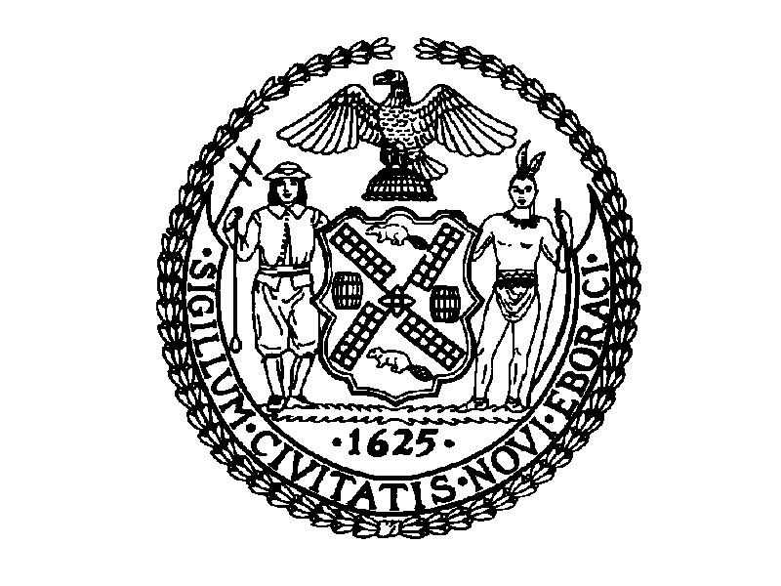
THE CITY OF NEW YORK
MANHATTAN COMMUNITY BOARD NO. 3
59 East 4th Street - New York, N.Y. 10003
Phone: (212) 533-5300 - Fax: (212) 533-3659
www.cb3manhattan.org - info@cb3manhattan.org

David McWater, Board Chair Susan Stetzer, District Manager

City Council Public Forum on improving the Department of Buildings
December 4, 2006

My name is Susan Stetzer, and I am district manager of Community Board 3 Manhattan. This district runs from 14th Street to the Brooklyn Bridge and from the East River to 4th Avenue, Bowery, and much of historic Chinatown. It is an area of intense development and construction.

Community Board 3 is currently working with the city on a contextual zoning plan for much of the northern part of the district and also beginning to consider zoning plans for other parts of the district. This has further intensified the development because of the land rush created by the rush to demolish and develop before new zoning regulations go into effect.

The Department of Buildings is a very important agency to our Board. We receive many calls for help from the community regarding construction and plans inappropriate, and sometimes dangerous, for the community. We have been concerned about enforcement of existing regulations to protect the community. The Community Board has also voted on policy issues needed for protection of our community.

Until April, 2006 when the current Manhattan Borough Commissioner became Acting Borough Commissioner, the Department of Buildings was an obstacle to the Community Board and the community. Questions were answered with “we checked the plans and they are approved and in compliance.” There were times when major mistakes were made, such as the self-certified plans that were approved at 81 E 3rd for a dormitory, although there was no lease in place with an educational institution as required. When the mistake was finally exposed and admitted, the resolution was to allow the developer to cure. This resulted in a 13-story dormitory that should never have been approved, and this is just one example. Our community will suffer for years from the impact of lack of protection of the community by enforcing existing laws until the recent change in the agency in Manhattan.

Community Board 3 is now coordinating resolution of specific problems with our City Council member and the Manhattan Borough President, and we have established a working relationship with DOB and now find the agency to be much more responsive. However, there are major policy problems that need to be fixed in the agency as well as improved audits, inspections, and enforcement. These are not under the control of the Manhattan Borough Commissioner—and must be fixed citywide.

One policy that has had disastrous impact on Community Board 3 is self certification. The Community Board voted in January 2005 that self certification is ineffective and detrimental to Community Board 3. There are developers and architects who misrepresent facts and/or submit self certification plans that would never pass an audit. For example, recently a commercial tenant on 13th Street self certified plans, and the Community Board asked for an audit. DOB found that the plans were for a use group 12 business, and not in compliance with use group 6 zoning for the block. The problem was caught because the Community Board was a watch dog and caught the problem before actual construction—but there was no penalty. Only twenty percent of self certified plans are audited. The worst that can happen is that noncompliance will be caught and the applicant will be asked to meet with DOB staff to cure objections. However, you don’t see floors being removed in the Lower East Side to cure objections. There are no tools to take away self certification privileges from architects or developers who self certify plans that would not pass audits. There is also no penalty that would stop this from being worthwhile. The fact that disciplinary action is virtually non-existent is a huge problem that invites repeat offenders. DOB has recently announced that it is looking to expand Rule 21 to allow the suspension or exclusion of architects or engineers who misuse professional certification. This would provide the beginning of very needed enforcement and deterrent. The DOB is moving in the right direction to protect our communities from serious problems with professional certification, and we urge enforcement measures and effective penalties be implemented immediately.

Community Board 3 also believes that the new weekend inspection program that provides for random inspections is a positive measure. We hope the quality of inspections is also improved. The most frequent DEP complaint in CB 3 is after hour construction noise. Many of these complaints are due to illegal after hours construction. Increased and thorough inspections with meaningful violations that are more than the “cost of business” are necessary for safety and for quality of life.

Another problem in our community is the interpretation of the Multiple Dwelling Law, a state law that strictly limits the extent to which a tenement building can be enlarged. This law limits non-fireproof buildings to six stories or less and is extremely important to Community Board 3 because so much of our housing stock is comprised of 5 and 6-story tenements. The DOB does not interpret a penthouse as an additional story because of the limited size of the footprint. This not only creates buildings out of character with the community, it creates serious structural problems to the building and adjacent buildings. The “upgrade” of these buildings, with community facility bonuses, are used as means of harassing residents or buying out residents resulting in loss of affordable housing. Limitations imposed by the Multiple Dwelling Law have both protected the architectural integrity of buildings by precluding enlargements, but also have assured minimum fire and life safety standards. We believe that DOB’s interpretation of this law is not in the spirit of the intention of the law, and the lack of enforcement and does not protect the safety or character of our community.

The footprint of a penthouse is also used to interpret the Sliver Law, which limits the height of new or enlarged narrow buildings in certain districts. Again, DOB does not consider a penthouse of less than thirty three and one-third percent of the floor below as a story. This perverse interpretation allows buildings that would be denied by the intent of the law.

Community facilities create a serious problem for Community Board 3. Community facilities are not necessarily real community facilities that benefit the community. A community facility can be a very expensive private school or a doctor’s office or dormitory. It does not need to be a facility that is needed in the community or that will benefit the people who live there. Except for a dormitory or hospital, the type of community facility does not need to be identified in the plans, so there is no real way to audit these plans.

Inspection needs to be possible for compliance to be monitored. Presently, DOB cannot mandate access to a private building that may be in noncompliance. If there are two visits with access unavailable, the case is closed. There is no protection for the community, no way to monitor and enforce compliance of rules. Again, there is no motivation for compliance. It is very possible that violations will not be inspected or enforced.

Access to documents is another area of concern. First, there needs to be a system that safeguards the documents. More than once the Board has requested plans for self certified buildings only to be told that plans are missing. Also, plans are not available if they are being audited. The public being impacted should have the right to view plans, even if they are not final plans. Plans are currently available that will be changed by the developer or by a future audit. There is no reason why the public, elected officials, or the Community Board cannot check plans before an audit is finished to identify possible areas of concern. Records of meetings between the agency and applicants would provide needed transparency and confidence.

The Community Board, often working with others in the community, can submit objections to plans that will be audited by DOB. The agency then works with the developer/architect to cure the objections. The Board and the public have no knowledge of how the objections will be cured until the revocation or objection is cured. This is inefficient because continuing objections will start the whole cycle over with a new Letter of Intent to Revoke. This is not hypothetical; we are dealing with this right now in our district. This allows continued construction on buildings that are often not in compliance, and it unnecessarily makes the whole process longer with resulting impact on the community as well as increased costs for the developer.

The last issue I will mention is a major problem. It is too often up to Community Boards, elected officials, and a few residents with expertise to catch suspect plans and ask for an audit. We do not have the expertise or resources to protect our community. Noncompliant development slips through—and for the problems we do catch, we spend a tremendous amount of time being a DOB watchdog, which severely impacts our ability to fulfill our mandated responsibilities. For example, we have issued objections to one site on E. 5th Street several times. Each time DOB finds some of the objections valid—and we have to keep going through this process over and over again. In this one location we identified a rent stabilized apartment that had been self certified as part of the community facility, and it looks like we have identified another that was planned to be part of a new duplex apartment. This is in addition to many other problems we have found and which DOB has forced the developer to cure, including making the community facility be ADA compliant. We need DOB to do its job of thorough and complete and accurate audits so that we can be assured that of compliance and so that we can fulfill the responsibilities or our offices.

The Department of Buildings is an agency of great importance to Community Board 3, particularly because of the onslaught of construction. We see the nature of our community changing. We believe that interpretation of laws and zoning resolutions must protect the community as well as allowing for development. We also believe that the DOB must develop tools that will give them the ability to enforce existing regulations.

