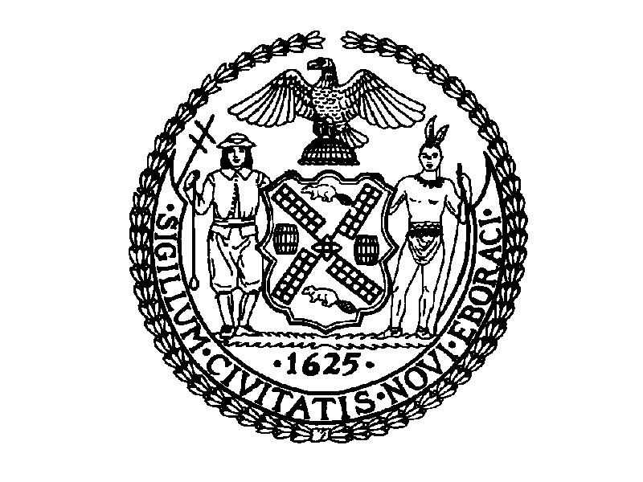
THE CITY OF NEW YORK
MANHATTAN COMMUNITY BOARD NO. 3
59 EAST 4TH STREET - NEW YORK, N.Y. 10003
PHONE: (212) 533-5300 - FAX: (212) 533-3659
HTTP://WWW.CB3MANHATTAN.ORG - INFO@CB3MANHATTAN.ORG

DAVID MCWATER, BOARD CHAIR SUSAN STETZER, DISTRICT MANAGER

City Council
DOiTT Committee Hearing
September 22, 2004-09-22

Thank you for this opportunity to testify for Intro 174-A. My name is Susan Stetzer and I am District Manager for Community Board 3 in Manhattan, which covers the East Village, Lower East Side, and Chinatown.

As you know, community boards are responsible for handling service complaints from the community as well as for making recommendations for agency activities and budgets and future agency programs. Community Boards need information from 311 to be able to perform all these functions.

Previously, community boards received complaints from residents and worked with city agencies to resolve them. This procedure allowed the Board to be aware of the problems in the district. They gained experience with working with agencies and developed relationships that gave them the means to improve service delivery issues. Boards used this information both to resolve issues and to plan and act proactively. The establishment of 311 immediately relieved boards of much of the more routine problems reported to 311. 311 seems to work well with clear cut problems that have clear solutions.

However, many problems are not so easy to resolve. For example, a rodent problem may involve three or more agencies. A loud bar may have music late at night, keeping people awake. The traffic is backed up with cabs and cars honking their horns. There are tables on the sidewalk—a situation that contributes to the noise. These are all multi-agency problems that community boards try to resolve by working with a taskforce of agencies. We need to work with the broader picture of problems that are being called in to 311 to see if they are connected to ongoing issues and to have complete information.

We need 311 information to know when we need to get involved in complaint resolutions. Complaints may be related to problems already being worked by the board and agencies, or they may be problems that should be dealt with by several agencies working together. Dealing with these problems at District Service Cabinets can be the most effective way to resolve them. The Community Boards and agencies are handicapped if we do not have complete information being reported to 311.

Follow up on complaints is a big issue for community boards. We need to know if a violation was issued or if there was a finding of “no violation.” Do we need to keep working on an issue? Do we need to get more agencies involved? Or, has the problem has been fixed? We get complaint numbers from 311, but when we follow up, we are often told that a complaint is closed or resolved. Does this mean a violation issued? Was the problem fixed? Was it transmitted to another agency that is now working on the issue? What information do we give residents who are calling us for answers?

The community board also needs information to make appropriate recommendations. We must give recommendations to approve or deny the renewal of liquor licenses and sidewalk cafes—but we don’t have access to necessary 311 information regarding history of complaints. We make recommendations to approve new sidewalk cafes. It is not responsible to have us make these recommendations without complete history of complaints of the establishment. We need to approve permits for block parties and street fairs and special events, but again we don’t have access to complaint history.

Community Boards are also responsible to for initial review and recommendations regarding land use development or improvement of land located in the district. We cannot exercise this function responsibly without all available information to identify needs and problems.

Community Boards also make recommendations for allocation of resources for their districts. They consider needs of district and consult and assist agencies in preparing plans for growth, improvement and development of districts. They write an annual statements of community district needs and recommendations for programs and projects and consult with agencies on needs of community district to be funded. We are asked to prioritize capital and expense needs for the district. This requires evaluation of quality and quantity of services provided by agencies. Information captured by 311 is necessary to make all of these recommendations.

Giving community boards information regarding our districts captured by 311 will gives us the best of both worlds. Many residents will use 311 to handle simple complaints and for information. We will be relieved of more routine complaints, and we will have better information to resolve more complex issues and have better information to plan for better services for our districts and to better prioritize district expense and capital needs.

