Economic Snapshot:
Change in the Community Board 3 Retail Sector
(2002 – 2007)

Paulo H. Lellis
Community Board 3 Urban Planning Fellow
January 31, 2010

TABLE OF CONTENTS

Executive Summary 3
Understanding Industry Shift-share 4
Analyses of CB3 Retail Industries 5
Comparing CB3 Retail to NYC & Manhattan 7
Comparing CB3 Retail to NYC & Manhattan (1-4 Employees) 8

Comparing Retail & Food Accommodations 9
Comparing Retail and Food & Accommodations 9
between NYC and CB3

Comparing Retail and Food & Accommodations 10
between Manhattan and CB3

Comparing Retail and Food & Accommodations 11
between NYC and CB3 (1-4 Employees)

Comparing Retail and Food & Accommodations 12
between Manhattan and CB3 (1-4 Employees)

Final Comments 13
APPENDICES
APPENDIX A - Retail Sector Definition 14
APPENDIX B - Accommodations & Food Services Sector Definition 16
APPENDIX C - Retail and Accommodations & Food Services Sectors 17
In Community Board 3 (2000-2007)
References 19

Executive Summary
In order to better understand the position of retail businesses as an industry in Community Board 3, this document examines the growth of the industry in the area. It analyzes the growth of Retail Industries sector in CB3 between 2002 and 2007 and compares it to the growth of the Food Services & Accommodations sector. The CB3 area is examined in comparison to New York City and Manhattan Borough through the use of Shift-share Analysis, or a technique for understanding an area’s competitiveness. The analysis reveals the following regarding the change in the number of industry establishments:

- CB3 Retail establishments were better off than NYC Retail and, to a greater degree, Manhattan Retail (Includes businesses of all sizes and those with 1-4 Employees).
- CB3 Retail experienced less growth than Food & Accommodation Industries in CB3 (Includes businesses of all sizes and those with 1-4 Employees).
- Although CB3 Retail was worse off than Food & Accommodations, a larger percentage share of CB3 industry growth went towards its favorable competitiveness with retail in NYC & Manhattan (Includes businesses of all sizes and those with 1-4 employees).
- The mix of local industries in relation to the development of individual industries in NYC and Manhattan indicate that Retail is a stagnating or declining industry that experienced relatively favorable growth in CB3.

By providing a snapshot of Retail growth in CB3, this document seeks to inform the Economic Development Committee of CB3 about the condition of Retail in the area.

Understanding Industry Shift-share
Shift-share is an analysis technique that accounts for the competitiveness of an area’s industries. It illustrates how well an area’s industries are performing by examining a larger area, local area, and three components of industry change.

Components of Industry Change
City/Borough Effect
- The share of local industry growth that is attributed to the growth of all industries in a larger reference area (City or Borough)
Industry Mix Effect
- The share of local industry growth that is attributed to the local area’s mix of industries in combination with the development of individual industries in a larger reference area
- This component accounts for the fact that in a larger reference area, some industries grow faster than others
Competitive Effect
- The share of local industry growth that is due to different rates of growth between local industries compared to their counterparts in a larger reference area
- This component examines how much better or worse was an industry in the local area compared to the same industry in the larger area

Analyses of Retail Industries
Between 2002 – 2007, there was a growth of 57 Retail Establishments in CB3
Retail Industries
Area | New York City |  | Community Board 3
Year | Year 2002 | Year 2007 | Year 2002 | Year 2007
Total Industries | 205,350 | 214,070 | 8,968 | 9,744
Retail Industries | 30,717 | 31,444 | 1,333 | 1,390

City Effect: 56.6
- The growth of 56 Retail Industry establishments in CB3 can be attributed to the growth of Total Industries in NYC between 2002 and 2007
Change in NYC Total Industries₂₀₀₂₋₂₀₀₇
(NYC Total Industries₂₀₀₇ - NYC Total Industries₂₀₀₂) / NYC Total Industries₂₀₀₂
(214,070 - 205,350) / 205,350
0.0424640857

City Effect
CB3 Retail Industries₂₀₀₂ x 0.0424640857
1333 x 0.0424640857
56.60462624
Industry Mix Effect: -25
- A decline of 25 Retail Industry establishments in CB3 can be attributed to CB3’s mix of industries along with the development of individual industries in NYC

Change in NYC Retail Industries₂₀₀₂₋₂₀₀₇
(NYC Retail Industries₂₀₀₇ - NYC Retail Industries₂₀₀₂) / NYC Retail Industries₂₀₀₂
(31,444 - 30,717) / 30,717
0.0236676759

Change in NYC Retail Industries₂₀₀₂₋₂₀₀₇ - Change in NYC Total Industries₂₀₀₂₋₂₀₀₇
0.0236676759 - 0.0424640857
-0.0187964098

Industry Mix Effect
CB3 Retail Industries₂₀₀₂ x -0.0187964098
1333 x -0.0187964098
-25.05561426

Competitive Effect: 25.4
- The growth of 25 Retail Industry establishments in CB3 can be attributed to different rates of growth between CB3 Retail Industries compared to their counterparts in NYC.

Change in CB3 Retail Industries₂₀₀₂₋₂₀₀₇
(CB3 Retail Industries₂₀₀₇ – CB3 Retail Industries₂₀₀₂) / CB3 Retail Industries₂₀₀₂
(1390 - 1333) / 1333
0.0427606902

Change in CB3 Retail Industries₂₀₀₂₋₂₀₀₇ - Change in NYC Retail Industries₂₀₀₂₋₂₀₀₇
0.0427606902 - 0.0236676759
0.0190930143

Competitive Effect
CB3 Retail Industries₂₀₀₂ x 0.0190930143
1333 x 0.0190930143
25.45098803

INTERPRETING THE RESULTS

City Effect: +56.6
Industry Mix Effect: -25
Competitive Effect: +25.4
_________________________
SUM 57 = Growth of Retail Industry Establishments in CB3 between 2002-2007

The growth of Retail Industries in CB3 was comparable to the expected growth based on the NYC Total Industry growth rate (City Effect)
- Actual growth of retail Industries in CB3 was 57 establishments
- Expected growth based on NYC’s growth rate in all industries was 56.6 establishments in CB3

CB3 was better off in the Retail Industry sector compared to NYC (Competitive Effect)
- The negative Industry Mix Effect suggested that retail in NYC was a stagnating or declining industry and that CB3’s share of retail growth was to decline by 25 establishments
- By outperforming New York City Retail Industries, however, CB3 Retail Industries displayed a larger competitive effect in this sector, a sector that was not performing well in the city

Comparing CB3 Retail to NYC & Manhattan

Retail Industries
Area | New York City |  | Community Board 3
Year | Year 2002 | Year 2007 | Year 2002 | Year 2007
Total Industries | 205,350 | 214,070 | 8,968 | 9,744
Retail Industries | 30,717 | 31,444 | 1,333 | 1,390
Area | Manhattan |  | Community Board 3
Year | Year 2002 | Year 2007 | Year 2002 | Year 2007
Total Industries | 103,698 | 104,063 | 8,968 | 9,744
Retail Industries | 11,795 | 11,657 | 1,333 | 1,390

Shift-share Analysis
 | CB3 & NYC | CB3 & Manhattan
City/Borough Effect | 56.60462625 | 4.691941985
Industry Mix Effect | -25.0556143 | -20.28787246
Competitive Effect | 25.45098805 | 72.59593048
Actual Change | 57 | 57

Results

- CB3 Retail was better off than NYC Retail and even more so when compared to Manhattan Retail (Competitive Effect)

- Growth of all industries in NYC accounts for a greater share of Retail growth in CB3 than the growth of all industries in Manhattan (City/Borough Effect)

- Due to the growth of individual industries in NYC and the mix of local industries, a greater share of CB3 Retail establishments were expected to decline than when local retail mix was compared to Manhattan (Industry Mix Effect)

Comparing CB3 Retail to NYC & Manhattan (1-4 Employees)

Retail Industries (1-4 Employees)
Area | New York City |  | Community Board 3
Year | Year 2002 | Year 2007 | Year 2002 | Year 2007
Total Industries | 128,344 | 134,260 | 5,591 | 6,168
Retail Industries | 20,481 | 20,682 | 815 | 860
Area | Manhattan |  | Community Board 3
Year | Year 2002 | Year 2007 | Year 2002 | Year 2007
Total Industries | 60,494 | 60,199 | 5,591 | 6,168
Retail Industries | 7,218 | 6,945 | 815 | 860

Shift-share Analysis
 | CB3 & NYC | CB3 & Manhattan
City/Borough Effect | 37.56731908 | -3.974361094
Industry Mix Effect | -29.56893033 | -26.85065969
Competitive Effect | 37.00161125 | 75.82502078
Actual Change | 45 | 45

Results

- CB3 Retail was better off than NYC Retail and even more so when compared to Manhattan Retail (Competitive Effect)

- Growth of all industries in NYC accounts for Retail growth in CB3 but the decline of all industries in Manhattan projected a decline in CB3’s share of Retail establishments (City/Borough Effect)

- Due to the growth of individual industries in NYC and the mix of local industries, a greater share of CB3 Retail establishments were expected to decline than when local retail mix was compared to Manhattan (Industry Mix Effect)

Comparing Retail and Food & Accommodations Sectors

Comparing Retail and Food & Accommodations between NYC and CB3

Retail Industries
Area | New York City |  | Community Board 3
Year | Year 2002 | Year 2007 | Year 2002 | Year 2007
Total Industries | 205,350 | 214,070 | 8,968 | 9,744
Retail Industries | 30,717 | 31,444 | 1,333 | 1,390
Food & Accommodations
Area | New York City |  | Community Board 3
Year | Year 2002 | Year 2007 | Year 2002 | Year 2007
Total Industries | 205,350 | 214,070 | 8,968 | 9,744
F & A Industries | 15,070 | 17,327 | 1,159 | 1,443

Shift-share Analysis
 | CB3 Retail |  | CB3 Food & Accommodations
City Effect | 56.60462625 | 99% | 49.21587533 | 17%
Industry Mix Effect | -25.0556143 | -44% | 124.3649475 | 44%
Competitive Effect | 25.45098805 | 45% | 110.4191772 | 39%
Actual Change | 57 | 100% | 284 | 100%

Results

- Food & Accommodations had larger actual growth than Retail in CB3
(Please see Appendix C)

- When compared to NYC, a greater number of Food & Accommodation establishments were expected to develop than Retail establishments in CB3, indicating a possible comparative advantage (Competitive Effect)

- Within the individual industries, CB3 Retail had a greater percentage of its industry growth be a result of its competitive position with NYC Retail than Food & Accommodations
Comparing Retail and Food & Accommodations between
Manhattan and CB3
Retail Industries
Area | Manhattan |  | Community Board 3
Year | Year 2002 | Year 2007 | Year 2002 | Year 2007
Total Industries | 103,698 | 104,063 | 8,968 | 9,744
Retail Industries | 11,795 | 11,657 | 1,333 | 1,390
Food & Accommodations
Area | Manhattan |  | Community Board 3
Year | Year 2002 | Year 2007 | Year 2002 | Year 2007
Total Industries | 103,698 | 104,063 | 8,968 | 9,744
F & A Industries | 7,636 | 8,497 | 1,159 | 1,443

Shift-share Analysis
 | CB3 Retail |  | CB3 Food & Accommodations
Borough Effect | 4.691941985 | 8% | 4.079490443 | 1%
Industry Mix Effect | -20.28787246 | -35% | 126.6039826 | 45%
Competitive Effect | 72.59593048 | 127% | 153.316527 | 54%
Actual Change | 57 | 100% | 284 | 100%

Results

- Food & Accommodations had larger actual growth than Retail in CB3 (Please see Appendix C)

- When compared to Manhattan, a greater number of Food & Accommodation establishments were expected to develop than Retail establishments in CB3, indicating a possible comparative advantage
(Competitive Effect)
- Within the individual industries, CB3 Retail had a greater percentage of its industry growth be a result of its competitive position with Manhattan Retail than Food & Accommodations
Comparing Retail and Food & Accommodations between
NYC and CB3 (1-4 Employees)
Retail Industries (1-4 Employees)
Area | New York City |  | Community Board 3
Year | Year 2002 | Year 2007 | Year 2002 | Year 2007
Total Industries | 128,344 | 134,260 | 5,591 | 6,168
Retail Industries | 20,481 | 20,682 | 815 | 860
Food & Accommodations (1-4 Employees)
Area | New York City |  | Community Board 3
Year | Year 2002 | Year 2007 | Year 2002 | Year 2007
Total Industries | 128,344 | 134,260 | 5,591 | 6,168
F & A Industries | 7,497 | 8,581 | 570 | 727

Shift-share Analysis
 | CB3 Retail |  | CB3 Food & Accommodations
City Effect | 37.56731908 | 83% | 26.27407592 | 17%
Industry Mix Effect | -29.56893033 | -65% | 56.14289087 | 36%
Competitive Effect | 37.00161125 | 82% | 74.58303321 | 47%
Actual Change | 45 | 100% | 157 | 100%

Results

- Food & Accommodations had larger actual growth than Retail in CB3 (Please see Appendix C)

- When compared to NYC, a greater number of Food & Accommodation establishments were expected to develop than Retail establishments in CB3, indicating a possible comparative advantage (Competitive Effect)

- Within the individual industries, CB3 Retail had a greater percentage of its industry growth be a result of its competitive position with NYC Retail than was the case for Food & Accommodations

Comparing Retail and Food & Accommodations between
Manhattan and CB3 (1-4 Employees)
Retail Industries (1-4 Employees)
Area | Manhattan |  | Community Board 3
Year | Year 2002 | Year 2007 | Year 2002 | Year 2007
Total Industries | 60,494 | 60,199 | 5,591 | 6,168
Retail Industries | 7,218 | 6,945 | 815 | 860
Food & Accommodations (1-4 Employees)
Area | Manhattan |  | Community Board 3
Year | Year 2002 | Year 2007 | Year 2002 | Year 2007
Total Industries | 60,494 | 60,199 | 5,591 | 6,168
F & A Industries | 2,913 | 3,122 | 570 | 727

Shift-share Analysis
 | CB3 Retail |  | CB3 Food & Accommodations
Borough Effect | -3.974361094 | -9% | -2.779614507 | -2%
Industry Mix Effect | -26.85065969 | -60% | 43.67559803 | 28%
Competitive Effect | 75.82502078 | 169% | 116.1040165 | 74%
Actual Change | 45 | 100% | 157 | 100%

Results

- The decline of all industries in Manhattan projected a decline in CB3’s share of Retail and Food & Accommodations (Borough Effect)

- Food & Accommodations had larger growth than Retail in CB3 (Appendix C)

- When compared to Manhattan, a greater number of Food & Accommodation establishments were expected to develop than Retail establishments in CB3, indicating a possible comparative advantage (Competitive Effect)

- Within the individual industries, CB3 Retail had a greater percentage of its industry growth be a result of its competitive position with Manhattan Retail than was the case for Food & Accommodations
Final Comments
The Shift-share analysis provided in this document gives a snapshot of the Retail Industry in CB3 and its competitiveness in relation to Retail in NYC and Manhattan. Additionally, the analysis examines the CB3 Retail in reference to the Food & Accommodation sector and by industry size. The analysis revealed the following information regarding the change in the number of industry establishments: 1.) CB3 Retail establishments were better off than NYC Retail and Manhattan Retail; 2.) CB3 Retail experienced less growth than Food & Accommodation Industries in CB3 (Includes businesses of all sizes and those with 1-4 Employees); 3.) Although CB3 Retail was worse off than Food & Accommodations, a larger percentage share of CB3 industry growth went towards its favorable competitiveness with retail in NYC & Manhattan (Includes businesses of all sizes and those with1-4 employees); and 4.) The mix of local industries in relation to the development of individual industries in NYC and Manhattan indicate that Retail was a stagnating or declining industry that experienced relatively favorable growth in CB3. Thus, the information provided in this document may serve to inform the Economic Development Committee of CB3 about the growth of Retail in CB3, Manhattan, and New York City.

APPENDIX A
2002 NAICS Retail Sector Definition
Retail Trade Sector 44-45--
“The Retail Trade sector comprises establishments engaged in retailing merchandise, generally without transformation, and rendering services incidental to the sale of merchandise.
The retailing process is the final step in the distribution of merchandise; retailers are, therefore, organized to sell merchandise in small quantities to the general public. This sector comprises two main types of retailers: store and nonstore retailers.
1. Store retailers operate fixed point-of-sale locations, located and designed to attract a high volume of walk-in customers. In general, retail stores have extensive displays of merchandise and use mass-media advertising to attract customers. They typically sell merchandise to the general public for personal or household consumption, but some also serve business and institutional clients. These include establishments, such as office supply stores, computer and software stores, building materials dealers, plumbing supply stores, and electrical supply stores. Catalog showrooms, gasoline services stations, automotive dealers, and mobile home dealers are treated as store retailers.
In addition to retailing merchandise, some types of store retailers are also engaged in the provision of after-sales services, such as repair and installation. For example, new automobile dealers, electronic and appliance stores, and musical instrument and supply stores often provide repair services. As a general rule, establishments engaged in retailing merchandise and providing after-sales services are classified in this sector.
2. Nonstore retailers, like store retailers, are organized to serve the general public, but their retailing methods differ. The establishments of this subsector reach customers and market merchandise with methods, such as the broadcasting of "infomercials," the broadcasting and publishing of direct-response advertising, the publishing of paper and electronic catalogs, door-to-door solicitation, in-home demonstration, selling from portable stalls (street vendors, except food), and distribution through vending machines. Establishments engaged in the direct sale (nonstore) of products, such as home heating oil dealers and home delivery newspaper routes are included here.
The buying of goods for resale is a characteristic of retail trade establishments that particularly distinguishes them from establishments in the agriculture, manufacturing, and construction industries. For example, farms that sell their products at or from the point of production are not classified in retail, but rather in agriculture. Similarly, establishments that both manufacture and sell their products to the general public are not classified in retail, but rather in manufacturing. However, establishments that engage in processing activities incidental to retailing are classified in retail. This includes establishments, such as optical goods stores that do in-store grinding of lenses, and meat and seafood markets.
Wholesalers also engage in the buying of goods for resale, but they are not usually organized to serve the general public. They typically operate from a warehouse or office and neither the design nor the location of these premises is intended to solicit a high volume of walk-in traffic. Wholesalers supply institutional, industrial, wholesale, and retail clients; their operations are, therefore, generally organized to purchase, sell, and deliver merchandise in larger quantities. However, dealers of durable nonconsumer goods, such as farm machinery and heavy duty trucks, are included in wholesale trade even if they often sell these products in single units” (Census, 2002).

APPENDIX B

2002 NAICS Accommodations & Food Services Sector Definition

Accommodation and Food Services Sector 72—
“The Accommodation and Food Services sector comprises establishments providing customers with lodging and/or preparing meals, snacks, and beverages for immediate consumption. The sector includes both accommodation and food services establishments because the two activities are often combined at the same establishment.
Excluded from this sector are civic and social organizations; amusement and recreation parks; theaters; and other recreation or entertainment facilities providing food and beverage services” (Census, 2002).

APPENDIX C
Retail and Accommodations & Food Services Sectors in Community Board 3 (2000-2007)
Total Number of Establishments by Sector in CB3 (2000-2007)
 | RETAIL | ACCOMMODATIONS & FOOD SERVICES
Year | Total Establishments | Total Establishments
2000 | 1,339 | 1,224
2001 | 1,328 | 1,473
2002 | 1,333 | 1,159
2003 | 1,380 | 1,271
2004 | 1,430 | 1,355
2005 | 1,417 | 1,464
2006 | 1,431 | 1,453
2007 | 1,390 | 1,443
Source: http://www.census.gov/econ/cbp/index.html
Retail and Accommodations & Food Services Establishments in CB3 (2000-2007)
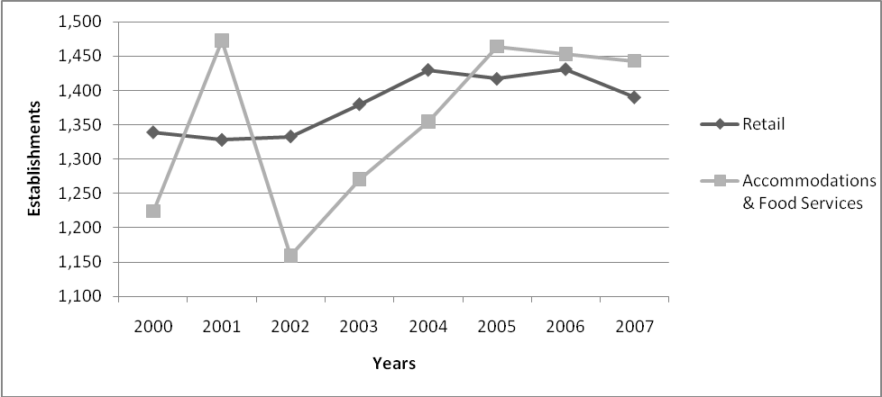
Source: http://www.census.gov/econ/cbp/index.html
Number of Establishments with 1-4 Employees by Sector in CB3 (2000-2007)
 | RETAIL | ACCOMMODATIONS & FOOD SERVICES
Year | Establishments with 1-4 Employees | Establishments with 1-4 Employees
2000 | 825 | 662
2001 | 823 | 860
2002 | 815 | 570
2003 | 854 | 654
2004 | 923 | 729
2005 | 909 | 819
2006 | 916 | 791
2007 | 860 | 727
Source: http://www.census.gov/econ/cbp/index.html
Retail and Accommodations & Food Services Establishments
(1-4 Employees in CB3 2000-2007)
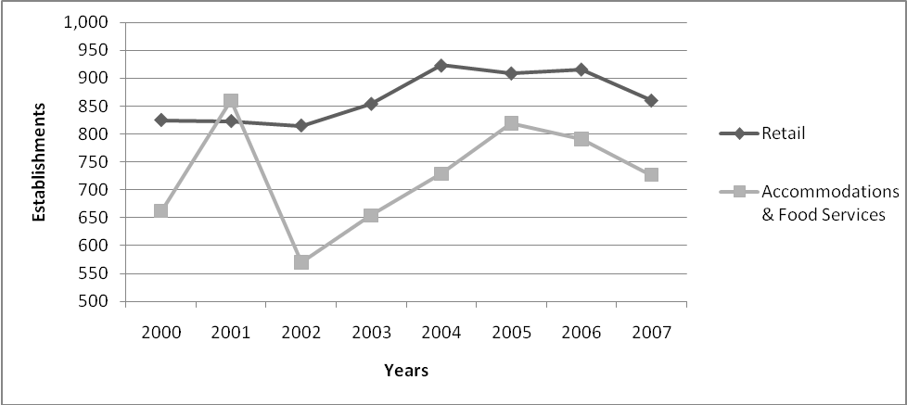
Source: http://www.census.gov/econ/cbp/index.html
Notes: Data for Retail Industry and Accommodations & Food Services sectors were obtained from the North American Industry Classification System (NAICS) and the Zip Code Business Patterns available on the U.S. Census website: http://www.census.gov/econ/cbp/index.html. Data for Zip Codes 10002, 10003, 10009, and 10038 were used for the area of CB
References
Gordon, M. (1998). A Dictionary of Sociology. New York: Oxford.
Krumme, G. (2005). Shift & Share Analysis. University of Washington, Seattle, Washington. Retrieved from http://faculty.washington.edu/krumme/350/shiftshare.html
Standard Occupational Components for Research and Analysis of Trends in Employment Systems (2002). Shift Share Analysis Narrative. SOCRATES. Retrieved from http://socrates.cdr.state.tx.us/iSocrates/files/ShiftShareNarrative.pdf
U.S. Census Bureau (2002). 2002 NAICS Definition: Sector 44-45—Retail Trade. Retrieved from http://www.census.gov/econ/cbp/index.html
U.S. Census Bureau (2002). 2002 NAICS Definition: Sector 72—Accomodation and Food Services. Retrieved from http://www.census.gov/econ/cbp/index.html
U.S. Census Bureau (2009). County Business Patterns (CBP). Retrieved from http://www.census.gov/econ/cbp/index.html
U.S. Census Bureau (2009). ZIP Code Business Patterns (ZBP). Retrieved from http://www.census.gov/econ/cbp/index.html

Data for Retail Industry and Food & Accommodations sectors were obtained from the North American Industry Classification System (NAICS), County Business Patterns, and Zip Code Business Patterns available on the U.S. Census website: http://www.census.gov/econ/cbp/index.html. Data for Zip Codes 10002, 10003, 10009, and 10038 are used for the area of CB3. For definitions of Retail and Food & Accommodations sectors, please see Appendix A and Appendix B.
Although Shift-share Analysis is often used to examine employment data, it has been adapted for purposes of this document to analyze data regarding industry growth by number of establishments.

