9th Street

Business Owner/Manager Survey

A Survey of Businesses along 9th Street
between 1st & 2nd Avenues

Paulo H. Lellis
Community Board 3 Urban Planning Fellow
April 19, 2010

TABLE OF CONTENTS

Executive Summary 3

Methodology 4

Business Characteristics 5

Problems for Business Owners/Managers 6

Problem Rankings 8

Concentration of Businesses 9

Rents & Leases 10

Final Comments 11

Survey Form 12

References 13

EXECUTIVE SUMMARY

The 9th Street Business Owner/Manager Survey was conducted in the area between 1st and 2nd Avenues with the purpose of gathering information on the concerns of owners and managers of retail businesses and other businesses in the community. The survey was developed with input from the Community Board 3 Economic Development Committee Chairs, Pearl Chin and Richard Ropiak, District Manager Suzan Stetzer, and Urban Fellow Paulo Lellis.

The purpose of this document is to report the results of the survey and the answers to questions regarding business characteristics, the problems faced by business owners/managers, concentration of businesses, rents, and leases. The survey revealed the following information:

- Business Characteristics
- The average number of years that businesses on 9th Street have been in operation is 13 years (Based on 27 responses)
- The average number of years that the businesses have been at their current location is 11 years (Based on 27 responses)
- The average number of employees is 3 (Based on 27 responses)
- Ranking of Problems Faced By Business Owners/Managers
(Based on 19 responses of owners/managers who answered all four questions regarding problems faced by businesses)¹
- Taxes
- Utility costs
- Vacant storefronts
- Difficulty getting loans
- Concentration of Businesses
- Most respondents perceived a concentration of businesses in the neighborhood (Based on 25 responses)
- Most respondents rated a concentration of businesses as very important and extremely important to the wellbeing of their businesses (Based on 24 responses)
- Rents & Leases
- The average length of a lease is 5 years (Based on 18 responses)
- The average monthly rent is $3,803 (Based on 13 responses)
- The average square feet of a commercial space is 614
(Based on 16 responses)

By highlighting the results of the 9th Street Business Owner/Manager Survey, this document seeks to provide information to the Economic Development Committee of CB3 regarding area businesses.

¹Percentages reported in individual question responses (Figures 3 – 6) differ from percentages used for ranking the problems (Figure 7) due to a difference in the number of responses. The ranking is based on respondents who answered all four questions regarding business problems. Please see page 8 for details.

METHODOLOGY

This section of the document outlines the development of the survey and its questions, the choice of location, and how the 9th Street survey of business owners/managers was conducted.

The survey was developed as a result of efforts by the Economic Development Committee of CB3 to gather information on businesses and the concerns of business owners/managers.

The location for the survey, 9th Street between 1st and 2nd Avenues, was selected by the Chairs of the Economic Development Committee, Richard Ropiak and Pearl Chin, and District Manager Susan Stetzer. The survey was drafted by Urban Fellow, Paulo Lellis.

A total of 11 survey questions were selected by the Chairs of the CB3 Economic Development Committee, the CB3 District Manager, and the CB3 Urban Fellow from a series of New York area surveys. The surveys/studies from which these questions were drawn include Lower East Side Merchants: Will they Survive the Malls, Martinis, and Media Hype, by Two Bridges (2009); NO GO for Local Business: The Decline of the Lower East Side’s Small Business Identity, by Good Old Lower East Side (GOLES) and the Community Development Project of the Urban Justice Center (2008); Saving the Mom & Pops: Ten Ways to Support Small Independent Retail Stores and Keep Manhattan Vibrant, by the Manhattan Borough President’s Office (2009); Encouraging Small Business Success in New York City and Northern New Jersey: What Firms Value Most, by the Citizens Budget Commission and the Federal Reserve Bank of New York (2005); and Out of Business: The Crisis of Small Businesses in Rezoned Downtown Brooklyn, by Families United for Racial and Economic Equality (FUREE) and Community Development Project of the Urban Justice Center (2008). Please see page 12 for the survey form.

Between February 22 and March 22 of 2010, the Urban Fellow visited 43 business establishments along 9th Street between 1st and 2nd Avenues and surveyed business owners/managers. Of the 43 businesses visited, 28 surveys were returned indicating that the surveys had a response rate of 65%. There were varying response rates for individual questions. The survey results were analyzed between February 22nd and April 4th of 2010 and are presented in this document.

Thus, through of the work of the CB3 Economic Development Committee Chairs, the CB3 District Manager, and the CB3 Urban Fellow, a neighborhood location was chosen to be surveyed, questions were drafted, and the survey was conducted.

BUSINESS CHARACTERISTICS

Questions 1 and 2 of the survey asked business owners/managers the number of years that their particular businesses have been in operation and the number of employees at the establishments. Question 1 of the survey specifically asked about the number of years that the respondent’s business has been in operation. The survey revealed that out of the 27 individuals that responded to this question, the average number of years of operation is 13 years with a median of 12 years (Figure 1). The average number of years of operation for businesses at their respective locations is 11 years and the median is 8 years. The difference between the average number of years and the median number indicates that some businesses which have operated at their current location for a long period of time increased the average number.

“I would hire more employees, but I can’t”
-9th Street business owner

FIGURE 1

How long has your business been in operation? At this location?
Length of Operations
 | Years of Operation | Years of Operation at this Location
Average | 13 years | 11 years
Median | 12 years | 8 years
Number of Responses | 27 | 27
Question 2 inquired about the number of employees for each business. The survey revealed that out of the 27 business owners/managers that responded, the average number of employees is 3 while the median number is 1. The average number is larger than the median because some businesses hire a larger number of employees (Figure 2). Thus, years of operation and number of employees are two characteristics affected by longstanding businesses and those with more employees.
FIGURE 2

Employees
 | Number of Employees
Average | 3
Median | 1
How many employees does your business have?

Number of Responses = 27

PROBLEMS FOR BUSINESS OWNERS/MANAGERS

Questions 3 – 6 of the survey asked how much of a problem vacant storefronts, difficulty getting loans, taxes, and utility costs are for the business owners/managers on 9th Street. Business owners/managers were asked to rate these concerns on a scale of 1 to 5, where 1 is considered, “Not a problem,” 2 is a “Slight problem,” 3 is “A problem,” 4 is a “Large problem,” and 5 is a “Serious problem” (Figures 3 – 6). Based on the percentage response in each category, the results of the survey revealed that the most pressing concerns in order most important to least important are taxes, utility costs, vacant storefronts, and difficulty getting loans (Figure 7). Please note that Figures 3 – 6 contain results for questions that have a varying number of responses as opposed to the ranking in Figure 7, which is based on the 19 responses of people who answered all four questions. This affects the percentage results reported in Figures 3 – 6 and these percentages may not directly correspond with the ranking based on 19 responses. Please see page 8 for further details.

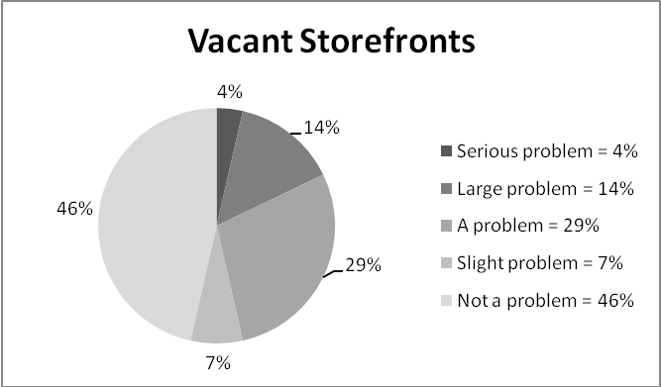
How much of a problem are vacant storefronts for your business?
Number of Responses = 28
The results show that while 29% of respondents considered vacant store-fronts “A problem,” 46% of respondents described it as “Not a Problem.”
FIGURE 3 5

FIGURE 4

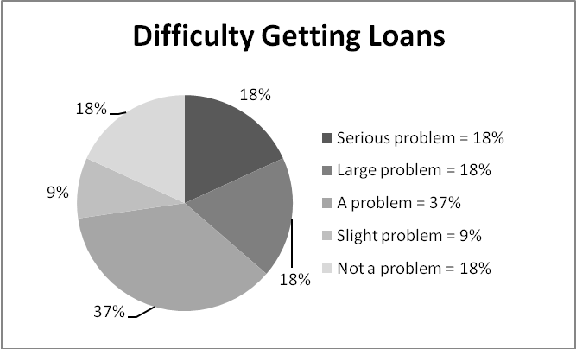
How much of a problem is difficulty getting loans to support your business?
Number of Responses = 22
The results show that 37% of respondents considered difficulty getting loans
“A problem,” and 18% considered it a “Large problem” and a “Serious problem,” respectively.
PROBLEMS FOR BUSINESS OWNERS/MANAGERS

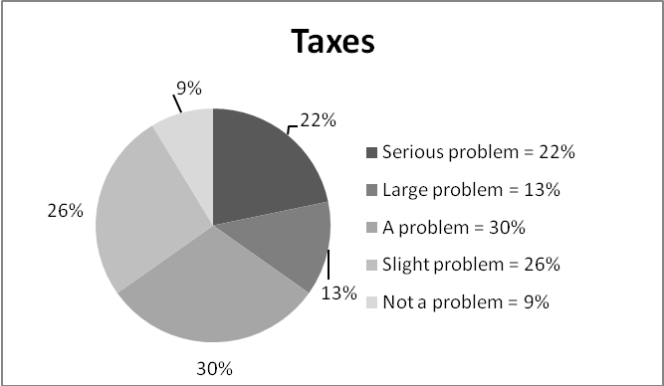
How much of a problem are Taxes for your business?

Number of Responses = 23
The results indicate that 30% of the respondents rated taxes as “A problem” and 22% considered taxes a “Serious problem.”
FIGURE 5

FIGURE 6

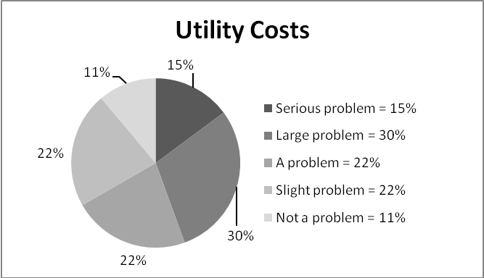
How much of a problem are Utility costs (electric, gas, telephone) for your business?
Number of Responses = 27
The results indicate that 30% of the respondents considered utility costs a “Large problem” and 22% considered it “A problem.”
The responses provided above (Figures 3 – 6) show how business owners/managers ranked the level of severity of each problem. When the responses to specific questions regarding problems are examined in context to each other, they can be used to infer the largest problem for business owners/managers.

“The real estate tax escalation is crushing us”
-9th Street business manager

PROBLEM RANKINGS

FIGURE 7
Problem Rankings | Serious problem | Large  Problem | A  problem | Slight  problem | Not a  problem
1.) Taxes | 26% | 16% | 26% | 26% | 5%
2.) Utility costs | 21% | 32% | 16% | 26% | 5%
3.) Vacant storefronts | 0% | 16% | 42% | 11% | 32%
4.) Difficulty getting loans | 16% | 21% | 37% | 11% | 16%
Based on 19 Responses

Figure7 shows how problems are ranked based on the percentage of responses across a scale measuring the severity of a problem. Along the shaded scale from the category “Serious problem” to “Not a problem,” the table highlights the highest percentage response in each category given that a problem, such as taxes, may not be ranked more than once in the analysis. In order to maintain consistency among the responses, the analysis is only based on the responses of 19 individuals who answered all four survey questions, questions 3 – 6, on vacant storefronts, difficulty getting loans, taxes, and utility costs. Thus, the percentage of responses listed in the table may differ from those reported in Figures 3 – 6.

Based on the percentage of responses in each category, the table suggests that taxes are the major concern for business owners/managers on 9th Street because it had the highest proportion of responses, 26%, under the category “Serious problem.” Utility costs are ranked second due to the fact that it had the highest proportion of responses, 32%, under the category “Large problem.” Vacant storefronts were ranked third as the result of having the largest proportion of responses 42%, under the category “A problem.” Lastly, difficulty getting loans is ranked the fourth concern due to the fact that all other problems had already been accounted for in the rankings before reaching the category “Slight problem.” The category “Not a problem” was not used in the rankings since there were only four listed problems and the analysis progressed from most serious to least serious problem in a 5 category scale.

Thus, the survey results allow one to infer that the major concerns indentified by business owners/managers in order importance are taxes, utility costs, vacant storefronts, and difficulty getting loans.

CONCENTRATION OF BUSINESSES

Question 7 of the survey asked whether business owners/managers perceive a concentration of similar businesses in the neighborhood. Question 8 asked how important is a concentration of businesses to the wellbeing of the business owner’s/manager’s business. A majority of those surveyed reported that there is a concentration of businesses and a majority reported that a concentration is “Very important” and “Extremely important” to the wellbeing of their individual businesses. Figures 8 and 9 display the results.
“The term small business is not accurate for us, we are micro business”
-9th Street business owner

Is there a concentration of similar businesses in your neighborhood?
FIGURE 8
Concentration of Similar Businesses
YES | NO
72% | 28%
Number of Responses = 25

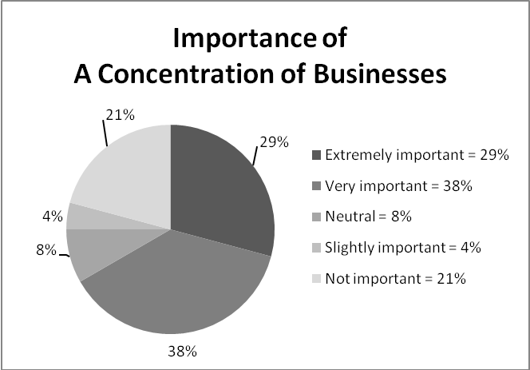
How important is a concentration of businesses to the wellbeing of your business?
38% of the respondents suggested that a concentration of businesses is “Very important” to the wellbeing of their business.
Number of Responses = 24
FIGURE 9

RENTS & LEASES

Questions 9 – 11 of the survey asked about commercial rents, length of leases, owner/manager confidence that he/she will obtain an affordable lease, and the size of the establishments. The survey showed that all 25 respondents to question 9 reported that they rent their commercial spaces. Out of a varying number of responses, the survey revealed that the average lease is 5 years, the average rent per month is $3,803, and the average square feet of an establishment in the survey area is 614. Lastly, out of 27 respondents, a majority reported that they were “Not confident” and “Not at all confident” that they would obtain an affordable lease in the future. The results are shown in Figures 10 – 12.

FIGURE 10

Commercial Space
Is this commercial space owned or rented?
Owned | Rent
0% | 100%
Number of Responses = 25
FIGURE 11

Lease, Monthly Rents, Square Feet, & Yearly Rent Per Month
 | Lease | Rent Per Month | Square Feet | Yearly Rent Per Square Foot
Average | 5 years | $3,803 | 614 | $76.32
Median | 5 years | $4,000 | 600 | $82.29
Responses | 18 | 13 | 16 | 11

In the future, how confident are you that you will obtain an affordable lease?
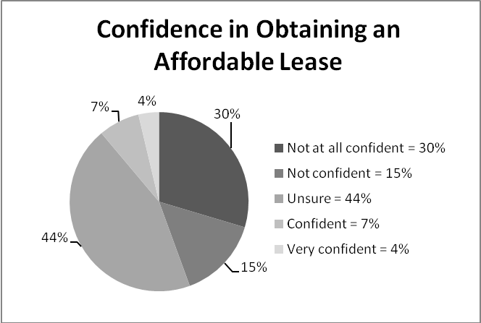
FIGURE 12
44% of business owners/managers reported being “Unsure” of whether they will obtain an affordable lease and 30% reported being “Not at all confident” on the issue.
Number of Responses = 27

FINAL COMMENTS

The purpose of the 9th Street Business Owner/Manager Survey, which covered the area between 1st and 2nd Avenues, was to gather information on retail businesses and other businesses in the community. This document reported the results of the survey which focused on the characteristics of the businesses, the problems faced by business owners/managers, concentration of businesses, rents, and leases.

In respects to the characteristics of the businesses, the survey revealed that the average number of years that businesses on 9th Street have been in operation is 13 years, the average number of years that they have been at their current location is 11 years, and the average number of employees is 3 (Based on 27 responses).

The survey also allowed one to make inferences and rank the problems faced by business owners/managers based on the percentage of responses on a five category scale measuring the severity of particular problems. Conducting the analysis by moving across the scale from “Serious problem” to “Not a problem” revealed that the most pressing problems in order of importance are taxes, utility costs, vacant storefronts, and difficulty getting loans (Based on 19 responses).

In regards to a concentration of businesses, the survey revealed that most respondents perceived a concentration of business in the neighborhood (Based on 25 responses). Additionally, most respondents rated a concentration of businesses as very important and extremely important to the wellbeing of their business (Based on 24 responses).

Lastly, the survey addressed rents and leases. The survey revealed that the average lease is 5 years (Based on 18 responses). The average rent per month is $3,803 (Based on 13 responses). The average square feet of a commercial establishment in the survey area is 614 (Based on 16 responses).

Thus, the survey results in this document provide information to the Economic Development Committee of CB3 regarding area businesses.

9th STREET BUSINESSES SURVEY 2010

Please answer the questions below.
(All survey forms are to be manually returned to the surveyor)

1. How long has your business been in operation? _______ years. At this location? _______ years.

2. How many employees does your business have? _______ employees.

On scale of 1 to 5, where 1 is considered “Not a problem,” 3 is considered “A problem,” and 5 is
a “Serious problem,” how much of problem are these things for your business (Circle one choice ONLY):
Not a problem | Slight problem | A problem | Large problem | Serious problem
1 | 2 | 3 | 4 | 5

3. Vacant storefronts?
1 | 2 | 3 | 4 | 5
4. Difficulty getting loans to support your business?
1 | 2 | 3 | 4 | 5
5. Taxes?
1 | 2 | 3 | 4 | 5
6. Utility costs (electricity, gas, telephone)?
1 | 2 | 3 | 4 | 5

7. Is there a concentration of similar businesses in your neighborhood? ___Yes ___No

8. How important is a concentration of businesses to the wellbeing of your business?
Not important | Slightly important | Neutral | Very important | Extremely important
1 | 2 | 3 | 4 | 5

9. Is this commercial space owned or rented? ___Owned ___Rented

QUESTIONS FOR RENTERS ONLY

10. How long is the lease? _____ years. Amount of rent per month? ______ for ______ square feet.

11. In the future, how confident are you that you will obtain an affordable lease?
Not at all confident | Not confident | Unsure | Confident | Very confident
1 | 2 | 3 | 4 | 5
-----------------------------------------------------------------------------------------------------------------------------------------
If you would like to be informed of the results of the survey, please provide your contact information.
Name:___________________________________ Phone :________________________________
Address:_________________________________ Email:_________________________________
References

Citizens Budget Commission, & Federal Reserve Bank of New York (2005). Encouraging Small Business Success in New York City and Northern New Jersey: What Firms Value Most. Retrieved from
http://www.newyorkfed.org/regional/smallbiz_survey.pdf

Families United for Racial and Economic Equality (FUREE), & Community Development Project of the Urban Justice Center (2008). Out of Business: The Crisis of Small Businesses in Rezoned Downtown Brooklyn. Retrieved from
http://www.urbanjustice.org/pdf/publications/oob_31jul08.pdf

Good Old Lower East Side (GOLES), & Community Development Project of the Urban Justice Center (2008). NO GO for Local Business: The Decline of the Lower East Side’s Small Business Identity. Retrieved from
http://www.urbanjustice.org/pdf/publications/Small_Business_report_FINAL.pdf

Manhattan Borough President’s Office (2009). Saving the Mom & Pops: Ten Ways to Support Small Independent Retail Stores and Keep Manhattan Vibrant. Retrieved from http://mbpo.org/uploads/SavingtheMomandPops.pdf

Two Bridges (2009). Lower East Side Merchants: Will they Survive the Malls, Martinis, and Media Hype? Retrieved from
http://www.twobridges.org/images/stories/PDFs/TB_Report.pdf

