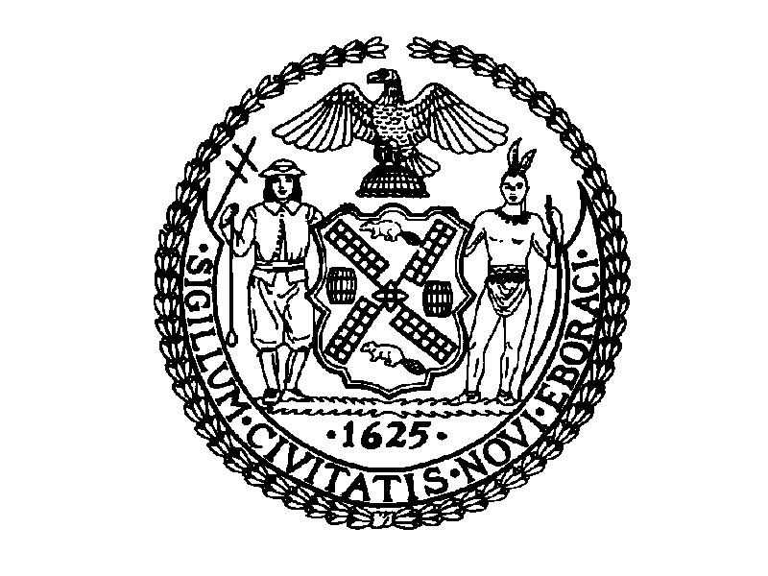
THE CITY OF NEW YORK
MANHATTAN COMMUNITY BOARD NO. 3
59 EAST 4TH STREET - NEW YORK, N.Y. 10003
PHONE: (212) 533-5300 - FAX: (212) 533-3659
WWW.CB3MANHATTAN.ORG - INFO@CB3MANHATTAN.ORG

David McWater, Board Chair Susan Stetzer, District Manager

Community Board No. 3 supports an initial funding allocation to launch the Greening a Block Project as outlined in the attached Implementation Plan for Phase I. This is an 18-month project for which Greening a Block is requesting an allocation of $456,000 from the Con Ed Settlement Fund.

Additional funding, an estimated $418,000 — is expected to be made available from state and federal energy-efficiency programs and from building owners who will benefit from the energy improvements.

CB#3 is requesting consent from all signatories of the settlement funds, Con Edison, NYPIRG, NYS Public Service Commission, and Mayor's Office for re-allocation of the settlement funds.

