Real World Foundation Asthma Free School Zone (AFSZ) Project

Proposal

Measuring Air Quality at 8-10 sites
in Chinatown and the Lower East Side of Manhattan (CB3)

Submitted September 30, 2010

to

Con Edison Task Force
of Community Board #3 Manhattan

by

Real World Foundation
Asthma Free School Zone Project

in collaboration with

Chinese Progressive Association

Contacts:
Stuart Leigh / Rebecca Kalin

Real World Foundation
131 Avenue B #1B
New York, NY 10009
212 460 5361
sleigh64@aol.com
rk@afsz.org

Air Quality Monitoring in Chinatown and the Lower East Side of Manhattan (CB3)

Background: In 2008-10 Asthma Free School Zone (AFSZ), with the support of Manhattan Community Board 3 and Con Edison, conducted a year-long air quality study in the East Village, Lower East Side and areas of Chinatown within CB3. The study revealed that exposure to air pollutants known to cause human respiratory and cardiovascular illness varied within the neighborhoods and were often very high for short periods, and that these exposures are not reflected in community ambient air monitoring conducted by the New York State Department of Environmental Conservation (NYS DEC). Four of the ten study sites exceeded the limits of exposure to PM_{2.5} established by the U.S. Environmental Protection Agency (EPA) to protect public health. Two of those sites were in the East Village and two were in Chinatown. Elevated levels at these sites can be seen in Table 1, which is derived from that study.

This proposal describes plans for evaluating air quality at 8-10 sites in Chinatown in association with the Chinese Progressive Association (CPA). CPA serves residents of Chinatown and the Lower East Side. For the past 15 years, CPA has done education, outreach and organizing in the areas of asthma, air quality, lead poisoning prevention. In 2002, after hearing about high levels of diesel pollution on Canal Street, CPA conducted a survey of over 580 Chinatown households. CPA found that 1 in 5 households had a person with asthma living there and that many of them were diagnosed with asthma after moving to Chinatown.

CPA is currently conducting an air quality and respiratory health survey with residents of Chinatown/Lower East Side. This project will result in a report that will educate residents, as well as community, business and government leaders about the condition of our neighborhood’s air quality and its link to our health. This survey will build and expand upon the asthma survey done in 2002. CPA seeks to better understand not only the extent of respiratory illness in residents but also their exposure to air pollutants. CPA inquired if AFSZ might be able to conduct local air quality monitoring to complement and augment their community survey. AFSZ and CPA have collaboratively developed this proposal and agree that a multi-site air quality study in Chinatown, conducted by AFSZ with the CPA’s assistance, together with CPA’s environmental respiratory health survey, would provide very useful data that may help reveal the extent to which Chinatown residents’ health may be adversely affected by local sources of air pollution.

This proposal will leverage investments in equipment and skills-development that have already been made by CB3-ConEd through the 2008 AFSZ Air Quality study. Under the current proposal, AFSZ will use the same equipment and techniques applied in the AFSZ Air Quality study to measure PM_{2.5} and elemental carbon (a diesel pollutant) at 8-10 sites in Chinatown and the Lower East Side. The findings from this study will provide CPA with more precise information about local air pollution sources and exposures than can be obtained through the NYS DEC’s ambient air monitoring system. The findings may then be geographically correlated by CPA with residents’ survey reports of respiratory health, residents reports of unusual events that may relate to temporary increases in local pollution, and possibly as well with CPA volunteers’ observation logs of diesel traffic at peak and off-peak times of the day and week. Together, the air monitoring results, community surveys and traffic logs will inform CPA and CB3 so that they may be able to develop specific strategies for reducing neighborhood pollution, thereby improving the health of Chinatown’s residents.

Objectives:

- To characterize PM_{2.5} and elemental carbon, an indicator of diesel exhaust, at 8-10 sites in Chinatown.

- To provide training for CPA Project Associates and volunteers so they may become part of the field work team and better understand air monitoring, air pollutants and their corresponding critical limits as they relate to respiratory and cardiovascular health.

- To provide air quality information to CPA that can be correlated with their community health survey data and with peak and off-peak counts of diesel vehicles.

Table 1: Weekly average PM_{2.5} filter samples sorted by distance from northeast corner of CB3.
Red= greater than 35 ug/M3, Orange= 15 ug/M3 to 35 ug/M3, Blue= lowest reading for a week’s campaign.

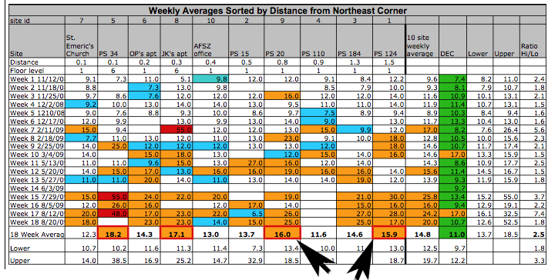

(Arrows show Chinatown/CB3 sites as two of the four sites with the worst air quality - as determined in AFSZ’s 2008-2010 ten-site air quality study. The two sites are PS 20 at 166 Essex Street and PS 124 at 40 Division Street. For full discussion, see page 17 of that study’s Final Report).

Source: Report to CB3 Con Edison Task Force, “Assessment of Air Quality in Various Locations within Community Board 3 Manhattan and Identification of “Hot Spots” That May Adversely Affect Health of CB3 Residents”, Real World Foundation, Asthma Free School Zone Project, July 16, 2010.

Activities:

- Spatial network development: 8-10 monitoring locations, identified with guidance from CPA, will be chosen in areas of Chinatown. The locations will for the most part be in areas where CPA’s survey catchment (zip codes: 10002, 10038 and 10013) and CB3 geographically coincide. Air sampling equipment will be deployed at each location for 4 consecutive weeks to determine concentrations of and variations in PM_{2.5} and concentrations of key chemical constituents, organic and elemental carbon, the latter being an indicator for diesel exhaust.

- Determination of high risk times-of-day: Real-time PM_{2.5} monitors will be paired with filter samplers at 3 locations to determine which times of day have highest exposure risks and determine whether there are excursions revealing very high short-term exposures.

- Evaluation of pollutants and source apportionment: Air filter samples will be sent to a professional laboratory for analysis of PM_{2.5}, organic carbon and elemental carbon. Laboratory results and real-time sampler data will be compared with the NYS DEC’s air quality data collected at its single monitoring site in Chinatown. Compiled data and a preliminary analysis will be delivered to CPA. ASFZ will work with CPA in an advisory capacity as the organization proceeds to address findings.

Methods:

- Network preparation: Permission to install and acquire periodic access to air sampling equipment will be obtained prior to beginning the project from willing individuals and/or businesses. Hard plastic air sampling cases will be customized for each site. New equipment will not need to be purchased. Each case will contain an SKC AirChek XR5000 sampling pump connected via plastic tubing to a Personal Modular Impactor (PMI) to obtain a 2.5 µm particle size cut point for particulate matter sampling. Air will be drawn in through the PMI and onto a quartz air filter. The PMI will be exposed to outdoor air through a 6-inch PVC pipe, protecting the equipment from rain and vandalism.
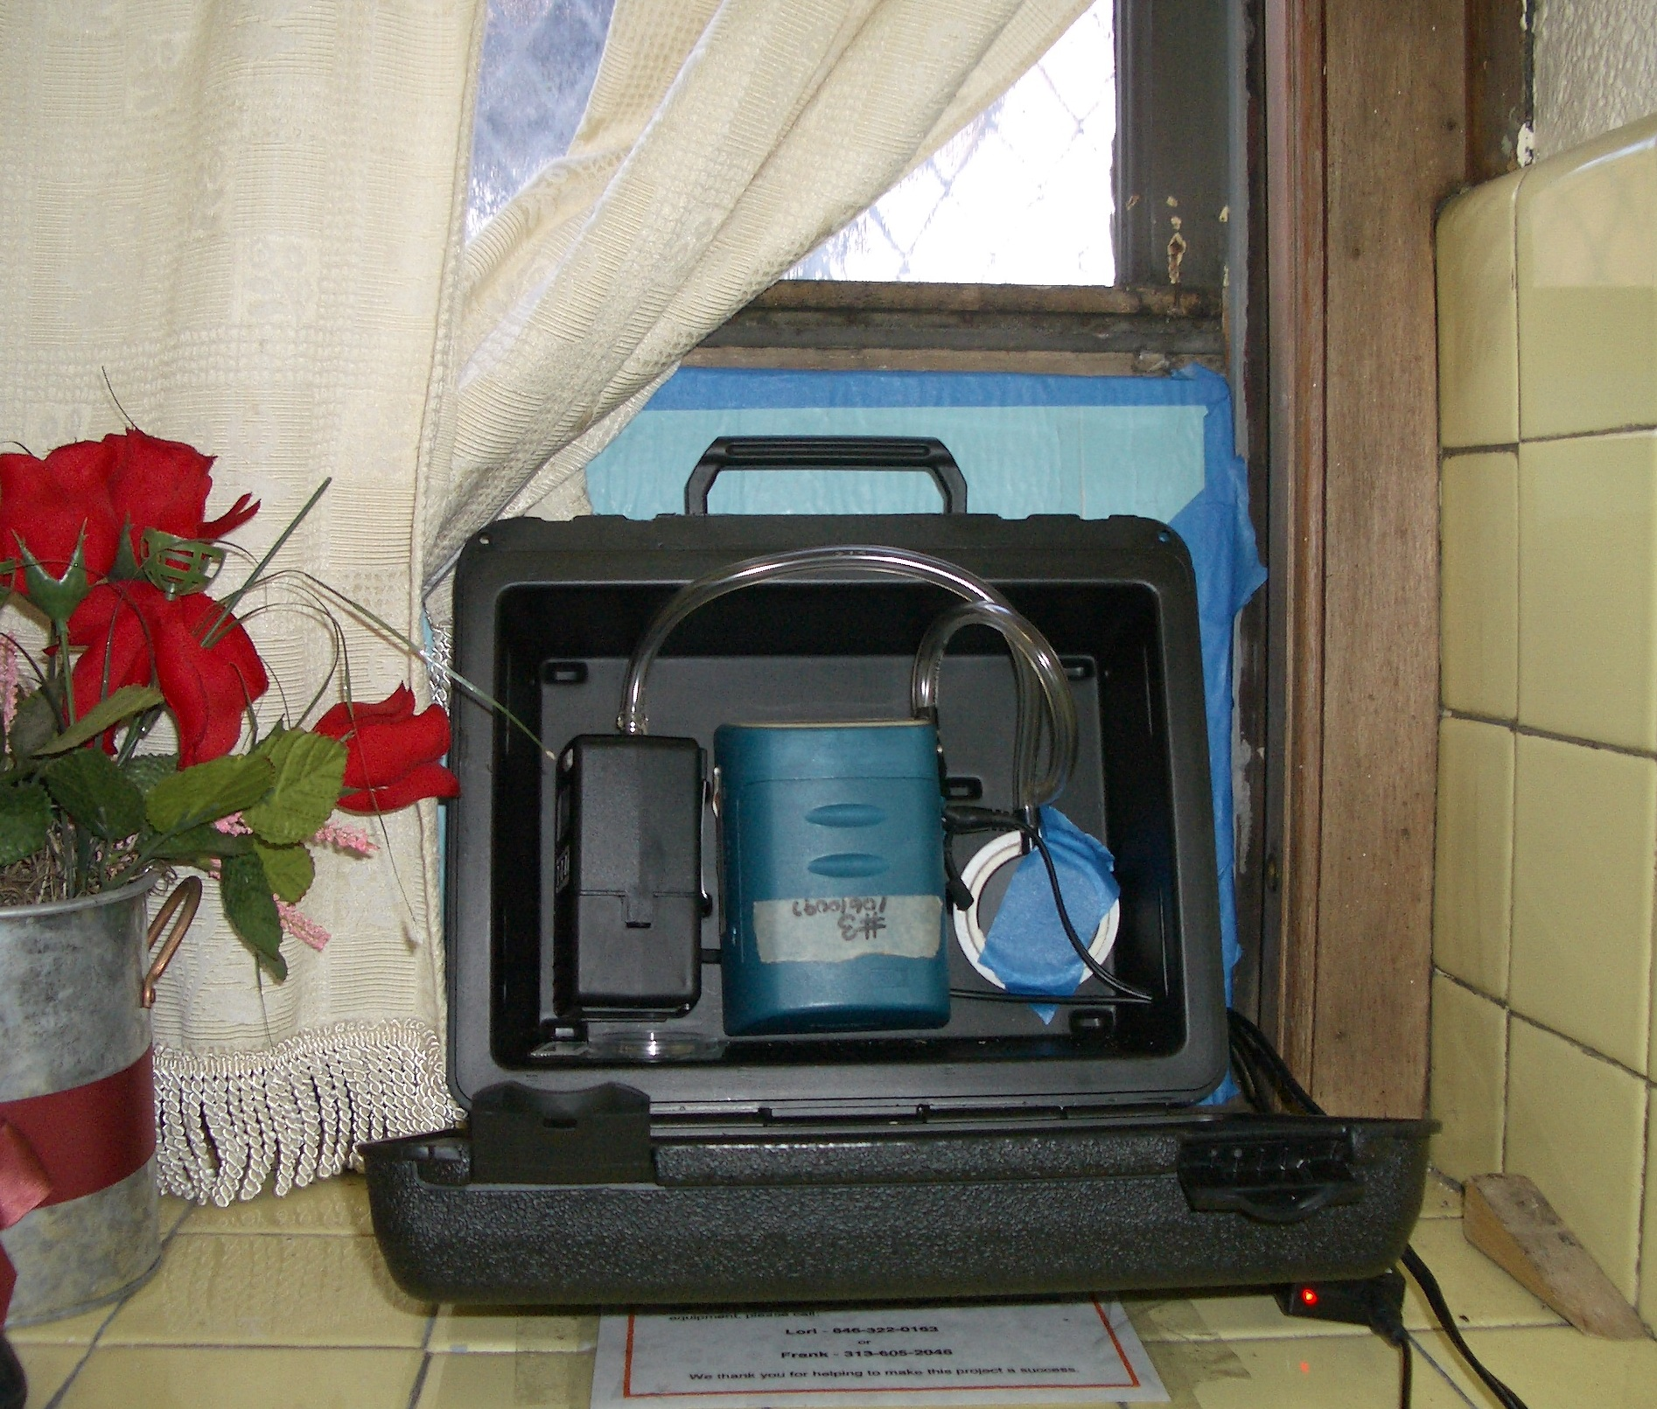
- At three sites a real-time Sidepak air sampler will be installed in the same case alongside the sampling pump. The Sidepak will draw in outdoor air through plastic tubing. The sampling cases will be installed in accessible but secure locations (e.g. behind window bars, on fire escapes) at each monitoring site, which will be identified by CPA. Because results from the previous AFSZ air quality study indicated that exposure levels vary with distance from ground level, at one or more sites we will seek to install sampling cases at two different elevations to determine exposure differentials.
Sampling case with sampling pump (L), Sidepak (C) and PMI (R) installed in window.

- Sampling will be conducted 24/7 for 4 consecutive weeks (real-time samplers may run only every other week due to the limitation of that equipment). Field technicians will visit each site weekly to record equipment run times, collect filters, re-calibrate flow rates, clean equipment, and insert new filters. AFSZ project personnel and CPA Project Associates will conduct weekly site visits. A weekly field log will be employed for quality assurance, and a filter log (chain-of-custody form) will be completed to track all filter-pump combinations.

- As with the earlier AFSZ-CB3 air quality study, collected filters will be sent to a professional laboratory for analysis of PM_{2.5}, organic carbon and elemental carbon. Gravimetric analysis will be performed to assess overall PM_{2.5} mass concentration, in conjunction with sampling flow rate. The laboratory will then use thermal absorption to perform analysis for elemental and organic carbon. AFSZ will perform a preliminary analysis of laboratory and real-time monitoring results to discern variability in concentration of PM_{2.5,} organic carbon and elemental carbon between and among sampling sites.

Institutional Roles:

Real World Foundation, Inc. (RWF): RWF is the 501c3 that manages the Asthma Free School Zone project (AFSZ). RWF will guide the project, providing the equipment and technical expertise to complete the air quality measurement work. RWF will work with CPA to collect data from the 8-10 sites. It will then send data to a laboratory for quantification. RWF will provide summary data to CPA and complete a summary report of measurement to CB3-ConEd. RWF will be the prime grantee for the project and provide financial management.

Chinese Progressive Association (CPA): CPA will identify and employ two Project Associates under this grant to work closely with RWF during a period of approximately 6 weeks. CPA will identify 8-10 sites where air quality monitoring equipment may be installed and then assist RWF in setting up the equipment in those locations. Over a period of four weeks the Project Associates will assist RWF in collecting air quality measurement data from the chosen sites. It may also assist through its volunteers in counting truck traffic. CPA will assist RWF as appropriate in final reporting by providing details of this community-based implementation.

Technical Personnel:

AFSZ/Chinatown Air Quality Project Director: Lori Bukiewicz, MPH, has thirteen years of experience in health education and intervention design and implementation, and four years of experience managing daily field operations and staff training for air sampling projects in NYC school communities.

Senior Consultant: Frank Mirer, PhD, is a professor at Hunter College He is a toxicologist and certified industrial hygienist. His main professional interests are risk assessment and policy in support of safety and health standards, and exposure assessment in the occupational environment. Dr. Mirer delivered testimony before OSHA regarding a dozen health and safety standards, and has testified before House and Senate Committees on occupational safety and health and regulatory policy matters. His primary teaching areas are toxicology, environmental chemistry, risk assessment, safety and health law

Hunter College MPH candidate/intern: Working in association with Dr. Mirer and under the direct guidance of Ms. Bukiewicz, this person, as available, will assist in network preparation and air sampling.

CPA Project Associates: CPA’s current air quality and respiratory health survey is being carried out by the Director, 2 interns and 20 volunteers. The volunteer group is composed of neighborhood residents and concerned individuals, half of whom have relevant experience and training in health education, public health and environmental science. Three of the project members have previously been involved in air sampling projects. CPA will identify and employ two appropriate people to receive training as Project Associates to regularly assist the project in carrying out the proposed site identification, equipment set-up, and weekly data collection/air monitoring activities. Other volunteers may be employed for traffic observations during at least two four-hour periods (one peak and one off-peak) when real-time samplers are deployed and generating minute-by-minute data.

Management:

Real World Foundation (RWF) Executive Director: Stuart Leigh, has been active for over 30 years in the design, implementation, management and evaluation of education and environmental health projects in the US and internationally. He provides leadership in project design and implementation, and in formative and summative project evaluation.

Asthma Free School Zone (AFSZ) Project Director: Rebecca Kalin, MPH, MA, has extensive experience in project and campaign design in the health and education fields, both in the United States and internationally. She is founder and project director of the Asthma Free School Zone.

Chinese Progressive Association (CPA) Executive Director: Mae Lee oversees CPA’s environmental health and justice project. In 2002, she directed a CPA survey project that looked into the prevalence of asthma in Chinatown due to the high volume of traffic on Canal Street. She was a board member of Community Toolbox for Children’s Environmental Health from 2004-2006 and is a board member of the New York City Coalition to End Lead Poisoning. She also represents the Chinese Progressive Association at the Chinatown Working Group (CWG), a community based planning initiative and co-chairs CWG’s immigrant affairs/social services task force.

Budget:
Laboratory Analysis | $2,980
Equipment & Supplies | $1,600
RWF Personnel | $6,560
CPA Project Associates | $800
CPA Site Fees | $250
Total Direct Costs | $12,190
Indirect Costs and RWF Benefits | $2,804
Total | $14,994

Appendix 1: Assessment of Air Quality in Various Locations within Community Board 3 Manhattan and Identification of “Hot Spots” That May Adversely Affect Health of CB3 Residents, Mirer, Bukiewicz, Leigh, Kalin, Real World Foundation, Inc, submitted to the Con Edison Task Force of CB3 Manhattan, 07/16/10.
This project will leverage investments already made by CB3 in AFSZ’s 2-year long air quality monitoring study which enabled AFSZ to acquire much of the equipment to be used in the proposed study.

