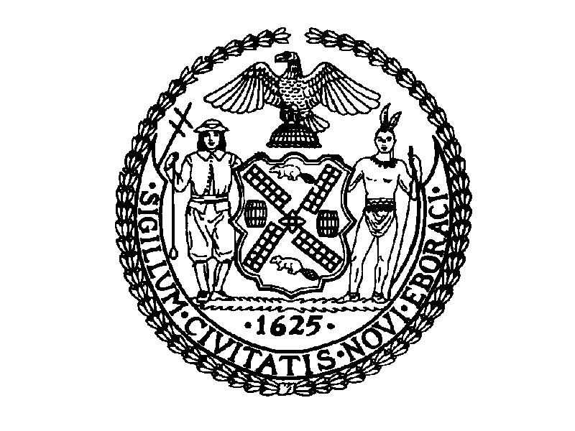
THE CITY OF NEW YORK
MANHATTAN COMMUNITY BOARD NO. 3

59 East 4th Street - New York, NY 10003

Phone: (212) 533-5300 - Fax: (212) 533-3659
www.cb3manhattan.org - info@cb3manhattan.org

Dominic Pisciotta, Board Chair Susan Stetzer, District Manager

Spring / Summer 2011

Dear Block Party Applicant,

The Street Activities Permit Office has an online procedure for applications. Applicants should go online to https://nyceventpermits.nyc.gov . This online procedure will streamline the process for you and will also allow you to check the status of your permits online. Applicants should allow 90 days for the application process -- 30 days for Community Board review and 60 days for SAPO to review.

You should also check the SAPO website for regulations. The Community Board will receive notification of your application on line and will contact you to schedule your application before the committee.

Online application is not mandatory. You may also submit a paper application to the SAPO office. However, the online process will allow for faster issuance of permits. You will receive permits earlier and have the ability to check real time status of permits. This also eliminates traveling to police precincts and community board office for approvals.

Block Party Guidelines:

- Applicant/Sponsor/Promoter
- Applicant/sponsor must be a community-based, not-for-profit organization, association, or the like, which has an indigenous relationship to the specific street for which the event is proposed and which demonstrates that it has the support of the community and is willing to take full responsibility for the conduct of the event. Proceeds of the event should directly benefit this community.
- If a promoter is used, sponsor/applicant must receive at least 45% of the proceeds. Sponsoring organizations must provide residents, businesses, and not-for-profit organizations on the affected block with reduced or free vendor space.

- Application Procedures

- If a block party has been occurring continuously for over 5 years in same location and in the same manner without complaints, the event will be approved by the Community Board without being placed on the committee agenda.
- Block parties that have been occurring for less than 5 years or that have recent complaints will be placed on the Parks Committee agenda for approval. Applicants who do not attend the meeting will be denied for non-appearance. Your Block Party is on the agenda because it has not been occurring for 5 years. If this is a mistake-please notify the office immediately.
- Sound permits are obtained from the local precinct. Permits are restricted to 4 hours.

- Community/Merchant Approval Process
- For blocks that have block associations, applicants who appear before the Parks Committee must provide on letterhead written approval from the block association.
- For locations where there are no block associations, the applicant/sponsor is required to obtain signatures of support from a majority of the residents and merchants on the affected block and submit when appearing at the Parks Committee.

