- CBOs must submit: General Liability Insurance Certificate for $1 million dollars with the policy’s endorsement; proof of: Worker’s Comp, Disability Ins and Broker’s Certification to dycdinsurance@dycd.nyc.gov. See the sample package on DYCD’s website for approved wording.
- If a CBO wants to participate in the Central Insurance Program (CIP), 4.5% of the total budget must be allocated to CIP (CBOs will NOT be required to submit proof of insurance) CIP covers Liability, Worker’s Compensation, Disability and Paid Family Leave Coverage for budgeted staff only.

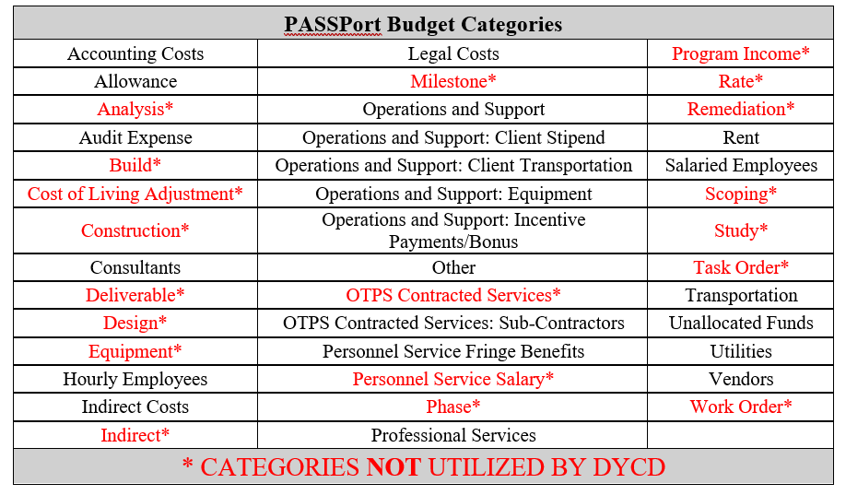
- Accounting Costs: Expenses for financial record-keeping, reporting, and analysis. This includes hiring Accountants and Bookkeepers, accounting software subscriptions, and related expenditures.
- Allowance: Must not be marked as invoiceable. The full amount reflected in the allowance are not funds Providers immediately have access to.
- Audit Expense: Expenses for financial review services, including fees for external auditors, internal audit teams, consulting, and related expenses. Audit Cost Allocation Form is no longer required to be submitted for budget approval.
- Consultants: Consultants may be corporations, nonprofit organizations, or individuals. A consultant hired on a health and human service contract is often a subject matter expert and does not perform or directly deliver a part of the prime contractor’s programmatic contractual obligations. For each consultant listed on the budget, a copy of a DYCD Consultant Agreement Form along with the consultant’s resume must be submitted.
  - Consultant Agreement Modification Form is required when a CBO is adjusting the amount to a consultant listed on an approved PO (Purchase Order).
- Hourly Employees: Hourly Rate cannot be below the City’s minimum hourly wage of $17.
- Indirect Rate: Must not exceed MOCS approved rate or 10% de minimis. Effective 7/1/19 the City of New York has adopted a Health and Human Services Cost Policies and Procedures Manual (“Cost Manual”) to provide uniform cost rate guidance for health and human service contracts.. For Discretionary contracts, Providers are capped at a rate of 10%. The correct Item Category is "Indirect Rate".
- Legal Costs: Legal costs cover expenses for legal services vital to ensuring compliance, risk management,
and protection of organizational interests. Funds cannot be used for litigation expenses, legal settlements, or legal judgments.
- Operations & Support: Consumable supplies, background checks, and facility safety inspections. The cost of waste and recycling removal services, costs for facilities and building maintenance. Other costs are recruitment materials such as flyers, newspaper, and online advertisements for Participants. Costs of General Liability, Property, and Other Insurance charged to a DYCD contract; costs of vehicle insurance associated with the DYCD contract.
- Operations & Support: Client Stipends may be included as a part of a training program, to assist a participant in acquiring the skills necessary to obtain employment and to subsequently retain employment. Providers must upload a breakdown and justification.
- Operations & Support: Client Transportation all participant-related travel expenses, e.g., bus trips and local travel, are to be budgeted under this category. Bus companies used for transporting participants must be insured.
- Operations & Support: Equipment computers, including software maintenance, service contracts, rental & licensing fees for office equipment, furniture, cameras, printers. etc., The CBO must list all items to be purchased in the "budget line-item" column. Approved Vehicle Purchases should be budgeted to the equipment line.
  - Allocations to Operations and Support: Equipment:
Click the Quantity text field and enter the number of items being purchased Click the Unit Price text field and enter the Unit price of the item.
Setting the Unit Price to reflect the per item cost is required for your indirect rate to be calculated accurately.
The description of the item being purchased is required in Budget Line Item
Budgeted Amount will reflect the total be allocated to the PO (Qty x Unit Price)
- Operations & Support: Incentive Payments/Bonus: means money or a money equivalent or something with value used to incentivize program participation are for participants of the Program only and cannot be paid to staff or volunteers. Providers must upload a breakdown and justification.
- Other: Any allocation that cannot be placed in defined budget categories. A detailed explanation must be provided.
- OTPS Contracted Services: Subcontractors may be corporations, nonprofit organizations, or individuals. A subcontractor agreement is required for every subcontractor listed.
  - Subcontractor Agreement Modification Form is required when a CBO is adjusting amount to a subcontractor listed on the approved budget.
- Personnel Services: Fringe Benefits amount must be listed if a CBO is allocating funds to salaries.
  - Fringe Benefits – minimum rate 8.25% (7.65% to cover FICA and .60% MTA tax) and maximum rate 35%of Salaries (may include Worker’s Compensation, Disability, Unemployment Insurance, Medical, Life & Pension Benefits)
  - If a CBO is utilizing the services of the Fiscal Agent (YMS), who is responsible for CBOs accounting, the minimum Fringe Benefit Rate of 13.25% of salaries must be allocated.
  - If a CBO is not allocating funds for Fringe Benefits, a letter stating that the CBO will take the responsibility for paying Fringe Benefits must be included with the budget.
- Professional Services: Allocations for AmeriCorps or City Year must be budgeted to this category.
- Rent: Space costs include expenses associated with paying for space necessary for the operation of a Program.
  - CBO must submit a Space Cost Allocation (SCA) form that outlines how the cost was calculated based on square ft usage, floor plan, a copy of a current Lease/DOE Permit and SCA attestation. If a CBO is paying mortgage, they must submit a copy of the Mortgage Statement. CBOs can charge for building maintenance and must attach a breakdown of maintenance fees & complete a Space Rental Form.
- Salaried Employees: The Annual Salary must reflect the staff member’s total yearly earnings, not just the portion that’s allocated to the contract. The Personnel Services Allocation Form must be uploaded to ensure budget approval.
- Transportation: Transportation costs refer to costs incurred for local travel by the employees conducting official business related to the DYCD contract.
- Unallocated Funds: Providers do not have access to these funds; therefore, it should not be marked invoiceable.
  - The only categories allowed under Unallocated Funds are: Central Insurance Program (CIP), Van Maintenance, Vehicle Purchase (pending approval), Fiscal Agent Services, Subcontractor Agreements (pending approval), Rent (pending Lease agreement), Consultant (pending agreement), Allowance Amendment Funds for migrated contracts.
- Utilities: This category includes costs such as Telephone; Electric; Water/Sewer; Oil-Heating; Gas-Heating; Security Systems; Internet Connectivity; Mobile Phones; Bundled Communication.
- Vendors: A vendor hired on a health and human service contract provides non-programmatic services or goods.

