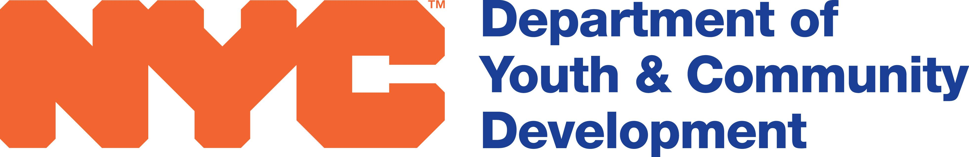
FY 2021 Subcontractor Agreement Modification
(use for adjusting amount owed to subcontractor only)

CONTRACTOR |  |  |  | DYCD ID #
SUBCONTRACTOR NAME |  | EIN:
ADDRESS
 |  | City | State |  | Zip Code
AMOUNT TO BE ADJUSTED:
REASON FOR ADJUSTMENT:
Schedule (for each City fiscal year of the Agreement):
 | Budgeted | Actual
Service Period Start and End Dates
No. Hours per Day
No. Days per Week
No. Weeks per Year

Budgeted Hours/Days/Weeks |  | X | Rate | $ | = | Budgeted Amount | $

Actual Hours/Days/Weeks |  | X | Rate | $ | = | Actual Amount | $

I ______________________ hereby certify that this modification adjusting the hours/days/weeks worked by _______________________(Subcontractor) accurately represents what was worked and what is owed to this Subcontractor.

__________________________________________________ *Notary Public*
Executive Director/Authorized Signatory Date State of ___________
County of_________
This _____ day of _________________________________________________ ___________20___
Print Name and Title

__________________________________________________ *Notary Public*
Subcontract/Authorized Signatory Date State of ___________
County of_________
This _____ day of _________________________________________________ ___________20___
Print Name and Title

