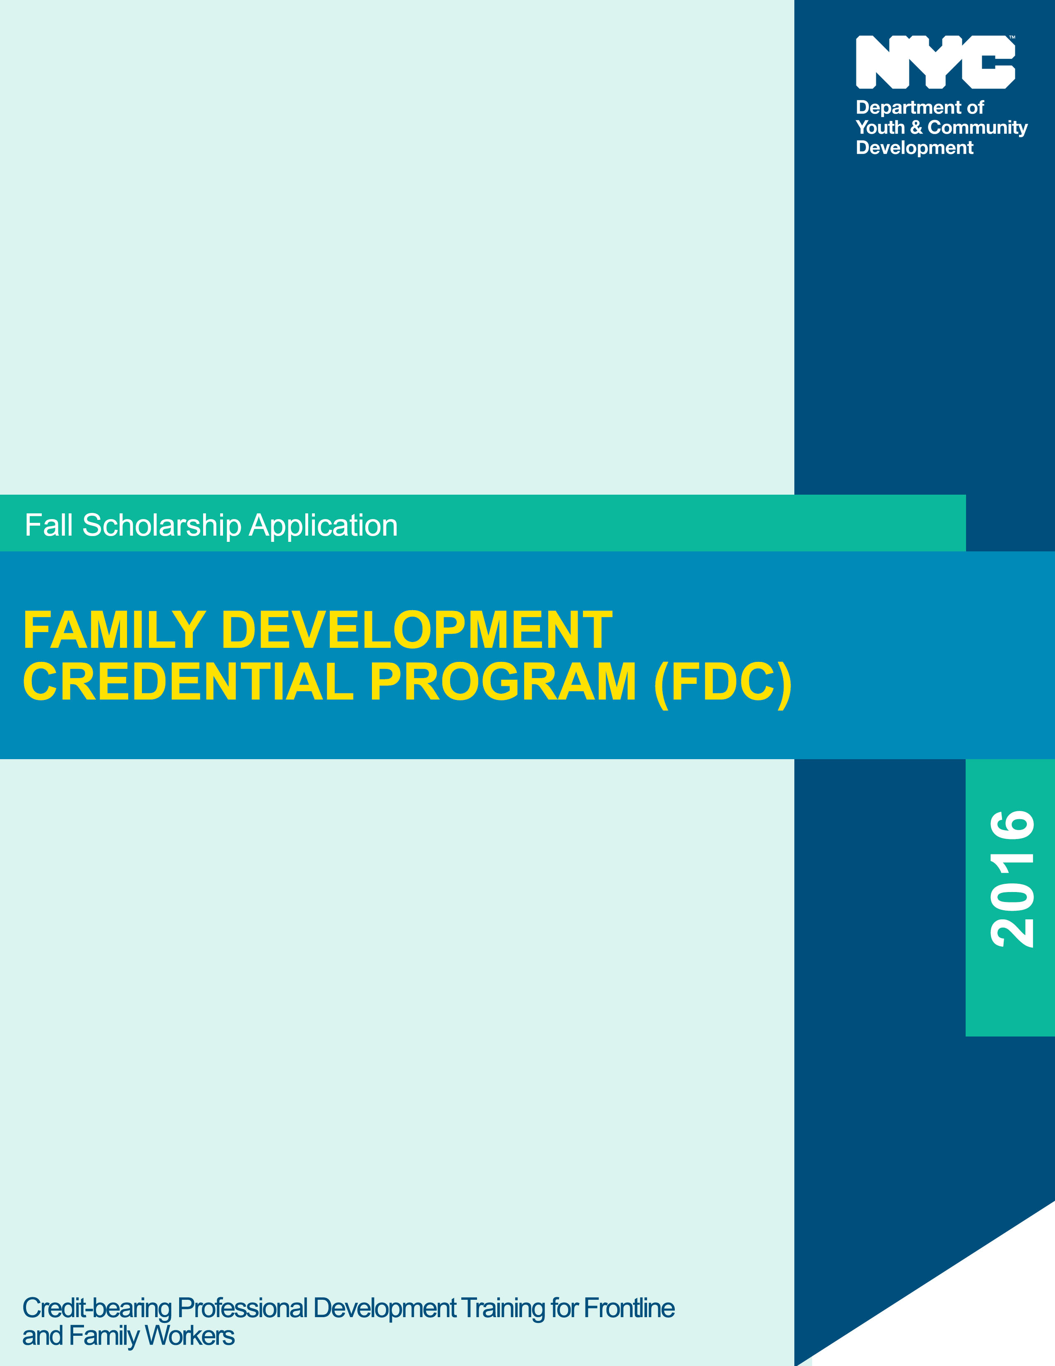

Welcome to the Family Development Credential Program (FDC)

Thank you for your interest in the Family Development Credential Program (FDC). This booklet contains the FDC Scholarship Application Form, as well as important information about FDC, including the curriculum, professional development benefits, and scholarship eligibility requirements.

The Family Development Credential Program (FDC) for frontline and family workers is a 90-hour intensive National professional development training which emphasizes empowerment and family support as a way of redirecting how health, education, and human services are delivered to families. The family development training curriculum was developed by the National FDC Program at the University of Connecticut.

The New York City Department of Youth and Community Development (DYCD) offers competitive scholarships to selected applicants which cover the full cost of the training. There is a growing network of credentialed workers in New York State and nationwide. Presently, there are over 6,500 credentialed workers in New York State and over 11,500 nationwide. (Other states that offer the FDC program include: Alaska, Arkansas, California, Colorado, Connecticut, Florida, Georgia, Illinois, Kentucky, Massachusetts, Missouri, New Jersey, North Carolina, Pennsylvania, Texas, Virginia and the District of Columbia.)

By participating in FDC, you are taking an important first step towards helping your organization to strengthen the skills of its staff, thereby enabling the families and individuals that you work with to set and reach goals of healthy self-reliance. Here are just a few of the ways that FDC benefits workers, families, and organizations:

- Workers develop effective skills in coaching families and individuals to set and reach goals of healthy self-reliance. Workers can use clock hours toward renewal requirements and certifications for Credentialed Alcohol and Substance Abuse Counselors (CASAC), NYS School Age Care Credential (SACC), and more. Additionally, Workers will be eligible to receive college credit upon earning their FDC credential.

- Families and individuals who work with FDC credentialed workers are better able to recognize their strengths, set goals and develop the capacity to solve problems.

- Organizations increase their resources, opportunities to collaborate, and enable workers to feel motivated and validated.

If you have questions, or need additional program information, please contact Rhodesia Humphrey, Deputy Director, Capacity Building, at 646-343-6224, or CB-FDC@dycd.nyc.gov, or rhumphre@dycd.nyc.gov.

1

SECTION 1 – The Family Development Credential Program (FDC) Curriculum

The FDC curriculum consists of interactive classroom study, facilitated by a certified FDC instructor, and an additional 10 hours (minimum) of small group instruction on portfolio development. The portfolio, which each student develops under the guidance of a portfolio advisor, enables workers to demonstrate their knowledge and understanding of the lessons learned in class through application of the FDC concepts at their work sites. (Students should expect to spend an additional 2-3 hours per week individually on the development of their portfolio.)

How do I earn the credential?
In order to be eligible to receive a credential from the University of Connecticut, students must meet the attendance requirements, complete all class work and portfolio assignments and requirements, and pass a multiple choice exam.

What topic areas are covered in the training (The curriculum was revised in 2015, to include new and updated topic areas.)
- Family Development: A Sustainable Route to Healthy Self-Reliance
- Communicating with Skill and Heart
- Presence and Mindfulness: Cornerstones of Healthy Relationships
- Taking Good Care of Yourself
- Our Diverse World
- Strengths-based Assessment
- Helping Families Set and Reach their Goals
- Helping Families Access Specialized Services
- Home Visiting
- Collaboration and Community Support

How often do classes meet?
Classes meet one day per week for 16 weeks, at City University of New York (CUNY) campuses and off-site campus locations. (See the Scholarship Application Form for schedules and locations.)

SECTION 2 – FDC Program Requirements
The FDC program is the equivalent of taking a college course. Selected applicants are required to fulfill the program requirements indicated below, in order to be successful in the program and eligible to earn the FDC credential.

- Attend class once per week (on Fridays) for 16 weeks
- Comprehend the FDC curriculum, which is written in English on a 9th grade level
- Meet and communicate with assigned class portfolio advisor, as scheduled

2
- Possess the writing skills needed to complete the portfolio and other assignments
- Complete and submit written portfolio assignments on time
- Read assigned modules in preparation for class/group discussions
- Pass a multiple choice examination
- Possess basis computer skills
- Have access to a valid email address, computer, printer and the internet for the purpose of communication, assignments, and portfolio work associated with the FDC program

What should I consider before applying for FDC?
In addition to the program requirements, applicants should consider the time commitment that is required to participate in the program, as well as the ability to balance the FDC requirements, with work and family.

SECTION 3 – Professional Development Benefits
There are many professional and educational benefits accessible to FDC graduates once they have earned a Family Development Credential. Besides being a part of a growing network of credentialed workers in New York State and nationwide, FDC graduates are eligible to earn:

- Charter Oak College credits issued by the issued by the National College Credit Recommendations Service (formerly National PONSI). For additional information, and to learn about participating colleges and universities that accept CCRS credits, visit www.nationalccrs.org

- Clock hours which can be used toward renewal requirements and certifications for:
- Credentialed Alcohol and Substance Abuse Counselors (CASAC) renewal requirements;
- Credentialed Prevention Professionals (CPP) and Credentialed Prevention Specialists (CPS) certification renewal;
- Runaway and Homeless (RHY) training requirements for youth development and youth issues as required by the NYS Office of Children and Family Services; and
- NYS School Age Care Credential (SACC) license renewal requirements.

SECTION 4 – How to Apply for FDC
Frontline and family workers can apply for the FDC scholarship by: (a) receiving a recommendation from their supervisor; and (b) completion of the scholarship application by both the applicant and their organization. Please note: agency or organization volunteers are not eligible for FDC scholarships.

3

What are the scholarship eligibility requirements?
Frontline and family workers of DYCD-funded and other community-based organizations, non-profits, or designated City agencies located in any of the 43 Neighborhood Development Areas* (NDAs) throughout New York City, are eligible to receive an FDC scholarship. (*NDAs are coterminous with Community Boards. See the list of NDAs below.)

Borough | Neighborhood Development Area/Community Boards
Bronx | 1,2,3,4,5,6,7,8,9,10,11,12
Brooklyn | 1,2,3,4,5,6,7,8,9,11,12,13,14,15,16,17,18
Manhattan | 3,7,9,10,11,12
Queens | 1,3,4,5,7,12,14
Staten Island | 1

Which City Agencies are eligible for scholarships?
Administration for Children Services (ACS), Dept. for the Aging (DFTA), Dept. for Homeless Services (DHS)*, Dept. of Juvenile Justice (DJJ), Dept. of Probation (DOP), and Dept. of Health and Mental Hygiene (DOHMH). (*For DHS only: contact Kimberly Wynn, HR Training Manager, DHS Training Bureau, at (212)361-8553, or kwynn@dhs.nyc.gov.)

What does the scholarship cover?
The NYC Department of Youth and Community Development (DYCD) offers competitive scholarships, which cover the full cost of tuition, credential exam and portfolio review fees. The selected applicant or their organization will be responsible for the cost of course materials (approximately $55). Do not include payment with scholarship application.

What if I do not meet the scholarship eligibility criteria?
Individuals who do not meet the above scholarship eligibility criteria, but are interested in participating in the FDC program should contact Carrie Shockley, Director, John F. Kennedy, Jr. Institute for Worker Education at the City University of New York, 646-664-8233, or Carrie.Shockley@cuny.edu regarding payment options.

4

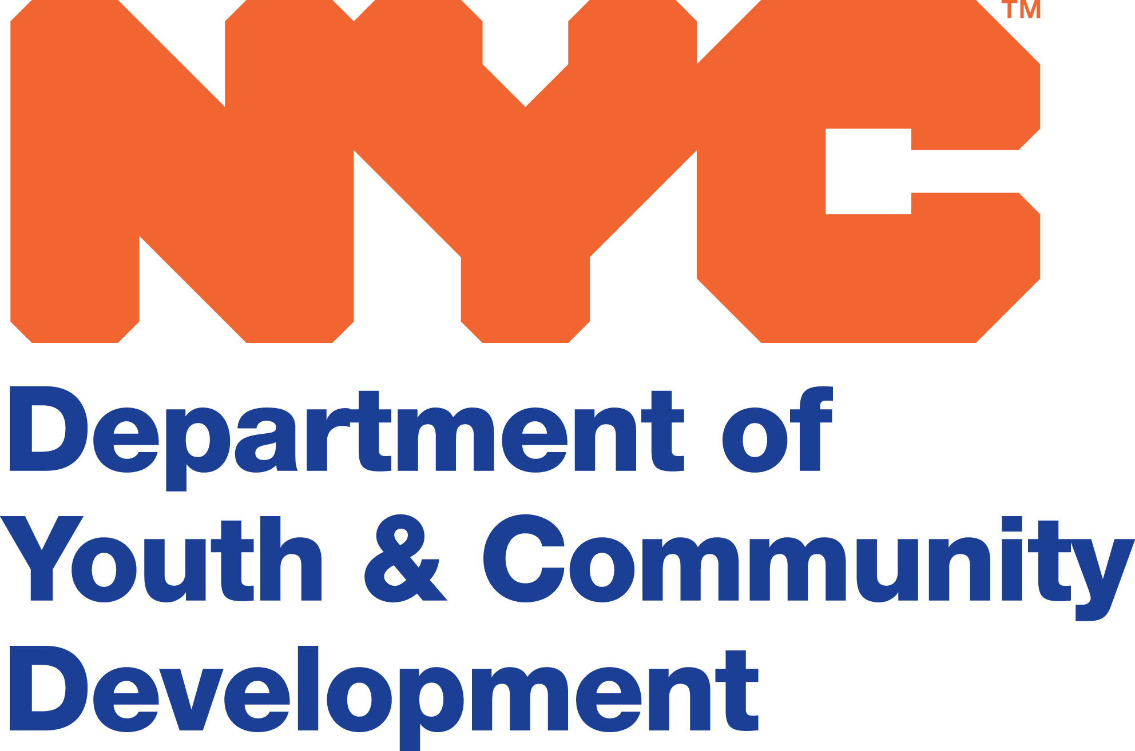

FAMILY DEVELOPMENT CREDENTIAL PROGRAM (FDC)
SCHOLARSHIP APPLICATION FORM

Instructions: This FDC Scholarship Application Form must be completed in order to be considered for the Family Development Credential Program (FDC). There are two sections to the application: Section 1, which must be completed by the applicant; and Section 2, which must be completed by the applicant’s supervisor, and a senior level/management staff person, where appropriate. Please remember that the application process is competitive. We recommend that you read carefully and provide complete and detailed responses to all questions. Responses should be either typed or printed clearly, legibly, and neatly in blue or black ink.

A Complete Application Package Includes:
- Applicant Information (Section 1)
- Campus Selection (Section 1)
- Portfolio Development Work Agreement (Section 1)
- Agency/Organization Recommendation (Section 2)

Application Deadline: July 22, 2016

Applications returned by email should be sent to: CB-FDC@dycd.nyc.gov

Applications returned by mail or in-person should be delivered to:

Attention: Esther Leon
NYC Dept. of Youth and Community Development
2 Lafayette Street – 20th Floor (Capacity Building Dept.)
New York, NY 10007

Notification of Receipt of Application
Applicants will receive an electronic confirmation regarding the receipt of their application, within one week of submission. Confirmations will also indicate whether the application is complete, or requires additional information.

If you do not receive a confirmation within one week of submission, then we have not received your application. Be sure to retain a copy of your completed application for your files. We are not liable, or responsible for lost or misdirected applications.

A-1

Application Number__________

FAMILY DEVELOPMENT CREDENTIALING PROGRAM (FDC)
SCHOLARSHIP APPLICATION FORM

SECTION I: APPLICANT INFORMATION

Instructions: Please complete all questions. Responses should be typed or printed clearly.

Demographic Information

Name: _________________________________________ Title: ______________________________

Home Address: __________________________________________________ Boro: ____________ Zip: _______

Home Phone: ________________________________ E-mail: _____________________________________

Agency/Organization: __________________________________________________________________________

Worksite Address (Applicant’s work location): _________________________ Boro: ____________ Zip: ________

Work Phone: ______________________________________ Fax: _________________________________

Agency Address: _________________________________________________ Boro: ___________ Zip: ________
(If the Agency address is different from worksite address.)
NDA/Community Board#: ______________

Date Hired: ____________________________________ Years in Position: __________________

If you have worked in your current position for less than 3 years, please list your previous work experience. (Include the name of the organization, job title and function.) ___________________________________________________________________________________________

____________________________________________________________________________________________

____________________________________________________________________________________________

____________________________________________________________________________________________

Check the appropriate program area, if your program is funded by the New York City Department of Youth and Community Development (DYCD):  COMPASS  SYEP  Beacon/Cornerstone  RHY  NDA
❑ Other____________

Indicate the name of the City agency, if your program is funded by another City agency (e.g. Dept. of Homeless Service (DHS), the Administration for Children Services (ACS), etc.):_____________________________________

Have you applied for an FDC Scholarship previously?  Yes  No If yes, indicate year____________

A-2

Application Number___________

FAMILY DEVELOPMENT CREDENTIAL PROGRAM (FDC)
SCHOLARSHIP APPLICATION FORM

How did you hear about the FDC?  Co-worker  supervisor  surfing the web  other __________

Check each box to confirm that you have home and/or work access to the following technology for communication, assignments, and portfolio work associated with the FDC program:  Computer
❑ Printer  Internet  Valid email address

Educational Background
Do you have a  High School Diploma  GED, year received? ___________

Are you  currently enrolled; or have you  attended some college;  graduated from college, or other institution of higher education? (If you are currently enrolled, have attended, or graduated, please complete the chart below.)

Name of College, or Institution of Higher Education | Dates of Attendance (Month/Year) | Degree  (e.g., Bachelors) | Major  (e.g., Psychology)

Other DYCD Intensive Training
Have you participated in other DYCD professional development intensive trainings (e.g., HPMI, or Leadership Caucus)?  Yes  No (Please indicate your status below.)
Initiative | Applied | Accepted | Currently Enrolled | Date Completed
 | ❑ | ❑ | ❑
 | ❑ | ❑ | ❑

Applicant Narrative Responses
Provide complete responses for Questions 1-6 below. Attach additional sheets, if necessary.

- Explain what your organization does, including the clients that are served.

______________________________________________________________________________________________

______________________________________________________________________________________________

______________________________________________________________________________________________

______________________________________________________________________________________________

A-3

Application Number____________

FAMILY DEVELOPMENT CREDENTIAL PROGRAM (FDC)
SCHOLARSHIP APPLICATION FORM

- Describe your responsibilities in your current position.

______________________________________________________________________________________________

______________________________________________________________________________________________

______________________________________________________________________________________________

______________________________________________________________________________________________

______________________________________________________________________________________________

- State why you are interested in participating in the FDC program.

____________________________________________________________________________________________

____________________________________________________________________________________________

_____________________________________________________________________________________________

______________________________________________________________________________________________

______________________________________________________________________________________________

- How do you think FDC will benefit you, your organization and the families that you serve?

______________________________________________________________________________________________

______________________________________________________________________________________________

______________________________________________________________________________________________

- Reflecting on your skills and abilities, describe what strength(s) you possess that would make you: (a) a good fit for the FDC program; and (b) successful at completing the FDC program. (Respond to both (a) and (b).)

___________________________________________________________________________________________

______________________________________________________________________________________________

______________________________________________________________________________________________

______________________________________________________________________________________________

A-4

Application Number____________

FAMILY DEVELOPMENT CREDENTIAL PROGRAM (FDC)
SCHOLARSHIP APPLICATION FORM

- Describe a challenging situation where you helped a family, or individual achieve success. (In your written response, include the steps that were taken to help resolve the problem.)

______________________________________________________________________________________________

______________________________________________________________________________________________

______________________________________________________________________________________________

______________________________________________________________________________________________

______________________________________________________________________________________________

Campus Selection

Instructions: Below are the CUNY campuses where the FDC classes will be held during the Fall Semester. Use each column to indicate your first and second choice of the CUNY campus where you would prefer to attend class. Classes meet once a week, for 16 weeks, on the day indicated below. (Schedules vary by campus.)

First CUNY Campus Choice (Select one.) | Second CUNY Campus Choice (Select one.)
- Lehman College (Bronx)  250 Bedford Park Boulevard West  Fridays, September 16, 2016 – January 20, 2017  10:00 AM- 5:00 PM  - New York City College of Technology (Brooklyn) 25 Chapel Street  Fridays, September 16, 2016 – January 27, 2017  9:00 AM – 4:00 PM  - School of Professional Studies (Manhattan)  119 West 31st Street  Fridays, September 16, 2016 – January 27, 2017  9:30 AM – 4:30 PM | - Lehman College (Bronx)  250 Bedford Park Boulevard West  Fridays, September 16, 2016 – January 20, 2016  10:00 AM- 5:00 PM  - New York City College of Technology (Brooklyn) 25 Chapel Street  Fridays, September 16, 2016 – January 27, 2017  9:00 AM – 4:00 PM  - School of Professional Studies (Manhattan)  119 West 31st Street  Fridays, September 16, 2016 – January 27, 2017  9:30 AM – 4:30 PM
For All Campuses – No classes will be held on October 14, November 11, November 25, and December 30. Additionally, for School and Professional Studies and College of Technology only, no classes will be held on December 23, 2016mforchool and Professional Studies and College of Technology only, no classes will be held on December 23, 2016

A-5

Application Number____________

FAMILY DEVELOPMENT CREDENTIAL PROGRAM (FDC)
SCHOLARSHIP APPLICATION FORM

Portfolio Development Work Agreement

Instructions: Please complete and sign the agreement below. (The portfolio is a demonstration of how the student applies FDC concepts at their worksite, based on their knowledge and understanding of the lessons learned. Each student is expected to create a portfolio under the guidance of an advisor.)

I, ___________________________________ of ______________________________understand that I am required
(Applicant name) (Name of organization)

to attend the additional minimum of 10 one-hour sessions of portfolio development with my Portfolio Advisor. (Sessions may occur based on a combination of the following: in-person, by phone, or email) as discussed and agreed upon by me and my Portfolio Advisor.)

Phone: _____________________________________________ E-mail: ____________________________

Signature: ___________________________________________________ Date: _______________________

A-6

Application Number ___________

FAMILY DEVELOPMENT CREDENTIAL PROGRAM (FDC)
SCHOLARSHIP APPLICATION FORM

SECTION 2: AGENCY/ORGANIZATION RECOMMENDATION

This section of the FDC scholarship application must be completed by a senior level/management staff person, and the applicant’s supervisor. A limited number of competitive scholarships which cover tuition, and credentialing fees, will be awarded to those applicants who are accepted into the FDC program. (Please note: DYCD does not cover the cost of the course materials, i.e., books. The applicant or their organization will be responsible for the cost of the course materials.)
This section consists two parts: Part 1: Designated FDC Partner Part 2: Agency/Organization Narrative Responses
FDC students must successfully meet the following criteria in order to be successful in the course and earn the FDC credential.

- Attend class once per week (on Fridays) for 16 weeks
- Comprehend the FDC curriculum, which is written in English on a 9th grade level
- Read assigned modules in preparation for class/group discussions
- Meet and communicate with assigned class portfolio advisor, as scheduled
- Possess the writing skills needed to complete the portfolio and other assignments
- Complete and submit written portfolio assignments on time
- Pass a multiple choice examination
- Possess basis computer skills
- Have access to a valid email address, computer, printer and the internet for the purpose of communication, assignments, and portfolio work associated with the FDC program

Part 1: Designated FDC Partner (a senior level/management staff person, or supervisor)

Participating in the FDC program is a commitment on both the part of the selected applicant and their organization. Once the applicant accepts the scholarship offer and becomes a student in the FDC program, a senior level/management staff person assigned to the role of the Designated FDC Partner, would be expected to: (a) become acquainted with the underlying concepts of FDC; (b) provide feedback via survey, if needed; (c) be responsible for monitoring the applicant’s attendance on a weekly basis; (d) be contacted in case of excessive absences from class or portfolio development sessions; (e) meet with DYCD staff if the applicant does not adhere to the FDC Student Information Guide, if needed. (The FDC Student Information Guide will be distributed during orientation.)

A-7

Application Number ______

FAMILY DEVELOPMENT CREDENTIAL PROGRAM (FDC)
SCHOLARSHIP APPLICATION FORM

Name: ____________________________________________________________________________________

Title: ______________________________________________________________________________________

Agency Mailing Address: _____________________________________________________________________

City: _____________________________________ State: ______________________ Zip: _________________

Phone: __________________________ Fax: ________________________ E-mail: _______________________

Relationship to applicant: _____________________________________________________________________

PART 2: Agency/Organization Narrative Responses (Questions 1-8 below, must be completed by the applicant’s supervisor.)

- Explain how you will support the applicant’s participation in the FDC program.
_________________________________________________________________________________________

__________________________________________________________________________________________

- How long have you worked with the applicant?
__________________________________________________________________________________________

__________________________________________________________________________________________

- Explain why you recommend the applicant for the FDC program.
___________________________________________________________________________________________

___________________________________________________________________________________________

- Based on your knowledge of the applicant’s work performance, what strength(s) does the applicant possess that would make them successful in the FDC program.

_____________________________________________________________________________

______________________________________________________________________________________________

______________________________________________________________________________________________

A-8

Application Number ______

FAMILY DEVELOPMENT CREDENTIAL PROGRAM (FDC)
SCHOLARSHIP APPLICATION FORM

- Explain how the applicant’s participation in FDC will enhance their job skills/work performance.
___________________________________________________________________________________________

___________________________________________________________________________________________

____________________________________________________________________________________________

- Explain how the applicant’s job skills/work performance has evolved during employment /appointment.

______________________________________________________________________________________________

______________________________________________________________________________________________

______________________________________________________________________________________________

- Are there any barriers (e.g., work meetings, projects) that may preclude the applicant from attending the FDC class regularly on Fridays, for 16 weeks? (Consistent attendance is a program requirement.) Yes No Maybe If yes, or maybe, please explain.
______________________________________________________________________________________________

______________________________________________________________________________________________

______________________________________________________________________________________________

- How would you assess the applicant’s ability to handle multiple assignments? (The timely submission of completed portfolio assignments is a key component of the FDC training.)
______________________________________________________________________________________________

______________________________________________________________________________________________

______________________________________________________________________________________________

______________________________________________________________________________________________

_______________________________________________________________________________________________

A-9

