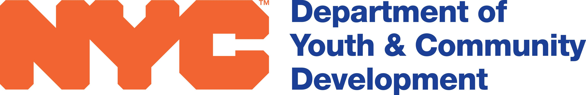

Audit COST ALLOCATION PLAN

Budget Line 3710

DYCD ID#: ________________________

CONTRACT TERM: ________________________

ANNUAL AUDIT COST: ________________________

COST APPLIED TO
DYCD CONTRACT: ________________________

If the audit is for this contract only, you may include the entire cost in this budget.

If the audit is for the entire agency, you may only include DYCD’s proportionate share.

The proportionate share should be calculated by dividing the DYCD budget by the agencies’ total budget and applying that percentage to the total audit cost.

****This is an example****

DYCD Budget $20,000
Agency Budget $100,000
% 20

Audit Cost $1,000
% 20
DYCD Share $200

I hereby affirm that the audit cost has been appropriately applied to this contract.

Executive Director Date

