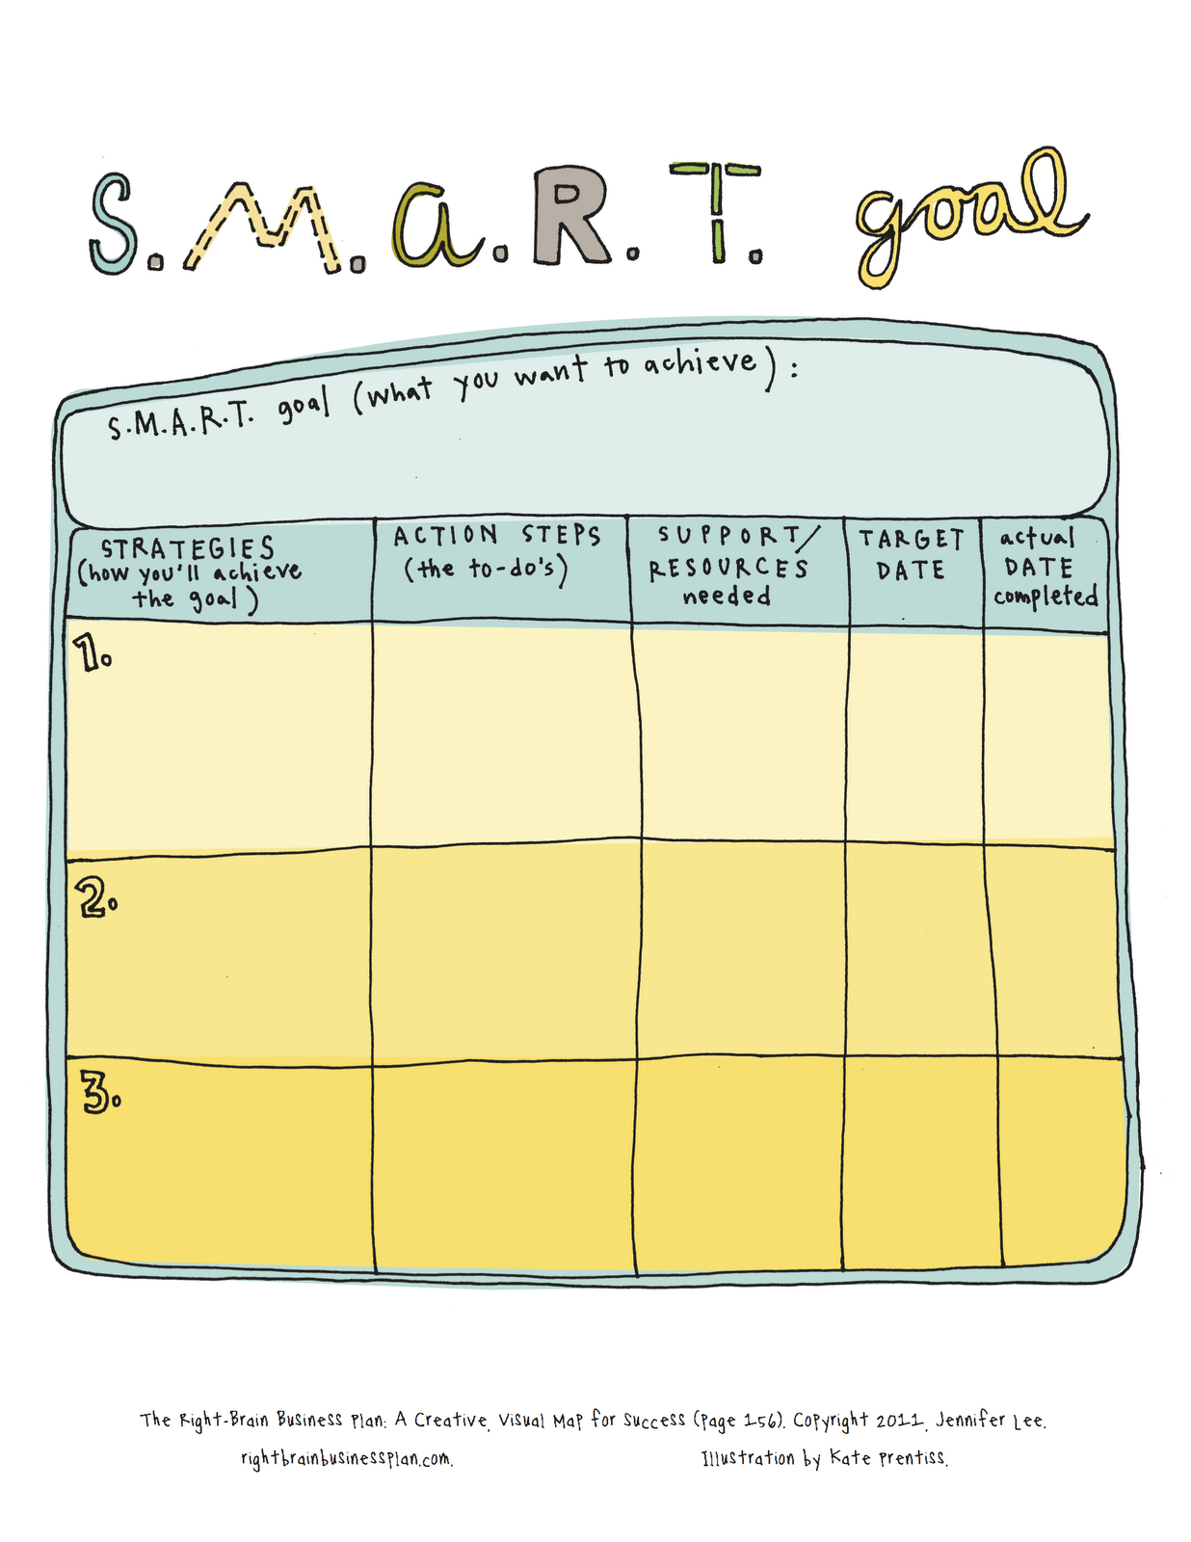

**What is your S.M.A.R.T.S. goal?**

**S**

**T**

**A**

**R**

**M**

**S**

