LIFE-CYCLE COST ANALYSIS AND GREEN INFRASTRUCTURE IN NEW YORK CITY
a NYC Town + Gown project

Research - Christopher Eshleman, Columbia University, School of International & Public Affairs
Advisor – Professor Eva Weissman
7.6.2014

Abstract. Permeable pavement and right-of-way bioswales both capture storm water. They have different upfront costs. They also have different long-term maintenance and replacement costs, and they perform differently under varying volumes of rainfall. The model accompanying this report is designed to help budget managers analyze those costs across time. This will help administrators and policy makers make informed decisions when it comes to choosing between pavement and bioswales.

Page left intentionally blank.

Table of Contents
Introduction and background 5
Life-cycle cost analysis 5
Green infrastructure 6
Methods 7
Units of analysis 9
Location analyzed 10
Analysis period 11
Data and inputs 11
Bioswale 11
Permeable pavement 13
Findings and sensitivity analysis 14
Limitations 14
Recommendations for agencies, policy makers 15
References 17

Page left intentionally blank.

Introduction and background
This project applies life-cycle cost analysis to infrastructure and capital project analysis at the City of New York (City). The City’s design department has shown great interest in helping agencies and budget managers analyze capital projects. Specifically, the department hopes to see managers evaluate capital projects across projects’ expected lifespans, not just based on up-front capital costs.
This project provides a model that can help the City view capital projects across a 30-year time horizon. I have designed the model to easily accommodate an analysis of two specific types of infrastructure. The Bloomberg Administration invested heavily in sustainability while wrestling with the issue of water quality, and this project therefore applies the model’s nuts and bolts to two types of green infrastructure, permeable pavement and bioswales.

Life-cycle cost analysis
The City and at least one sister entity have taken tangible and visible steps toward incorporating life-cycle cost (LCC) analysis into capital planning. Holistic analytical tools such as LCC guide investment decisions to help minimize the City’s operating costs by considering long-run responsibilities, not just up-front capital spending. As put by the Port Authority of New York and New Jersey:
“… [C]osts and benefits are evaluated over a single replacement or rehabilitation lifecycle for major project components. All alternatives must be evaluated over the same period in order to avoid distortions in the analysis. Where the alternatives under consideration have different lives, the longest life should be chosen as a common appraisal period for all alternatives.”
Life-cycle cost analysis is common, and is not limited to any given sector (public, private, academic, et cetera). The State of New York (State) applies LCC, or cost-benefit analysis (closely related), at many levels, as does the federal government. For example, the New York State Department of Transportation follows a published life-cycle costing guide that helps its managers determine whether to build certain individual projects using asphalt, which costs less up front but requires more maintenance, or concrete, which costs more but is durable.
This project follows in the footsteps of group of New York University’s Wagner School of Public Policy students, who built a life-cycle cost model in 2011. The team examined the comprehensive costs and benefits of different design elements in road and streetscape projects, trying to consider life-long costs and external benefits to help policy makers and administrators choose between alternatives during the capital planning process. The guide aimed to help the city’s transportation managers understand how different materials — for example, granite versus concrete — perform, and cost, over time.
This model was built for accessibility and simplicity. Any green infrastructure (GI) specialists from sister agencies at the City, at least those willing to sit at the table and plug in reasonable assumptions — estimates — will be able to easily find and compare life-cycle cost estimates of alternative types of green infrastructure. In the absence of that sort of cross-agency collaboration, other analysts at the City can still use the model to help illuminate the tradeoffs associated with infrastructure decisions.

Green infrastructure
The City is faced with the challenge of managing storm water and, through that, protecting water quality in New York Harbor and its surrounding tributaries. More specifically, it wrestles with the challenge of managing storm water better than in the past. In 2010, the city’s Department of Environmental Conservation shared an aggressive strategy: it would use a number of different techniques to divert storm water away from New York’s sewer system, a so-called “combined” system that carries both sewage and rainwater to a handful of water treatment plants. Heavy rains occasionally overwhelm the system during larger storms and can, in the process, foul harbor water with sewage. This has contributed billions of gallons of sewage entering the harbor on an average year, causing a public health hazard and compromising fragile ecosystems (Columbia, 2011). Administrators refer to these events as combined sewer overflows, or CSOs.
The Department of Environmental Protection (Environmental Protection) plan — the 2010 Green Infrastructure Plan — coincided roughly with a consent order, signed by both City and State environmental authorities, that required the City government to significantly reduce combined sewer overflows or face penalties. More specifically, it also set a target of capturing the first inch of rainfall from impervious areas within combined sewer watersheds during storm events (DEP, 2010).
The plan built atop previous approaches to storm water management that had centered on large and often expensive infrastructure projects, built through traditional public engineering approaches, targeted at reducing CSOs. Those infrastructure projects, local officials had realized, could lack the “sustainability benefits” stakeholders had sought from major public investments. Environmental Protection’s new plan presented:
“[A]n alternative approach to improving water quality that integrates ‘green infrastructure,’ such as swales and green roofs, with investments to optimize the existing system and to build targeted, smaller-scale ‘grey’ or traditional infrastructure.”
While the City has already made significant investments in green infrastructure, it was positioned at the end of 2013 for even more spending. Much would go toward the installation of right-of-way bioswales across eastern New York, work being led by Environmental Protection. Right-of-way bioswales are vegetated pits built at relatively low elevations that collect and retain storm water flowing along adjacent curbs.
The New York City Department of Transportation (Transportation Department) is, along similar lines, installing permeable pavement at a handful of right of way locations. The installations function not unlike, albeit not precisely the same as, a right-of-way bioswale, working somewhat as a sieve — otherwise-standard asphalt or concrete is designed to accommodate small holes that let storm water drain through (Columbia, 2011). The Transportation Department has sought federal aid for green infrastructure pavement projects that would help the City meet its goal of capturing 10 percent of storm water on impervious surfaces in combined sewer overflow areas.

Methods
This research project prepares budget analysts to better compare bioswales and permeable pavement projects in New York City on the bases of:
- Cost, both up front and over time, and;
- Efficiency.
Specifically, it positions budget analysis to conduct cost-effectiveness analysis (CEA), an analytical step similar to cost-benefit analysis. A standard format would hold the benefits of each alternative equal and then compare their respective costs, with the lower cost representing the more efficient (cost-effective) alternative (Boardman et al, 2011). Data limitations compromise that effort, leaving the need for some interpretation of the results — the two projects evaluated here produce different benefits; specifically, one may capture more storm water than the other during larger storms, meaning its relatively higher upfront capital costs must be held in perspective.
The steps referenced below — also discussed in the model document itself — subscribe to and operationalize the foundations of life-cycle cost analysis, which public and private organizations widely use to help compare alternatives in the sphere of public works. The State identifies the following steps in a typical life-cycle cost analysis:
1. Identify alternatives;
2. Determine an appropriate analytical time period;
3. Calculate the costs over time for each alternative;
4. Discount future costs to secure all-inclusive net present values;
5. Test the values to sensitivity against individual variables, and;
6. Use that information to help choose the best alternative.
The centerpiece is a reliance on discounted cash flows for each project alternative. The State refers to this in terms of a “present worth” method of discounting all costs over time — initial construction, ongoing maintenance, rebuilding costs, et cetera — to today’s dollars for ease of comparison. As the State puts it:
“Present worth of a treatment strategy may be thought of as the amount of money that would have to be invested now to fund future treatments when necessary. To account for the time value of money, the present worth method of [life cycle costing] discounts future treatment costs to their worth in today’s dollars. The rate at which future treatments are discounted, or “discount rate,” is the difference between return on public investments (interest) and inflation.”
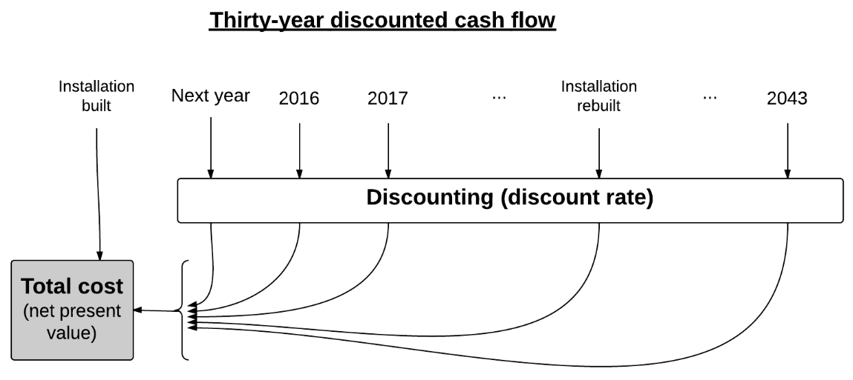

Author’s depiction of the discounted cash flow model used in this project.

The tool anchoring this process is the discount rate, which lets the analyst take benefits or costs across different times and convert them to a single point in time (specifically, today). It’s a process used widely across disciplines. Efforts to identify an ideal discount rate for a given project or at a given time are complex, but the rate often hovers around 4 percent, the rate adopted for the State Department of Transportation’s and the Port Authority’s analyses and the rate used here.,

Units of analysis
The City designs GI installations to suit specific areas — a catchment area, or tributary — where storm water drains toward a low point, the common location for a curb drain. (Physics dictate that rainwater across a given catchment area will flow to those low points.) The City locates its GI installations, such as bioswales or permeable pavement installations, at those points. They will thus capture the most storm water per dollar spent.
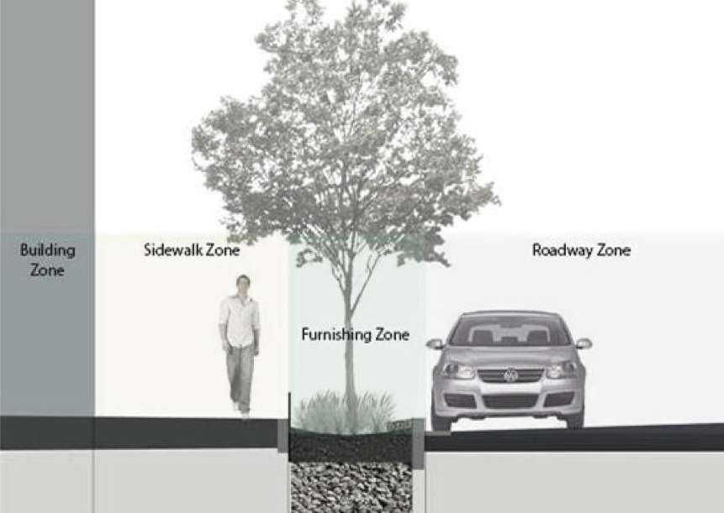
The size of a given catchment area appears to be the biggest determinant as public engineers’ design installations. That is, the design of a given bioswale or pavement installation is determined in large part by the size of a given location’s relevant catchment area. City agencies calculate the appropriate installation size using Microsoft Excel-based “calculators.” Those models appear to be quite similar across agencies, whether the proposed installation in question is pavement or a bioswale. Bioswales are commonly 100 square feet (20 feet long by five feet wide), although the City has built installations of other sizes.
Many of the City’s green infrastructure alternatives focus on water in the right of way. Above, a typical position for right-of-way bioswales. (From NYC DOT, via DEP’s Green Infrastructure 2013 Annual Report.)
The level of storm discussed throughout this project is a one-inch rainfall event — not big enough to compare with major storms, but larger than most. For context, an average year between 1981 and 2010 saw only 14 days of more than one inch of precipitation (Environmental Protection, 2011).

Location analyzed
The model is designed to accommodate any site, but the pilot analysis discussed here focuses on a conceptual site, not a specific installation, compiled using data published by the City or otherwise available from existing projects. It envisions two alternatives — a bioswale with characteristics mimicking those built in 2011 in Brooklyn near the corner of Dean Street and Fourth Avenue, and a permeable pavement project similar to one designed the Queens corner of Linden Boulevard and 204th Street.
The Dean Street bioswale at focus is typical of the City’s recent bioswale design: 20 feet by five feet with a five- to 10-foot deep pit. The handful of bioswales near the Dean Street location were designed to handle 1,870 gallons of storm water each per storm.

The analysis also uses information from recent permeable pavement installations. The Transportation Department installed prefabricated permeable pavement in the winter of 2012 at two intersections in Queens in response to persistent flooding. The installations allowed storm water to seep into the ground within minutes (rain had, prior to the work, been collecting in pools at the intersection’s curbs). The department viewed permeable pavement as a flexible alternative to bioswales that, while limited in applications, appeared to perform well in low-density areas where rainfall pooling had been a problem. The department has also installed permeable pavement in College Point, Queens after receiving a grant.
Maintenance and reconstruction costs are important when analyzing infrastructure options. In the case of right-of-way bioswales and permeable pavement, however, initial construction costs appear to dominate when calculating total costs across the life of each option.

Analysis period
This model prepares agencies to analyze alternatives over a 30-year period of time. This is slightly shorter than the 40-year time frame identified by the State as common practice for analysis of pavement alternatives, but it is still enough time to include one reconstruction event in each alternative.

Data and inputs
The cost components for bioswales and permeable pavement are analyzed at the unit level:
Inputs and sources | Bioswale | Source | Permeable pavement | Source
Initial costs | $38,000 / 100 sq ft | NYC DEP | $72,500 / 160 sq ft | NYC DOT
Annual maintenance | $2.14 / sq ft / year | Portland OR; NYC DPR | $0.40 / sq ft / year | NYC OMB
Replacement | $18,029 after 25 yrs | Portland OR; NYC DDC | $23,604 after 20 yrs | Portland OR; Bangor ME
Efficiency | 40 percent | NYC DEP; Drexel Univ. | 75 percent | NYC DOT

Bioswale
a. initial cost
Environmental Protection’s green infrastructure team suggested in November that published initial cost data for a bioswale of $38,000 was generally applicable to any installation. The City sizes its infrastructure based on the needs and geographic constraints of a given location. The analysis described here envisioned a 10,000 tributary, which may allow for a bioswale system of less than 100 square feet; nonetheless, a bioswale of 100 feet is adopted for the purposes of estimating costs.
b. annual maintenance
Environmental Protection’s green infrastructure team could offer no guess as to the cost of maintaining a bioswale. At the department’s suggestion, I looked instead to the City of Portland, which has already built hundreds of bioswales and was happy to share its maintenance costs: bioswales cost $1.55 per square foot per year to maintain. Roughly two-thirds of that estimate is labor, and this project adopts a New York-specific estimate of $2.14 per year, which adjusts the labor-specific component of the Portland figure to account for the geographic difference in labor costs.
c. reconstruction cost and longevity
Portland officials also shared estimates for the cost of reconstructing bioswales: a typical reconstruction costs roughly 60 percent of the installation’s original construction and design costs. Applied to NYC Environmental Protection’s initial cost figures, the information from Portland suggests it would cost $18,000 to reconstruct a typical right-of-way bioswale in New York City, a step that would be needed, on average, 25 years after construction.
d. efficiency
Documents from the City’s Transportation Department suggest Environmental Protection assigns a 0.2-cent cost to the treatment of one gallon of storm water.
Bioswales may cost more per gallon of water captured, given their relative efficiency, than permeable pavement but smart design would help close any such gap.
Monitoring at a handful of green infrastructure installations across the City suggests the typical bioswale captures the overwhelming portion of storm water during small rain events, and captures much of the storm water during medium rainfalls, but captures only a fraction of the water during severe storms with larger storms with significant rain. That information, however, comes from monitoring results based on pilot projects built before the City’s recent and significant investment in green infrastructure. The reported efficiency from those monitoring reports therefore must be adopted with caution, as Environmental Protection’s green infrastructure office suggests the department’s more recently-designed and -built bioswales may perform better. Environmental Protection publications nevertheless indicate bioswales may capture roughly 40 percent of storm water from their respective catchment areas during a typical one-inch rainfall (DEP 2011).

Permeable pavement
a. initial cost
The city is building permeable pavement installations in locations around the city. One notable example is the corner of Linden Boulevard and 204th Street, where the city’s 4 and 64 bus lines make frequent stops. The Transportation Department generated a conceptual cost estimate for a general pavement project using actual cost estimate specifics from the Linden and 204th project. I use that conceptual project in my analysis. It would cost $72,500 up front.
b. annual maintenance
This project assumes permeable pavement would cost $0.40 per square foot per year to maintain. I adapted this estimate from detailed calculations, kept by the Transportation Department and the City’s Office of Management and Budget, of actual road maintenance costs pertaining to traditional, nonpermeable pavement of $0.20 per square foot per year. The Transportation Department was unsure how much it would cost to maintain permeable pavement installations, and I interviewed a retired maintenance official from Portland who confirmed the Transportation Department’s suggestion that permeable pavement would require more intense maintenance than normal, impermeable pavement. The City of Portland required the purchase and use of a vacuum truck to ensure its permeable pavement functioned and remained free of moss, which — absent maintenance — significantly injured efficiency.
The model assumes it would cost twice as much to maintain permeable pavement than traditional, impervious pavement.
c. reconstruction cost and longevity
I used the Transportation Project’s initial cost estimates to compile a detailed reconstruction cost estimate. The work would essentially redo portions of the initial installation, producing a project cost under $24,000. The manufacturer of StormCrete, a brand of prefabricated permeable pavement in use in other municipalities, estimates its product would function for 15 years before needing to be replaced. Transportation analysts in two cities were using that longevity estimate in their calculations, and it is adopted here.
d. efficiency
Permeable pavement installations may be more efficient than bioswales when it comes to capturing water during major storms — Portland’s installations initially proved capable of capturing water at a rate of 40 inches per hour, a figure that fell to 20 inches per hour after four years due to documented problems (moss clogging drain holes) (Kesterson, 2013). New York City Transportation officials are unsure what percentage of storm water during a typical one-inch rainfall would be captured by the installation described above.
The model assumes a rate of efficiency of 75 percent during a one-inch rainfall.

Findings and sensitivity analysis
These findings can be considered a starting point for evaluating green infrastructure alternatives. The values used for inputs, particularly those specific to maintenance and reconstruction, are based on limited observational evidence. The starting point is nonetheless a good one given the presence of detailed and very real data specific to initial costs, which account for the majority of total costs. The model, using the inputs described above, suggests a typical bioswale would cost less over 30 years than would a similarly-sized permeable pavement project; it also suggests, however, that a pavement project’s superior efficiency at capturing storm water during larger rain events may make it more cost-effective — and thus less expensive, when everything is accounted for — than a bioswale at the same site.

Limitations
There are external benefits and costs of each project not discussed here. One of the biggest, if not the biggest, is the aesthetic and environmental benefit offered by bioswales. These benefits can be investigated and monetized with software such as the iTree program.
The model also limits analysis to that of a fixed storm event — a one-inch rainfall. A more dynamic approach would account for storm variability, and would thus account for the fact that installations’ efficiency variables with storms’ degree of strength. A step along those lines is explained in the ‘Recommendations’ section before.

Recommendations for agencies, policy makers
I recommend three steps aimed at helping the City reach the most effective green infrastructure policy possible.
First, the City should account for major external benefits when evaluating alternatives. These will not have a major impact on the alternatives’ respective bottom line, but accounting for them will significantly improve buy-in and interest in the evaluation process. The type of software identified in the ‘Limitations’ section above should make this step quite manageable.
Second, analysts should take the logical step of incorporating historical weather data into the model. Environmental Protection declined to give the author raw data from a bioswale monitoring project, but the written report from that project clearly indicates that the typical bioswale’s efficiency varies markedly with the size of a given storm: the more rainwater is introduced, the more runoff escapes into the sewer system (and the less efficient the installation proves to be during that given storm). This is to be expected. I would have, had Environmental Protection shared the raw data from the monitoring project, expanded the model’s bioswale components. Managers at City — in any agency — can take that step itself by:
- Securing the monitoring data from Environmental Protection;
- Securing New York City-specific storm data from the National Weather Service; it could then easily identify the probabilities associated with different storms (that is, different volumes of rainfall) in the city across an average year;
- Multiplying those probabilities by the efficiency data provided through the monitoring project.
Third, and most broadly, agencies should collaborate in evaluating green infrastructure alternatives. Environmental Protection has taken the lead in installing green infrastructure, but other agencies — including the Transportation Department and the Department of Parks and Recreation — have obvious assets to bring to the discussion. Agencies should share data and institutional knowledge; even when the data isn’t concrete, they should share the best numbers available. On this front, the City should pay close attention to the efficiency of different green infrastructure installations as those numbers become available. Environmental Protection accepted bids last year for what it suggests will be a major monitoring project regarding bioswales. Also, City lawmakers have asked for an analysis of porous pavement in 2016. Those two reports will help managers administering and overseeing green infrastructure to understand how well various alternatives work.
If the City hopes to build hundreds of new bioswales at nearly $40,000 per installation in the coming years, administrators should better understand how effective those installations are at capturing storm water compared to the alternatives. This model and the recommendations outlined above are designed to help on that front.

References

Basch, E, R Brana, E Briggs, C Chang, A Iyalla, D Logsdon, R Meinke, M Moomjy, OD Price, S Sinckler. 2012. Roadmap for pervious pavement in New York City: a strategic plan for the New York City Department of Transportation. Columbia University.
Boardman, AE, D Greenberg, A Vining, D Weimer. Cost-benefit analysis: concepts and practice. 2010. Prentice Hall, Upper Saddle River, NJ (fourth edition)
Council for Community and Economic Research. 2013. ACCRA cost of living index.
New York City Department of Environmental Protection (Environmental Protection). 2010. NYC Green Infrastructure Plan.
New York City Department of Environmental Protection (Environmental Protection). 2012 and 2013. Green infrastructure annual reports.
New York City Department of Parks & Recreation. nd. Green infrastructure calculator.
New York City Department of Transportation. nd. Green infrastructure calculator.
New York State Department of Transportation, Technical Services Division. 2001. Comprehensive pavement design manual, engineering bulletin 01-017.

The Port Authority of New York and New Jersey.
Collaboration would provide real value to any capital analysis by bringing subject-matter expertise to the table.
Adapted from the New York State Department of Transportation’s Comprehensive Pavement Design Manual.
Also from the guidebook: “Returns on public investment result from improved infrastructure, employment, sales, income and sales taxes, and benefits to local economies. Relationships among these factors are complex. Studies show that over time the discount rate is about 4 percent.”
Port authority’s runway slides.
A note of caution: the City has built hundreds of green installations identified as either “bioswales” or “greenstreets”; most, to date, have been greenstreets, but most going forward would — under plans as of late 2013 — be bioswales. This analysis focuses on bioswales in their new form — as designed to capture storm water.
http://www.nyc.gov/html/dep/html/press_releases/11-99pr.shtml#.UwDofUJdWPY.
The corners of Hollis Avenue & 209th Street and Linden Boulevard & 204th Street.
The department’s seminal Green Infrastructure Plan from 2011 identifies a cost of $36,500 (2011 dollars) and breaks it into parts per design stage. This project adjusts that number upward slightly to account for two years of inflation at 2 percent per year.
This news might trouble policy makers, who are being asked to fund construction of nearly two thousand bioswales in a short amount of time.
Juon, M. Dec 5, 2014. City of Portland Environmental Services. Email to the author.
Adjusted using the ACCRA cost of living index compiled by the Council for Community and Economic Research.
Kesterson, B. Nov 20, 2014. City of Portland Bureau of Environmental Services (retired). Phone call with the author.
These benefits are sometimes referred to as co-benefits.

