# 

# **2017-2018 Chevrolet Bolt Interim Fix Guide**

Due to the recalls affecting 2017-2018 Chevrolet Bolts, DCAS Fleet has created an interim fix that you can perform on your own.

***Please note that this interim fix is only for Chevrolet Bolts that are the 2017-2018 model year.***

* Everything that you need to know will take place in the infotainment system located in your main console.
* Please make sure that your Bolt is on and **NOT** plugged in charging.
* On the left-hand side of the screen, press the green energy icon.

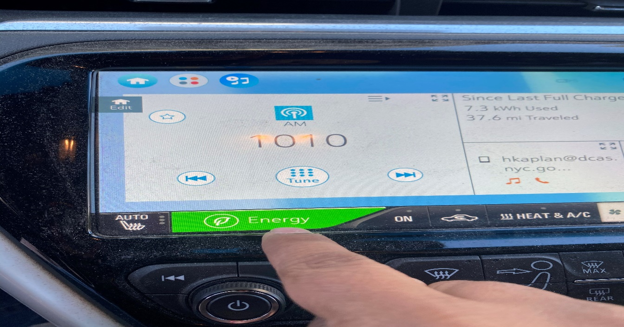

* Once the new page appears press on the on the ***Energy Settings*** icon.

* Then press on ***Hill Top Reserve*** and confirm that ***Hill Top Reserve*** has been switched to **ON.**

* Head back to the home screen where we originally began, turn off the vehicle, then turn it back on, review the steps and confirm that ***Hill Top Reserve*** is in the **ON** position.

## **The interim fix is complete after this last step.**

