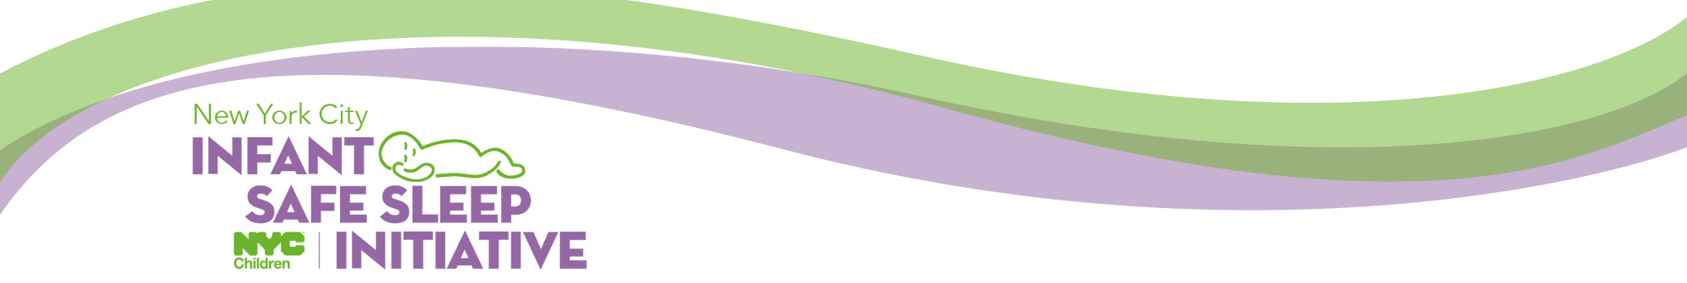
Training Request Form
REQUEST DATE
YOUR ORGANIZATION
Organization Name: |  |  | Contact Email:
Contact Name: |  |  | Contact Phone:
Organization/Program Description:
Organization Address:
TRAINING MODULE (Select one below)
Parent and Caregiver Training |  |  | Provider Training
Training Location (Full Address):
Training Date: |  | Training Start Time: |  |  | Est. Number Attendees:
AVAILABLE EQUIPMENT
Laptop (Y/N): |  |  | Projector (Y/N):
TARGET AUDIENCES
Professional Staff (Y/N): | Faith-Based Group (Y/N): |  |  | Parents/Caregivers (Y/N):
Parenting Teens (Y/N): | Other, please describe
Please return this completed form to: CFWB.NYCInfantSafeSleepInitiative@acs.nyc.gov
NOTE: Training requests should be made AT LEAST two weeks prior to your event.
Allow 2-3 business days for event confirmation.

