David A. Hansell
Commissioner

Dr. Jacqueline McKnight
Executive Deputy Commissioner
Child Welfare Programs

Kathleen Hoskins, Esq.
Assistant Commissioner
Office of Education Support and Policy Planning

150 William Street
11th Floor, 11H-1
New York, NY 10038
(212)341-0977 tel
(212) 341-3264 fax
Date(dd/mm/yyyy):
Child’s Name: |  |  |  |  |  | DOB (dd/mm/yyyy):
Foster Parent #1 Name: |  |  |  |  |  | Phone:
Foster Parent #2 Name: |  |  |  |  |  | Phone:
Address: |  |  |  |  |  | Home Phone:
Foster Care Agency: |  |  |  |  |  | Phone:
Agency Caseworker Name: |  |  |  |  |  | Phone:
Agency Caseworker Supervisor: |  |  |  |  |  | Phone:
Choose the student’s current educational program
☐ General Education | ☐ Special Education |  |  | ☐ Specialized Program (ie: ESL, G&T, or art/dance)
Describe specialized program/special education:
Child’s Previous school: |  |  |  |  |  |  | Last Grade :
To Principal:

The above-named child is in the care and custody of the Commissioner of the Administration for Children's Services, and has been placed in care with the above-named foster care agency. This serves as notice of the foster care placement. The foster parent should be informed of all educational information relating to the child. The foster parent and foster care agency have day-to-day responsibility for the care of this child and the school’s information systems should be changed to reflect this. Please update the student’s information in ATS immediately upon receipt.

In the absence of a court order or other documentation from ACS or the foster care agency indicating otherwise, birth parents remain the primary decision-makers for all educational matters. Birth parents retain the right to access education records and should also be informed of all educational information relating to the child.

If the child’s school is being changed, there has been a determination from the foster care agency that a change in school placement is in the best interest of the child. Please be advised that Chancellor's Regulation A-101 calls for the prompt admission of all pupils, including children in foster care. The child must be enrolled regardless of whether she/he has the required documentation or before an investigation of her/his school history is completed. If there are any concerns, an investigation can be conducted after the admission has been completed.

If the student is enrolled in special education, she/he should be afforded a comparable service plan until such time as the school can arrange for special education services in accordance with the student’s Individualized Education Plan.

The child’s foster care status is strictly confidential and should only be revealed to school staff on a need-to-know basis. We appreciate your sensitivity to this issue on behalf of the student. For additional questions regarding the release of information to birth parents, please contact the Senior Field Counsel assigned to your school.

Thank you in advance.
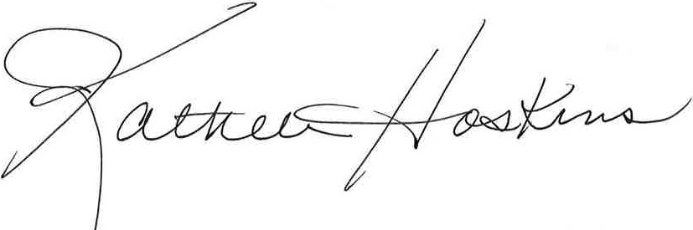
Kathleen Hoskins, Esq.

