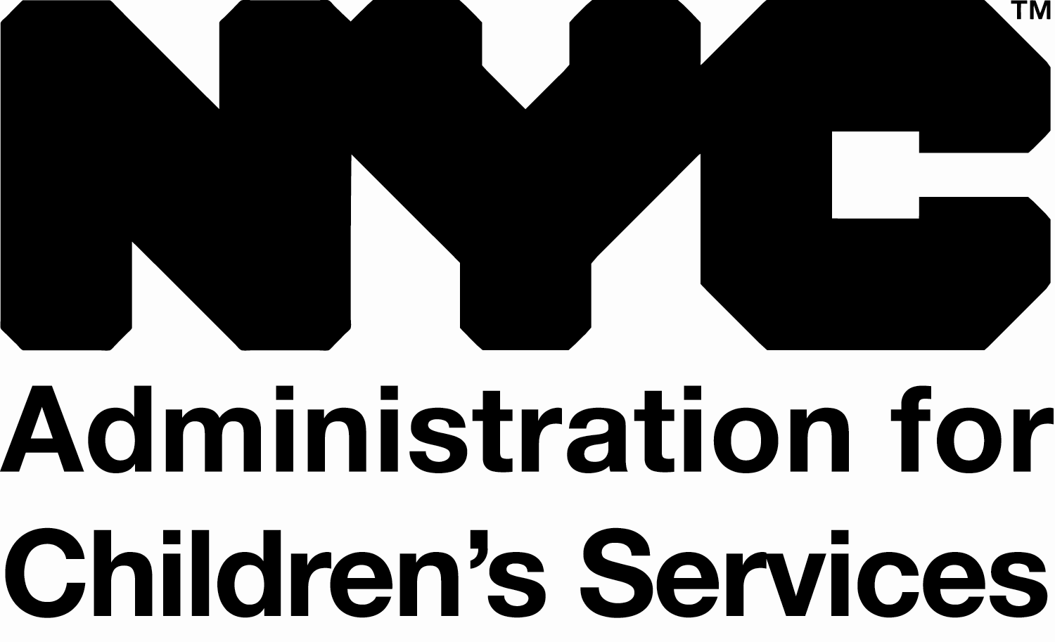ACS ECE 9801-E

**New York City** **Administration for Children’s Services**

**Division of Early Care & Education**

Rev. 1/2016

**AUTHORIZATION REQUEST FOR EMERGENCY CENTER CLOSING**

**If a program closes for “local emergency” reasons, immediately email earlycare&education@acs.nyc.gov with your name, program name, site location and reason for the local emergency closure. If this is a facilities-related matter, also immediately call the Help Desk at 212-453-0945 and email** [**earlylearnfacilities@acs.nyc.gov**](mailto:earlylearnfacilities@acs.nyc.gov)**.**

Submit this form within 2 business days of emergency closing; attach documentation if available. Type in your responses, print and sign. Scan and submit via email: [ayleen.guzman@acs.nyc.gov](mailto:ayleen.guzman@acs.nyc.gov) or in hard-copy to the attention of Ayleen Guzman at: ACS Early Care & Education, 66 John Street, 8th Floor | New York, NY 10038.

|  |  |  |  |  |  |
| --- | --- | --- | --- | --- | --- |
| **GENERAL INFORMATION** | | | | | |
| **Contractor / Agency** |  | **Center Name** | |  | |
| **Board Chair Name** |  | **Site Director Name** | |  | |
| **Board Chair Phone #** |  | **Site Director Phone #** | |  | |
| **Board Chair Fax #** |  | **Site Director Fax #** | |  | |
| **Board Chair Email** |  | **Site Director Email** | |  | |
| **Program’s WES ID #** |  | **Age** | **# Awarded EarlyLearn Slots** | | **# Enrolled**  **EarlyLearn Children** |
| **Fiscal ID #** |  | **Infant** |  | |  |
| **Site Address** |  | **Toddler** |  | |  |
| **Preschool** |  | |  |

|  |  |  |  |  |  |  |  |  |  |  |  |
| --- | --- | --- | --- | --- | --- | --- | --- | --- | --- | --- | --- |
| **INFORMATION ON SITE CLOSURE** | | | | | | | | | | | |
| **Date Site Closed** |  | | **Date Site Reopened** | |  | **Total # Business Days Closed** | | | |  | |
| **Describe reason site closed. Note anticipated re-opening date if site is still closed.** | |  | | | | | | | | | |
| **Date families were notified of closure:** |  | | | **Were alternative service arrangements offered? (mark one)** | | | **[ ]** | **YES** | **[ ]** | | **NO** |
| **If offered, describe alternative service arrangements:** |  | | | | | | | | | | |

|  |  |  |  |
| --- | --- | --- | --- |
| **CONTRACTOR REPRESENTATIVE SUBMITTING FORM** | | | |
|  |  |  |  |
| ***Signature*** | ***Printed Name*** | ***Title*** | ***Date*** |

|  |  |  |  |  |  |  |  |  |
| --- | --- | --- | --- | --- | --- | --- | --- | --- |
| **FOR ACS STAFF USE ONLY** | | | | | | | | |
| ***OFFICE OF EARLYLEARN FACILITIES (if closure is due to facility related issue)*** | | | | | | | | |
| **Approved:** |  | **Rationale for denial:** |  | | | | | |
| **Denied:** |  |
| **Facilities Liaison:** |  | | | | **Title:** |  | **Date:** |  |
| ***OFFICE OF EARLY CARE & EDUCATION*** | | | | | | | | |
| **Approved request submitted to Claims dept:** | | | |  | **Approved request sent to Contractor:** | | |  |
| **ECE Liaison:** |  | | | | **Title:** |  | **Date:** |  |