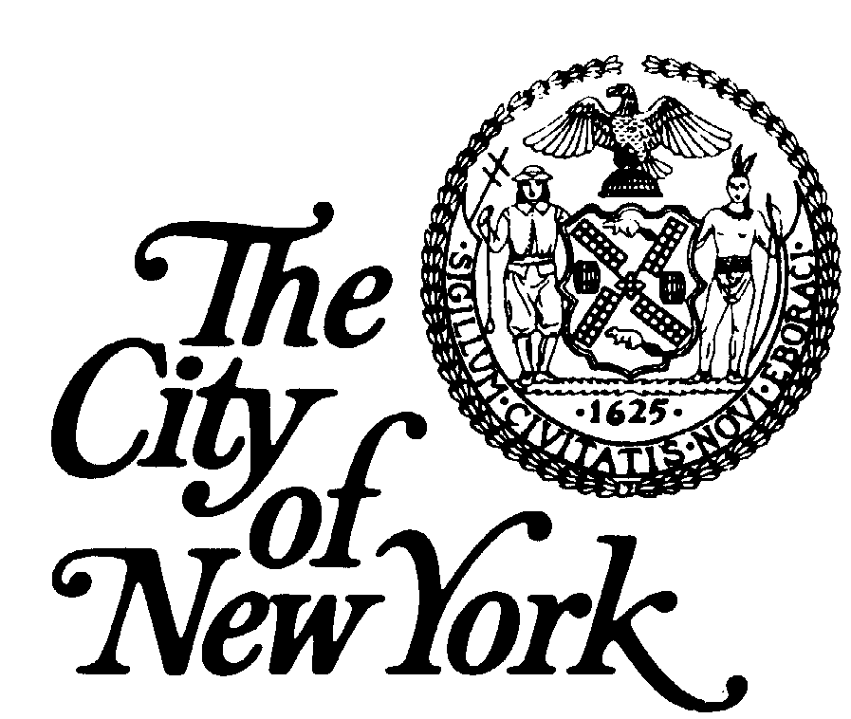
COMMUNITY BOARD # 4Q
Serving: Corona, Corona Heights, and Elmhurst
46-11 104th Street
Corona, New York 11368-2882
Telephone: 718-760-3141 Fax: 718-760-5971
e-mail: cb4q@nyc.rr.com

Helen Marshall Anthony R. Moreno
Borough President Chairperson

Barry Grodenchik Richard Italiano
Deputy Borough President District Manager
Director of Community Boards
____________________________________________________________________________________________________________

COMMUNITY BOARD MEETING

DATE: TUESDAY, JANUARY 11, 2011

TIME: 8:40 P.M.

PLACE: Elks Lodge #878
82-20 Queens Blvd.
Elmhurst, NY 11383

I. Chairperson Anthony Moreno called the meeting to order at 8:40 p.m.

II. The Pledge of Allegiance was recited by all.

III. District Manager Richard Italiano took the attendance. A quorum was present.

IV. VOTE: Minutes of the December 7, 2010 Meeting
Ms. Lucy Schilero made a motion, seconded by Mr. George Onuorah, to accept the minutes of the December 7, 2010 meeting.

By a voice vote, the Board voted 26 in favor, 0 opposed, with 0 abstentions. Unanimous. Motion passed.

V. REPORT OF THE CHAIRPERSON
Chairperson Moreno reported on the NYC Council Committee Hearings scheduled in response to the December 2010 Blizzard Cleanup. Since the hearing was so successful, additional community hearings are planned in each borough to gauge the reaction of the snow aftermath. For Queens, a follow up hearing will be held on Friday, January 21, at 12 Noon, at Queens Borough Hall. The Chairperson urged all to attend this important meeting to voice our opinions. It’s the first time they are asking about our concerns on something that had affected us so drastically. Flyers were on the back table for further information.

At this point, Mr. Tom McKenzie reported on his previous motion to remove the wording, “Corona Heights” from the Board’s letterhead, which was carried. However since that time he had changed his mind and asked the Board to have the motion reconsidered. However according to Parliamentary Procedure, it was brought to his attention as Parliamentarian that the reconsideration motion was improper because it can only be considered the same day the motion is made. The American Arbitration Association was consulted to verify reported information, which was confirmed.

Therefore in view of this new information, Mr. McKenzie called for a Public Hearing to be held in February to have the public come forward to express their views and at which time Mr. McKenzie would make a third motion to accept or reject the wording “Corona Heights” to the Board’s letterhead.

Chairperson Moreno said this issue has been brought up numerous times and must be cleared up and ended. Mr. Moreno said a motion is necessary to proceed.

Mr. Tom McKenzie made a motion, seconded by Mrs. Judy D’Andrea, to hold a Public Hearing in February on this issue for the purpose to make another motion as to whether or not the Board approves or opposes the wording “Corona Heights” on the Board’s letterhead. Mr. McKenzie suggested the February Board meeting to be held in Corona.

By a voice vote, the Board voted 25 in favor, 1 opposed, with 0 abstentions.

VI. REPORT OF THE DISTRICT MANAGER
District Manager Richard Italiano reported on the Queens Library Foundation’s Buy A Book program. The Queens Library’s budget was cut drastically and this is one way to make a difference. Contribute $25 or more and a bookplate with your name (or the name of the person you wish to honor) will be placed in a new book in a library of your choice.

From the Queens Borough President’s Office, applications for the Queens Youth Board were available at tonight’s meeting.

VII. REPORT OF THE LEGISLATORS
Council Member Daniel Dromm reported on the December 2010 Snow Blizzard, noting his office had received 150 calls about unplowed streets, which were not cleared for days. The seriousness of the calls was about emergency vehicles such as fire trucks and ambulances not able to maneuver the snow covered streets to assist sick individuals. As a result, a woman died and a baby could not get to the hospital. As a Council Member, Mr. Dromm felt he had an obligation to inform the Administration of the terrible conditions in our community. He spoke about the hardships encountered during the snow storm, mentioning parking meters were still in effect and the difficulty of digging out the car but not being able to get it onto the snow covered street.

Council Member Dromm spoke about keeping channels open to the Mayor. In the past, snow clearing had not been a problem, but this time something went terribly wrong. Serious questions arose about the City’s snow emergency policy and response.

At a public hearing held on January10, it was determined the Mayor was not in town and Deputy Mayor Goldsmith was also not in town. Council Members want to know the line of command. No one at the hearing was able to answer that which needs to be addressed to move forward.

Local concerns were provided about the main thoroughfares being cleared such as Broadway, but the secondary streets around Broadway were not done, which is why ambulances could not get through.

As a top priority, Council Member Dromm asked the Administration not only to clear primary streets but also to clear secondary streets that are near essential institutions.

Next, Council Member Dromm spoke about school closing alerts and parents receiving notification so that arrangements can be made for their children in advance.

Next, Council Member Dromm spoke about an upcoming restaurant event for the Elmhurst community. Details will be forthcoming.

Subsequently, Council Member Dromm spoke about the construction accident in Elmhurst. Developer Tommy Huang has a long history of violations and whose construction site was the scene of the worker’s death. The history of the builder involved will be thoroughly investigated. A 26 year old man died because a cinderblock wall collapsed and fell on him. This accident occurred in Council Member Karen Koslowitz’s district, and an investigation is continuing.

Tom McKenzie said there was a warrant out for the site and wanted the Developer made known as undesirable and deported.

Next, Council Member Dromm spoke about graffiti around St. John’s Queens Hospital. In general, the condition of the hospital is not good. The developer was contacted to clean-up not only the graffiti but also the whole site. Hoffmann Drive is still filthy and an eyesore, added a community resident. Discussion ensued about the property.

Chairperson Moreno asked about the disposition of the property. Many rumors abound, but nothing is concrete. Council Member Dromm responded the realty company that purchased the property has a mixed track record. In order to work with the community, Council Member Dromm directed them to clean up the graffiti. He also mentioned similar problems on 37th Avenue where a fire had occurred. Right now, the developer is thinking of making it green office space for small offices where entrepaneurs use a small area to work, giving those people an opportunity to set up established businesses. This concept has been very successful in Brooklyn.
Use is still unclear, but the green space idea was mentioned. However, Council Member Dromm would like to see a primary care facility for the site, and had already reached out to a number of primary care resource centers.

Council Member Dromm provided funding in the amount of $1,000,000 to Elmhurst Hospital to create a new chest pain unit that is being constructed as part of its emergency department. Details were provided.

Next, a community business seminar is planned for January 26 by the Queens Chamber of Commerce at the Bulova Corporate Center aimed at small business about alternative loans and methods for surviving the recession. All were invited to attend.

Lastly, Community Board applications must be submitted to the Council Member as soon as possible.

At this point, Ms. Lucy Schilero complimented Council Member Dromm for his exemplary efforts during the recent snow blizzard and thanked him for his assistance.
She also spoke about frustrations about her own street when no city plows showed up and busy 911 calls and calls for help that were not answered.

Discussion ensued on the city’s many resources, which were not used such as CERT, during the recent snow blizzard.

As a resident, Mrs. Judy D’Andrea complimented our local officials on their excellent response during the crises and stated she was extremely pleased. Calls to the Mayor’s Office and 311 were unresponsive.

At this point, Ms. Yoselin Genao, representing Council Member Julissa Ferreras, reported our district was heavily affected: 230 people were left homeless in the areas of Corona, East Elmhurst and Jackson Heights because of power outages by the heavy snow. Most tragically, a baby died because of the snow blizzard. Throughout those tragedies, the following members of Community Board 4 were personally thanked for their tremendous efforts: Joe DiMartino, Pat Terranova, Al Perna and Judy D’Andrea members of the Corona Lions Club, whose donations paid for the funeral of the baby that died as a result of the snowstorm.

Ms. Claudia Filomena representing CAU was also thanked for her efforts during the December 26 blizzard.
She also reported on problems encountered during the blizzard.

VIII. TRANSPORTATION COMMITTEE
Committee Chair Joseph DiMartino presented the Committee’s report.

1. One Way Conversion of Granger Street
Mrs. Judy D’Andrea made a motion, seconded by Ms. Laraine Donohue, to accept the one way conversion.
By a voice vote, the Board voted 26 in favor, 0 opposed, with 0 abstentions. Unanimous. Motion passed.

Next, the Dongan Avenue project was brought up. Packets describing the project’s purpose and description were on hand for review.

At this point, Chairperson Moreno called for opinions or comments from either the Public or the Board members on this project. None voiced.

Mr. Nick Pennachio made a motion, seconded by Ms. Audrey Galligen, to accept, the Dongan Avenue project.
By a voice vote, the Board voted 26 in favor, 0 opposed, with 0 abstentions. Unanimous. Motion passed.

2. TLC Renewals:
Santo Domingo Car Service
Cooperativa Car Service

Mr. Tom McKenzie made a motion, seconded by Ms. Myrna Littlewort, to accept both TLC base license renewals.
By a voice vote, the Board voted 26 in favor, 0 opposed, with 0 abstentions. Unanimous. Motion passed.

3. SAPO South Asian Mela June 12, 2011
Time: 11 a.m. to 8:30 p.m. # of People 1,000

The Chair called for a motion on this SAPO application. After questioning from the Board, the Committee Chair reported the location of the event was 73rd Street and Woodside Avenue (between Roosevelt Avenue and 41st Avenue). It has come before the Board before and the applicant is the Bangladesh of America. Discussion ensued. It was noted by the Committee Chair the Committee had asked the applicant to modify the hours of the event from 8:30 p.m. to 6:30 p.m.

Mr. Tom McKenzie made a motion, seconded by Ms. Ann Coyne, to accept the application with the time stipulated as 8:30 a.m. to 6:30 p.m.
By a voice vote, the Board voted 26 in favor, 0 opposed, with 0 abstentions. Unanimous. Motion passed.

At this point, representatives from the National Children’s Study addressed the Board. It was explained the National Children’s Study is an environmental health study that follows children and the effects of the environment on their health. There is an actual study taking place in Queens to help to get in the community because the study involves the participation of people living in Elmhurst and surrounding communities. A Community Advisory Board had been formed, which the District Manager is a part of.

In September, the first Inaugural National Children’s Study met recognized by the Queens Borough President to honor its board members for all their help in forming how the study was conducted in the community and for their role as its designated representatives. Since Mr. Italiano was unable to attend the ceremony in September, he was honored tonight and presented with an award for his dedication and participation to the organization’s Community Advisory Board. He was thanked for his commitment to the cause and the organization during his three years of service. A ‘round of applause was given to the District Manager.

IX. ULURP & Zoning
Vote: BSA #31-10BZ

Committee Chair Miriam Levenson reported the Committee met with the developer and agreed to grant the variance with the stipulation that the applicant provides truck and vehicle entrances on Queens Boulevard and/or Broadway. The building’s primary pedestrian entrance would be on Broadway but another entrance would be added on Queens Blvd. Reeder Street is narrow and does not allow room for truck and vehicle movements.

Mrs. Miriam Levenson made a motion, seconded by Mr. Tom McKenzie, to approve the variance with the new modifications.

By a voice vote, the Board voted 26 in favor, 0 opposed, with 0 abstentions. Unanimous. Motion passed.

X. PUBLIC SAFETY COMMITTEE
Vote: SLA Applications

Committee Chair Lucy Schilero presented the Committee’s report.

New Applicants

Establishment’s Name Establishment’s Address Committee Recommendation
House Bar, Inc. 71-26 Roosevelt Avenue Approved
On Premises Liquor Jackson Heights, NY

Picanteria LaGualacenita, Corp. 40-08 Hampton Street Approved
Restaurant Wine Elmhurst, NY

Renewal Applicants

Establishment’s Name Establishment’s Address Committee Recommendation
El Chino Latino, 93-26 Corona Avenue Approved
Dba El Paisa Restaurant Elmhurst, NY

E&P Deli & International Groc. Inc. 41-36 Junction Blvd. Denied. Sale to minors
Beer Only Corona, NY 4x in one year.

El Rincon Criollo Rest. Inc. 40-09 Junction Blvd. Approved
Restaurant Wine Corona, NY

Shin Best Choice 40-12 82 Street Approved
Restaurant Wine Jackson Heights, NY

Alteration

Establishment’s Name Establishment’s Address Committee Recommendation
WB 44th Avenue Restaurant Corp. 102-01 44th Avenue Denied
On Premises Liquor Corona, NY Two entrances on 102 Street.
One of those entrances under
200’ rule. Has not cleared Issues with the Buildings. Dept.

Mr. Tom McKenzie made a motion, seconded by Mr. Melvin Morgan, to accept the Committee’s report as presented.

By a voice vote, the Board voted 26 in favor, 0 opposed, with 0 abstentions. Unanimous. Motion passed.

Next, Ms. Lucy Schilero mentioned the Blood Drive St. Leo’s Church is sponsoring on Sunday, January 16 from 9:00 a.m. to 3:00 p.m.

XI. CONSUMER AFFAIRS
Sonero’s Enclosed Sidewalk Café

Committee member Helen Landaverde presented the Committee’s report.

Mr. Diego Freire, made a motion, seconded by Ms. Laraine Donohue to accept application for an enclosed sidewalk café.

However before the Board cast its vote, Mrs. Judy D’Andrea asked the motion be amended with the stipulation that the current owner is responsible for the permit and that the permit is not transferable to a new owner.

At this point, Mr. Tom McKenzie asked how far out the proposed structure extends. The Chair responded 6’8”. The District Manager added the remaining open sidewalk is 11’4” , after the structure is built.

By a voice vote, the Board voted 26 in favor, 0 opposed, with 0 abstentions. Unanimous. Motion passed.

XII. PRESENTATIONS
1. NEDAP Luis Caridad
2. New Life Redd Sevilla

NEDAP representative Luis Caridad reported NEDAP is a resource and advocacy center for community groups in New York City and its mission is to promote community economic justice and to eliminate discriminatory economic practices that harm communities and perpetuate inequality and poverty.

A map of Queens depicting certain parts of Queens, especially in Community Board 4, which were targeted for high cost predatory lending. NEDAP’s Fair Lending Education & Outreach Program works to combat predatory mortgage lending in New York City. Through the Fair Lending Education & Outreach Program, NEDAP provides free education, training, and referrals to community organizations and homeowners.

Options are available to convince banks to reduce monthly payments for homeowners to keep their homes.

He also spoke about scam artists who ask people to put up large fees upfront to save their homes. He cautioned homeowners beware of them because they will take your money and run. For more information, flyers were on the left on the table.

2. New Life Redd Sevilla
Guest speaker was not in attendance.

COMMITTEE REPORTS
Environmental
Committee Chair Tom McKenzie reported on the cable wires hanging down all over the neighborhood. It is a neighborhood eyesore which needs immediate attention and corrected. On a six block survey, Mr. McKenzie reported 35 locations with hanging cable wires. He asked if the cable company representative was in attendance at the Board’s District Cabinet meeting. The District Manager responded it had to be a separate meeting. Mr. McKenzie asked for a speaker to address the Board on this issue.

He also said Committee members need to be notified when it would be a convenient day for them to meet.

Next, Mr. McKenzie had asked the Sanitation Dept. why cars were not ticketed for alternate side street parking.
He was informed Sanitation did not have the supervisory personnel. Details were provided.
Mr. McKenzie spoke about snow removal on Queens Blvd.

Parks
No report. Committee Chair not in attendance.

Postal
No report. Committee Chair not in attendance.

Health
Committee Chair Priscilla Carrow reported the presentation from the National Children’s Study was given as part of the Health Committee’s report.

Youth
Committee Chair Clara Salas reported a Youth Committee is scheduled for April, 201l. Details were given.

PUBLIC FORUM
No speakers.

There being no further business, Mrs. Miriam Levenson made a motion, seconded by Ms. Laraine Donohue to adjourn. Meeting adjourned at 9:30 p.m.

