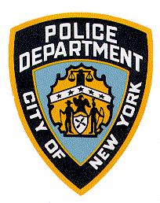COMMUNITY AFFAIRS BUREAU 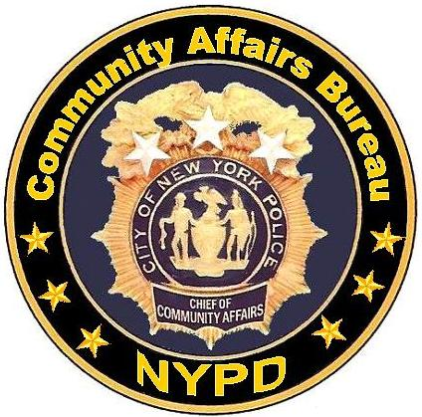
RIDE ALONG PROGRAM

Participants whose applications are approved are limited to one (1) ride along per year. Ride Alongs are conducted Monday through Friday with a duration of two (2) to four (4) hours. There will be no more than two (2) participants per car. A maximum of two (2) rides per precinct will be allowed per scheduled day.

REQUIREMENTS
- Applicants must be 18 years or older and a bona fide resident of New York State.
- Applications are available at Community Affairs Bureau, 1 Police Plaza [Monday – Friday, 9:00 am – 5:00 pm], any local precinct, or can be downloaded at www.nyc.gov/nypd, (click on Community Affairs, click on Participating Programs, choose Civilian Observer Ride Along Program).
- Applications must be received by the Community Affairs Bureau within the following period:
  - New York State Residents…………………………………………15 Days prior to request date
  - Out of State or International Law Enforcement Personnel………30 Days prior to request date
  - Walk-in applicants will not be approved
- Out-of-state or international applicants (law enforcement only) must provide a letter of sponsorship on official letterhead from the Commanding Officer of the law enforcement agency.
- Applicants must submit a copy of a valid New York State photo ID with the application.
- International law enforcement personnel will submit a copy of their passport and their police ID.
- All applications are subject to approval and to background checks by NYPD.
- Approved applicants with scheduling conflicts may reschedule their appointments by contacting Community Affairs Bureau at (212) 343-3676. Please allow up to two weeks to reschedule your appointment.
- Applicants are encouraged to complete a survey form at the conclusion of the ride.

RULES OF CONDUCT
- A valid photo ID and the Ride Along Permission Slip must be presented at the time of the ride.
- The use of cameras, recording devices and cell phones are prohibited.
- The Police Officer(s) assigned to the ride will provide a brief orientation on the program. If an emergency should occur during the ride, for your own safety, you must comply with any directive given to you by the officer(s).
- No weapons or any other items prohibited by law, including self-defense sprays are allowed, while participating in the program.
- All participants will be provided with a bullet proof vest that must be worn during the ride.
- Ride will be cancelled, if applicant arrives more than 15 minutes late for appointment.

I acknowledge with my signature that I have read and understand the Ride Along Requirements & Rules listed above.

Applicant’s Name (Print): ___________________________________________________________________

Applicant’s Signature: _________________________________________ Date: _____________________

“Police and Community Working Together”

RIDE ALONG APPLICATION
Please return completed application to any local precinct or forward to Community Affairs Bureau, Ride Along Program, One
Police Plaza, New York, NY 10038. (Please print clearly and complete all information requested.)

Name: First ______________________________________ Last ____________________________________ Title: ____________

Address: __________________________________________ City _____________________ State __________ Zip_____________

Country/Providence: _______________________ Phone # (H): __________________ (C) ________________ (W) ____________

Occupation: __________________________ School/ Agency ________________________ Email ___________________________
(Members of the Media/Journalism Students must state, on a separate sheet, the reason(s) for participating in the Ride Along)

Date of Birth: _______________ Race: ______________ Sex: ______ Date of Last Ride Along: ____________________

Where did you hear about the Ride Along Program?_________________________________________________________________

Reason for Ride Along Request: _______________________________________________________________________________

_________________________________________________________________________________________________________

_________________________________________________________________________________________________________

Please choose a date, time and borough for the Ride Along:

1. Date of Ride _____________________ Time: (7:00 AM or 3:00 PM) _________________

2. Brooklyn _____ Bronx _____ Manhattan _____ Queens _____ Staten Island _____
(Note: Exceptions can be made on a case by case basis)

Precinct Commanding Officer(s) may restrict or cancel an appointment for cause in consultation with Community Affairs Bureau.

ASSUMPTION OF RISK

I, _________________________________________, reside at_______________________________________________________
and being over eighteen (18) years of age, and have voluntarily requested to participate in the Ride Along Program of the New York City Police Department. I understand the inherent dangers involved in police work, and I understand that I may be exposed to such dangers, including but not limited to, those risks to a passenger riding in marked police cars on patrol responding to calls, as well as accidentally coming across occurrences of an emergency or criminal nature.
I assume the risk of any and all injuries that may result from my participation in this program.

Applicant Signature _________________________________________________ Date ________________________

Witnessed By: _____________________________________________________ Date ________________________
GENERAL RELEASE

I, _________________________________________________, a participant in the New York City Police Department’s Ride Along Program (herein after referred to as PROGRAM), am over eighteen years of age and reside at_____________________________________________________________________________________________________.
In consideration of and for the permission and authority to participate in the PROGRAM, I hereby release and forever discharge and shall hold harmless and indemnify the New York City Police Department, the City of New York, and its agents, servants and employees (collectively hereinafter referred to as CITY) from all actions, causes of action, suits, debts, sums of money, accounts, damages, judgments, claims and demands whatsoever which I, my heirs, executors, administrators, successors and assigns may have now or in the future against the CITY pursuant to my participation in the PROGRAM including, but not limited to, the riding in a New York City Police Department Vehicle and any acts related thereto.

This release may not be changed orally.

Participant Signature ________________________________________________ Date ___________________

Witnessed By: _____________________________________________________ Date ___________________

FOR PRECINCT USE ONLY

ENDORSEMENT

Commanding Officer, ____________________________ to Executive Officer, Community Affairs Bureau,
Month ______ Date _______ Year _________. Contents noted. Recommend APPROVAL/DISAPPROVAL
of applicant(s) request to participate in the Ride-Along Program. Forwarded for your consideration.

____________________________________
(Name)

______________________
(Rank)

FOR COMMUNITY AFFAIRS BUREAU USE ONLY

ENDORSEMENT

Executive Officer, Community Affairs Bureau to Commanding Officer, _____________________________
Month _______ Date ________ Year _______. Contents noted. Recommend APPROVAL/DISAPPROVAL. Forwarded for your information.

___________________________________
(Name)

______________________
(Rank)

