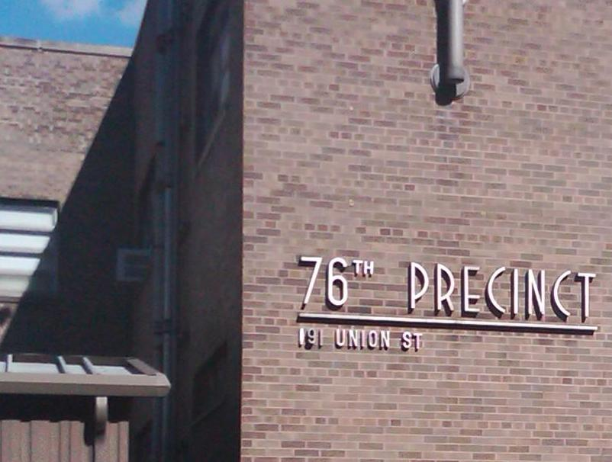
This newsletter is published by the Commanding Officer of the 76th precinct in conjunction with the 76 Precinct Community Council, serving the communities of Red hook, Carroll Gardens, Gowanus and Cobble Hill. Its purpose is to provide information to the communities we serve, and in conjunction with the community, to enhance public safety throughout the precinct.

The 76 Precinct Community Newsletter

Message from the Commanding Officer
I would like to extend to the residents of the 76 precinct my wishes for Happy and Safe Holiday Season. Please remember to designate a driver if you intend to drink at any holiday or New Year’s Eve parties.
Inside This Issue
- Message from the Commanding Officer
- Upcoming Events
- Public Safety News
- Newsworthy Accomplishments
- Our Strategy for a Safe Precinct
- Public Safety Tips
- Important Phone Numbers
- Upcoming Events

December 9, 2010
76 PRECINCT
191 Union St., Brooklyn, NY 11234

Highlights from this issue
- Public Safety News. Crime trends, and how the 76 precinct, in conjunction with the community, is responding.

- Traffic Safety Tips. Vehicle and pedestrian accident trends, and how we can prevent them.

- Upcoming events within the precinct.

For the month of November, the 76 precinct experienced a significant decrease in overall crimes. The largest reduction was in burglaries with a 50% reduction, followed by grand larcenies with a 35% reduction compared to 2009. Grand Larceny Auto also experienced a reduction, with only 3 cars stolen in the entire month.

Analysis of the five (5) robberies that occurred in November reveals that a large percentage of the robberies took place in the immediate vicinity of the Red Hook and Gowanus housing developments. In an effort to prevent robberies and apprehend the perpetrators of the robberies when they occur, we at the 76 precinct have deployed our personnel in the areas where the crimes are taking place. The officers deployed in these areas have been directed to pay particular attention to low level crimes and quality of life offenses. Eleven people were arrested for robberies in the past month. The majority of those arrested were 19 years of age or younger. Most of them had little or no prior criminal history.

Public Safety News

In an effort to prevent robberies and apprehend the perpetrators of the robberies when they occur, we at the 76 precinct have deployed our personnel in the areas where the crimes are taking place.

Newsworthy Accomplishments
The Cop of the Month for November is Police Officer Darnell Simon. Officer Simon affected eight arrests in the month of November including seven arrests for robberies. Officer Simon is an integral part of the 76 Precinct’s crime reduction team.
In an effort to reduce violence the 76 Precinct has placed great emphasis on removing guns from the street. To do this we are employing several different strategies. One of these is to ask whether guns are present in the household whenever we responded to domestic incidents. Police Officer Dynell Powell affected an arrest for possession of a semi-automatic pistol as a result of making one of these inquiries.
Another strategy is to work in conjunction with personnel from Probation & Parole and visit the residences of persons convicted of violent crimes. Police Office Anna Carrasco, from the 76 Precinct Anti Crime Unit arrested a probationer for possession of a loaded .40 caliber pistol and 350 decks of heroin, during one of these visits.
.
$1,000 REWARD
FOR INFORMATION LEADING TO THE ARREST OF ANYONE WHO POSSESSES AN
ILLEGAL HANDGUN
CALL
1 866 GUN-STOP
486-7867
If you know someone who is carrying, selling, or using handguns illegally, call anonymously

Remember: You don’t have to leave your name……

Our Strategy for a Safe Precinct
In addition to effective deployment of police personnel, it is necessary to ensure that there is appropriate follow-up whenever a person is arrested for one of these crimes. Whenever a person is arrested for a robbery, an executive member from the 76 precinct confers with the prosecutor and conveys the importance of the case and the gravity of the problem being experienced in the community. We constantly work with the prosecutor to ensure that perpetrators are arraigned on the appropriate charge and request that appropriate bail is set in order to ensure the defendants appearance in court.

Part of our reduction strategy is to vigorously patrol the areas where known perpetrators of robberies frequent and reside. Youthful offenders are visited at their residences and at their schools in an attempt to turn them away from a life of crime. We at the 76 Precinct believe that with constant analysis of the crime data, effective deployment and relentless follow-up we will be able to reduce robberies in 2011.

Public Safety Tips
As always the police need the publics help in the fight against crime. Some simple measures that can be taken to reduce the chance of becoming a victim are:

- Always be aware of your surroundings, particularly when dialing a cell-phone or texting or e-mailing from a portable electronic device.
- Report suspicious activity to 911.
- Never leave valuables unattended, particularly when in public places such as parks, transit facilities, retail establishments and restaurants.
- If you become the victim of a crime, promptly report the incident to 911. This greatly increases our chances of apprehending the perpetrator, thereby preventing others from being victimized.
- With the holiday season upon us, the volume of packages delivered by FedEx & UPS has significantly increased. Packages left unattended in front of doors or otherwise visible from the street can be seen as an invitation to some.

Never leave valuables unattended, particularly when in public places such as parks, transit facilities and retail establishments.

Always be careful when opening your car door. Numerous accidents occur in our precinct in this fashion.

Traffic Safety Tips
The 76 Precinct wants you to be safe!! Many of our traffic accidents are eminently preventable. The following tips are developed from trends observed in recent accident reports:

- Always be careful when opening your car door. Numerous accidents occur in our precinct in this fashion. Remember, many of our streets are narrow, and great care should be used when opening your car door.
- Do NOT double park!! Again, incidents of double parking, combined with the narrow streets, cause many needless traffic accidents.
- ALWAYS wear your seat belt. It has been proven time and time again that the use of seat belts greatly reduces injuries in the event of an accident.
- Do NOT use your cell phone while driving. Again, the distraction caused by cell phones often leads to accidents.
- Please make sure that when are crossing major streets, you allow enough time to get to the other side safely. Large intersections pose a significant problem to our senior citizens and to our children when going to and coming from school. These large intersections account for a large percentage of pedestrian fatalities citywide.

Important phone numbers

76 Precinct (718) 834 - 3211
Community Affairs (718) 834 - 3207
Community Policing (718) 834 - 3203
Crime Prevention (718) 834 - 3203
Domestic Violence (718) 834 - 3204
Youth Officer (718) 834 - 3218
Auxiliary Coordinator (718) 834 - 3218
Detective Squad (718) 834 - 3221

Upcoming Events

Many local parks are hosting tree lighting ceremonies. Please consult with the Department of Parks and Recreation or look at message boards at individual parks for posting of dates and times.

Precinct Community Meeting January 4, 2011

