
PRESENTS
BACK TO SCHOOL BLAST
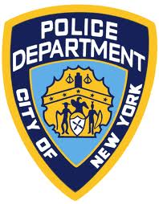
75 PCT 69 PCT PSA 1
Community Affairs Community Affairs Community Affairs

All Three precincts have come together in One Awesome Event!!!
Thursday, August 25th 2011 from 10:00 AM to 2:00 PM
Breukelen Playground, Between Louisiana and Stanley Avenue

COME JOIN THE FUN! Free School Supplies while they last!
Music!! Face painting!! Light Refreshments!! First Come, First Serve!
Rock Wall climbing, P.A.L. Activities

Come and get free information on:
Health and safety, Crime prevention, NYPD Cadet Program, Explorers, P.A.L. Parks Dept. FDNY, Downstate Medical Services- Blood pressure Screening, Glaucoma Screening,

Meet Mcgruff! Our Crime fighting Dog!!

Operation Safe Child- Identification program for children from ages 1 through 16 years old

Contact: 75 pct Community Affairs Office: 718 827-3553
69 pct Community Affairs Office: 718 257-6205
Psa 1 Community Affairs Office: 718 265-7313
Brooklyn Outreach Unit 718 368 6507

