**[Hospital Name]**

**Climate Action Plan**



**Produced by [Name of Lead Author, Department]**

**[Submission Date, Year]**

**Please remove this photo and replace with an image of your own institution.**

**[Primary Contact Name]**

**[Primary Contact Email]**

**[Primary Contact Phone]**

Produced with assistance from the Mayor’s Office of Sustainability

**Table of Contents**

1. Executive Summary **[Page Number]**
2. About the Challenge **[Page Number]**
3. About **[Hospital Name]**  **[Page Number]**
4. Additional Commitments **[Page Number]**
5. Local Law 84 and Local Law 87 Information **[Page Number]**
6. Carbon Emissions Inventory **[Page Number]**
7. Completed Projects and Strategies **[Page Number]**
8. Highlights **[Page Number]**
9. Next Steps **[Page Number]**

**Instructions:**

**To fill out this Climate Action Plan (CAP) template, please follow the instructions, designated in blue text, at the beginning of each section. Please be sure to delete the instructions before submitting your final Plan. Black text can remain in the CAP, but can be edited to take what is useful. Bolded text needs to be replaced with your hospital-specific information, and gray text is example language that should be replaced with your own information. We recommend completing the “Executive Summary” section after the rest of the sections are complete. Please note: City Hall Hospital is not a real hospital. All information is intended to serve as sample text only. Please submit your CAP to the Mayor’s Office of Sustainaiblity by Friday, May 6th, 2015. Once submitted, please feel free to distribute internally and/or make publically available.**

**To replace bolded text, you can use Word’s “Find and Replace” function (Ctrl F) to update to update the following throughout the document:**

* **[Hospital Name] – Replace with your Hospital’s name**
* **[Base Year] – Replace with your base year**
* **[Start Year] – Replace with your start year**
* **[End Year] – Replace with your end year**
* **[Current Year] – Replace with the year of your current inventory**

**Executive Summary**

**[Hospital Name] ’s Commitment to the NYC Carbon Challenge**

The NYC Carbon Challenge is a voluntary program for universities, hospitals, commercial offices, multifamily buildings and hotels in New York City who have committed to reduce their greenhouse gas (GHG) emissions intensity by 30% or more in ten years. City Hall Hospitalaccepted the NYC Carbon Challenge for Hospitals in 2009, committing to reduce the emissions intensity of its New York City buildings by 30% from 2006 levels by 2019. [Building off of the success that City Hall Hospital has had in reducing its carbon emissions, the hospital administration signed on to extend their existing reduction goal by committing to a 50% reduction in carbon intensity by 2025]. This Climate Action Plan lays out City Hall Hospital’sstrategy to meet this goal.

**Current Reductions in Emissions**

Since accepting the NYC Carbon Challenge, City Hall Hospitalhas reduced its carbon emissions intensity, measured by in metric tons of carbon dioxide equivalent per square foot, by 28.08% and its energy consumption by 30.29% from its 2006 base year levels. The reduction came from a combination of energy efficiency projects and fuel switching from No. 6 oil to No. 2 oil and natural gas. Overall, City Hall Hospital’s Main Campus in Manhattan contributes the greatest absolute energy use and carbon emissions, but the Flushing Campus has greater energy and carbon intensity.

**Reductions in Carbon and Energy Use Intensity**



**Please fill out Table 1 in your Climate Action Plan Tool Kit and insert it here.**

**Current and Completed Projects**

City Hall Hospitalhas completed several projects to reduce carbon emissions, increase building efficiency, and decrease operational costs. These include lighting replacements on City Hall Hospital’s Main Campus, heating oil conversions to eliminate the burning of No. 6 oil, retro-commissioning, capital upgrades, lighting, and an energy reduction competition. As a result, as of 2015 the hospital system saved an estimated 99,319 MMBtus, 7,206 metric tons of carbon dioxide equivalent, and a total of $560,000 in reduced energy costs.

**Planned Projects and Next Steps**

Building on its progress thus far in the Challenge, City Hall Hospital has developed a road map to meet the NYC Carbon Challenge goal. The Hospital has identified projects and strategies across the areas of lighting, operations and maintenance, training for building staff, energy efficient standards for new construction, major capital improvements, and retro-commissioning. Projects have already been identified that reduce GHG emissions by an estimated 4,883 metric tons of carbon dioxide equivalent and will save the hospital $1.6 million in electricity and fuel costs per year. City Hall Hospital will continue to evaluate projects and monitor progress toward the Challenge goal. By committing to this goal, the Hospital is demonstrating its dedication to environmental sustainability and helping New York City achieve its goal to reduce citywide GHG emissions by 80% from 2005 levels by 2050.

**[Hospital Name] ’s Carbon Emissions and Energy Use Reduction,** **[Base Year] - [Current Year]**

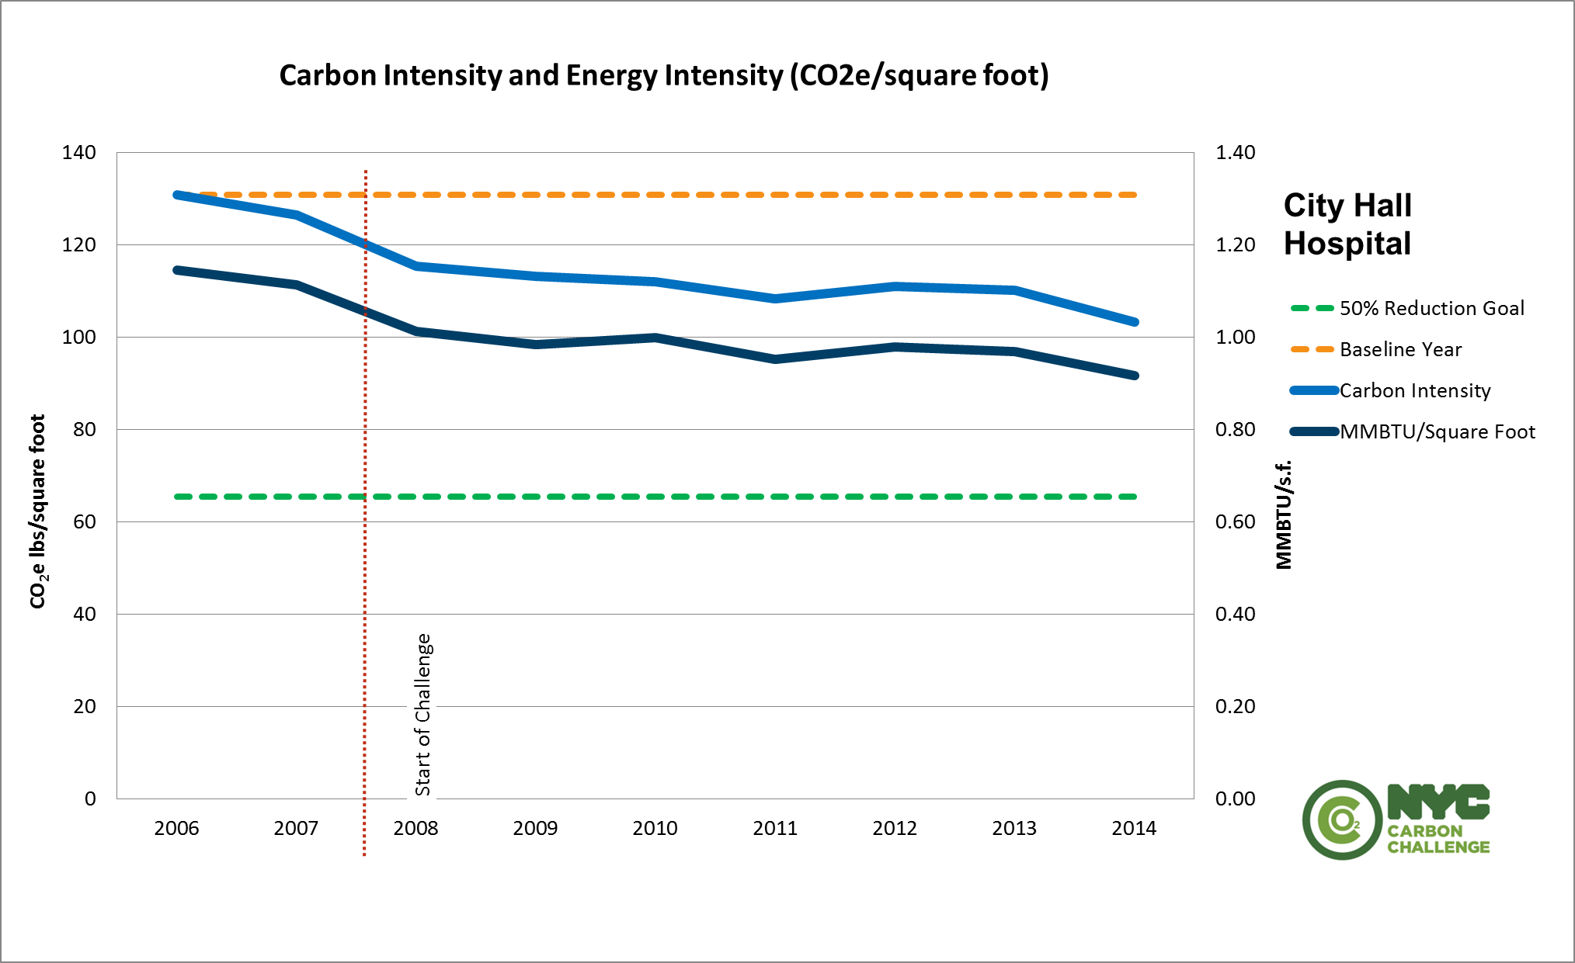

Please insert Graph 1 from your Climate Action Plan Tool Kit here.

**[Hospital Name]’s Plan to Reach a [30%/50%] Reduction in Carbon Intensity**

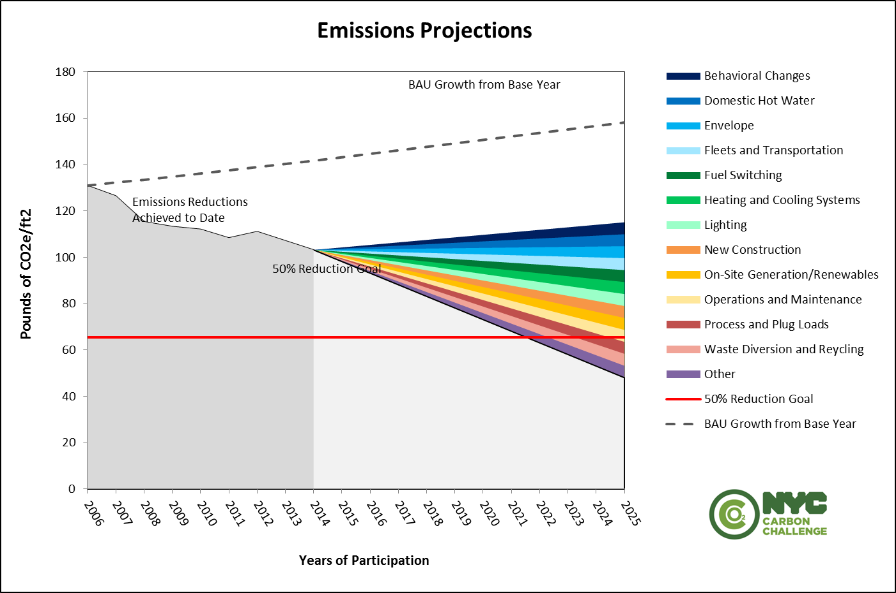

Please create this graph in the Wedge Chart tab of your Climate Action Plan Tool Kit and insert it in this section.

**About the Challenge**

**In this section, please provide an introduction that summarizes:**

**The need for action**

**Background on *OneNYC*, *One City: Built to Last*, the Greener, Greater Buildings Plan and the NYC Carbon Challenge**

**Your institution’s commitment to the NYC Carbon Challenge**

**Scope of the Climate Action Plan**

**An explanation of standard units**

**Please take what is useful from the following text.**

**Background**

Global climate change is the challenge of this century, and the stakes are high. Across the globe, greenhouse gas (GHG) emissions are growing at an unprecedented rate, causing a rise in average global temperature and changes to climate patterns. In New York City, we are experiencing the impacts of climate change firsthand from rising sea levels, increasing temperatures and heat waves, and more frequent and intense storms. The New York City Panel on Climate Change (NPCC) projects that average annual temperatures will increase in New York City by as much as 6.7° F by the 2050s and 8.8° F by the 2080s. Furthermore, sea levels are projected to rise from 11 to 21 inches by the 2050s and 18 to 39 inches by the 2080s.[1]

To address these challenges and mitigate the threats from climate change, New York City is committed to both adapting to a changing climate and taking bold action to reduce the harmful GHG emissions that contribute to climate change.

**One New York: The Plan for a Strong and Just City (OneNYC)**

On Earth Day 2015, New York City Mayor Bill de Blasio announced *One New York: The Plan for a Strong and Just City (OneNYC)*, a groundbreaking effort to address New York City’s long-term challenges, including a population forecast of up to 9 million residents by 2040, changing climate conditions, an evolving economy, and aging infrastructure. *OneNYC* is the City’s blueprint for a growing sustainable, resilient, and equitable city.

Recognizing the existential threat that climate change poses to New York City and the world, Mayor Bill de Blasio has set the ambitious goal to reduce citywide GHG emissions by 80% from 2005 levels by 2050. As part of the “80x50” goal, the City has set interim targets to reduce citywide GHG emissions by 40% by 2030 and building-based GHG emissions by 30% by 2025. With these commitments, New York City is continuing its longstanding leadership in addressing global climate change.

**One City: Built to Last**

The energy used in New York City’s one million buildings accounts for 71% of citywide GHG emissions, and at least 80% of the buildings that exist today will still be here in 2050. This means that improving the energy efficiency of the city’s existing building stock represents the greatest opportunity to reduce citywide GHG emissions. To put New York City on a pathway towards the 80x50 goal, the City released a 10-year plan called *One City: Built to Last—Transforming New York City’s Buildings for a Low Carbon Future* to address the energy used in our buildings. The plan is comprised of 22 specific initiatives that are projected to achieve roughly a 30% reduction in building-based emissions by 2025.

*One City: Built to Last* builds on many of the City’s previous efforts to improve the efficiency of its buildings. In 2009, the City enacted a package of legislation collectively known as the Greener, Greater Buildings Plan (GGBP). GGBP requires owners of all buildings greater than 50,000 square feet to measure their energy performance annually and conduct energy audits and retro-commission building systems once every ten years. The laws also require owners of non-residential buildings over 50,000 square feet to upgrade to more energy efficient lighting and provide all commercial tenants larger than 10,000 square feet with energy sub-meters by 2025. One of the key initiatives announced in *One City: Built to Last* is to bring the threshold of these laws down to 25,000 square feet in order to deliver the same benefits for the City’s mid-sized buildings.

**The NYC Carbon Challenge**

Started in 2007, the NYC Carbon Challenge is a voluntary leadership program for universities, hospitals, commercial offices, and multifamily buildings to reduce their building-based GHG emissions by 30-50% in ten years. To date, New York City’s 17 of leading universities, 11 largest hospital organizations, 11 global companies, 18 residential management firms, and 17 hotels have pledged to achieve these goals. Together, these participants make up more than 255 million square feet of space and contribute roughly 7 percent of citywide building-based emissions. The program builds on a strong partnership between the City and the private and institutional sectors and will help pave the pathway towards New York City’s 80x50 goal.

Building on the past successes of the Carbon Challenge, the City will expand the program by increasing the number of participants in the multifamily and commercial office sectors; add new sectors to the program; and continue to challenge universities, hospital, and commercial office participants to commit to an even greater goal of a 50% reduction in GHG emissions by 2025.

**[Hospital Name] ’s Commitment to the NYC Carbon Challenge**

**[Hospital Name]** accepted the NYC Carbon Challenge in **[Start Year]** and committed to reduce its GHG emissions[2] by 30% from **[Base Year]** levels by 2019. **[In the fall of 2015, [Hospital Name] extended their commitment to the Challenge by committing to a 50% reduction by 2025].** This Climate Action Plan lays out **[Hospital Name]**’sstrategy to meet this goal and the progress it has made through **[Current Year]**.

This Plan puts forward a framework to develop and implement strategies to meet this goal and allows the hospital to track its progress as it moves forward with the NYC Carbon Challenge.

**Scope**

This Plan includes:

* Background information about **[Hospital Name]** and its facilities;
* A description of **[Hospital Name]**’s additional commitments to environmental sustainability;
* Energy use benchmarking information and energy audit & retro-commissioning for all **[Hospital Name]** ’s New York City-basedproperties over 50,000 square feet, as required by LL84 and LL87;
* An inventory of annual GHG emissions from all of **[Hospital Name]**’s New York City properties using the NYC Carbon Challenge reporting methodology;
* A description of completed projects and strategies the hospital has undertaken to reduce its energy use and emissions;
* Highlights of **[Hospital Name]** ’s innovative projects;
* An explanation of the strategy moving forward that will enable **[Hospital Name]** to meet its **[30%/50%]** emissions reduction goal by **[End Year]**.

**Feel free to add a description of anything else you have included in the Plan.**

**Standard Units**

The NYC Carbon Challenge and the U.S. Environmental Protection Agency’s (EPA) Portfolio Manager Tool, which is used to complete LL84 benchmarking, require energy reporting to be completed in standard units. Below is a list and explanation of these standard units, which will be used throughout this Climate Action Plan.

**Standard Units for the NYC Carbon Challenge**



**Standard Units for EPA’s Portfolio Manager**



**About [Hospital Name]**

**Please provide a narrative description of your institution’s facilities that includes, at a minimum:**

* **A brief description of your hospital**
* **A brief description of each of your hospital’s campuses and a general description of the activities that each one supports**
* **A description of any planned or recently completed expansions of your institution and the projected impact on your institution’s energy use and carbon emissions**
* **Description of internal decision-making and planning process for how the Climate Action Plan was prepared**
* **A map of each campus that makes up your hospital**
* **Tables 2 and 3 from your Climate Action Plan Tool Kit**

**Please also include:**

* **Number of full-time employees**
* **Square footage of medical related space**

**The following is sample text—please remove and insert your own text in its place.**

### Background

City Hall Hospital was founded in 1811 and is now one of New York City’s leading hospitals specializing in medical research. Across two campuses, City Hall Hospital has 2,051 full-time equivalent employees.

**Campuses and Buildings**

City Hall Hospital is made up of a Main Campus in Manhattan and a satellite campus in Queens (see map in few pages). City Hall Hospital’s Main Campus is located in the Civic Center neighborhood of lower Manhattan. It includes office space, medical space, a data center and one large mix-ed use building. The Hospital’s satellite campus is located in Flushing, Queens, and consists of additional office and medical space and a new data center.

Across its two campuses, City Hall Hospital owns and operates four buildings with a gross area of 1,709,000 square feet. It also leases 500,000 square feet of space at 253 Broadway on its Main Campus for a system-wide total of five buildings and a gross area of 2,209,000 square feet. Following the methodology of the NYC Carbon Challenge, only 50 percent of the leased property’s square footage is counted in City Hall Hospital’s carbon emissions inventory to account for the base building system energy use, but the full square footage of all properties are listed in the table below.

The Main Campus contains four of the five buildings and constitutes the majority of the Hospital system. It is used by 404 full-time employees. City Hall Hospital’s Flushing Campus consists of one building dedicated primarily to additional medical space and is staffed by 100 full-time staff.

City Hall Hospital is in the process of expanding a number of its facilities. Since 2005, City Hall Hospital added an energy-intensive data center to its Flushing Campus and is now in the preliminary stages of expanding into one additional 500,000 square foot building located in the TriBeCa neighborhood of Manhattan. The hospital is expected to break ground on the new building in 2016.

### Please provide information about the process of the CAP’s intial development.

### Climate Action Plan Initial Development

After the commitment to the NYC Carbon Challenge in 2009, the Board of Trustees at City Hall Hospital formed a Sustainability Advisory Group to oversee all environmental initiatives at the hospital, including topics such as waste reduction, sustainable transportation, and socially responsible procurement. The Sustainability Committee is comprised of a diverse set of stakeholders in the Hospital, with the intent of having members serve as ambassadors to the hospital community by communicating the hospital’s sustainability goals and objectives.

Under the Committee’s direction, a full-time Director of Energy was hired in 2011 to be the point person for all energy management decisions at City Hall Hospital and provide long-term leadership in meeting the NYC Carbon Challenge goal. To help collaboratively guide the direction and provide support to the overall energy management process, the Energy Director created an energy management team, comprised of engineering staff, facilities staff, financial officers, and outside consultants.

Led by the Energy Director with assistance from the energy management team, City Hall Hospital’s first Climate Action Plan was created in 2012. The Energy Director and the energy management team did a comprehensive walk-through of all of City Hall Hospital’s buildings on its Main campus and Flushing campus to take a survey of all building equipment and identify energy conservation measures. The Energy Management Team then collaborated with the Facilities Department’s financial officers to determine which projects were financially and organizationally feasible to implement to achieve the NYC Carbon Challenge goal.

### If you are updating your Climate Action Plan, please provide information about the process of the CAP’s update.

**Climate Action Plan Update Development**

The CAP serves its best values when updated consistently, reflecting the progress towards the NYC Carbon Challenge Goal and the continued commitment to energy efficiency and sustainability. The process behind the update helps create insight for new actions, provides staff the opportunity to contribute to and understand the process of energy management, and creates specific success stories and financial results to communicate to internal and external stakeholders.

To reflect the progress to date, the updated CAP has been updated with new utility and energy information from the past few years. Information about completed projects and strategies was pulled directly from an internal tracking system that the energy management team uses to implement and track projects proactively. Additional ideas for the Climate Action Plan came from LL87 audits that were conducted for the Flushing Campus’ main building and feedback from hospital employees about behavior change campaigns.

**If you plan to include emissions from waste and fleets into the Challenge, please provide information about these sources.**

**Waste and Fleets**

City Hall Hospital also owns and operates a fleet of 27 vehicles. These include 7 diesel-powered vans, 10 diesel-powered buses, 10 gasoline-powered ambulances.

Across its two campuses, City Hall Hospital disposes of 100,000 pounds of waste annually, of which approximately 25,000 pounds is diverted for recycling and composting. The hospital plans to conduct a physical waste audit in 2016 to gain a better understanding of the composition of its waste stream and implement a waste-reduction strategy.

**Please include a map of your institution and Data Tables 2 and 3 from your Climate Action Plan Tool Kit. If you have multiple campuses, please provide separate maps and data tables for each campus. A labeled campus map is preferable, but if one is not available, you may also create a map using an online mapping tool such as Google Maps.**

**Campus Map**

**City Hall Hospital – Main Campus**

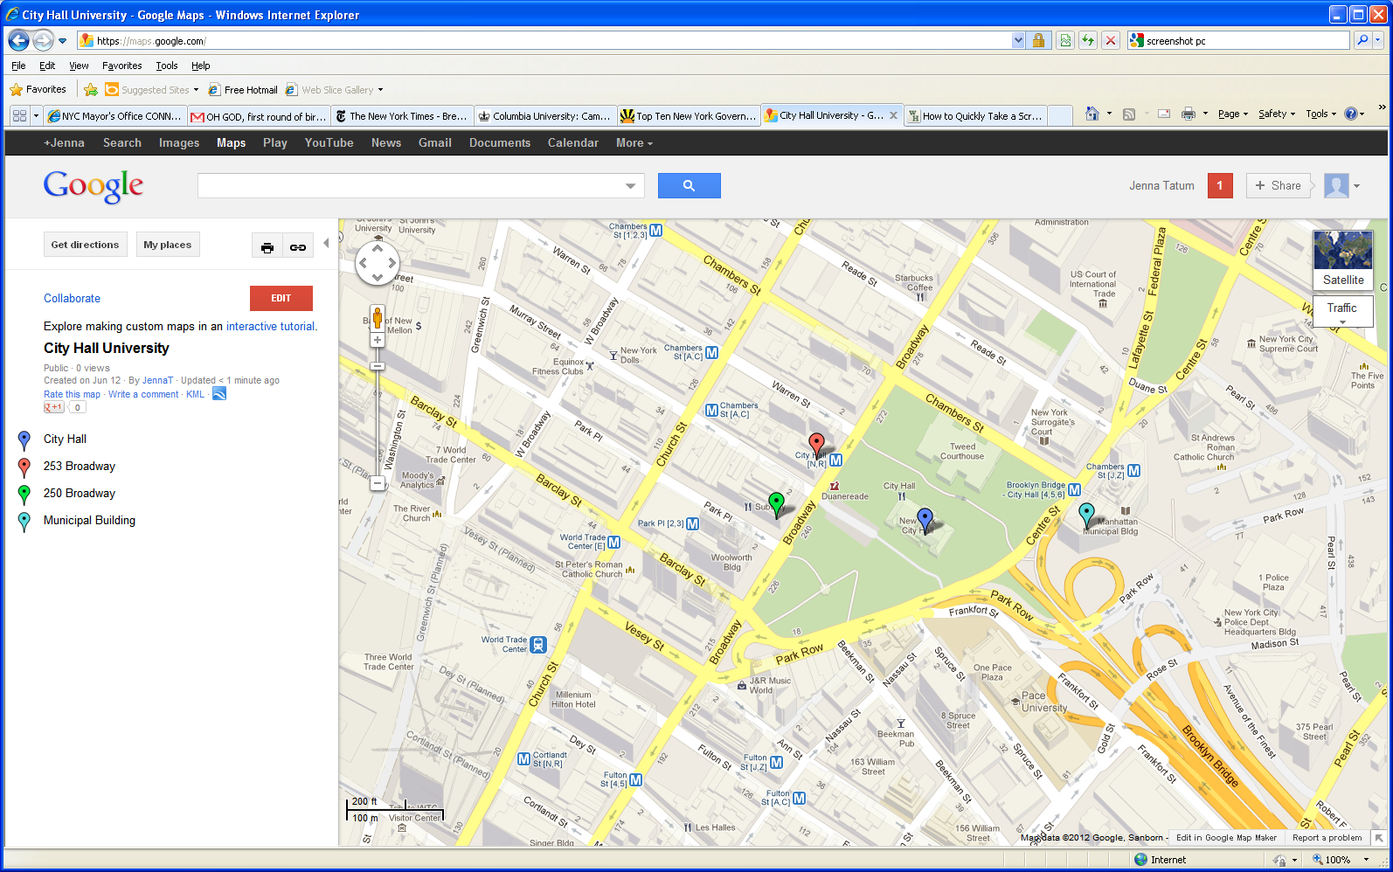

**Please remove this map and replace with a map of your own campus.**

1

2

3

4

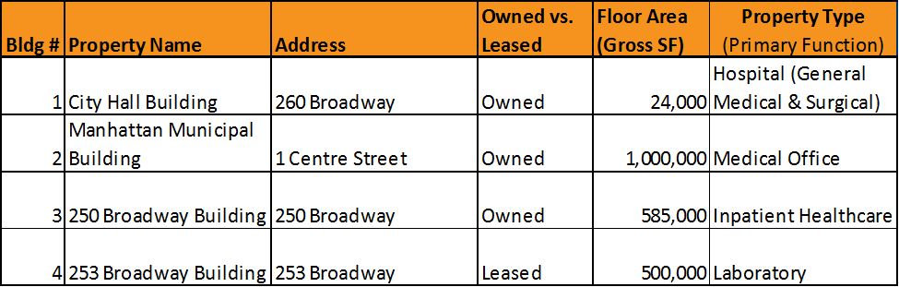**Building Area Breakdown for City Hall Hospital – Main Campus**

**Please fill out Tables 2 and 3 in your Climate Action Plan Tool Kit and insert them in this section. Note: Total square footage in this list may not be equal to the square footage in the Inventory. Square footage for some leased properties may be discounted by 50% to account for the base building system energy use.**



**City Hall Hospital – Flushing Campus**

**Please remove this map and replace with a map of your own campus.**

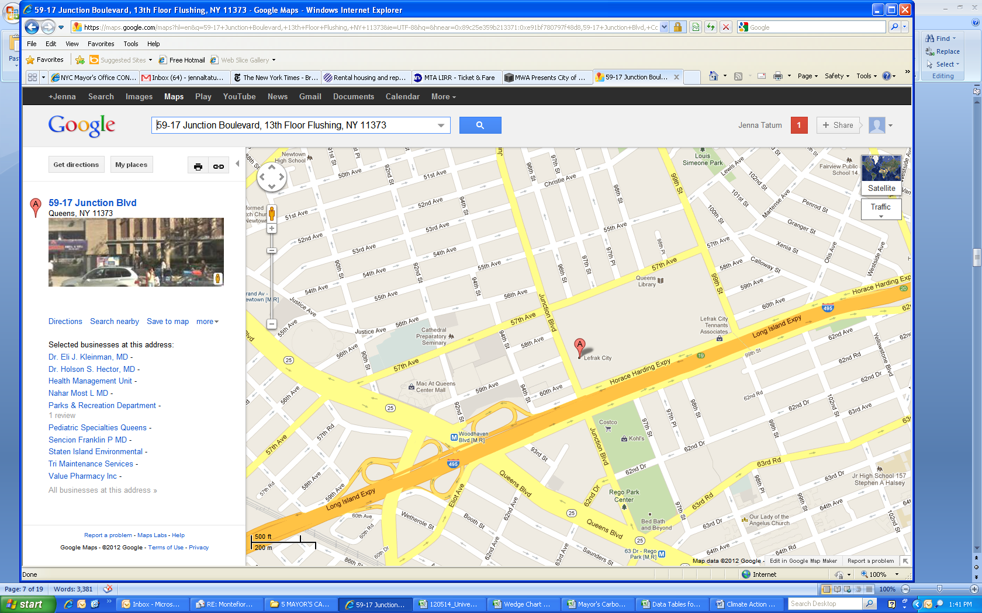

**Please remove this map and replace with a map of your own campus.**

1

**Building Area Breakdown for City Hall Hospital – Flushing Campus**



**Please fill out Tables 2 and 3 in your Climate Action Plan Tool Kit and insert them in this section. Note: Total square footage in this list may not be equal to the square footage in the Inventory. Square footage for some leased properties may be discounted by 50% to account for the base building system energy use.**



**Additional Commitments**

### Please include a description of any additional commitments to environmental sustainability that your institution has made.

**The following is sample text—please remove and insert your own text in its place.**

### [Hospital Name] ’s Additional Commitments to Sustainability

In addition to its commitment to the NYC Carbon Challenge, City Hall Hospital has made other internal and external commitments to reduce its global environmental footprint and increase the sustainability of its operations.

City Hall Hospital’s other sustainability goals include commitments to offer sustainably grown food in cafeterias and to review the environmental impact of its supply purchases. Additionally, City Hall Hospital has implemented a recycling awareness campaign and aims to achieve a 100% waste diversion rate by 2030.

**Water Conservation**

Recognizing the effects of climate change on water scarcity, as well as its own environmental impact, City Hall Hospital has committed to taking steps to reduce its water consumption. In 2011, City Hall Hospital consumed 40 million gallons of water costing it over $500,000 in utility bills. By switching to more water efficient appliances, capturing and returning condensate in cooling towers, tightening outstanding water leaks, installing aerators on all faucets, and educating the Hospital community on the importance of water conservation, water consumption has been cut by 22% since 2011, accounting for almost 9 million gallons saved per year.

Improvements to cooling towers and condenser technologies in chillers have been the largest contributor to water reductions, while optimizing cooling systems have offered further energy efficiency gains. By pursuing these strategies, City Hall Hospital has gained synergistic improvements to both water and energy efficiency in its facilities.

**Fostering Behavioral Changes**

City Hall Hospital has developed strategies focusing on behavioral changes through energy-saving competitions. The first year of the competition in the Manhattan Municipal Building realized an 8% energy savings, translating to a 2% reduction in overall carbon intensity. City Hall Hospital aims to continue the energy-saving competition and create a new competition that includes the City Hall Building to achieve an additional 2% reduction in carbon intensity.

**Green Cleaning**

City Hall Hospital has also committed to implement a green cleaning policy for its facilities. All cleaning products purchased and cleaning procedures implemented are to be consistent with the United States Green Building Council’s (USGBC) Leadership in Energy and Environmental Design (LEED): Existing Building Operations and Maintenance standards.

**Local Law 84 and 87 Information**

**In this section, for all buildings required to comply with NYC Local Law 84 (LL84), please provide the information from the energy and water use benchmarking you completed in US EPA’s Portfolio Manager tool.**

City Hall

**At a minimum, please include:**

* **Background information on benchmarking, energy auditing, and retro-commissioning under LL84 and Local Law 87 (LL87)**
* **The total number of buildings at your institution that are required to comply with LL84 and LL87**
* **OPTIONAL: For all buildings that have been required to comply with LL87 since 2013 through the current year, provide the estimated outcomes of all planned and completed energy conservation measures recommended in the energy audit and retro-commissioning measures as reported in the Energy Efficiency Report (EER) that was required to be submitted to the NYC Department of Buildings.**
* **Data Table 4 from your Climate Action Plan Tool Kit with benchmarking results from the current year**
* **OPTIONAL: Benchmarking results from base year**

**Please take what is useful from the following text.**

**Background**

New York City’s Local Law 84 of 2009 (LL84) is part of a package of four local laws collectively called the Greener, Greater Buildings Plan (GGBP). LL84 requires owners of all buildings over 50,000 square feet in gross floor area and in lots with more than 100,000 square feet of built floor area to report their buildings’ annual energy use through a process called bench-marking. Benchmarking measures a building’s total energy use by fuel type and adjusts for other factors, which allows owners to compare building energy performance to other similar buildings and helps determine whether systems are operating efficiently.

**[Hospital Name]** benchmarked its properties for **[Current Year]** using an online tool developed by the U.S. EPA called Portfolio Manager. Using **[Hospital Name]**’s energy use information, Portfolio Manager produces a measure of energy use intensity (EUI), or energy use per square foot per year, and an ENERGY STAR score for each benchmarked building.

A building’s EUI can be expressed in several ways. Portfolio Manager generates site EUI and the weather-normalized source EUI for each benchmarked building. The site EUI provides the on-site energy use per unit of gross building area, while the weather-normalized source EUI incorporates weather fluctuations and losses from production, transmission, and delivery of the energy source into the final number.

The ENERGY STAR score is a number on a scale of 1-100 assigned to each eligible building that compares the efficiency of energy use across similar facilities. For example, an ENERGY STAR score of 75 indicates that a building performs better than 75% of all comparable buildings nation-wide. The score is based on the Commercial Building Energy Consumption Survey (CBECS), which is conducted every four years by the U.S. Department of Energy’s Energy Information Administration. ENERGY STAR scores are only available for certain building types and at least 30% of the gross floor area must be one of these eligible building types to receive a score, so the lack of an ENERGY STAR score for a building does not indicate poor energy performance in a building.

Local Law 87 of 2009 (LL87) is another component of the GGBP that requires owners of buildings over 50,000 gross square feet to conduct an audit of all energy-using systems in the building and retro-commission these systems once every ten years to ensure they are performing as originally intended.

The requirements of LL87 are meant to provide information that will allow building decision-makers to make cost-saving investments in their buildings and tune up equipment performance to ensure existing equipment is performing as efficiently as possible. Covered buildings are required to complete an Energy Efficiency Report (EER) that includes their energy audit and retro-commissioning data, and submit it to the City electronically. The standardized Energy Efficiency Report (EER) reporting tool is provided by the NYC Department of Buildings.[3]

**[Hospital Name] ’s Benchmarking and Energy Audits & Retro-Commissioning Information**

**[Hospital Name]** has submitted benchmarking information for its owned buildings to comply with LL84 since 2011. In **[Current Year]**, **[Hospital Name]** was required to benchmark **[Number of Benchmarked Buildings]** buildings.

**[Hospital Name]** hascompleted EERs and retro-commissioning measures for **[Number of Completed LL87 Buildings]** of its buildings to comply with LL87 as of 2014. **[Hospital Name]**  will be required to perform energy audits and retro-commissioning measures on **[Number of Remaining LL87 Buildings]** by December 31st of **[Last Year LL87 Report is Due]** as required by Local Law 87.

**OPTIONAL: Please complete if your hospital has submitted EERs for any of its owned properties. Please take what is useful from the following text.**

The recommended projects by theauditing of existing buildings that **[University Name]** has *decided to implement* have reduced energy consumption by an **[Estimated Energy Savings in kBtu]**, which translates to about **[Estimated Metric Tons of CO2e]**  of carbon dioxide equivalent. These strategies have reduced energy costs by **[Estimated Cost Savings Per Year]** and cost **[Estimated Cost of Projects]** to implement, implying a payback period of **[Estimated Payback Period]**. The implemented projects have made a significant contribution to the Challenge goal by reducing carbon emissions per square foot by an additional **[Estimated Percentage Reduction in Carbon Intensity]**.

The recommended projects by theauditing of existing buildings that **[University Name]** *plans to implement* have reduced energy consumption by an **[Estimated Energy Savings in kBtu]**, which translates to about **[Estimated Metric Tons of CO2e]**  of carbon dioxide equivalent. These strategies have reduced energy costs by **[Estimated Cost Savings Per Year]** and cost **[Estimated Cost of Projects]** to implement, implying a payback period of **[Estimated Payback Period]**. These planned projects will make a significant contribution to the Challenge goal by reducing carbon emissions per square foot by an additional **[Estimated Percentage Reduction in Carbon Intensity]**.

The energy conservation measures and retro-commissioning recommendations in the energy audit(s) that have been implemented are in the “Completed Projects” section. Energy conservation measures outlined in the energy audit(s) that will be completed are in the “Planned Projects” section.

Below is a table that includes the LL84 results and LL87 compliance information for these buildings in **[Current Year].**

**OPTIONAL:** Benchmarked energy use for these **[Number of Benchmarked Buildings]** buildings for the base year of **[Base Year]** is also included below for purposes of comparison.

**The following is sample text—please remove and insert your own text in its place.**

*Site EUI:* City Hall Hospital’s average site EUI for benchmarked buildings in 2014 was 131.25 kBtu/ft2, with a high of 175 and a low of 75 kBtu/ft2.

*Source EUI:* The average weather-normalized source EUI for 2015 was 143.75 kBtu/ft2, with a high of 200 and a low of 100 kBtu/ft2.

*Water Use:* City Hall Hospital’s average water use in 2015 was 14.25 gallons/ft2, with a high of 17 and a low of 12 gallons/ft2.

*ENERGY STAR Scores:* In 2014, City Hall Hospital’s ENERGY STAR scores from benchmarked buildings ranged from a low of 37 in the 250 Broadway Building to a high of 74 in the Manhattan Municipal Building.

**[Hospital Name] Benchmarking and Energy Audits & Retro-Commissioning Information – [Base Year]**



**Please fill out Table 4 in your Climate Action Plan Tool Kit and insert it here. Note that it is optional to report benchmarking information for your hospital’s base year.**

**[Hospital Name] Benchmarking and Energy Audits & Retro-Commissioning Information – [Current Year]**

**Carbon Emissions Inventory**

**In this section, please include information from your Carbon Emissions Inventory, including:**

* **Background information on the emissions sources, GHG accounting methodology, and carbon coefficients used for the NYC Carbon Challenge**
* **Your hospital’s reported energy use, carbon emissions, and square footage for the base year and current year**
* **The reduction in carbon intensity achieved in the current year**
* **Any major changes in fuel sources since the base year**
* **Tables 5 and 6 from your Climate Action Plan Tool Kit**
* **Graphs 1 - 3 from your Climate Action Plan Tool Kit**
* **OPTIONAL: A description of your emissions by campus and Graphs 4 and 5 from your Climate Action Plan Tool Kit**

**Background**

All NYC Carbon Challenge participants complete a portfolio-wide carbon emissions inventory to calculate their energy use and associated carbon emissions for New York City-based properties for each year of the Challenge, beginning with a selected base year and ending with the last year of the Challenge.The base year in which a participant’sGHG emissions are calculated is the year from which NYC Carbon Challengereduction goal is measured. **[Hospital Name]** accepted the NYC Carbon Challenge in **[Start Year]** and committed to reduce its GHG emissions[4] by 30% from **[Base Year]** levels by 2019. **[Building off of the success that City Hall Hospital has had in reducing its carbon emissions, the hospital administration signed on to extend their existing reduction goal by committing to a 50% reduction in carbon intensity by 2025].**

**Emissions Sources**

The NYC Carbon Challenge covers all building-based emissions from the energy use over which participants have direct operational control. These include emissions that are attributable to on-site energy use on participants’ properties as well as emissions that result from off-site generation of the energy sources. It is important to note, however, that emissions reported for the NYC Carbon Challenge do not include the full profile of each participant’semissions. For one, the NYC Carbon Challenge only includes emissions from properties that are located in New York City, and some participants operate properties outside the city limits that are not counted in the Challenge. In addition, emissions include only what the World Resources Institute (WRI) labels “Scope 1” and “Scope 2” emissions.

According to the WRI’s Greenhouse Gas Protocol, an institution’s full profile of emissions consists of: Scope 1 emissions, which include emissions that are physically produced on an institution’s property (for example, fossil fuels used in boilers); Scope 2 emissions, which are indirect emissions from the offsite generation of energy sources that are used on-site (for example, electricity or district steam); and Scope 3 emissions, which are emissions that are not produced on-site or from offsite generation but are nonetheless attributable to the institution’s activities (for example, from air travel or solid waste disposal). The NYC Carbon Challenge includes Scope 1 and Scope 2 emissions but does not necessarily include Scope 3 emissions because they are not always produced within city boundaries and lack general agreement on proper accounting methodologies.

The NYC Carbon Challenge requires that **[Hospital Name]** measure emissions from all buildings and properties that it owns and operates and from rental properties greater than 10,000 square feet where **[Hospital Name]** pays the entire utility bill. In rental properties greater than 10,000 square feet where **[Hospital Name]** does not pay the entire bill, the gross square footage of the property is discounted by 30%. Rental properties of less than 10,000 square feet are optional under the Challenge. **[Hospital Name] [has/has not]** decided to count these properties.

The majority of carbon emissions from hospitals come fromthe energy used in their buildings. For this reason, the participants in the NYC Carbon Challenge are focused primarily on reducing carbon emissions from these sources. Reducing and reporting carbon emissions from vehicle fleets and solid waste are optional under the Challenge. **[Hospital Name] [has / has not]** chosen to include carbon emissions from its vehicle fleet and waste stream. inventory.

**GHG Accounting Methodology**

As a NYC Carbon Challenge participant, **[Hospital Name]** agrees to track its carbon emissions according to the methodology of the NYC Carbon Challenge. Under this methodology, participants report their non-weather normalized source energy use for all covered properties by fuel type and aggregate it annually for every year of the Challenge, beginning in the base year and ending in the end year. Participants enter this energy use into a carbon emissions inventory calculator tool, provided by the NYC Mayor’s Office of Sustainability, which multiplies energy consumption by a “carbon coefficient” to find the associated level of carbon dioxide equivalent (CO2e).

All carbon coefficients for the NYC Carbon Challenge were developed by the NYC Mayor’s Office and Sustainability and are in compliance with the 2013 United States Community Protocol for Accounting and Reporting Greenhouse Gas Emissions (USCP). The NYC Carbon Challenge uses New York City-specific carbon coefficients for electricity and steam, which are calculated by the Mayor’s Office Sustainability based on power plant data. All coefficients for natural gas and heating fuel oils No. 2, 4, and 6 were developed by the U.S. EPA.

For the purposes of the Challenge, the coefficients used to determine the carbon emissions associated with electricity and steam are fixed at 2005 levels, because these coefficients can change dramatically over time. For example, since 2005, the retirement of coal-fired power plants, increased use of natural gas, and construction of more energy-efficient combined cycle power units have decreased the carbon intensity of New York City’s electricity supply by more than 30 percent. Annually changing the electricity coefficient to reflect this reduction would provide an advantage to Challenge participants that depend primarily on electricity. Fixing the electricity and steam carbon coefficients at 2005 levels therefore measures only the direct efforts of the participants, and not exogenous changes to the energy supply. Please see below for the complete list of the NYC Carbon Challenge carbon coefficients.

**OPTIONAL: If you are including emissions from waste and/or fleets, please keep this methodology here. If you are not including these emissions, you may remove the methodologies below.**

The NYC Carbon Challenge gives participants the option to include carbon emissions associated with vehicle fleets and solid waste, but it is not required. Under the methodology of the Challenge, fleets are vehicles owned and operated by an institution. This includes maintenance vehicles, ambulances, buses, shuttles, and security vehicles, but does not include personal commuting or employer-owned vehicles that are leased to individuals. The minimum reporting requirement for fleets are the total annual gallons of fuel consumed, aggregated by fuel type (gasoline, diesel, biodiesel). The electricity used to fuel hybrid, plug-ins, and electric vehicles are reported in the institution’s carbon emissions inventory. All carbon coefficients for fleets were calculated according to New York City’s methodology for greenhouse gas inventories, which are based on EPA and/or ICLEI protocols.

For institutions like **[Hospital Name]**  that elect to include emissions from solid waste, the NYC Carbon Challenge requires a minimum reporting of annual mixed/unsorted MSW (general municipal solid waste sent to a landfill), recycled waste (sent to a recycling facility), and composted waste (if there is an institutional composting program). Waste inventories are recorded in short tons. Institutions have the option to complete a physical waste audit to determine waste characterization percentages, which would break down the mixed/unsorted MSW category into mixed recyclables, mixed organics, and sorted MSW. Breaking down the waste stream provides more accurate emission levels.

The emission factors for mixed/unsorted MSW, mixed recycling, and mixed organics were derived from the EPA WARM model, Exhibit 6 and material definitions list. They were modified according to the methodology New York City accounts for GHG emissions. Transportation to landfills is not included in the equation, as it is counted separately for the city and would have a minor effect on the coefficients. For simplicity of accounting, all waste is assumed to be taken to a landfill. According to New York City data, 95% of commercial waste is landfilled, and only 5% is incinerated. The NYC Carbon Challenge assigns a carbon coefficient of zero for recycling and composting, including food digester systems, although it recognizes that the EPA WARM model provides a negative coefficient for these diversions because of attributed carbon sequestration. This methodology was meant for influencing waste management practices, not GHG accounting. A zero coefficient acknowledges that recycling and composting reduces emissions, but there is no current research to accurately quantify it.

**NYC Carbon Challenge Emissions Coefficients**

**Emissions Coefficients for Buildings**

|  |  |  |  |  |  |  |  |
| --- | --- | --- | --- | --- | --- | --- | --- |
|  | **Electricity (kWh)\*** | **Natural Gas (therms)\*** | **#2 Fuel Oil (gal)** | **#4 Fuel Oil (gal)** | **#6 Fuel Oil (gal)** | **Diesel For Back-up Generation (gal)** | **Steam (Mlbs)** |
| **MT CO2e per unit energy** | 0.000422704 | 0.005315600 | 0.010264026 | 0.011016722 | 0.011327550 | 0.010264026 | 0.086629611 |
| **MMBtu per unit energy** | 0.009546 | 0.1 | 0.138 | 0.146 | 0.15 | 0.138 | 1.33015 |

*Held constant at 2005 Levels

**Emissions Coefficients for Fleets**

|  |  |  |  |  |
| --- | --- | --- | --- | --- |
|  | **Gasoline (gal)** | **Diesel (gal)** | **Biodiesel B20 (gal)** | **Biodiesel B5 (gal)** |
| **MT CO2e per unit energy** | 0.008477 | 0.01021 | 0.008672 | 0.008526 |

**Emissions Coefficients for Waste**

|  |  |  |  |  |  |
| --- | --- | --- | --- | --- | --- |
|  | **Mixed MSW - Sorted & Unsorted (tons)** | **Mixed Organics (tons)** | **Mixed Recyclables (tons)** | **Composted Waste (tons)** | **Recycled Waste (tons)** |
| **MT CO2e per unit weight** | 0.819 | 0.282128 | 0.416475 | 0 | 0 |

**[Hospital Name] ’s Goal**

Participants create a baseline carbon emissions inventory, which measures emissions levels in their base year, ultimately displaying their progression in moving towards the NYC Carbon Challenge goal. Based on this inventory, **[Hospital Name]** will reduce its **[Base Year]** carbon intensity of **[Carbon Intensity in Base Year]** pounds per foot by **[30%/50%]** to **[Carbon Intensity for Challenge Goal]** by **[End Year].**

**[Hospital Name] ’s Carbon Emissions Inventory**

**[Hospital Name] completed** its current carbon emissions inventory for the NYC Carbon Challenge for **[Current Year]**. Based on this inventory, **[Hospital Name]** has reduced its carbon intensity by **[Reduction in Carbon Intensity]** and reduced its energy use intensity by **[Reduction in Energy Use Intensity].** See below for a summary of **[Hospital Name]**’s progress.

**[Hospital Name] ’s Carbon Emissions Reduction, [Base Year] – [Current Year]**



**Please fill out Tables 5 and 6 in your Climate Action Plan Tool Kit and insert it here.**

**[Hospital Name] ’s Energy Use Reduction, [Base Year] – [Current Year]**



**[Hospital Name] ’s Carbon and Energy Use Intensity Reduction,** **[Base Year] – [Current Year]**

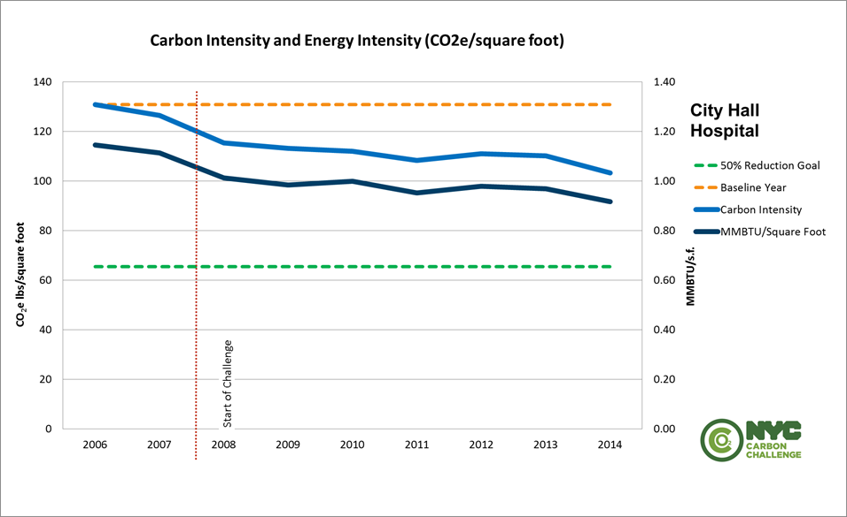

**Please insert Graph 1 from your Climate Action Plan Tool Kit here.**

**Factors Affecting [Current Year] Inventory**

**If applicable, please explain factors that contributed to your emissions and/or energy use reductions such as new construction or demolition.**

**Exogenous Impacts**

Exogenous factors can significantly impact building-level energy use and therefore affect City Hall Hospital’s progress in the NYC Carbon Challenge. The winter of 2014 and 2015, proved to be unusually cold and long. These exogenous events put increased strain on City Hall Hospital’s heating system, requiring extra heating fuel demand than normal, and thus negatively affected the hospital’s carbon emissions.

**Please feel free to add more information about the impact of your reduction. EPA’s GHG Equivalencies Calculator may be useful:**

[**http://www.epa.gov/cleanenergy/energy-resources/calculator.html**](http://www.epa.gov/cleanenergy/energy-resources/calculator.html)

**[Hospital Name] ’s Energy Use and Carbon Intensity by Fuel Types,** **[Base Year] – [Current Year]**

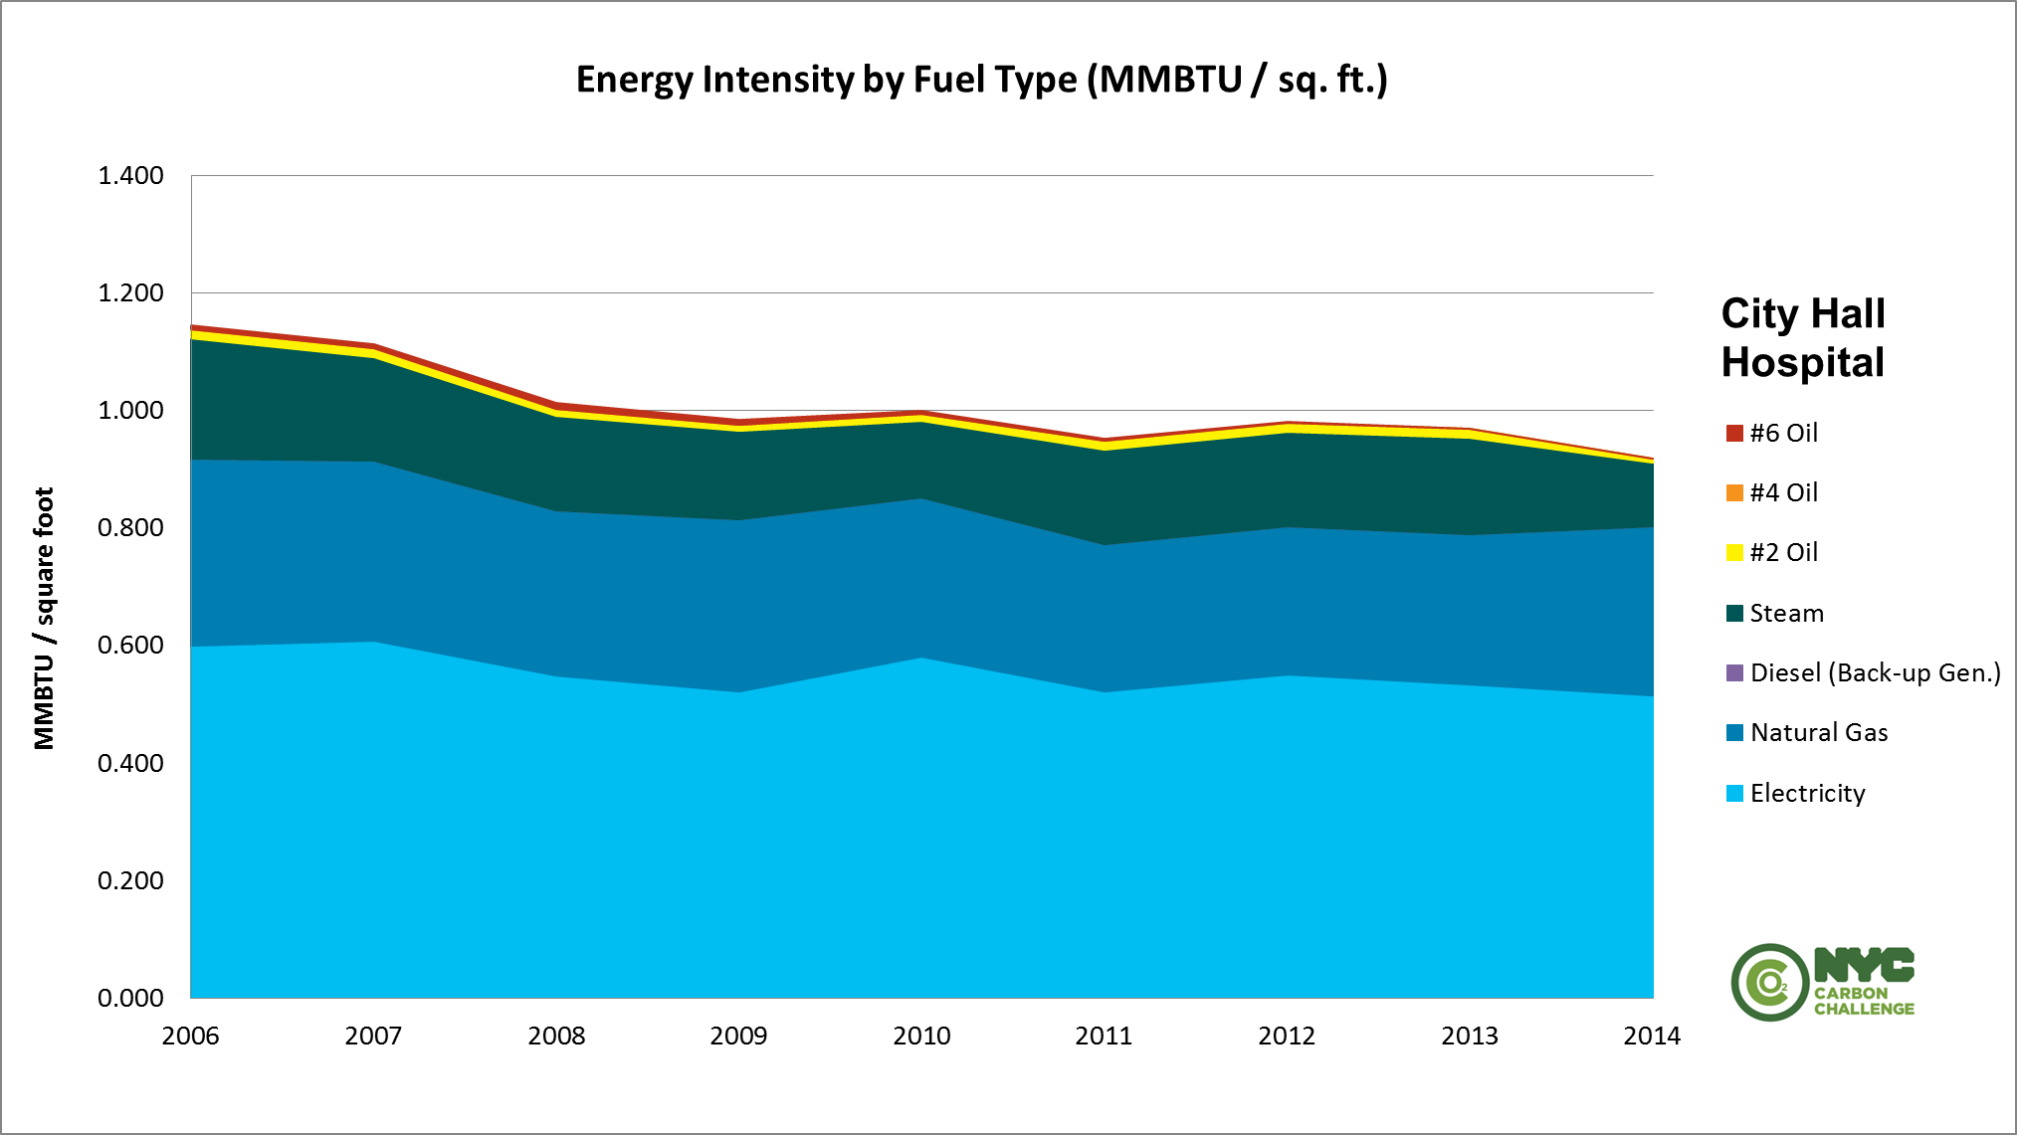

**Please insert Graphs 2-3 from your Climate Action Plan Tool Kit here.**

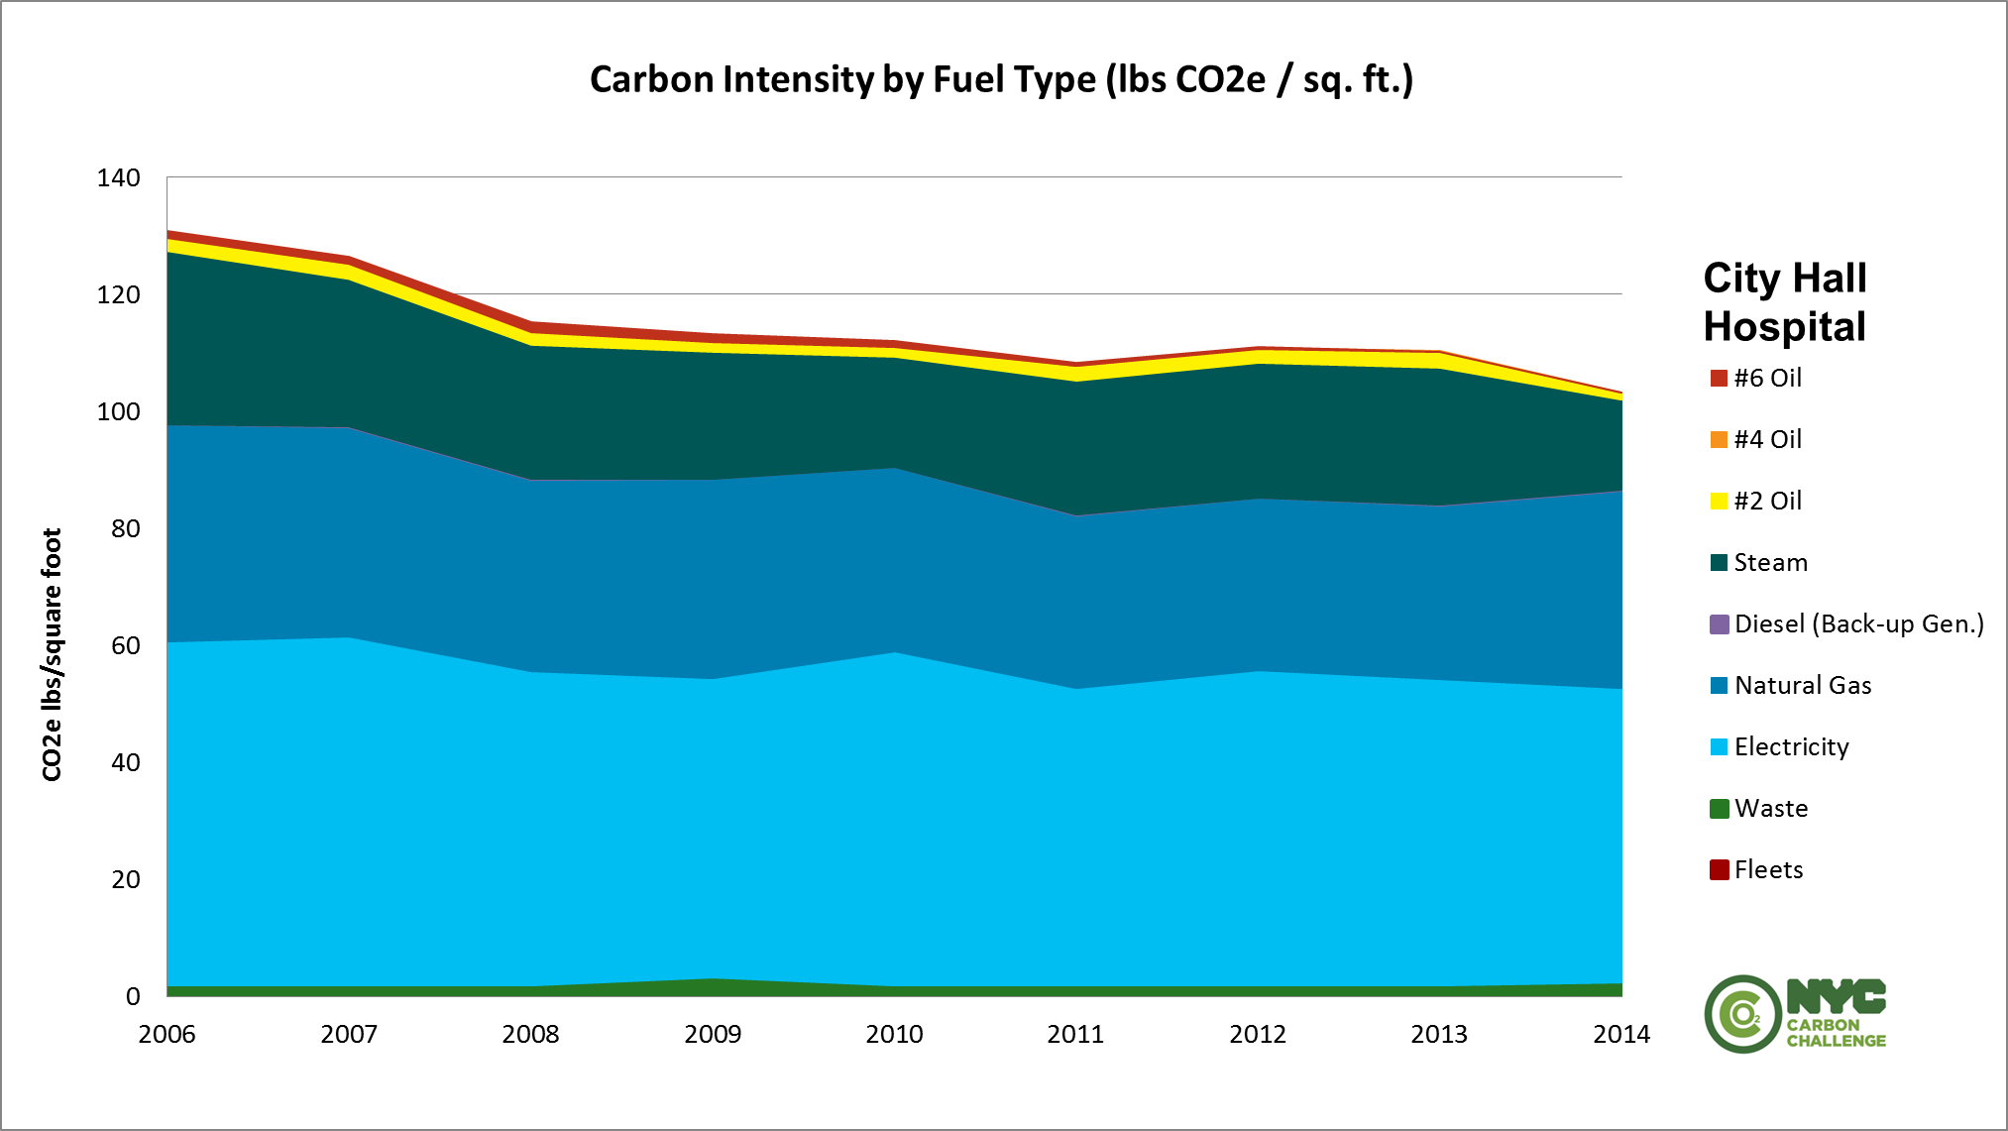

**Carbon Emissions by Campus**

**OPTIONAL: If you have energy use data broken down by campus, please:**

* **Describe the contribution of each campus to your carbon emissions in the base year and current year**
* **Include the campus graphs in your Climate Action Plan Tool Kit**

**The following is sample text—please remove and insert your own text in its place.**

Breaking down City Hall Hospital’s carbon emissions and carbon intensity by campus offers insight into opportunities for further reductions in emissions from each campus.

Because City Hall Hospital’s 2,109,000 square foot Main Campus is significantly larger than its Flushing Campus, the absolute emissions from this campus unsurprisingly make up the greatest share of the Hospital’s overall emissions profile in 2014. Approximately one-third of City Hall Hospital’s emissions come from its property in the Manhattan Municipal Building, meaning that energy efficiency investments in this property will have a significant impact overall. City Hall Hospital’s buildings at 250 Broadway and 253 Broadway make up the next largest contributions to the Hospital’s total emissions, respectively, while the City Hall Building accounts for the smallest portion. By comparison, the Flushing Campus only accounts for 2,317 MT CO2e, which is roughly 5 percent of the Main Campus’s total emissions.

Separating City Hall Hospital’s carbon intensity by campus shows that the Flushing Campus contributes the largest proportion of carbon emissions per square foot. This is likely due in part to City Hall Hospital’s recent installation of new, energy-intensive data center on this campus. Thus, making energy efficiency investments at the Flushing property will also be an important opportunity for reducing City Hall Hospital’s carbon intensity.

**[Hospital Name] ’s Carbon Emissions by Property, [Base Year] – [Current Year]**



**If you choose to report your emissions by property, please insert Table 7 from your Climate Action Plan Tool Kit here.**

**City Hall Hospital’s Carbon Emissions and Carbon Intensity by Property, [Base Year] – [Current Year]**

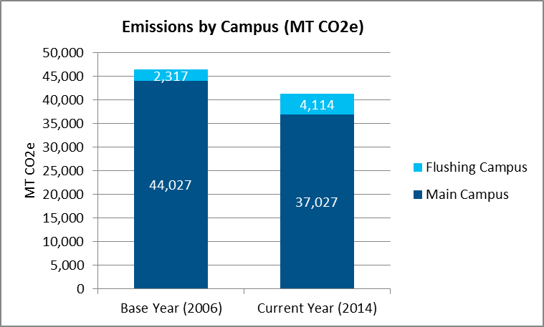

**If you choose to report your emissions by property, please insert Graphs 4-5 from your Climate Action Plan Tool Kit here.**

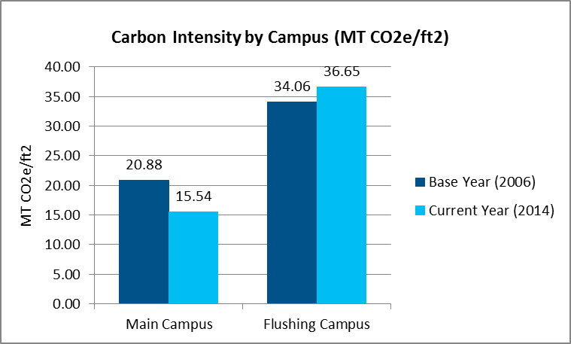

**Completed Projects and Strategies**

**In this section, please include information about the projects and strategies you’ve completed that have contributed to your emissions reduction to date. Please include:**

* **An overview of the section and description of changes in energy sources**
* **A description of your measurement and verification process for estimating energy savings**
* **A description of the projects and strategies your hospital has completed to date and their estimated energy reductions, carbon reductions, financial savings, and payback times**
* **Financial impacts and funding sources of energy conservation projects**
* **Any adjustments you have made to your emissions projections**
* **OPTIONAL: Description of operations, and maintenance procedures in place to maintain optimal energy performance. OPTIONAL: Description of demand response programs that the hopsital participates in.**
* **OPTIONAL: Description of your campus engagement strategy to communicate progress towards the Carbon Challenge goal and other sustainability achievements to the broader hospital community.**
* **Table 8-9 from your Climate Action Plan Tool Kit**

**You are encouraged to include photos of your selected projects interspersed within the text.**

**Please take what is useful from the following text.**

**Overview**

Participants in the NYC Carbon Challenge may achieve reductions in carbon emissions through both energy efficiency projects and conversions to cleaner energy sources. Energy efficiency projects include the installation of equipment or implementation of processes that are more efficient than currently required by relevant standards and achieve a permanent reduction in energy consumption. Fuel conversions include the replacement of one energy source for a building system with another source, which can result in emissions reductions even while using the same level of energy.

**Please state whether your hospital has completed fuel conversions or any other major changes in your energy sources here.**

**Methodology of Estimating Energy and Carbon Reductions**

**Please describe how your Hospital measures and verifies energy savings. Please take what is useful from the following text.**

To quantify the energy and carbon reductions of completed projects and strategies, **[Hospital Name]** uses a measurement and verification process that adheres to the **[Your Hospital’s M&V Protocol]**.Measurement and verification includes data collection, measurements, monitoring, and analysis to determine the energy and demand savings from completed energy efficiency and fuel conversion projects. Using the CAP Tool Kit provided by the Mayor’s Office, **[Hospital Name]** applied carbon coefficients to the energy savings to find the resulting GHG emissions reduction of each project. It is important to note, however, that even with a robust measurement and verification process, there is always some degree of uncertainty in the energy reduction estimates that may be the result of end use or demand changes, exogenous factors such as the weather, and inherent uncertainties with modeled data.

**The following is sample text—please remove and insert your own text in its place.**

**Completed Projects and Estimated Impacts**

In the past eight years, City Hall Hospital has implemented several projects have enabled the Hospital to achieve a 28.08% reduction in its carbon emissionsper square foot since its 2006 base year.

*Heating Oil Conversion:* In 2008, City Hall Hospital began replacing boilers and burners to eliminate the use of all No. 4 and No. 6 heating oil on its Main Campus. The Hospital completed this conversion in December 2011, installing cleaner-burning natural gas boilers that use No. 2 oil as a backup fuel. This project is estimated to have reduced City Hall Hospital’s carbon emissions per square foot by roughly 14% compared to baseline levels.

*Lighting Upgrades:* In addition to eliminating heavy heating oil on its Main Campus, City Hall Hospital began investing in lighting upgrades for both the Main Campus and the Flushing Campus in 2009. So far, 30% of existing lights in City Hall Hospital have been replaced with energy efficient LED lights. This change has resulted in savings of more than 15% in annual energy use for lighting, translating to a 3% reduction in City Hall Hospital’s baseline carbon intensity.

*Capital Upgrades:* In 2013, Facilities Operations approved the replacement of 45 fume hoods in the research laboratories. The new, high efficient motors and drives require significantly less energy as well as maintenance. The replacement is expected to reduce energy consumption by over 745,000 kWh and payback in 1.8 years. In 2013, four 32 year old chillers and 20 circulating pumps were removed and replaced with a single more efficient 100 ton air cooled chiller with 2 circulating pumps.

*Office Competition:* In 2009, City Hall Hospital also installed energy sub-meters on each floor of its Manhattan Municipal Building, which allowed the building to launch a floor-by-floor competition to reduce resident energy use. Each floor competed to save energy by turning off lights and shutting down computers at night. The first year of the competition realized an 8% energy savings, translating to a 2% overall reduction in our baseline energy intensity and associated carbon emissions.

**Financial Impacts**

Not only have these strategies reduced City Hall Hospital’s carbon emissions, they have also translated to significant financial savings. The completed fuel conversion will provide the Hospital an annual savings of about $500,000, primarily due to lower rates for natural gas, with a payback time of 3 years. In addition, City Hall Hospital’s lighting upgrades are expected to save $45,000 annually, with a payback time of 2 years, and the office competition will save an estimated $15,000 annually. In total, City Hall Hospital expects to save $560,000 per year as a result of these energy conservation strategies.

Funding for these strategies came first from the City Hall Hospital green revolving fund, which was further supplemented by NYSERDA’s electric efficiency performance incentives. NYSERDA offers incentives of $0.16 per kWh saved for projects from the major LED lighting retrofit[5] that City Hall Hospital was able to draw upon.

**Measurement and Verification**

Based on the projects that City Hall Hospital has completed, the Hospital has updated its strategy and adjusted its original projections for energy savings and emissions reductions.

The institution originally predicted that its fuel conversion would reduce total emissions by 12% and save $300,000 annually, but this was revised upwards to a 14% reduction in emissions and $345,000 in cost savings because of greater than anticipated boiler efficiencies and the falling price of natural gas. The emissions, energy use, and cost reductions realized from lighting upgrades are generally consistent with City Hall Hospital’s original projections. This means that completing the rest of the upgrades should realize a total of 6% emissions reductions and $45,000 in cost savings.

City Hall Hospital’s energy use competition exceeded initial projections. To continue this strategy will cost virtually nothing beyond the initial investment in energy sub-meters and should continue to realize at least 2-3% in energy savings and associated emissions reductions for each additional year of the Challenge. Given the positive results of this project, City Hall Hospital has decided to launch additional competitions and initiatives aimed at changing behavior as a cost-effective way to achieve additional reductions.

**If you plan to include a description of your Operations and Maintenance plan or participate in a demand response program, please provide that information below.**

**Operations and Maintenance**

Recognizing that a robust Operations and Maintenance (O&M) program designed to enhance operating efficiency can save 5 to 20 percent on energy bills without the need for significant capital investment[6], City Hall Hospital’s Facilities Department took action to draft their own O&M plan. This O&M plan emphasized the procedures for City Hall Hospital staff to perform regularly scheduled diagnostic and repair activities to ensure efficient building systems are operating as specified by their manufacturers. This O&M plan was formalized in a written document for easy communication to facilities staff.

As part of its O&M plan, City Hall Hospital performs scheduled maintenance on its existing building systems to confirm they are operating as designed and efficiently as possible, as well as commissioning all new building systems upgrades and installations. This robust operations and maintenance plan prevents potential energy losses associated with maladjusted or inoperable controls, steam, water and air leaks, uninsulated lines, or equipment in need of replacement.

City Hall Hospital has developed templates to record all changes in equipment, sequences of operation, set points, control strategies and schedules. Additionally, as part of its O&M plan, City Hall Hospital has written its procedures to include specific reviews of HVAC and lighting schedules, temperature set-points, and occupant/tenant use requirements to ensure that equipment runs only when needed

**Demand Response**

City Hall Hospital has enrolled in Con Edison’s Demand Response incentive program. By doing so, City Hall Hospital reduces its energy demand during peak load events caused by higher than average temperatures, while also receiving incentives equal to $10 per kW per month plus $1 for each kWh reduced during such peak load events. These demand response incentives are then added to the Hospital’s green revolving fund for use in Carbon Challenge strategies and projects.

**If you have a process for communicating Carbon Challenge performance results to the hospital community that you wish to include, please do so below.**

**Carbon Challenge Communication**

To ensure productive involvement by the City Hall Hospital community in meeting the NYC Carbon Challenge goal, updates on performance are regularly communicated to staff and administrators. The information is disseminated to staff through inclusion in monthly e-mail newsletters to all hospital personnel and to senior administrators through quarterly update meetings. This ongoing hospital engagement and regular measurement reporting has served to maintain active community interest in the Carbon Challenge as well as open lines for communication for feedback.

**[Hospital Name] ’s Completed Projects and Strategies**



**Please fill out Tables 8-9 in your Climate Action Plan Tool Kit and insert it in this section.**

**Total Savings from [Hospital Name]’s Projects and Strategies**



**Highlights**

**In this section, please highlight at least one project of particular interest. The following is sample text—please remove and insert your own text in its place.**

**Flushing Building Competition**

In 2014, City Hall Hospital launched a pilot energy use competition among the five floors of office space in the Flushing Building on its Flushing Campus. Using energy sub-meters installed on each floor, the floors compete against each other for the lowest energy use for the month of April in honor of Earth Day.

The energy savings and emissions reductions resulting from the competition were significant. Energy use decreased every month of the Challenge as staff learned new savings techniques, culminating in a 10.5% energy use reduction from the first month of the competition. In total, the first year of the competition realized an 8% energy savings, which translated to a 2% overall reduction in the baseline energy intensity and associated carbon emissions.

Not only did the competition translate to real energy savings and emissions reductions, it also facilitated greater energy consciousness and environmental awareness among the staff body. Staff became enthusiastic about the competition and formed “Energy Teams” that led the floor-wide efforts to reduce energy consumption.

To implement this pilot competition, City Hall Hospital set up energy use dashboards that employees used to monitor their daily energy performance. City Hall Hospital also used employee engagement tools provided by the Mayor’s Office, including an animation featuring the GreeNYC mascot Birdie who dispenses energy saving tips to employees. The goal is now to sustain energy reductions of 0.5% for the remainder of the Challenge through continued employee engagement.

Image: Birdie will dispense energy-saving tips to City Hall Hospital’s employees.

Please remove this photo and replace with your own image.

**Next Steps**

**In this section, please detail your plan to reach your emissions reduction goal. Please include:**

* **An overview of the section**
* **A description of Business as Usual Growth**
* **An estimate of remaining reductions needed to meet the Carbon Challenge goal, taking into account both achieved reductions and business as usual growth**
* **A brief description of your hospital’s project identification process**
* **A brief description of each planned project and/or strategy and the estimated energy reductions, carbon reductions, financial savings, and payback times**
* **A general plan for achieving the remaining reductions, broken down by project or strategy types**
* **Tables 10 and 11 from your Climate Action Plan Tool Kit**
* **A Wedge Chart illustrating a combination of your planned projects and additional opportunities for reductions by broad strategy**

**Please take what is useful from the following text.**

**Overview**

To achieve the NYC Carbon Challenge goal, **[Hospital Name] must** identify and assess the estimated energy and carbon reductions from a range of potential projects. This section includes a list of **[Hospital Name]** ’s planned projects in the short term for which the hospital has completed comprehensive analysis of energy projections, as well as a broader strategy to meet the goal based on potential opportunities that have not yet been fully assessed. Taken together, **[Hospital Name]’s** planned projects and strategies provide a road map for meeting the Challenge goal.

**“Business as Usual” Projected Growth**

**If you have used an alternate calculation of business as usual growth, please remove the text below and describe your own calculation here. If you assume no business as usual growth, please explain why.**

To map out the strategy for meeting the NYC Carbon Challenge goal, participants must understand both their base year level of emissions and their “Business as Usual” projected growth if no further action is taken to reduce energy use or carbon emissions. Based on the available historical data, the Mayor’s Office assumes citywide “Business as Usual” growth to be roughly a 1% increase in emissions per year. For planning purposes, **[Hospital Name]** will assume 1% annual growth under its “Business as Usual” scenario to account for expected increases in emissions as a result of greater intensity of energy use from increased use of IT equipment, labs, or other energy-intensive sources. This means that the Hospital will plan to reduce emissions intensity by *more than* **[30%/50%]** in order to offset this projected growth in emissions and meet the Challenge goal.

**The following is sample text—please remove and insert your own text in its place.**

**Remaining Reduction**

In the years since it joined the NYC Carbon Challenge, City Hall Hospital has reduced its carbon intensity by 28.08%. To reach the Carbon Challenge goal, City Hall Hospital must reduce its carbon intensity per square foot by an additional 21.92% by 2025. This corresponds to a drop in emission intensity from 16.55 Lbs. CO2e/Sq. Ft. in 2014 to 15.20 Lbs. CO2e/Sq. Ft. by the end of the Challenge.

However, assuming a “Business as Usual” projection of 1% growth in carbon intensity per year, City Hall Hospital would expect emissions to increase by 5% if the Hospital took no additional action. To offset this potential future growth, City Hall Hospital plans to achieve an additional 18-20% reduction in carbon intensity from its base year levels.

**Project Identification Process**

To identify additional projects to meet this goal, City Hall Hospital engaged a private, third-party engineering firm to complete an ASHRAE Level II energy audit and complete retro-commissioning on all existing equipment in order to comply with NYC LL87. This included modeling the energy use of many of its properties to more fully understand the contribution of various equipment and design features of each building to the Hospital’s total energy use. After developing a baseline model, the firm modeled energy conservation measures to understand the impact of each on total energy use, both separately and taken together. Based on this assessment, City Hall Hospital has selected a portfolio of projects that will reduce energy consumption and allow it to meet the Challenge goal.

City Hall Hospital began requirements for LL87 in December 2014. Based on this assessment, the Hospital has selected the projects below based their energy and GHG reduction potential.

**Planned Projects and Strategies**

To help achieve this remaining goal, City Hall Hospital has identified five projects and completed an assessment of potential energy reductions.

*Strategy 1 – Complete Lighting Upgrades:* City Hall Hospital has already replaced 30% of its existing lights with energy efficient LED lights. This has resulted in savings of more than 15% in annual energy use for lighting, translating to a 3% reduction in City Hall Hospital’s carbon emissions per square foot. Over the next two years, City Hall Hospital will complete the remaining lighting upgrades, realizing an additional 3% reduction in carbon intensity from baseline levels, bringing the total reduction to 6%. This corresponds to annual savings of 700,000 kWh of electricity annually, which translates to a GHG reduction of 296 metric tons of carbon dioxide equivalent. The payback time of this project is expected to be 2 years.

*Strategy 2 – Improve Operations and Maintenance of Equipment through Training:* In addition to its regular operations and maintenance plan, City Hall Hospital will hold annual trainings for all building managers and operators, which will focus on training for advanced control systems and active monitoring of building equipment. Based on the experience of similarly sized hospitals, City Hall Hospital expects to realize a 5% reduction in energy use and associated carbon emissions per square foot as a result. These reductions in energy consumption will save an estimated $51,000 in electricity costs annually, with a payback time of 2 years.

*Strategy 3 – Build all new buildings to LEED Gold Standards:* City Hall Hospital has committed to build its new facilities in the TriBeCa neighborhood to a high-performance LEED Gold standard. As City Hall Hospital continues to expand, these building standards are expected to reduce the carbon intensity of its facilities by a total of 5%.

*Strategy 4 – Major Capital Improvements:* The final component of City Hall Hospital’s strategy will focus on major capital improvements in the City Hall Building and 253 Broadway. City Hall Building will be replacing two 1,000-ton gas fired absorption chillers with a 1,800-ton high efficiency electric chiller than uses 17 percent less electricity than standard performance chillers. Additionally, 253 Broadway will be implementing an Energy Management System to shut off un-used ventilation systems during off hours.

*Strategy 5 –Retro-Commissioning:* Beginning in 2014, City Hall Hospital will continue to retro-commissioning its facilities to optimize energy performance and comply with New York City’s Local Law 87. This includes auditing of its existing buildings and identifying low-cost improvements to equipment controls to optimize system performance. This will reduce City Hall Hospital’s electricity consumption by an estimated 1.5 million kWh, which translates to about 634 metric tons of carbon dioxide equivalent. The strategy will reduce energy costs by $20,000 per year and is expected cost only $50,000 to implement, implying a payback period of 2.5 years. The Hospital expects this strategy to make a significant contribution to its goals by reducing its carbon emissions per square foot by an additional 1.3%.

These five projects represent relatively simple strategies to reduce City Hall Hospital’s energy use and carbon emissions. Taken together, the strategies are projected to reduce City Hall Hospital’s total energy use by about 86,488 MMBtu and cut GHG emissions by roughly 4,882 metric tons of carbon dioxide equivalent. Based on current electricity prices, this will save the Hospital $1,621,000 in energy costs annually with a payback time of 10 years overall.

Because there is a degree of uncertainty in all projections, City Hall Hospital will continue to update energy use projections over the next five years to reflect additional evaluation, measurement, and verification of its projects using the 2010 International Performance Measurement and Verification Protocol.

**Additional Opportunities and General Strategy to Meet the Challenge Goal**

Based on the results of City Hall Hospital’s LL87 Energy Efficiency Report (EER), the Hospital estimates that it will achieve the remaining carbon reductions to meet the the Challenge goal through three main strategies: additional lighting projects; plug load reductions through a combination of energy efficient purchasing standards, software controls, and staff engagement; and on-site generation. The contribution of each strategy is demonstrated by the wedge chart below, which assumed a 1% annual growth in “business as usual” emissions for planning purposes.

**[Hospital Name]’s Planned Projects and Strategies**



**Please fill out Tables 10-11 in your Climate Action Plan Tool Kit and insert it in this section.**



*Estimated reduction in carbon intensity is based on current square footage, which is expected to change over the timeline of the Challenge.

**[Hospital Name]’s Plan**



Please insert your wedge chart and projected reductions table from your Climate Action Plan Tool Kit in this section.



1. http://onlinelibrary.wiley.com/doi/10.1111/nyas.2015.1336.issue-1/issuetoc
2. Note: For purposes of the NYC Carbon Challenge, greenhouse gas emissions are measured in terms of carbon dioxide equivalent (CO2e) per square foot. Please see the explanation of standard units on the next page for more information.
3. http://www.nyc.gov/html/gbee/html/plan/ll87_eer.shtml
4. Note: For purposes of the NYC Carbon Challenge, greenhouse gas emissions are measured in terms of carbon dioxide equivalent (CO2e) per square foot. Please see the explanation of standard units on the next page for more information.
5. http://www.nyserda.ny.gov/All-Programs/Programs/Existing-Facilities-Program/Electric-Efficiency-Incentives
6. <https://www.energystar.gov/ia/business/15best.pdf>